Clinical Medicine and Surgery I · Exam 7 — Study Guide
Editable Word copy of the PA_Quizzes study aid. Headings use real Word styles, so the navigation pane and the contents field below both work, and restyling one heading restyles them all.
[In Word: right-click here and choose Update Field to build the contents.]

1 · Phases of Sleep (Sleep Physiology)
Lecture 39 · Chand Shah, MPAS, PA-C, Assistant Professor · Monday 2 November 2026, 10–11 AM
INSTRUCTIONAL OBJECTIVES
PHASES OF SLEEP (SLEEP PHYSIOLOGY) — Chand Shah, MPAS, PA-C
- Compare and contrast sleep and coma
- Compare and contrast slow-wave sleep and rapid eye movement sleep.
- Discuss the physiological functions of sleep.
- Differentiate between the waveforms of a normal EEG: alpha waves, beta waves, theta waves, delta waves.
- Compare and contrast characteristic changes in the EEG at different stages of wakefulness and sleep.
Quoted as the syllabus prints them (objective a has no final period). Answered in order: a in 1.1; b in 1.2–1.4; c in 1.5–1.6; d in 1.7; e in 1.8. EEG is the electroencephalogram. The deck’s own objectives slide words objective a as “Define sleep and distinguish sleep from coma.”

NOTE
What Prof. Shah stressed (live recording, Monday 2 November; the lecture ran about 33 minutes): the two basic types of sleep, REM and non-REM, which alternate through the night (the slide 7 graph). The most time went to non-REM sleep (deep, restful, parasympathetic, dreams that are not remembered), then the four brain waves, the EEG as sleep deepens, why sleep matters and REM sleep. She called arousability the “one big way to differentiate sleep from coma.” Stars below mark what she stressed; facts are still from the slides.
What she said is not the focus: the separate non-REM stages (“we’re not going to go into each of these ... I just want everyone to understand the two basic overviews”); the sleep-wake cycle paragraph (“there for you all to ... review ... know that it’s a positive feedback system”); and the slide 28 stage table (“if you want to take a look at that, you’re welcome to”). A student’s last question, whether the exam asks you to name a wave from a tracing, is cut off on the recording.

NOTE
Where the slides are loose or disagree
- Three or four non-rapid eye movement (NREM) stages. Slides 13, 15 and the slide 28 table use three (N1, N2, N3); the slide 7 sleep graph, the slide 27 list and the slide 29 picture use four (stages 1–4, delta waves in stage 4). Asked in class about a fourth stage, she said it belongs to sleep medicine and that for this course there are three. This guide uses N1–N3 and notes the four-stage figures where they appear.
- Where sleep spindles sit. Slide 27 puts spindles (“short spindle-shaped bursts of alpha waves”) in the first stage, and the slide 29 picture labels “Stage 1 sleep (low voltage and spindles)”; the slide 28 table puts sleep spindles and K complexes in stage N2.
- What “slow-wave sleep” means. Slide 6 uses it for all non-REM sleep (“Slow-Wave Sleep (aka non-REM sleep – NREM)”); the slide 28 table uses it for stage N3 only (“deep sleep, or slow-wave sleep”).
- Delta frequency. Slide 26 defines delta as below 3.5 cycles per second; slide 27 says “only 1–3 waves per second in stage 4,” which sits inside that range. Learn the slide 26 definition (below 3.5).
- Theta. The slide 28 table gives theta for N1 and N2; the slide 29 picture labels “Stages 2 and 3 sleep (theta waves).”
- How hard to wake. Slide 10: in REM sleep the person is “more difficult to arouse by sensory stimuli than during NREM”; the slide 28 table calls N3 “More difficult to arouse” (the deepest NREM stage). In lecture she said REM is “really, really difficult to arouse.”
- Muscles in REM. Slide 10 links REM with “active bodily muscle movements” and slide 13 with “more bodily muscle activity”, while slide 10 also says muscle tone is “very depressed” and the slide 28 table gives atonia. She said tone is “very, very depressed.” Learn the tone: very depressed, atonia except the eyes and diaphragm.
- REM after sleep loss. Slide 9 says extreme sleepiness makes REM episodes short or absent; current references also describe a REM rebound in recovery sleep after deprivation. Learn the slide.
- Brain metabolism in REM. Slide 10: up to 20%; she said “sometimes 20%, sometimes 25%.” Learn the slide’s 20%.

1.1 · Sleep versus coma
★ PROFESSOR EMPHASIS
★ “One big way to differentiate sleep from coma”; capitals on the slide (slide 5)
State | Definition
Sleep | Unconsciousness from which a person CAN be aroused by sensory stimuli or other stimuli
Coma | Unconsciousness from which a person CANNOT be aroused by stimuli

Arousable unresponsiveness is sleep. A person who is unconscious yet is roused by a loud voice and a squeeze of the shoulder, and then answers questions, was asleep. Sleep is unconsciousness from which a person can be aroused by sensory or other stimuli.
Coma versus sleep. Arousability separates the two states: sleep is unconsciousness from which a person can be aroused by sensory or other stimuli, and coma is unconsciousness from which a person cannot be aroused. Failure to rouse to any stimulus points to coma.
Telling sleep from coma by arousal. Sleep is unconsciousness from which a person can be aroused by sensory or other stimuli; coma is unconsciousness from which a person cannot be aroused. Waking when shaken shows he was arousable, so he was asleep, even though a quieter stimulus had failed first.
Sleep is one of many states of brain activity (sleep, wakefulness, extreme excitement, different levels of mood such as exhilaration, depression and fear); they arise mostly from activating or inhibiting forces generated within the brain (slide 3). The decision is arousability: both states are unconsciousness, but only sleep can be ended by stimuli.

1.2 · Sleep architecture: cycles and stages
- About 8 hours of sleep on average, containing 4–5 separate sleep cycles, each 90–120 minutes (slide 6).
- ★ Two types of sleep (slide 6): slow-wave sleep (non-REM sleep), deep and restful; and rapid eye movement (REM) sleep, not restful or deep.
- Non-REM is divided into stage N1, stage N2 (the majority of the sleep cycle) and stage N3; REM is “just REM sleep” (slides 13, 15).
- The night on a graph (slide 7): sleep descends through the stages to the deepest stage within the first hour; REM periods recur about every 90 minutes; the deepest stage appears in the early cycles and REM periods grow longer toward morning (the graph labels four stages, see the box above).
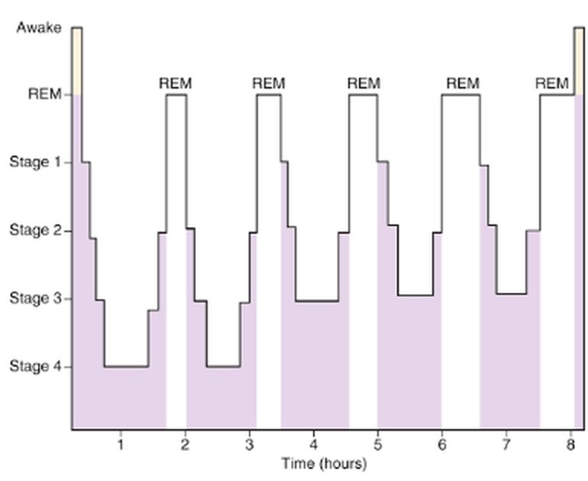
One night of sleep: stage 4 is reached within the first hour and only in the early cycles, while the labeled REM periods recur and lengthen toward morning. The graph draws four non-REM stages; this course uses three (box above). Slide 7

1.3 · Rapid eye movement sleep
- Occurs in episodes and occupies about 25% of a young adult’s sleep time; each episode recurs about every 90 minutes and lasts 5 to 30 minutes (slide 9).
- ★ When a person is extremely sleepy, each REM episode is short or even absent; as the person becomes more rested, REM episodes lengthen (slide 9).
- Rapid eye movement episodes when sleepy. When a person is extremely sleepy, each rapid eye movement episode is short or even absent. As the person becomes more restful and less sleepy, the duration of rapid eye movement episodes increases, so the later periods of a night are longer.
- Not the most restful sleep; associated with vivid dreaming; the brain is very active; the sleeper is not fully aware of surroundings and is asleep (slide 9).
- Active sleep (slide 10): dreaming and active bodily muscle movements, including rapid eye movements and irregular muscle movements. The person is more difficult to arouse by sensory stimuli than during NREM, yet people can awaken spontaneously in the morning during REM.
- Electrooculogram. The electrooculogram, the eye-movement recording, shows the irregular, sharply peaked eye movements of rapid eye movement sleep. The eye muscles are spared from the atonia that affects other voluntary muscles, so the eyes keep moving.
- Rapid eye movement sleep. Rapid eye movement sleep is the active, dreaming form of sleep: dreams are vivid, heart and breathing rates become irregular, and muscle tone is very depressed, with atonia of voluntary muscles except the eyes and diaphragm.
- Waking from rapid eye movement sleep. Rapid eye movement sleep is associated with vivid dreaming, and people can awaken spontaneously in the morning during rapid eye movement sleep; in a typical night the last rapid eye movement period leads into waking.
- Muscle tone is very depressed (inhibition of spinal muscle control areas); the slide 28 table: atonia of voluntary muscles except the eyes and diaphragm, from inhibited alpha motor neurons (slides 10, 28).
- Electromyogram. The electromyogram, the muscle recording, shows atonia of voluntary muscles in rapid eye movement sleep, sparing the eye muscles and diaphragm, as inactivity due to inhibited alpha motor neurons.
- Heart rate and respiratory rate become irregular (characteristic of the dream state); brain metabolism can rise by as much as 20% (slide 10).
- The EEG resembles wakefulness, so REM is also called paradoxical sleep (slide 10) and desynchronized sleep (a lack of synchrony in neuron firing; waves irregular and high frequency; often hard to tell from awake and active) (slide 29).
- Desynchronized sleep. Rapid eye movement sleep is also called desynchronized sleep because there is a lack of synchrony in neuron firing when there is brain activity. The tracing is irregular and high frequency, much like an awake, active person's.

1.4 · Slow-wave (non-rapid eye movement) sleep, and the comparison
- Extremely restful. The deep sleep in the first hour after going to sleep after more than 24 hours awake is this kind of sleep (slide 12).
- Decreased peripheral vascular tone and other vegetative functions: a 10–30% decrease in blood pressure, heart rate, respiratory rate and metabolic rate (slide 12). Physiologic changes: ★ increased parasympathetic tone; low blood pressure, slow heart rate, decreased respiratory rate; less vivid dreams (slide 14).
- Non-rapid versus rapid eye movement physiology. Non-rapid eye movement sleep brings increased parasympathetic tone with low blood pressure, a slow heart rate and a decreased breathing rate, part of a 10 to 30% fall in vegetative functions. In rapid eye movement sleep, heart and breathing rates become irregular instead.
- Often called the dreamless state, which is not always accurate: dreams and nightmares do occur in NREM. REM dreams carry more bodily muscle activity, and ★ NREM dreams are often not remembered because they are not consolidated in memory (slide 13).
 | Slow-wave (NREM) sleep | Rapid eye movement (REM) sleep
Restfulness | Deep, extremely restful | Not restful or deep
Dreams | Less vivid; often not remembered (no consolidation) | Vivid; with bodily muscle activity
Autonomic tone | Increased parasympathetic tone | Heart rate and breathing irregular
Blood pressure, heart rate, breathing, metabolism | 10–30% lower | Brain metabolism up by as much as 20%
Muscles | — | Tone very depressed (atonia except eyes and diaphragm); rapid eye movements and irregular movements
Arousal | N3 the hardest NREM stage to arouse | Harder to arouse by sensory stimuli than NREM; spontaneous morning waking can occur
EEG | Slows progressively to delta waves | Like wakefulness (paradoxical, desynchronized)

Stage N3. Stage N3, also called deep sleep, is restful sleep and the deepest non-rapid eye movement stage, marked by delta waves. Body and tissue growth and repair occur in it, and it decreases with age.
Slides 6, 9, 10, 12–14, 28, 29

1.5 · Why sleep matters: the physiological functions
- Sleep restriction over a few days can decrease cognitive and physical performance, overall productivity and health (slide 16).
- Sleep restriction. Sleep restriction over a few days can decrease a person's cognitive and physical performance, overall productivity and health. That is one reason sleep is considered essential, even though its specific physiological functions are still being researched.
- Researchers have limited understanding of why sleep is essential; its specific physiological functions remain a mystery and are still researched (slide 16).
- Two major types of physiological effects: effects on the nervous system and effects on other functional systems of the body (slide 17).
- Other functions (slide 17): neural maturation; facilitation of learning or memory; targeted erasure of synapses to forget unimportant information that might clutter the synaptic network; cognition; clearance of metabolic waste products generated by neural activity in the awake brain; conservation of metabolic energy.

1.6 · The cycle between sleep and wakefulness
There is no definitive explanation of the sleep-wakefulness cycle, only proposed theories (slide 18):
- Sleep centers are not activated, so the mesencephalic and upper pontile reticular activating nuclei are released from inhibition and activate spontaneously.
- They excite the cerebral cortex and peripheral nervous system, which send positive feedback signals back to the same reticular nuclei: wakefulness sustains itself (slides 18–19).
- After many hours of activity the neurons of the activating system become fatigued, the positive feedback cycle between the mesencephalic reticular nuclei and the cortex fades, and the sleep-promoting centers take over: the transition from wakefulness to sleep (slide 19).
What ends wakefulness. After the brain has remained active for many hours, neurons in the activating system become fatigued. The positive feedback cycle between the mesencephalic reticular nuclei and the cerebral cortex fades, and the sleep-promoting centers take over.

1.7 · The four waveforms of a normal EEG
The intensity and pattern of electrical activity depend on the level of excitation of parts of the brain in sleep, wakefulness or brain disorders such as epilepsy or psychosis (slide 21).
Wave | Frequency | Where and when
Alpha | 8–13 cycles/second, rhythmical | Almost all healthy adults awake in a quiet, resting state; most intense in the occipital region (also parietal and frontal); disappear during deep sleep; on the slide 28 table, awake with eyes closed
Beta | Greater than 14, as high as 80 cycles/second | Mainly parietal and frontal regions during specific activation; asynchronous, low voltage; the person is awake, alert and actively processing information
Theta | 4–7 cycles/second | Parietal and temporal regions in children; during emotional stress in some adults (especially disappointment and frustration); in many brain disorders, especially degenerative brain states
Delta | Less than 3.5 cycles/second | Voltages 2–4 times greater than most other brain waves; occur strictly in the cortex, independent of lower brain regions; in very deep sleep, infancy, serious organic brain disease, and the cortex of animals whose cortex was cut off from the thalamus (subcortical transection)

What shapes the electroencephalogram. The intensity and patterns of electrical activity on the electroencephalogram are determined by the level of excitation of different parts of the brain, which varies with sleep, wakefulness and brain disorders such as epilepsy or psychosis.
- Alpha to beta (slide 24): when an awake person’s attention is directed to a specific mental activity, alpha waves stop and are replaced by beta waves; the slide 24 trace shows alpha disappearing when the eyes open and returning when they close.
Slides 21–26, 28
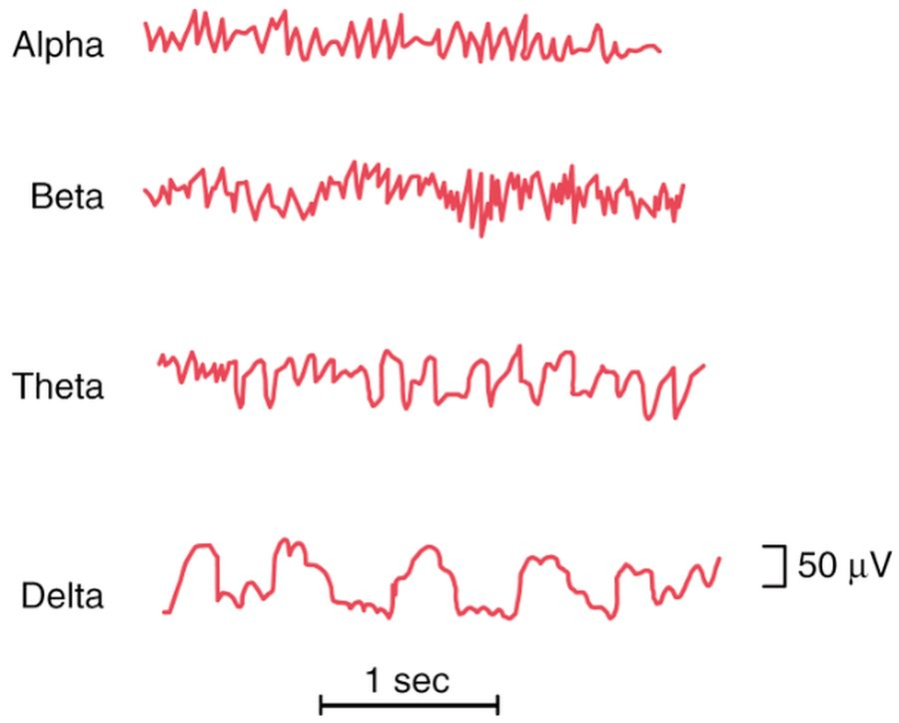
The four waves on one 1-second scale: the rhythm slows from alpha and beta to theta and then delta, the slowest and tallest (delta voltages are 2–4 times most other waves, slide 26). Slide 21
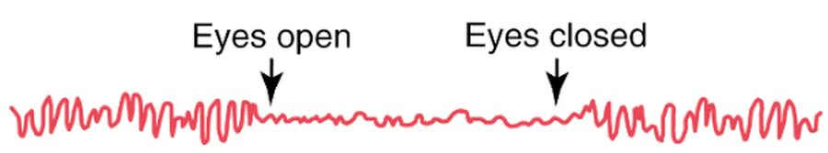
Alpha waves stop at “Eyes open” and come back at “Eyes closed”: directed attention replaces alpha with beta. Slide 24

1.8 · EEG changes across wakefulness and sleep
- Alert wakefulness: high-frequency beta waves. Quiet wakefulness: alpha waves (slide 27).
- Slow-wave sleep: the first stage is light sleep with low voltage, broken by sleep spindles; the frequency becomes progressively slower through the stages until delta waves at the deepest stage (slide 27; four stages on that slide).
Stage | Description | EEG
Awake, eyes open | Alert and active | Beta
Awake, eyes closed | Decreased alertness, relaxation | Alpha
N1 | Transition from wakefulness; somnolent or drowsy; light sleep | Theta
N2 | Less responsive, deeper sleep; heart rate and temperature decrease; longest stage by total duration | Theta; sleep spindles (bursts of monomorphic 12- to 14-Hz waves); K complexes (negative sharp waves followed by a positive component)
N3 (deep sleep, slow-wave sleep) | Restful sleep, deepest NREM stage; more difficult to arouse; body and tissue growth and repair; decreases with age | Delta
REM (stage R, the dream state) | EEG mixed and low voltage with sawtooth waves; rapid, irregular, sharply peaked eye movements; atonia of voluntary muscles except the eyes and diaphragm | Beta (like the awake state, but with atonia)

Delta waves. Waves slower than 3.5 cycles per second with high voltage are delta waves, and delta waves mark stage N3, the deep, restful and deepest non-rapid eye movement stage, in which body and tissue growth and repair occur.
Rapid eye movement sleep versus wakefulness. In rapid eye movement sleep the waves are irregular and high in frequency, beta waves like those of an awake, active person, which makes it often difficult to tell rapid eye movement sleep from alert wakefulness. Atonia of voluntary muscles is the difference.
Slide 28 (table), with slides 27 and 29
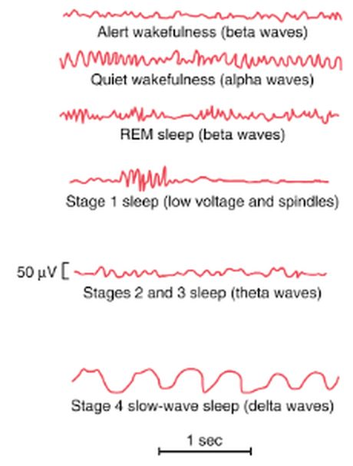
Down the column the EEG slows and grows, from alert wakefulness (beta) and quiet wakefulness (alpha) to stage 4 slow-wave sleep (delta), while REM sleep (beta) looks like wakefulness. Labels as drawn: four stages, spindles in stage 1 (the slide 28 table puts them in N2, box above). Slide 29
Memory aid (made here, not from the slides): going down into sleep the waves go down the alphabet’s speed: Busy (beta, eyes open) → At rest (alpha, eyes closed) → Tired (theta, N1 and N2) → Deep (delta, N3); then REM jumps back to beta.

2 · Obstructive Sleep Apnea and Obesity Hypoventilation Syndrome
Lecture 40 · Chand Shah, MPAS, PA-C, Assistant Professor · Monday 2 November 2026, 11 AM–12 PM
INSTRUCTIONAL OBJECTIVES
OBSTRUCTIVE SLEEP APNEA AND OBESITY HYPOVENTILATION SYNDROME — Chand Shah, MPAS, PA-C
- Compare and contrast the etiologies, epidemiology, risk factors, clinical manifestations, differential diagnosis, diagnostic testing (including ordering and interpretation), management (acute and chronic, including applicable rehabilitative and palliative care), appropriate referrals, patient education, and prognosis for obstructive sleep apnea and obesity hypoventilation syndrome: a. Obstructive sleep apnea b. Central sleep apnea c. Obesity hypoventilation syndrome (also known as Pickwickian Syndrome)
- Discuss screening tools for obstructive sleep apnea
- Discuss the following complications of untreated obstructive sleep apnea and comorbidities of obstructive sleep apnea, including: a. Atrial fibrillation and cardiac arrythmias b. Pulmonary hypertension and right heart failure c. Heart failure d. Systemic hypertension e. Coronary artery disease f. Type 2 diabetes mellitus and metabolic syndrome g. Nonalcoholic fatty liver disease
- Identify medical care strategies for obstructive sleep apnea and obesity hypoventilation syndrome for the following populations. 1. adult 2. elderly
Quoted as the syllabus prints them (its spelling “arrythmias” kept; a stray empty “a.” before the disease list left out). Answered in order: a across 2.1–2.6 (obstructive sleep apnea), 2.9 (central sleep apnea) and 2.10 (obesity hypoventilation syndrome); b in 2.5; c in 2.8; d in 2.11. The deck’s objectives slide adds three of its own, answered in the same places: why obesity hypoventilation syndrome is a diagnosis of exclusion (2.10), central sleep apnea as a differential for obstructive sleep apnea (2.4, 2.9) and the STOP-Bang questionnaire (2.5).

NOTE
What Prof. Shah stressed (live recording, Monday 2 November; about 39 minutes of slide teaching after a 14-minute warm-up case): the most time went to managing obstructive sleep apnea (continuous positive airway pressure and the devices), then diagnosis (the sleep study and its two criteria), then who gets it and how it presents, central sleep apnea and obesity hypoventilation syndrome. She gave the diagnosis “as simple as possible, five or more plus a symptom or 15 or more”; said “patient education is like the most important thing that we can do”; asked everyone to understand that central apnea’s risk factors are different because its treatment is treating them; and called obesity hypoventilation syndrome a “diagnosis of exclusion” with weight loss plus BiPAP or CPAP “first line, first line, first line.” Stars below mark what she stressed; facts are still from the slides.
Not in the deck: the opening case (a 55-year-old man whose wife hears him stop breathing) was taught from slides that are not in this deck, so nothing here is built on it; the case studies at the end were left for self-study (“I’ll post them and you guys can work through them”). Nothing was said to be off the exam.

NOTE
Where the slides are loose or disagree
- Neck size. As an obstructive sleep apnea risk factor and exam finding (slides 6–7): 17 inches or more in men, 16 in women (slide 7 writes “>17in”). On the STOP-Bang questionnaire (slide 17): 16 inches / 40 cm or larger, for anyone. Use each number inside its own tool.
- Body mass index. STOP-Bang counts more than 35 kg/m²; obesity for obesity hypoventilation syndrome is more than 30 (slides 30, 32).
- Sex. Obstructive sleep apnea: “Male > women” (slide 6), yet sleep-disordered breathing is more prevalent after menopause than before (slide 5). Obesity hypoventilation syndrome: “Male gender is not a risk factor” (slide 29), and the sleep-hypoventilation subgroup is “older females” (slide 30).
- Two “gold standards.” Slide 8 labels both the split-night and the all-night polysomnogram the gold standard for obstructive sleep apnea; slide 32 labels polysomnography with continuous nocturnal carbon dioxide monitoring the gold standard for obesity hypoventilation syndrome.
- Heart rate. Slide 21 lists both increased sympathetic tone and bradycardia among the cardiovascular effects of untreated obstructive sleep apnea.
- CPAP in central sleep apnea, twice. Slide 24 lists patients using CPAP among central apnea’s risk factors; slide 26 makes CPAP the first treatment to consider once the cause is treated. Both are keyed, each in its own role.
- Said aloud, not on a slide (never keyed): a complete blood count, metabolic panel and liver tests in the obstructive apnea workup (slide 8 lists only thyroid-stimulating hormone); home-kit cost and insurance.
- Spoken slips (the slide is keyed): slide 13’s maxillomandibular advancement is surgery, though she called it a device “the dentist will create”; slide 22 says elderly mortality is lower because the patients compensate, which she tied to CPAP; slide 30 gives the sleep-hypoventilation subgroup less witnessed apneas, though she said they could have witnessed apneas.
- Severity by index. The mild / moderate / severe cut-offs of the apnea-hypopnea index are in the speaker notes only, not on a slide; this guide does not give them.

2.1 · Sleep-disordered breathing: the definitions
- Sleep-disordered breathing is divided into obstructive sleep apnea, central sleep apnea and sleep-related hypoventilation (slide 3).
- Apnea: a decrease in airflow of 90% or more, measured by thermistor, lasting at least 10 seconds; episodes of near or total cessation of breathing.
- Apnea and its obstructive type. An apnea is a 90% or greater fall in airflow on the thermistor lasting at least 10 seconds, and when airflow stops but respiratory effort continues, the apnea is obstructive. The airway collapses while the patient still tries to breathe.
- Hypopnea: slowed, shallow, restricted breathing in episodes of 10 seconds or longer, repeatedly during sleep.
Apnea type (slide 3) | Airflow | Respiratory effort
Obstructive | None | Continued
Central | None | None
Mixed | None | Absent in the first part of the event, resumes in the latter part

2.2 · Obstructive sleep apnea: who gets it and why
- The most common form of sleep-disordered breathing; prevalence increases with age; more prevalent in post-menopausal than premenopausal women (slide 5).
- Etiology: narrowing of the upper airway from excessive soft tissue or structural abnormalities (slide 5).
- Risk factors (slide 6): obesity; macroglossia; micrognathia; retrognathia; neck circumference 17 inches or more (men) and 16 (women); enlarged tonsils; increasing age; male more than female; family history; use of alcohol or sedatives; concomitant medical conditions such as hypothyroidism.
- Enlarged tonsils. Enlarged tonsils are a risk factor and examination finding of obstructive sleep apnea, alongside obesity, macroglossia, micrognathia, retrognathia, a thick neck and a crowded posterior oropharynx. They point to structural narrowing of the upper airway.
★ “That’s an important thing”: sleep-disordered breathing is more prevalent after menopause than before (slide 5), so a woman’s age helps a lot when you weigh her risk.

2.3 · Obstructive sleep apnea: presentation
History (slide 7) | Physical exam (slide 7)
Daytime sleepiness; unrefreshing sleep; witnessed apnea; awakening with snorting or gasping; loud, habitual snoring; morning headaches; nocturia; poorly controlled hypertension; decreased concentration or memory, irritability; decreased libido; nocturnal sweating | Obesity; macroglossia; micrognathia; retrognathia; neck circumference over 17 inches (men) and 16 (women); enlarged tonsils; crowded posterior oropharynx

Obstructive sleep apnea history and examination. Loud habitual snoring, witnessed apneas, awakening with gasping, unrefreshing sleep, morning headaches, nocturia and poorly controlled hypertension are its history findings, and a large neck and a crowded posterior oropharynx are its examination findings. Narrowing of the upper airway by soft tissue or structure causes it.
★ Listen to the family: the patient cannot report witnessed apneas or the snoring; the bed partner can (slide 7).

2.4 · Obstructive sleep apnea: differential and diagnosis
Differential (slide 10): central sleep apnea; nocturnal dyspnea (congestive heart failure); abnormal swallowing disorder; panic attacks; nocturnal asthma; gastroesophageal reflux disease; nocturnal seizures; other causes of daytime sleepiness (narcolepsy, periodic limb movement disorder).
★ PROFESSOR EMPHASIS
★ “Gold standard” on the slide (slides 8–9)
- Thyroid-stimulating hormone if hypothyroidism is suspected.
- Split-night polysomnogram (gold standard): the first 2 hours of sleep are recorded to determine severity, then continuous positive airway pressure (CPAP) titration if the apnea is significant (finding the exact pressure that keeps the airway open).
- All-night polysomnogram (gold standard): performed if sleep-disordered breathing is mild to moderate at baseline; shows severity in different stages of sleep and sleep positions.
- Positive airway pressure titration: used if the diagnosis is already known.
- Home testing kits: assess only obstructive sleep apnea, not other sleep disorders; will not always diagnose mild disease (helpful for moderate to severe). Use a polysomnogram, not a home kit, with significant cardiopulmonary disease, neuromuscular weakness, awake hypoventilation or hypoxemia, stroke, long-term opioid use, severe insomnia, or concern for a non-obstructive sleep disorder.
Index (slide 9) | Formula
Respiratory disturbance index | (apneas + hypopneas + respiratory effort-related arousals) ÷ total sleep time in hours
Apnea-hypopnea index | (apneas + hypopneas) ÷ total sleep time in hours

A respiratory effort-related arousal is an obstructive reduction of the upper airway that is not an apnea or hypopnea. The diagnosis is confirmed when either criterion is met and the symptoms are not explained by another medical or sleep condition, medication or substance use:
- 5 or more predominantly obstructive respiratory events per hour of sleep plus one symptom: sleepiness, fatigue, insomnia or other symptoms impairing sleep-related quality of life; waking with breath holding, gasping or choking; or habitual snoring or breathing interruptions noted by a bed partner or other observer; or
- 15 or more predominantly obstructive respiratory events (no symptom needed; the slide gives no time unit for this one).

Negative home sleep apnea test. At-home kits will not always diagnose mild obstructive sleep apnea; they are most helpful in moderate to severe disease. A negative home study with ongoing snoring and sleepiness therefore needs a polysomnogram, which can also find other sleep disorders a home kit cannot assess.
★ PROFESSOR EMPHASIS
★ “As simple as possible” (recording; slides 8–9)
Two routes to the diagnosis, said twice: 5 or more predominantly obstructive events per hour plus a symptom, or 15 or more. The sleep study (polysomnogram) is the gold standard. A home kit is convenient but checks only obstructive sleep apnea; use a polysomnogram, not a home kit, with significant cardiopulmonary disease or neuromuscular weakness (slide 8), and for central sleep apnea, where home testing is not sufficient (slide 26).

2.5 · Screening: the STOP-Bang questionnaire
- Screening questionnaires should not be routinely used to screen for obstructive sleep apnea in the community, and STOP-Bang cannot be used as a true, accurate screening tool in asymptomatic patients (slide 16).
- STOP-Bang has been used as a preoperative evaluation tool for people without a known diagnosis who may be at risk of perioperative complications; it has the highest sensitivity of all the questionnaires; it has some value in highly symptomatic patients in high-risk settings such as preoperative evaluation (slide 16).
★ PROFESSOR EMPHASIS
★ The questionnaire (slide 17, a picture): one point per yes
Letter | Question
Snoring | Snore loudly (heard through closed doors, or the bed partner elbows you)?
Tired | Often tired, fatigued or sleepy in the daytime (such as falling asleep driving or talking)?
Observed | Has anyone observed you stop breathing or choking/gasping in your sleep?
Pressure | Have or being treated for high blood pressure?
BMI | Body mass index more than 35 kg/m²?
Age | Older than 50?
Neck size | Neck (shirt collar) 16 inches / 40 cm or larger?
Gender | Male?

General population: low risk = yes to 0–2; intermediate = 3–4; high = 5–8; or high risk with yes to 2 or more of the 4 STOP questions plus male gender, or plus body mass index over 35 kg/m², or plus neck circumference 16 inches / 40 cm.
For general population (slide 17) | Score
Obstructive sleep apnea (OSA) – Low Risk | Yes to 0–2 questions
OSA – Intermediate Risk | Yes to 3–4 questions
OSA – High Risk | Yes to 5–8 questions  or Yes to 2 or more of 4 STOP questions + male gender  or Yes to 2 or more of 4 STOP questions + body mass index (BMI) > 35 kg/m²  or Yes to 2 or more of 4 STOP questions + neck circumference 16 inches / 40 cm

STOP-Bang worked total (4 and 3). Snoring 1 + observed apnea 1 + body mass index above 35 1 + neck 16 inches or larger 1 = 4; tiredness, pressure, age and gender (female) score 0. A total of 4 is intermediate, but yes to 2 of the first four questions plus a body mass index above 35 makes high risk. Snoring 1 + pressure 1 + age older than 50 1 = 3 is intermediate risk, and no combination rule applies.
High risk despite a total below 5. Snoring and tiredness are 2 of the first four questions, and a neck of 16 inches (40 cm) or larger completes a high-risk combination. The total is only 3, yet the person is high risk, as with 2 or more of the first four plus male gender or a body mass index above 35.
STOP-Bang risk bands. Snoring 1 + treated pressure 1 + age older than 50 1 + neck 17 inches 1 + male 1 = 5, the high-risk band (5 to 8); body mass index 35 does not count because it is not more than 35. Two yes answers to the first 4 questions plus male gender also make high risk. The low-risk band is 0 to 2: the body mass index rule needs 2 or more yes answers to the first 4 questions.
STOP-Bang worked example, score of 3. Snoring 1 + tired 1 + observed apnea 0 + pressure 0 + body mass index 38 (more than 35) 1 + age 50 (not older than 50) 0 + neck 15 inches 0 + female 0 = 3: intermediate by the count alone (3 to 4), but 2 yes answers to the first 4 questions plus a body mass index above 35 meet the questionnaire's added high-risk rule.
STOP-Bang worked example, score of 6. Snoring 1 + tired 0 + observed apnea 1 + treated pressure 1 + body mass index 33 (not more than 35) 0 + age 56 (older than 50) 1 + neck 16.5 inches (16 or larger) 1 + male 1 = 6; a score of 5 to 8 is the high-risk group for obstructive sleep apnea.
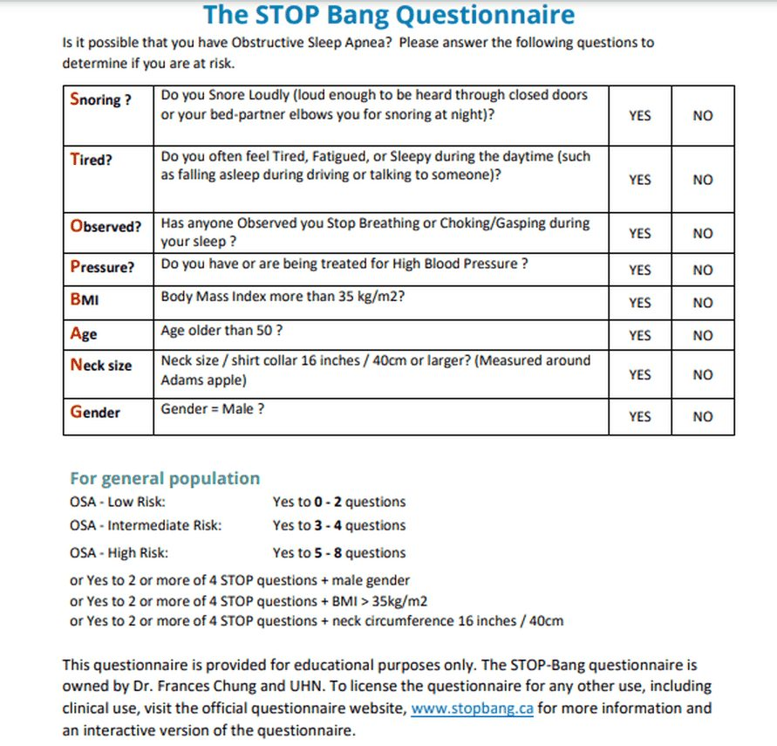
The questionnaire as printed: one yes per letter, then the risk bands. Its cut-offs are its own: neck 16 inches / 40 cm for anyone and body mass index more than 35 kg/m², not the 17 / 16 inch risk-factor numbers of slides 6–7. Slide 17

2.6 · Obstructive sleep apnea: management, education and referral
Type | What the slides say
Non-pharmacologic (slide 12) | Continuous positive airway pressure (CPAP): the most effective. Autotitrating (adjustable) positive airway pressure: for patients without significant comorbid conditions. Positional therapy if events occur when supine (a sleep belt or shirt keeps the lateral position). Oral appliance: not effective in severe disease or if the patient has no teeth. Nasal expiratory resistance device (uses the patient’s own breathing to make expiratory positive airway pressure).
Pharmacologic (slide 11) | Stimulants (modafinil or armodafinil): side effects headache, nervousness or anxiety, dizziness, nausea, dermatologic and systemic hypersensitivity; many drug interactions; caution with cardiovascular, hepatic and psychiatric conditions; lower doses in the elderly. Nasal steroids for nasal congestion or inflammation from allergic rhinitis.
Surgical (slide 13) | Radiofrequency ablation (mild to moderate disease, cannot tolerate CPAP); palatal implants (mild disease, cannot tolerate CPAP); maxillomandibular advancement; tracheostomy is a cure (it bypasses the site of upper airway obstruction); bariatric surgery for weight loss may help.
Risk modification (slide 15) | Diet and exercise for weight loss; avoid alcohol and other sedatives.
Education (slide 15) | Refer to a sleep physician; proper counseling.

Modafinil and armodafinil cautions. These stimulants need caution in patients with cardiovascular, hepatic or psychiatric conditions, so liver disease calls for care. They also have many potential drug interactions, and elderly patients receive lower doses.
Modafinil and armodafinil side effects. Listed side effects include headaches, nervousness or anxiety, dizziness, nausea, and dermatologic and systemic hypersensitivities. A widespread rash with feeling unwell after starting the drug fits a dermatologic and systemic hypersensitivity reaction.
★ PROFESSOR EMPHASIS
★ “Patient education is like the most important thing that we can do” (recording)
CPAP is the most effective (slide 12), and patients often dislike the mask, so counseling is the treatment’s other half (slide 15: proper counseling, refer to a sleep physician). An oral appliance is not effective in severe obstructive sleep apnea (slide 12): those patients need CPAP. Tracheostomy is a cure (slide 13), but she placed it at the end of a stepwise, patient-by-patient order, never first.

Positive airway pressure at home (slide 14; the slide puts no labels on these photographs)
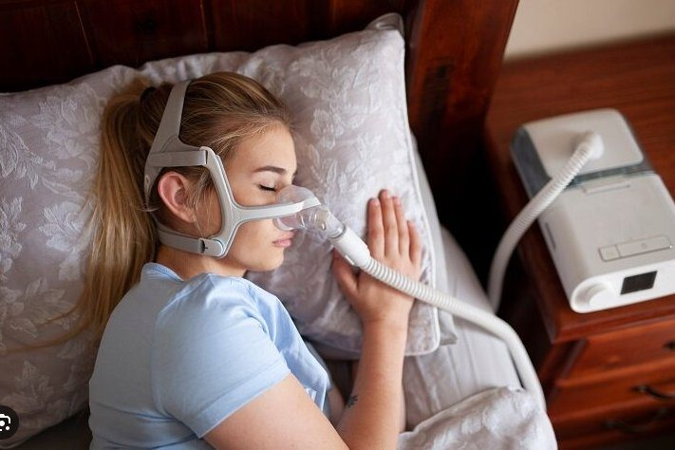  Mask over the nose  Hose to a bedside machine  Slide 14 | 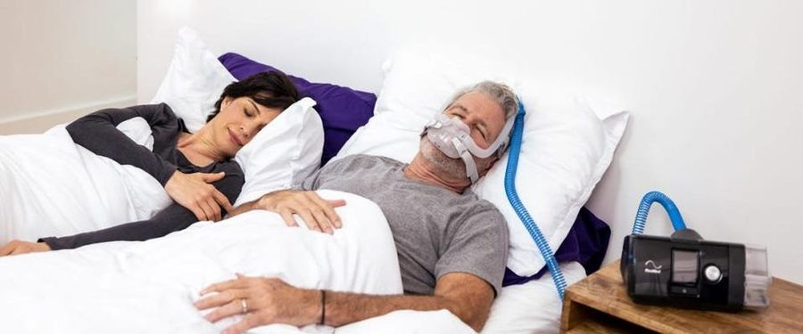  Mask over nose and mouth  Hose to a bedside machine  Slide 14

Obstructive sleep apnea
Defining feature: loud habitual snoring and witnessed apneas with daytime sleepiness in an obese patient with a large neck, from upper airway narrowing while respiratory effort continues
DefinitionSleep-disordered breathing with no airflow but continued respiratory effort, from narrowing of the upper airway by excess soft tissue or structural abnormality.Who gets itThe most common form of sleep-disordered breathing; prevalence rises with age; men more than women; post-menopausal more than premenopausal women.Risk factorsObesity, macroglossia, micrognathia, retrognathia, neck 17 inches or more (men) or 16 (women), enlarged tonsils, age, male sex, family history, alcohol or sedatives, hypothyroidism.Classic signs & symptomsDaytime sleepiness, unrefreshing sleep, witnessed apnea, snorting or gasping awakenings, loud habitual snoring, morning headache, nocturia, poorly controlled hypertension.Physical exam findingsObesity, large tongue, small or set-back jaw, large neck, enlarged tonsils, crowded posterior oropharynx.Diagnostics / testsPolysomnogram (split-night or all-night): 5 or more obstructive events per hour plus a symptom, or 15 or more; thyroid-stimulating hormone if hypothyroidism suspected; home kits only without the listed comorbidities.First-line treatmentContinuous positive airway pressure (most effective), weight loss, avoid alcohol and sedatives; positional therapy, oral appliance, surgery for selected patients; refer to a sleep physician.ComplicationsHypertension, cardiovascular disease, arrhythmias, sudden cardiac death at night, heart failure, pulmonary hypertension, stroke, insulin resistance and diabetes, fatty liver, reflux, motor vehicle crashes.
Slides 3, 5–13, 15–22

2.7 · What happens if obstructive sleep apnea is left untreated
★ PROFESSOR EMPHASIS
★ Capitals on the slide (slide 18)
Mortality | Morbidity
2.5 times the driving accidents  3–6 times the risk of sudden cardiac death AT NIGHT  High mortality from heart failure | 3 times the risk of hypertension  Pulmonary hypertension  Stroke  Insulin resistance  Arrhythmias  Ischemic heart disease

- Reflux (slide 19): 75–100% of patients have gastroesophageal reflux disease or laryngopharyngeal reflux from decreased intrathoracic pressure; it improves with CPAP.
- Cardiovascular effects (slide 21): increased sympathetic tone; bradycardia; increased blood pressure variability; increased arrhythmias; increased risk of aortic aneurysm and aortic dissection.
- Endocrine effects (slide 21): increased C-reactive protein, cortisol and amyloid; decreased growth hormone and prolactin. Immunity (slide 22): increased proinflammatory cytokines, which improve with CPAP.
- Also (slides 15, 20): increased motor vehicle crashes from daytime sleepiness; increased risk of gout.
★ She read these numbers aloud for patient education: 2.5 times the driving accidents, 3 times the hypertension, 3–6 times the sudden cardiac death at night (slide 18). Reflux and immunity improve with CPAP (slides 19, 22).

2.8 · The syllabus complications and comorbidities, one by one
Syllabus item | What the slides say
Atrial fibrillation and cardiac arrhythmias | Arrhythmias (slide 18); increased arrhythmias, bradycardia, increased sympathetic tone (slide 21); 3–6 times the risk of sudden cardiac death at night (slide 18). Atrial fibrillation is not named on the slides.
Pulmonary hypertension and right heart failure | Pulmonary hypertension (slide 18). Obstructive sleep apnea is classified with group 3 pulmonary hypertension, especially with obesity hypoventilation syndrome or another cause of daytime hypoxemia (slide 20). Right-sided heart failure from pulmonary hypertension is given for obesity hypoventilation syndrome (slides 30, 34, 35).
Heart failure | High mortality from heart failure (slide 18); congestive heart failure is a complication of obesity hypoventilation syndrome (slide 34).
Systemic hypertension | 3 times the risk (slide 18); hypertension (slide 15); increased blood pressure variability (slide 21); poorly controlled hypertension in the history (slide 7).
Coronary artery disease | Ischemic heart disease (slide 18); cardiovascular disease (slide 15); markers of inflammation and atherosclerosis (slide 20).
Type 2 diabetes mellitus and metabolic syndrome | Increased insulin resistance, type 2 diabetes and diabetes complications; increased glucose and triglycerides independently associated; may exacerbate cardiovascular risk in metabolic syndrome (slide 20); insulin resistance (slides 15, 18).
Nonalcoholic fatty liver disease | 2–3 times the prevalence (slide 20).

Pulmonary hypertension in obstructive sleep apnea. Obstructive sleep apnea is classified with group 3 pulmonary hypertension, especially when it coexists with obesity hypoventilation syndrome or another cause of daytime hypoxemia. Right-sided heart failure from pulmonary hypertension is a late feature of obesity hypoventilation.

2.9 · Central sleep apnea
- The brainstem stops sending signals to breathe: increased sensitivity to arterial carbon dioxide gives an unstable pattern of hyperventilation alternating with apnea. In central apnea airflow stops because respiratory effort is absent or decreased; in obstructive apnea the airway collapses while the patient still tries to breathe. Less common than obstructive sleep apnea (slide 24).
- Risk factors (slide 24): congestive heart failure (especially from Cheyne-Stokes breathing, caused by a prolonged circulation delay between the pulmonary capillaries and the carotid chemoreceptors); stroke; opioid medications; hypoxia; high altitude; patients using CPAP.
- Presentation (slide 25): insomnia, frequent awakenings, nocturnal dyspnea, nonrestorative sleep, daytime sleepiness; snoring is less common than in obstructive apnea; it sounds very similar to obstructive sleep apnea.
- Diagnosis (slide 26): polysomnography (home testing is not sufficient): repetitive apneas in the absence of thoracic-abdominal excursion.
★ PROFESSOR EMPHASIS
★ “I really want everyone to understand these risk factors” (recording; slides 24, 26)
Central sleep apnea’s risk factors differ from obstructive apnea’s: congestive heart failure, stroke, opioid medications, hypoxia, high altitude and patients using CPAP (slide 24). They matter because the treatment is to treat the underlying cause: optimize heart failure therapy, reduce opioids, descend from altitude (slide 26).

★ PROFESSOR EMPHASIS
★ Asterisks on the slide (slide 26)
- Treat the underlying cause: heart failure → optimize heart failure therapy; opioids → reduce the opioids; high altitude → descend.
- Consider CPAP first.
- If CPAP fails, consider adaptive servo-ventilation, a positive airway pressure therapy that monitors breathing in real time and adjusts the pressure.
** Adaptive servo-ventilation is not used for all patients, for safety reasons, especially in heart failure with reduced ejection fraction: with poor left ventricular function, reducing preload can decrease cardiac output; Cheyne-Stokes breathing can be a protective mechanism.

Central sleep apnea
Defining feature: repetitive apneas with no thoracic-abdominal movement on polysomnography, in a patient with heart failure, stroke, opioids or altitude
DefinitionSleep-disordered breathing in which the brainstem stops signaling breathing: no airflow and no respiratory effort.Who gets itLess common than obstructive sleep apnea; patients with heart failure, stroke, opioid use, hypoxia, high altitude or on CPAP.Risk factorsCongestive heart failure (Cheyne-Stokes breathing), stroke, opioid medications, hypoxia, high altitude, CPAP use.Classic signs & symptomsInsomnia, frequent awakenings, nocturnal dyspnea, nonrestorative sleep, daytime sleepiness; less snoring than obstructive apnea.Physical exam findingsNot covered on the slides beyond the underlying cause.Diagnostics / testsPolysomnography (home testing not sufficient): repetitive apneas without thoracic-abdominal excursion.First-line treatmentTreat the cause (optimize heart failure therapy, reduce opioids, descend); then CPAP; adaptive servo-ventilation if CPAP fails, avoided especially in heart failure with reduced ejection fraction.ComplicationsNot covered on the slides.
Slides 3, 10, 24–26

2.10 · Obesity hypoventilation syndrome (Pickwickian syndrome)
- Definition (slide 28): awake alveolar hypoventilation (raised awake arterial carbon dioxide) in an obese person that cannot be attributed to other conditions associated with alveolar hypoventilation. More likely as body mass index increases; associated with increased cardiovascular morbidity and mortality.
- Risk factors (slide 29): central obesity (high waist-to-hip ratio); reduced lung function from obesity; reduced inspiratory muscle strength; severe obstructive sleep apnea. Male gender is not a risk factor. Patients may present in their 50s and 60s.
- Presentation (slide 30): symptoms are not specific and reflect obesity, coexisting obstructive sleep apnea and complications such as pulmonary hypertension. Obese (body mass index over 30) and hypersomnolent. 90% have coexisting obstructive sleep apnea symptoms (70% severe): daytime hypersomnolence, loud snoring, choking during sleep, resuscitative snorting, fatigue, impaired concentration and memory, small oropharynx, thick neck. 10% have coexisting sleep hypoventilation: fewer witnessed apneas, older females. Many present late, with end-stage disease: severe hypoxemic hypercapnic respiratory failure, right-sided heart failure from pulmonary hypertension.
★ “Diagnosis of exclusion is kind of the big thing” (said three times); “the gender does not matter here” (slide 29: male gender is not a risk factor).
★ PROFESSOR EMPHASIS
★ Who to screen and how the diagnosis is made (slides 31–32)
Screen an obese person (with or without obstructive sleep apnea) who has: unexplained awake room-air oxygen saturation of 94% or less, or an overnight lowest saturation below 80%; unexplained dyspnea on exertion; signs of pulmonary hypertension or right-sided heart failure (elevated jugular venous pressure, hepatomegaly, pedal edema); facial plethora (facial swelling, puffiness); a raised bicarbonate on labs.
Diagnosis of exclusion: all three
Obesity: body mass index over 30
Awake alveolar hypoventilation: arterial carbon dioxide pressure over 45 mm Hg
Alternative causes of hypercapnia and hypoventilation excluded

Labs: comprehensive metabolic panel, complete blood count, thyroid function tests, pulmonary function tests, chest film, toxicology screen, serum bicarbonate (when suspicion is low to moderate: over 27 means a higher chance of obesity hypoventilation syndrome and the need for an arterial blood gas). Gold standard: polysomnography with continuous nocturnal carbon dioxide monitoring.

Workup of obesity hypoventilation syndrome. Obesity hypoventilation syndrome is a diagnosis of exclusion: alternative causes of hypercapnia and hypoventilation must be excluded. The workup therefore includes a metabolic panel, blood count, thyroid function tests, pulmonary function tests, chest radiograph and toxicology screen.
Management (slide 33) | What the slide says
Approach | Multidisciplinary
First line | Weight loss program + BiPAP (bilevel positive airway pressure) or CPAP: with obstructive sleep apnea, CPAP; with sleep-related hypoventilation, BiPAP. Lifestyle: diet, exercise, behavioral change.
Second line (fail or cannot tolerate first line) | Tracheostomy with nocturnal ventilation is very effective; bariatric surgery may help; medications only for those who fail diet and exercise.

★ “First line, first line, first line”: a weight loss program plus BiPAP or CPAP (slide 33). Bariatric surgery “may be helpful” for the weight (slide 33); she added “it will not cure it.”
- Complications (slide 34): pulmonary hypertension, right-sided heart failure, daytime sleepiness, hypertension, congestive heart failure, insulin resistance. Education: refer to a sleep specialist; proper counseling.
- Prognosis (slide 35): high mortality and morbidity; tends to progress untreated, many developing pulmonary hypertension and right-sided heart failure; leading cause of death: cardiovascular disease; higher hospitalization rates, more likely to need intensive care, intubation or long-term care at discharge; worse health status and more health care use; poor prognosis with significant awake hypoxemia at diagnosis and on positive airway pressure therapy (how therapy affects the cardiovascular complications is unsure).

Obesity hypoventilation syndrome
Defining feature: an obese patient (body mass index over 30) with awake arterial carbon dioxide over 45 mm Hg that no other cause explains, usually with severe obstructive sleep apnea
DefinitionAwake alveolar hypoventilation in an obese person not attributable to another cause (Pickwickian syndrome).Who gets itObese adults, more likely as body mass index rises, often presenting in their 50s and 60s; male sex is not a risk factor.Risk factorsCentral obesity, reduced lung function from obesity, weak inspiratory muscles, severe obstructive sleep apnea.Classic signs & symptomsHypersomnolence and the symptoms of coexisting obstructive sleep apnea (90%); dyspnea on exertion; late presentation with respiratory failure.Physical exam findingsObesity, thick neck, small oropharynx, facial plethora, elevated jugular venous pressure, hepatomegaly, pedal edema.Diagnostics / testsScreen: awake saturation 94% or less, nocturnal nadir below 80%, raised bicarbonate (over 27 calls for a blood gas). Diagnose by exclusion; gold standard polysomnography with continuous carbon dioxide monitoring.First-line treatmentWeight loss plus CPAP (with obstructive apnea) or BiPAP (with sleep hypoventilation); second line tracheostomy with nocturnal ventilation or bariatric surgery; refer to a sleep specialist.ComplicationsPulmonary hypertension, right-sided heart failure, congestive heart failure, hypertension, insulin resistance; cardiovascular death.
Obesity criterion. Obesity for this diagnosis means a body mass index above 30 kg/m2, together with awake arterial carbon dioxide above 45 mmHg and exclusion of other causes. The syndrome becomes more likely as body mass index increases, and patients are typically obese and hypersomnolent.
Slides 28–35

2.11 · Adults and older adults
Domain | Adults | Older adults
Who | Obstructive sleep apnea rises with obesity, male sex, alcohol and sedatives; obesity hypoventilation often presents in the 50s and 60s | Prevalence of obstructive sleep apnea increases with age (slide 5); STOP-Bang counts age over 50 (slide 17)
Untreated disease | Hypertension, cardiovascular disease, crashes, metabolic disease | Mortality from obstructive sleep apnea is lower in the elderly because they compensate, but they still have drowsiness and nocturia, which improve with CPAP (slide 22)
Drugs | Stimulants for residual sleepiness; caution with cardiovascular, hepatic and psychiatric disease | Lower stimulant doses in the elderly (slide 11)
Referral | Sleep physician or sleep specialist; counseling (slides 15, 34) | The same

Treating the elderly. Mortality from obstructive sleep apnea is lower in the elderly because they compensate, but they still have drowsiness and nocturia, and both improve with continuous positive airway pressure.

3 · Inflammatory Lung Diseases
Lecture 41 · Rob Gray, DMSc, PA-C, Adjunct Instructor (guest lecturer) · Monday 2 November 2026, 1–3 PM
INSTRUCTIONAL OBJECTIVES
INFLAMMATORY LUNG DISEASES — Rob Gray, DMSc, PA-C
- Compare and contrast the etiologies, epidemiology, risk factors, clinical manifestations, differential diagnosis, diagnostic testing (including ordering and interpretation), management (acute and chronic, including applicable rehabilitative and palliative care), appropriate referrals, patient education, and prognosis of the following inflammatory lung diseases: 2. Interstitial lung disease of unknown etiology: a. Sarcoidosis b. Idiopathic pulmonary fibrosis (IPF) c. Pulmonary fibrosis associated with connective tissue disorders (CTD) 3. Interstitial lung disease of known etiology: a. Occupational lung diseases 4. Hypersensitivity pneumonitis 5. Pneumoconiosis 6. Asbestosis 7. Silicosis 8. Idiopathic interstitial pneumonia 9. Acute respiratory disease syndrome (ARDS)
- Identify medical care strategies for inflammatory lung disease in the lecture topic list for the following populations. 11. adult 12. elderly
Quoted as the syllabus prints it, its own numbering kept (it numbers the disease list 2–9 and the populations 11–12, and prints “Acute respiratory disease syndrome” for acute respiratory distress syndrome). Answered in order: 1 across 3.1–3.11 (the common ground of interstitial lung disease 3.1–3.3; unknown etiology: idiopathic interstitial pneumonia and idiopathic pulmonary fibrosis 3.4, connective tissue disease 3.5, sarcoidosis 3.6; known etiology, the occupational diseases: pneumoconiosis 3.7, asbestosis 3.8, silicosis 3.9, hypersensitivity pneumonitis 3.10; acute respiratory distress syndrome 3.11); 2 in 3.12.

NOTE
What Dr. Gray stressed, and what he said is and is not tested (his own narrated recording of the deck, 66 minutes; our machine transcript, quotes checked against the slides; every fact below still comes from the slides).
- History is the clue. He says it five times: “every board question is going to have … a person showing up at a place with a thing … What’s their occupation? … What are their hobbies?” and, closing, “The presentation may be same, but their history will be your indicator.” Most of these diseases share exertional dyspnea, a dry cough and crackles; the job, the exposure and the timing separate them.
- Do not memorize the charts. The cause and drug tables (slides 9–10, 15–16) are “there for your reference”: know that many drugs cause interstitial disease over time, and the short list he repeats (methotrexate, amiodarone, nitrofurantoin, chemotherapy, radiation).
- Rare subtypes are not test material: “Am I gonna go like hey, is that desquamative interstitial pneumonia on a test? No.” The steroid-responsive idiopathic subtypes are “pretty rare … don’t find your way too far down the rabbit hole.” Churg-Strauss and Wegener: “you’re not gonna get like a lot of … questions.” The sarcoid immunology slide (41): “I’m not spending a lot of time on this.”
- What he does point at: idiopathic pulmonary fibrosis “is kind of the most common thing”; “Sarcoid, you could see questions about”; the laboratory clue slide (25): “I would pay attention to this slide”; lupus pernio with a dry cough is a “red flag for … consider sarcoid”; ferruginous bodies mean “ah, asbestos”; a thick, milky lavage is “usually confirmatory of … a silicosis”; hypersensitivity pneumonitis: “find the agent, avoid the agent.”
- The acute respiratory distress syndrome pictures were made with an AI tool: “do not lose your minds about it … shock, they literally say Chuck … I’ll be specific about it where it’s important.” He calls the syndrome “a feared complication” (“You don’t have spontaneous ARDS”), and recommends the StatPearls article as background (not testable slide content).
- Time on topic (minutes of narration): acute respiratory distress syndrome 11; the common ground of interstitial disease 12 (2 of them on the “don’t memorize” charts); sarcoidosis 8; presentation and workup 8; idiopathic interstitial pneumonia and pulmonary fibrosis 7; asbestosis and mesothelioma 5; hypersensitivity pneumonitis 4; coal workers’ pneumoconiosis 4; connective tissue and granulomatous disease 4; silicosis 3. The practice sets follow these shares.

NOTE
Where the slides are loose or disagree
- Milky lavage. Slide 62 gives a thick, milky lavage with foamy, lipoproteinaceous macrophages for silicosis; current references tie that appearance mainly to acute silicosis (silicoproteinosis). Learn it as the slide and the lecturer give it.
- Slide 74 recovery box. The heading reads “Monitor Restrictive Defects” while its text says “residual diffusion deficits and obstructive changes often persist.”
- Slides 72–74 are generated pictures on acute respiratory distress syndrome with typing errors (“chuck” for shock, “protomine” for protamine, “AROS” for ARDS). Read for meaning; the facts below are what they plainly show.
- Plateau pressure. Slide 74 says low tidal volumes “constrain ventilatory plateau pressures under 50 cm H2O” (he does not mention the number on the recording). Current guidelines use 30 cm H2O; no question here turns on the number.
- Connective tissue disease: known or unknown cause? The slide 12 classification (Harrison’s) files it under interstitial lung disease of known cause (systemic disease); slide 18 and the syllabus put pulmonary fibrosis with connective tissue disease under unknown etiology.
- What is most common. Slide 3 says interstitial lung disease is “largely due to occupational and environmental exposure”; slides 15, 31 and 32 make idiopathic interstitial pneumonia, and idiopathic pulmonary fibrosis within it, the most common diagnosis. The slide 15 percentages add up to well over 100%.
- Silicosis onset. Slide 60: the simple disease is “usually asymptomatic”; slide 61: “Rapid onset of symptoms.”
- Steroids for silicosis appear only on the coal workers’ pneumoconiosis management slide (slide 54: “may relieve the chronic alveolitis in silicosis”).
- Angiotensin-converting enzyme. Slide 25 lists an elevated level for “sarcoidosis, hypersensitivity silicosis”; slide 44 gives it for sarcoidosis (elevated in 40–80%; on the recording he says “about half to 80%”).
- Why coal sits high. On the recording he first credits “the weight of the coal dust,” then says it is “pretty light”; the slides give the upper lung fields for coal without a reason, and “lighter dust” for silica (slide 60).
- Steroids in acute respiratory distress syndrome. He says “Steroids are gonna be huge, usually within the first 14 days”; the slide 74 picture says guidelines “conditionally support” corticosteroids within 14 days. Learn the slide’s wording.

3.1 · Interstitial lung disease: what it is and what causes it
- A broad category of more than 200 disorders, hard to classify, characterized by scarring (fibrosis) and/or inflammation of the lungs. It involves the parenchyma, the gas-transfer portion (alveoli, alveolar ducts, respiratory bronchioles): alveolar septal thickening, fibroblast proliferation, collagen deposition and, if prolonged, pulmonary fibrosis. Not malignant and not infectious (slide 3).
- What it means (slides 4–5): injury causes inflammation and fibrosis that impair ventilation and gas exchange; scarring damages the alveoli, most often permanently; tissue becomes stiff and restrictive, so patients most commonly present with shortness of breath. Fibrosis is permanent scar tissue, a response to inflammation.
- Pathophysiology (slide 6): macrophages, lymphocytes, monocytes and neutrophils accumulate in alveolar walls → alveolitis → fibroblast production → collagen, which causes the fibrosis. Slide 7: exogenous and endogenous stimuli (dust, fumes, cigarette smoke, autoimmune conditions; drugs, infections, radiation) cause microscopic lung injury; intact wound healing returns the lung to homeostasis, aberrant healing (genetic predisposition, autoimmune conditions) gives pulmonary fibrosis.
- Two groups (slide 11): inflammation and fibrosis, and granulomatous reactions; each divided into known and unknown causes; most have acute and chronic stages.
- Most common of KNOWN etiology (slide 13): occupational or environmental exposures: inorganic dusts, organic dusts, fumes and gases. ★ Take the occupational and exposure history: it is the clue to the known causes. Most common of UNKNOWN etiology (slide 14): sarcoidosis, idiopathic pulmonary fibrosis, pulmonary fibrosis with connective tissue disorders.
- Occupational and environmental exposures. Exposures are grouped as inorganic dusts, organic dusts and fumes or gases. Stone work releases free crystalline silica, and pneumoconiosis is caused by inhaled coal dust or various inorganic or silicate dusts, so stone work is an inorganic dust exposure.
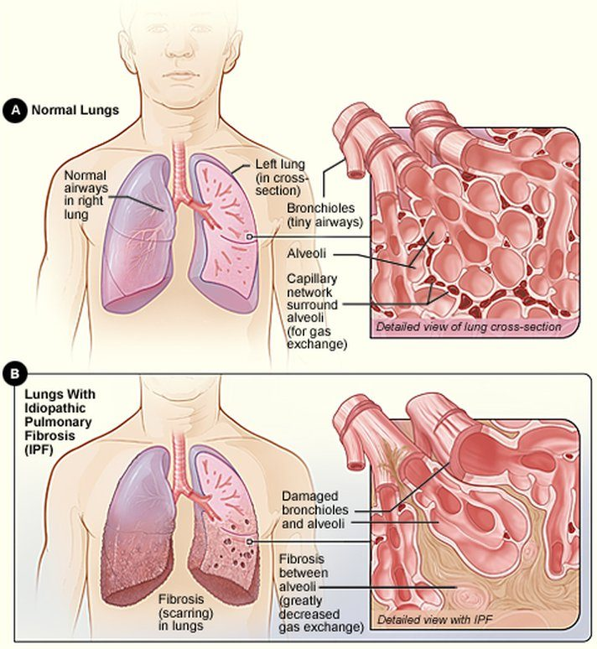
Normal lungs (A) against idiopathic pulmonary fibrosis (B): look for the fibrosis between the alveoli, labeled “greatly decreased gas exchange,” and the damaged bronchioles and alveoli. Slide 5
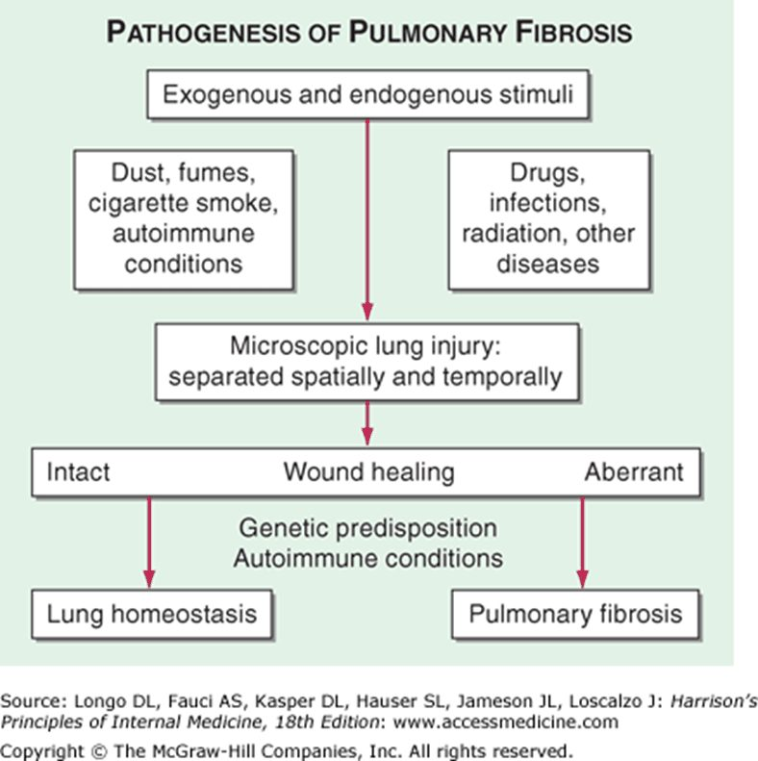
Pathogenesis of pulmonary fibrosis: stimuli cause microscopic lung injury; intact wound healing returns the lung to homeostasis, aberrant healing (genetic predisposition, autoimmune conditions) ends in pulmonary fibrosis. Slide 7
Lung specimens shown after the fibrosis slides (slide 8 labels them only A and B)
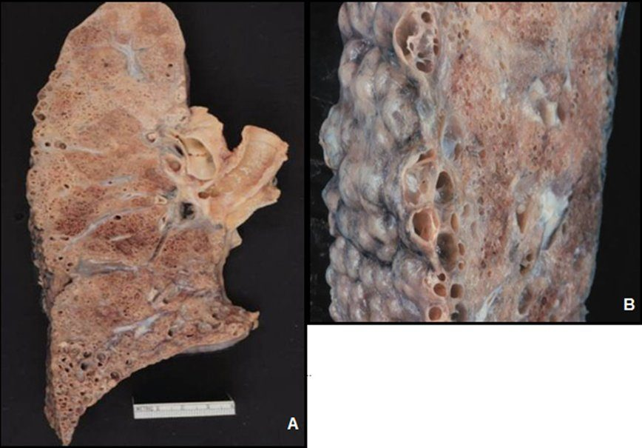  Cut lung (A) and close view (B)  Gross specimen  Slide 8 | 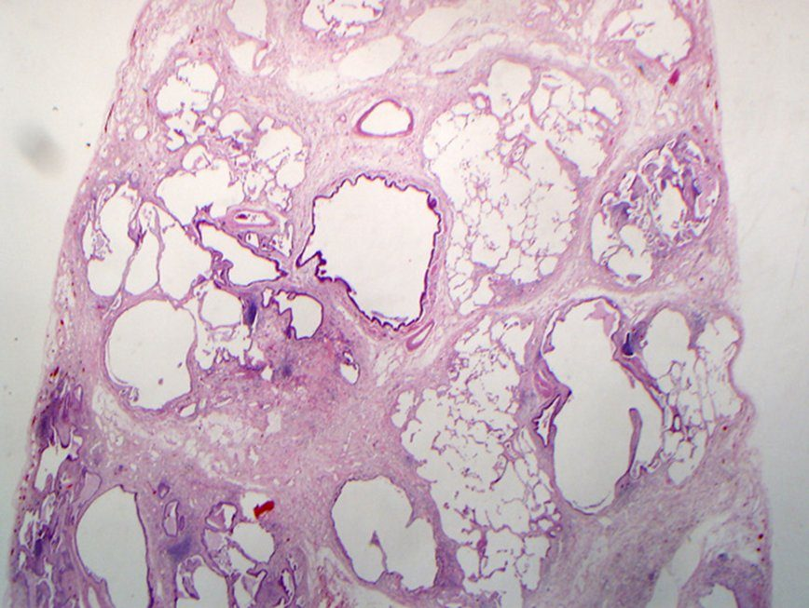  Microscope section  Stained section; the slide does not label it  Slide 8

Classification (slide 12) | Examples
Known cause: occupational exposure | Asbestosis, silicosis
Known cause: treatment related | Radiation, methotrexate, amiodarone, nitrofurantoin, chemotherapeutics
Systemic disease: connective tissue disease | Rheumatoid arthritis, scleroderma, polymyositis/dermatomyositis
Unknown cause: idiopathic interstitial pneumonias | Idiopathic pulmonary fibrosis; nonspecific interstitial pneumonia, respiratory bronchiolitis-associated interstitial lung disease, desquamative interstitial pneumonia, cryptogenic organizing pneumonia, acute interstitial pneumonia, lymphocytic interstitial pneumonia
Granulomatous lung disease | Sarcoidosis, hypersensitivity pneumonitis; with vasculitis: granulomatosis with polyangiitis, Churg-Strauss
Other | Lymphangioleiomyomatosis, pulmonary alveolar proteinosis, Langerhans cell histiocytosis, pleuroparenchymal fibroelastosis

Drug-induced interstitial lung disease. Nitrofurantoin is one of the treatment-related causes of interstitial lung disease, beside radiation, methotrexate, amiodarone and chemotherapeutics, and it is also named among drugs that cause pulmonary toxicity. Exertional dyspnea, dry cough, crackles and restriction after years of use fit a drug cause.
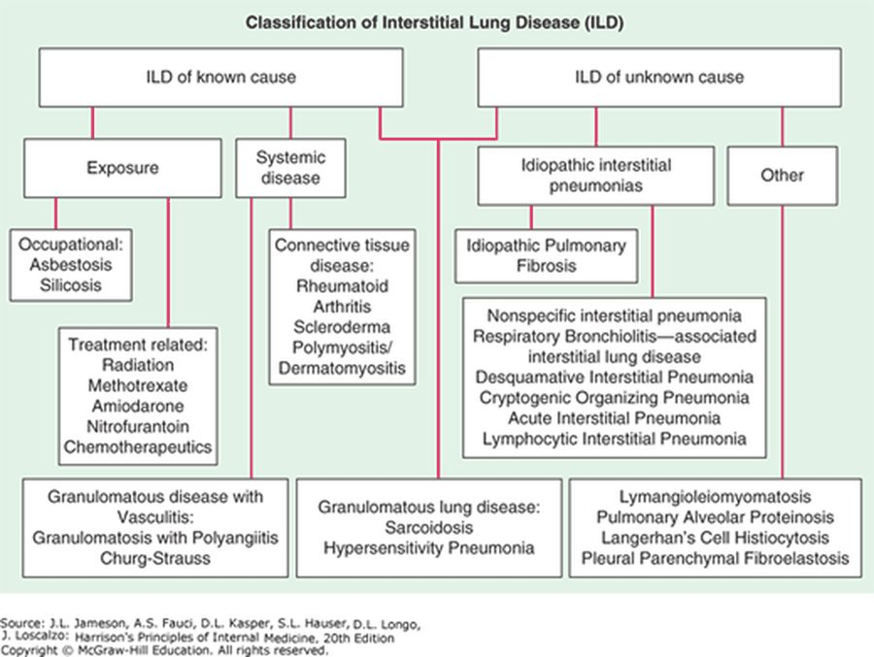
The original chart for the table above: known cause (exposure, systemic disease) on the left, unknown cause (idiopathic interstitial pneumonias, other) on the right, and granulomatous lung disease (sarcoidosis, hypersensitivity pneumonia) drawn from both. Slide 12
- Drug causes (slide 9): amphotericin B, bleomycin, busulfan, carbamazepine, chlorambucil, cocaine, cyclophosphamide, diphenylhydantoin, flecainide, heroin, melphalan, methadone, methotrexate, methylphenidate, methysergide, mineral oil (chronic microaspiration), nitrofurantoin, nitrosoureas, procarbazine, silicone (subcutaneous injection), tocainide, vinca alkaloids (with mitomycin).
- Other causes (slides 9–10): circulatory (chronic pulmonary edema, pulmonary veno-occlusive disease); connective tissue disorders; inorganic exposures (aluminosis, asbestosis, berylliosis, coal workers’ pneumoconiosis, hard metals, radiation fibrosis, siderosis, silicosis, talc) and organic ones (bagassosis, bird fancier’s lung, farmer’s lung, hot tub lung, humidifier lung, mushroom worker’s lung and others); infections (aspergillosis, histoplasmosis, parasitic, mycobacterial, viral); vasculitis; the idiopathic interstitial pneumonias; miscellaneous (alveolar proteinosis, amyloidosis, chronic microaspiration, eosinophilic pneumonia, lipoid pneumonia, sarcoidosis, tuberous sclerosis and others).
- Inflammatory/fibrotic response causes (slide 17): asbestos, fumes and gases, drugs, radiation, aspiration pneumonia, idiopathic interstitial fibrosis/pneumonias, autoimmune diseases (rheumatoid arthritis, lupus, scleroderma).
Causes of interstitial lung disease, the full reference tables (slides 9–10)
Circulatory disorders | Chronic pulmonary edema; Pulmonary veno-occlusive disease
Connective tissue disorders | Ankylosing spondylitis; Behçet’s syndrome; Dermatomyositis and polymyositis; Goodpasture’s syndrome; Mixed connective tissue disease; Rheumatoid arthritis; Sjögren’s syndrome; Systemic lupus erythematosus (SLE); Systemic sclerosis; Undifferentiated connective tissue disease
Drugs | Amphotericin B, bleomycin, busulfan, carbamazepine, chlorambucil, cocaine, cyclophosphamide, diphenylhydantoin, flecainide, heroin, melphalan, methadone, methotrexate, methylphenidate, methysergide, mineral oil (via chronic microaspiration), nitrofurantoin, nitrosoureas, procarbazine, silicone (subcutaneous injection), tocainide, vinca alkaloids (with mitomycin)
Occupational and environmental exposure | Inorganic: Aluminosis (caused by exposure to metallic aluminum powder), asbestosis, baritosis, berylliosis, coal workers’ pneumoconiosis, exposure to hard metals (eg, cadmium, cobalt, titanium oxide, tungsten, vanadium carbides), radiation fibrosis, siderosis, silicosis, stannosis, talc pneumoconiosis  Organic: Bagassosis, bird fancier’s lung, coffee worker’s lung, farmer’s lung, hot tub lung, humidifier lung, malt worker’s lung, maple bark stripper’s lung, mushroom worker’s lung, tea grower’s lung
Infections | Aspergillosis; Histoplasmosis; Parasitic infection; Mycobacterial infection; Viral infection
Vasculitis | Churg-Strauss syndrome; Giant cell arteritis (rare); Microscopic polyangiitis; Polyarteritis nodosa (rare); Takayasu’s arteritis (rare); Wegener’s granulomatosis
Idiopathic interstitial pneumonias | Acute interstitial pneumonia; Cryptogenic organizing pneumonia; Desquamative interstitial pneumonia; Idiopathic pulmonary fibrosis; Lymphocytic interstitial pneumonia; Nonspecific interstitial pneumonia; Respiratory bronchiolitis-associated interstitial lung disease
Miscellaneous disorders | Alveolar proteinosis; Amyloidosis; Chronic microaspiration; Eosinophilic granuloma; Eosinophilic pneumonia; Gaucher’s disease; Lipoid pneumonia; Lymphangioleiomyomatosis; Microlithiasis; Neurofibromatosis; Niemann-Pick disease; Pulmonary lymphoma; Sarcoidosis; Tuberous sclerosis

Relative frequency of interstitial lung disease (slide 15)
Diagnosis | Relative frequency as %
Idiopathic pulmonary fibrosis | 55
Idiopathic interstitial pneumonias | 40
Occupational & environmental | 26
Nonspecific interstitial pneumonia | 25
Respiratory bronchiolitis- interstitial pneumonia | 15
Sarcoidosis | 10
Connective tissue diseases | 9
Cryptogenic organizing pneumonia | 3
Acute interstitial pneumonia | <1
Drugs and radiation | 1
Pulmonary hemorrhage syndrome | <1
Other | 13

3.2 · Onset, symptoms and examination
Onset (slide 22) | Time course | Typical of
Acute | Days to weeks | Allergy
Subacute | Weeks to months | Any, but most common with sarcoidosis and drug-induced disease
Chronic | Months to years | Most interstitial lung diseases: idiopathic pulmonary fibrosis, sarcoidosis, pneumoconiosis, connective tissue disease
Episodic | Less common | Hypersensitivity pneumonitis

Episodic presentation. An episodic presentation is less common in interstitial lung disease and can be seen with hypersensitivity pneumonitis, where inhaled organic material leads to illness after exposure; symptoms can be reversible if the problem is caught early.
Onset patterns. Interstitial lung disease can present acutely over days to weeks, subacutely over weeks to months, chronically over months to years, or episodically. The episodic pattern of recurrent bouts is less common and can be seen with hypersensitivity pneumonitis.
- Symptoms (slide 23): progressive exertional dyspnea or a persistent nonproductive cough; hemoptysis; wheezing; chest pain; tachypnea; anorexia; as disease progresses, dyspnea at rest.
- Examination (slide 24): small lung volumes, bibasilar dry rales (inspiratory crackles); distal clubbing; right heart failure with advanced disease; early in the disease the exam may be normal.
- Advanced disease. Right heart failure appears with advanced interstitial lung disease, and dyspnea that has spread from exertion to rest also marks progression. Early in the disease the examination may be normal.

3.3 · Laboratory tests, imaging and pulmonary function
★ PROFESSOR EMPHASIS
★ “I would pay attention to this slide” (slide 25)
Laboratory finding (slide 25) | Points to
Erythrocyte sedimentation rate increased | Active sarcoidosis
High antinuclear antibody | Collagen vascular diseases
c-ANCA (cytoplasmic antineutrophil cytoplasmic antibody) | Granulomatosis with polyangiitis
Anti-glomerular basement membrane and anti-alveolar basement membrane antibodies | Goodpasture syndrome (glomerulonephritis and diffuse pulmonary hemorrhage, mostly in young adults)
Elevated angiotensin-converting enzyme | Sarcoidosis (the slide also writes “hypersensitivity silicosis”)
Eosinophilia | Eosinophilic pneumonia, sarcoidosis, drug-induced disease
Complete blood count, comprehensive metabolic panel | Baseline

- Chest radiography (slide 26): hilar and mediastinal lymphadenopathy: sarcoidosis, silicosis. Low lung volumes and patchy ground-glass, reticular, nodular, reticulonodular or cystic opacities. Reticular (curvilinear) opacities: fine (ground glass) = early; medium (honeycombing) = late; coarse = cystic spaces. Nodular = nodules; reticulonodular = overlap of reticular shadows with nodules (sarcoid). In idiopathic pulmonary fibrosis the brighter interstitial markings are in the lower lung fields (slide 27).
- Reticular opacities on the chest film. Among reticular opacities, fine ground-glass change is an early finding and medium reticular change, honeycombing, is a late finding. Moving from ground glass to honeycombing marks progression, consistent with fibrosis, which damages the alveoli permanently.
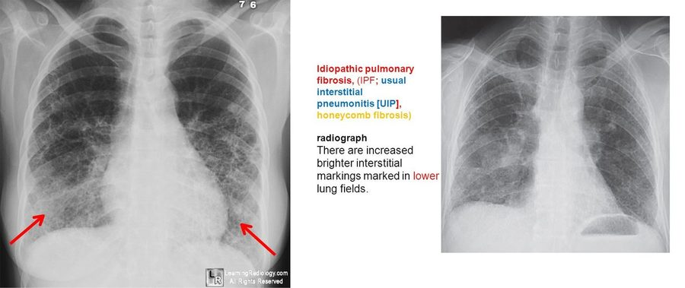
Chest X-rays, general interstitial lung disease. The slide’s label: idiopathic pulmonary fibrosis (usual interstitial pneumonitis, honeycomb fibrosis) shows increased, brighter interstitial markings in the lower lung fields , where the red arrows point on the left film. Slide 27
Restrictive pattern (slides 26, 29) | Result
Ratio of forced expiratory volume in 1 second to forced vital capacity | Normal or increased
Total lung capacity and forced vital capacity | Decreased (reduced lung volumes)

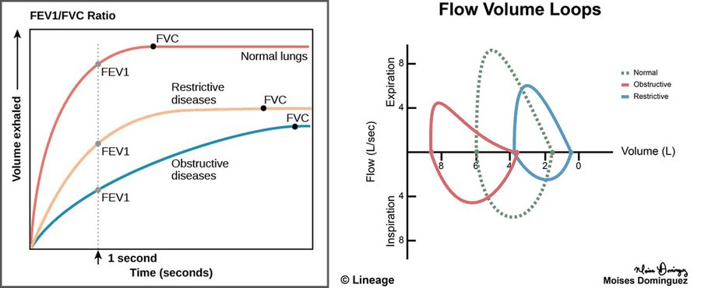
Left: the restrictive curve levels off at a lower forced vital capacity (FVC) than normal lungs; right: flow-volume loops, normal (green dotted), obstructive (red) and restrictive (blue). The slide’s restrictive pattern: normal or increased ratio of forced expiratory volume in 1 second (FEV1) to FVC, decreased total lung capacity and FVC. Slide 29
Restrictive pattern on testing. Interstitial lung disease stiffens the lung so it no longer expands, giving a restrictive pattern: total lung capacity and forced vital capacity fall while the ratio of forced expiratory volume in 1 second to forced vital capacity stays normal or rises.
Restrictive pattern. A restrictive pattern is a normal or increased ratio of forced expiratory volume in 1 second to forced vital capacity (normal 0.70 or more) with decreased total lung capacity and forced vital capacity (normal 80% or more of predicted).

3.4 · Idiopathic (fibrosing) interstitial pneumonia and idiopathic pulmonary fibrosis
- Histopathologic patterns (slide 31): idiopathic pulmonary fibrosis, desquamative interstitial pneumonitis, nonspecific interstitial pneumonia, cryptogenic organizing pneumonia, respiratory bronchiolitis-associated interstitial lung disease, lymphoid interstitial pneumonia, acute interstitial pneumonitis. Suspect it in unexplained interstitial lung disease; it is the ★ most common diagnosis among patients with interstitial lung disease; 67–75% of patients with idiopathic pulmonary fibrosis and familial lung fibrosis have a history of smoking.
- Diagnosis (slide 32): may require biopsy; idiopathic pulmonary fibrosis is the most common subtype; age, sex, prodrome, imaging and histology decide; treatment and prognosis depend on the subtype.
- Symptoms (slide 33): insidious DRY cough, exertional dyspnea, constitutional symptoms (fatigue, malaise). Exam: clubbing; bibasilar inspiratory crackles; tachypnea; reduced chest expansion.
- Studies (slide 34): chest film: progressive fibrosis over several areas; CT: diffuse patchy fibrosis with pleural-based honeycombing; pulmonary function: restrictive (decreased lung volume, normal to increased ratio); bronchoalveolar lavage, transbronchial biopsy, surgical lung biopsy.
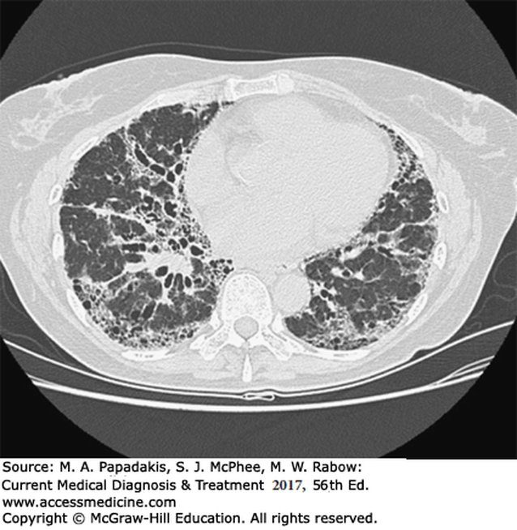
CT of idiopathic (fibrosing) interstitial pneumonia: look for what slide 34 names, diffuse patchy fibrosis with pleural-based honeycombing , the clustered small air spaces lining the lung edges. Slide 36
Idiopathic pulmonary fibrosis / usual interstitial pneumonia diagnosed with 90% confidence, no surgical biopsy needed (slide 35): patients over 65 with all four
1 | Idiopathic disease by history, with inspiratory crackles on examination
2 | Restrictive physiology on pulmonary function testing
3 | Radiographic evidence of progressive fibrosis over several years
4 | Diffuse, patchy fibrosis with pleural-based honeycombing on high-resolution CT

- Management (slide 37): controversial. Nothing has been shown to improve survival or quality of life compared with no treatment; an accurate diagnosis identifies who may benefit; smoking is the cause in the majority of cases and cessation is critical to prolong life.
- Corticosteroids may be used (slide 38) in cryptogenic organizing pneumonia (bronchiolitis obliterans organizing pneumonia), lymphoid interstitial pneumonia and nonspecific interstitial pneumonia. Symptoms vary by subtype.

Idiopathic pulmonary fibrosis
Defining feature: an older smoker with an insidious dry cough, exertional dyspnea, clubbing and bibasilar inspiratory crackles, a restrictive pattern and pleural-based honeycombing on CT
DefinitionThe most common idiopathic (fibrosing) interstitial pneumonia: pulmonary fibrosis with the usual interstitial pneumonia pattern and no associated cause.Who gets itThe most common diagnosis among interstitial lung diseases; over 65 in the no-biopsy criteria; 67–75% have smoked.Risk factorsSmoking (the cause in the majority); familial lung fibrosis.Classic signs & symptomsInsidious dry cough, exertional dyspnea, fatigue and malaise.Physical exam findingsClubbing, bibasilar inspiratory crackles, tachypnea, reduced chest expansion.Diagnostics / testsRestrictive pulmonary function; chest film with progressive fibrosis (lower fields); high-resolution CT with diffuse patchy fibrosis and pleural-based honeycombing; biopsy unless the four over-65 criteria are met.First-line treatmentControversial: nothing has improved survival; smoking cessation is critical.ComplicationsProgressive fibrosis; right heart failure with advanced interstitial disease.
Slides 15, 24, 27, 31–37

3.5 · Connective tissue disease, pulmonary hemorrhage and granulomatous vasculitis
- Connective tissue diseases (slide 18), “think autoimmune”: an inflammatory/fibrotic response in systemic lupus erythematosus, rheumatoid arthritis, ankylosing spondylitis, systemic sclerosis, Sjögren syndrome, polymyositis-dermatomyositis and scleroderma. Methotrexate, used for many autoimmune diseases including lupus and rheumatoid arthritis, is itself a cause of interstitial lung disease.
- Pulmonary hemorrhage syndromes / alveolar filling disorders (slide 19): Goodpasture syndrome, idiopathic pulmonary hemosiderosis, isolated pulmonary capillaritis. Goodpasture: anti-glomerular basement membrane antibodies (slide 25).
- Granulomatous response (slides 20–21): still interstitial disease of unknown etiology; T lymphocytes, macrophages and epithelioid cells organized into granulomas in the parenchyma. Examples: sarcoidosis, the granulomatous vasculitides (granulomatosis with polyangiitis, formerly Wegener, c-ANCA positive; allergic granulomatosis of Churg-Strauss).

Pulmonary fibrosis with connective tissue disease
Defining feature: a patient with a known autoimmune disease (rheumatoid arthritis, lupus, scleroderma, polymyositis) who develops progressive dyspnea and a restrictive pattern
DefinitionAn inflammatory and fibrotic interstitial response in connective tissue (autoimmune) disease.Who gets itPatients with systemic lupus erythematosus, rheumatoid arthritis, ankylosing spondylitis, systemic sclerosis, Sjögren syndrome, polymyositis-dermatomyositis, scleroderma.Risk factorsThe autoimmune disease itself; methotrexate treatment (also a cause of interstitial lung disease).Classic signs & symptomsChronic progressive exertional dyspnea and nonproductive cough.Physical exam findingsBibasilar inspiratory crackles, clubbing, small lung volumes.Diagnostics / testsHigh antinuclear antibody (collagen vascular disease); restrictive pulmonary function; imaging.First-line treatmentNot detailed on the slides beyond recognizing the autoimmune cause and the drug cause.ComplicationsFibrosis; right heart failure with advanced disease.
Slides 12, 17, 18, 22–25

3.6 · Sarcoidosis
- A multi-organ disease of idiopathic cause with noncaseating granulomatous inflammation (lungs, lymph nodes, eyes, skin, liver, spleen, salivary glands, heart, nervous system); the lungs and lymphatic system are most often affected; thought to be environmental triggers (viral, bacterial, mycobacterial, inhaled agents, mold and mildew) in a genetically predisposed person (slide 39). It may come from a lack of modulation of the immune response after antigen recognition (slide 41).
- Who (slide 40): granulomatous lung inflammation in about 90%; more common in North American Black people and Northern European white people; more often women; onset in the third and fourth decades.
- Symptoms (slide 42): cough; dyspnea of insidious onset; chest discomfort; malaise, fever; weakness, weight loss; nontender lymphadenopathy; other organ systems.
- Exam (slide 43): erythema nodosum (itchy, painful rashes on the lower legs and ankles) or parotid enlargement; lymph node enlargement; liver or spleen enlargement; crackles; skin involvement such as ★ lupus pernio (painful skin sores on the face); eye problems and heart and brain complications in the picture.
- Lupus pernio. Lupus pernio, skin sores on the face, is the skin involvement of sarcoidosis. A dry cough, insidious dyspnea, nontender lymphadenopathy and liver and spleen enlargement complete its multi-organ picture. Sarcoidosis also occurs more often in Black patients and in women.
- Diagnosis (slide 44): chest film: symmetric bilateral hilar and right paratracheal adenopathy and bilateral reticular infiltrates. Labs: leukopenia, eosinophilia, elevated sedimentation rate, hypercalcemia, hypercalciuria; angiotensin-converting enzyme elevated in 40–80%; hypercalcemia in 5%. Transbronchial lung biopsy or fine-needle node biopsy confirms it, with noncaseating granulomas.
- Angiotensin-converting enzyme in sarcoidosis. Angiotensin-converting enzyme levels are elevated in 40 to 80% of patients with sarcoidosis. Other laboratory findings include leukopenia, eosinophilia, an elevated erythrocyte sedimentation rate, hypercalcemia in about 5% of patients and hypercalciuria.
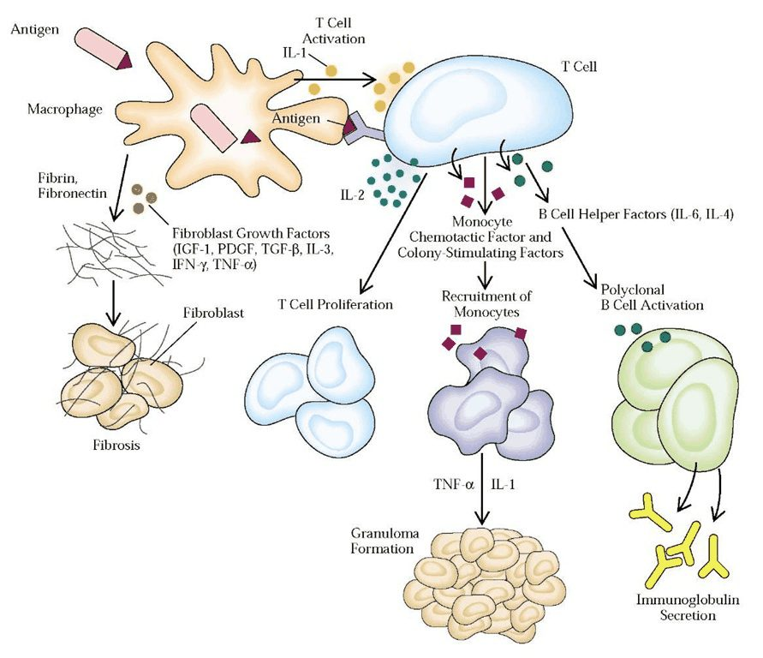
The immune response after antigen recognition: a macrophage presents antigen to a T cell, and the pathways end in granuloma formation (recruited monocytes), fibrosis (fibroblast growth factors) and immunoglobulin secretion. Slide 41
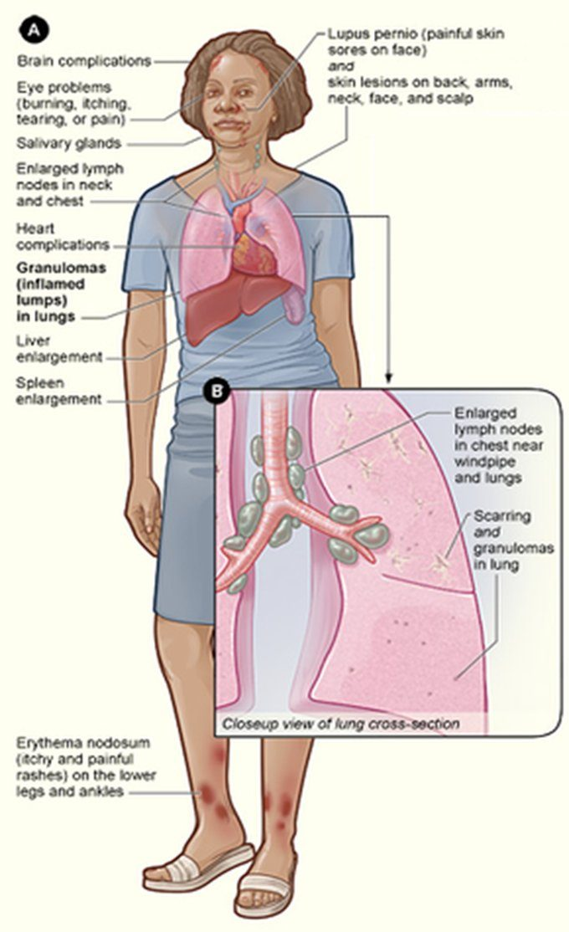
Where sarcoidosis shows: lupus pernio (painful skin sores on the face), enlarged lymph nodes in the neck and chest and near the windpipe, granulomas and scarring in the lungs, liver and spleen enlargement, eye, heart and brain complications, and erythema nodosum (itchy and painful rashes) on the lower legs and ankles. Slide 43
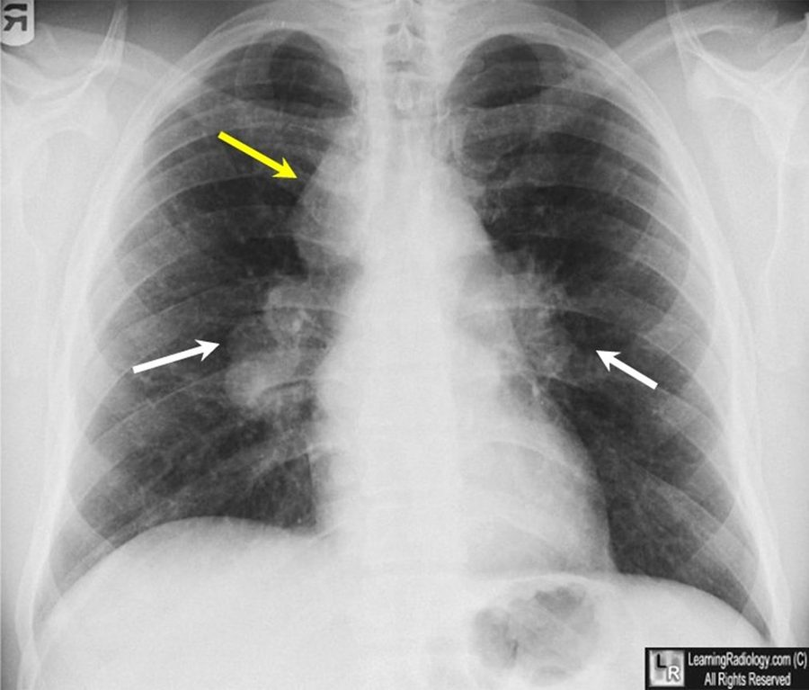
Chest X-ray in sarcoidosis. The slide does not key its arrows; they sit at both hila (white) and beside the right side of the trachea (yellow), the places slide 44 names for the “symmetric bilateral hilar and right paratracheal adenopathy”. Slide 28
Chest film stage (slide 45) | Findings
I | Bilateral hilar adenopathy alone
II | Hilar adenopathy and parenchymal involvement
III | Parenchymal involvement alone (diffuse reticular infiltrates)
IV | Advanced fibrosis: honeycombing, hilar retraction, bullae, cysts, emphysema

Biopsy is essential whenever the clinical and radiographic findings suggest an alternative diagnosis such as lymphoma (slide 45).
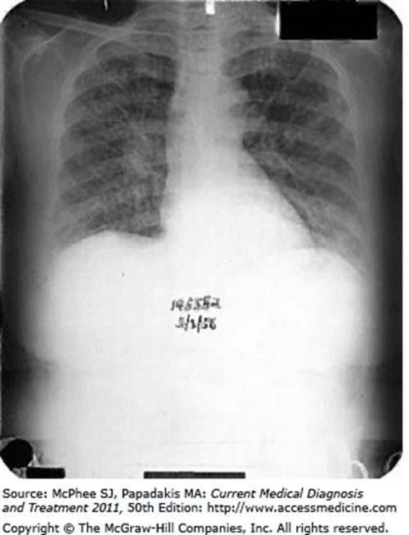
The chest X-ray printed beside the stage list (the slide does not say which stage it shows). Slide 45
- Management (slide 46): about 90% respond to corticosteroids and can be controlled with moderate maintenance doses. Immunosuppressants, most commonly methotrexate, azathioprine or infliximab, for patients intolerant of corticosteroids or with corticosteroid-refractory disease.
- Methotrexate. Methotrexate is one of the immunosuppressants most commonly used when sarcoidosis is corticosteroid-intolerant or refractory, and it treats many autoimmune diseases such as lupus and rheumatoid arthritis. It is also implicated as a cause of interstitial lung disease.
- Methotrexate to avoid. Methotrexate is one of the immunosuppressants used for corticosteroid-refractory sarcoidosis, but it has also been implicated as a cause of interstitial lung disease. Azathioprine or infliximab covers the same refractory indication, so methotrexate should be avoided in a patient whose lung injury it already implicated.
Indications for oral corticosteroids (slide 47)
Disabling constitutional symptoms · Hypercalcemia · Iritis · Uveitis · Arthritis · Central nervous system involvement · Cardiac involvement · Granulomatous hepatitis · Cutaneous lesions other than erythema nodosum · Progressive pulmonary lesions

- Prognosis (slide 48): best with hilar adenopathy alone; parenchymal involvement on imaging means a worse prognosis; 20% with lung involvement develop irreversible impairment (progressive fibrosis, bronchiectasis, cavitation). Every year: physical exam; pulmonary function tests, chest film, electrocardiogram; chemistry panel; ophthalmologic evaluation (to find and manage ocular inflammation).

Sarcoidosis
Defining feature: a young adult in the third or fourth decade with symmetric bilateral hilar adenopathy, nontender nodes, erythema nodosum or uveitis, and noncaseating granulomas on biopsy
DefinitionA multi-organ disease of unknown cause with noncaseating granulomatous inflammation, mostly of the lungs and lymphatics.Who gets itNorth American Black people and Northern European white people; women more often; onset in the third and fourth decades.Risk factorsGenetic predisposition plus environmental triggers (viral, bacterial, mycobacterial, inhaled agents, mold).Classic signs & symptomsCough, insidious dyspnea, chest discomfort, malaise, fever, weight loss, nontender lymphadenopathy.Physical exam findingsErythema nodosum, parotid enlargement, lymph node, liver and spleen enlargement, crackles, lupus pernio.Diagnostics / testsChest film (bilateral hilar and right paratracheal adenopathy; stages I–IV); elevated angiotensin-converting enzyme, sedimentation rate, calcium; transbronchial or node biopsy showing noncaseating granulomas confirms.First-line treatmentOral corticosteroids for the listed indications (about 90% respond); methotrexate, azathioprine or infliximab if intolerant or refractory; yearly exam, pulmonary function, chest film, electrocardiogram, chemistry and eye exam.ComplicationsIrreversible lung impairment in 20% with lung involvement (fibrosis, bronchiectasis, cavitation); hypercalcemia; eye, heart and nervous system disease.
Corticosteroids in sarcoidosis. Hypercalcemia (calcium above the 8.5-10.5 mg/dL range) is one of the indications for oral corticosteroids in sarcoidosis. About 90% of cases respond to corticosteroids, so they come first even when the chest film shows hilar adenopathy alone.
Slides 21, 25, 26, 39–48

3.7 · Pneumoconiosis: coal workers’ pneumoconiosis
- Pneumoconiosis (slide 50): chronic fibrotic lung disease from inhaling coal dust or various inorganic or silicate dusts.
- Coal workers’ pneumoconiosis (slide 51): alveolar macrophages take up inhaled coal dust, forming coal macules. Simple disease is usually asymptomatic, with unimpressive pulmonary function. Complicated disease is “progressive massive fibrosis”: conglomeration in the upper lungs.
- Symptoms (slide 52): may be asymptomatic when simple; complicated: dyspnea, progressive dyspnea, inspiratory crackles, finger clubbing, cyanosis.
- Tests (slide 53): pulmonary function: restrictive with reduced diffusing capacity (diffusing capacity of the lungs for carbon monoxide). Chest film: nodular opacities in the upper lung fields (coal macules 2–5 mm).
- Management (slide 54): supportive; no effective curative treatment: oxygen, vaccinations (pneumococcal, influenza), rehabilitation, smoking cessation; lung transplant in severe cases. Complication: progressive massive fibrosis (conglomeration and contraction in the upper lung fields).
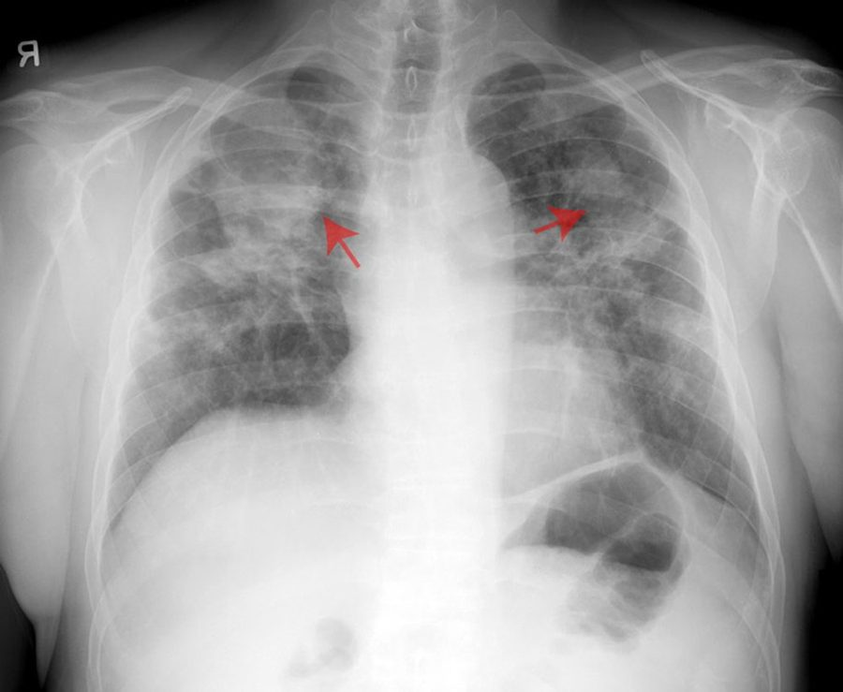
Coal workers’ pneumoconiosis. The slide does not key the red arrows; the text puts the nodular opacities in the upper lung fields (coal macules 2–5 mm in diameter). Slide 53

Coal workers’ pneumoconiosis
Defining feature: a coal miner with 2–5 mm nodular opacities in the upper lung fields
DefinitionA pneumoconiosis: chronic fibrotic lung disease from inhaled coal dust taken up by alveolar macrophages into coal macules.Who gets itCoal workers.Risk factorsInhaled coal dust.Classic signs & symptomsSimple: often none. Complicated: progressive dyspnea.Physical exam findingsInspiratory crackles, clubbing, cyanosis in complicated disease.Diagnostics / testsRestrictive pulmonary function with reduced diffusing capacity; upper-zone nodular opacities (coal macules 2–5 mm).First-line treatmentSupportive (no cure): oxygen, pneumococcal and influenza vaccines, rehabilitation, smoking cessation; transplant if severe.ComplicationsProgressive massive fibrosis (upper-lobe conglomeration and contraction).
Management of coal workers' pneumoconiosis. Management is supportive, with oxygen, vaccinations, rehabilitation and smoking cessation, and in severe cases lung transplant may be indicated.
Slides 50–54

3.8 · Asbestosis and mesothelioma
- History (slide 55): asbestos fibers from insulation, demolition, shipyards, construction; exposure over 10–20 years; patients usually seek attention about 15 years after exposure. Cigarette smoking increases radiographic pleural and parenchymal changes and markedly increases lung carcinoma. A ★ ferruginous body in tissue (a histologic finding resulting from inorganic dust inhalation) suggests significant exposure.
- Mechanism (slide 56): asbestos invades lung tissue and cannot be removed, so chronic inflammation and macrophage invasion scar the terminal bronchioles, alveoli and interstitium; fibers can penetrate further and cause mesothelioma (cancer of the pleural lining).
- Symptoms and exam (slide 57): dyspnea on exertion, rarely cough; with progression, fine bibasilar crackles and clubbing. Labs not helpful; pulmonary function: reduced vital capacity and total lung capacity.
- Imaging (slide 58): often normal early; pleural plaques are the most common chest film finding (linear streaking at the bases); reticulonodular opacities at the bases; CT: pleural plaques, alveolitis, fibrosis, honeycombing in advanced disease. CT is the preferred imaging for asbestosis.
- Treatment (slide 56): supportive, because the fibers cannot be removed: oxygen, physiotherapy, medications, vaccinations. Complications: increased risk of lung cancer and mesothelioma, especially in smokers.
- Mesothelioma (slide 59): primarily a pleural cancer, nearly always caused by asbestos; incurable with poor long-term survival, no treatment known to prolong survival, primarily supportive care; frequent pleural effusions, diagnosable by pleural fluid cytology; 10% lifetime risk for asbestos workers.
Asbestosis imaging (slide 58): the slide names pleural plaques (the most common chest X-ray finding), linear streaking and reticulonodular opacities at the bases, and on CT pleural plaques, alveolitis or fibrosis; it does not key the arrows
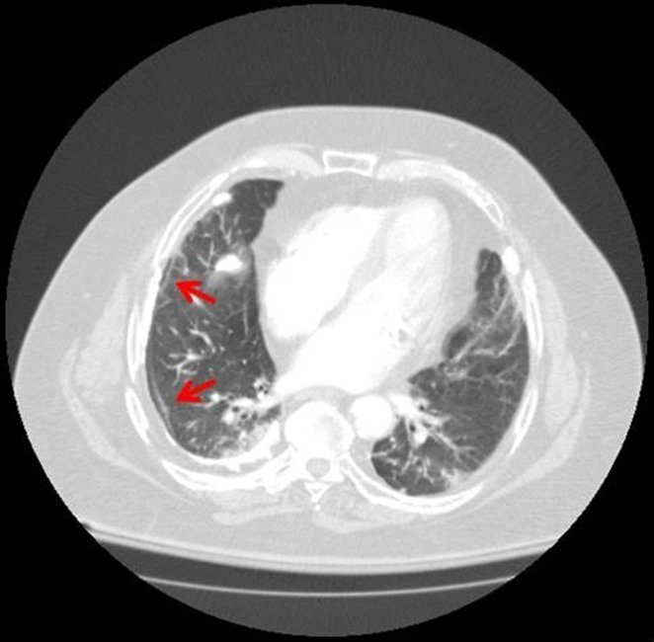  CT, lung window  Red arrows at the right pleura  Slide 58 | 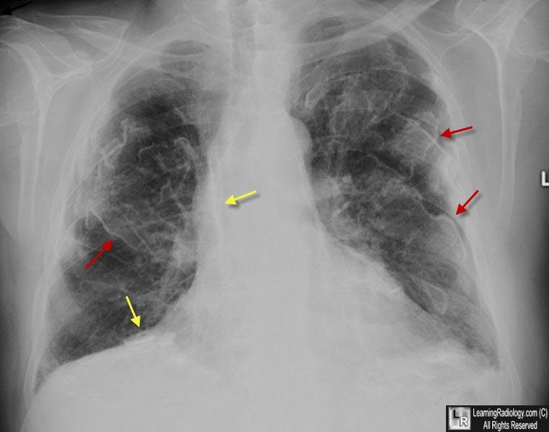  Chest X-ray  Red and yellow arrows over both lungs  Slide 58 | 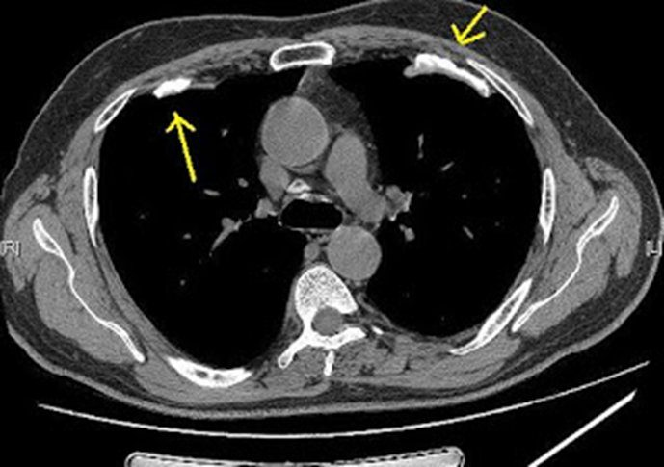  CT, soft-tissue window  Yellow arrows at bright plaques on the pleura  Slide 58

Asbestosis
Defining feature: a former shipyard, insulation, demolition or construction worker with exertional dyspnea about 15 years after exposure, pleural plaques and basal crackles
DefinitionInterstitial fibrosis of the terminal bronchioles, alveoli and interstitium from asbestos fibers that cannot be removed.Who gets itWorkers in insulation, demolition, shipyards and construction, after 10–20 years of exposure; presenting about 15 years later.Risk factorsAsbestos exposure; smoking worsens radiographic changes and markedly raises lung cancer risk.Classic signs & symptomsDyspnea on exertion; cough is rare.Physical exam findingsFine bibasilar crackles and clubbing with progression.Diagnostics / testsPleural plaques (most common film finding), basal reticulonodular opacities; CT preferred; reduced vital and total lung capacity; ferruginous bodies; labs not helpful.First-line treatmentSupportive: oxygen, physiotherapy, medications, vaccinations; smoking cessation.ComplicationsLung cancer and mesothelioma, especially in smokers (mesothelioma lifetime risk 10% in asbestos workers).
Slides 55–59

3.9 · Silicosis
- History (slide 60): mining, sandblasting, quarry work, stone work; free crystalline silica dust (silicon dioxide). Simple disease usually asymptomatic with unimpressive function; complicated disease: conglomeration of the upper lungs. Silica deposits in the alveoli, causing chronic inflammation, macrophage invasion and fibrosis and also nodular lesions; it is usually carried to the upper lobes because it is a lighter dust.
- Presentation (slide 61): rapid onset of symptoms (see the conflict box); dyspnea, cough, weight loss, fatigue; often crackles.
- Studies (slide 62): labs: arterial blood gas, otherwise not contributory; pulmonary function: reduced forced vital capacity and forced expiratory volume in 1 second; ★ bronchoalveolar lavage: thick, milky effluent with foamy, lipoproteinaceous macrophages.
- Imaging (slide 63): nodular opacities throughout (silicotic nodules, 1–10 mm): nodular pulmonary fibrosis; “eggshell” calcification of the periphery of the hilar lymph nodes.
- Silicosis presentation. Sandblasting is a free crystalline silica exposure, and silicosis shows silicotic nodules 1-10 mm across throughout the lungs with eggshell calcification of the periphery of the hilar lymph nodes. Dyspnea, cough, weight loss, fatigue and crackles fit its presentation.
- Treatment (slide 64): largely supportive: oxygen, physiotherapy, medications, vaccinations; smoking cessation. Complications: increased risk of tuberculosis, progressive massive fibrosis, scleroderma; patients should have a tuberculosis skin test and a current chest film.
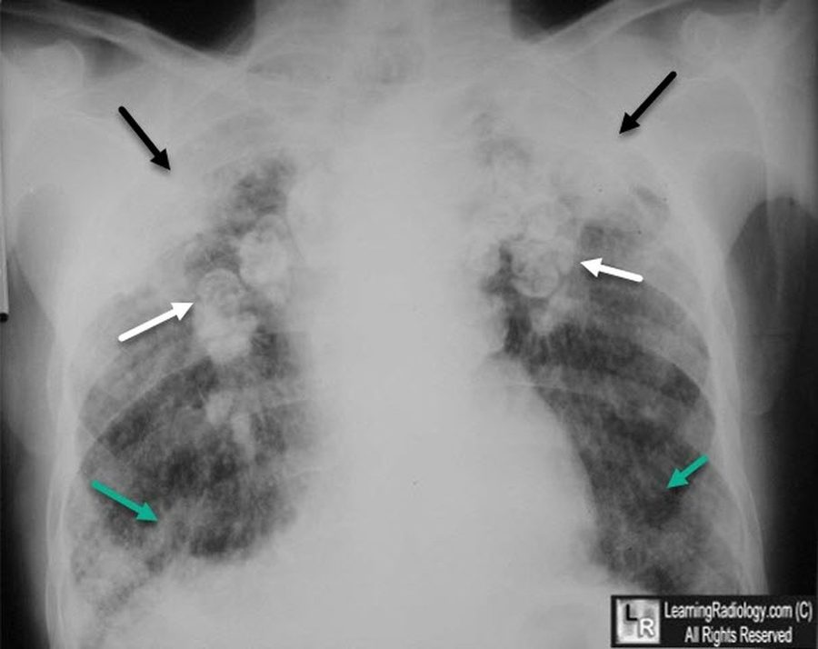
Silicosis: the white arrows point at hilar nodes outlined by a thin bright rim, the slide’s “eggshell” calcification of the periphery of the hilar lymph nodes , with nodular opacities (silicotic nodules, 1–10 mm) through both lungs. The slide does not key any of the arrows. Slide 63

Silicosis
Defining feature: a sandblaster, miner, quarry or stone worker with upper-lobe silicotic nodules and eggshell calcification of the hilar nodes
DefinitionFibrosis and nodular lesions from free crystalline silica (silicon dioxide) dust deposited in the alveoli.Who gets itMiners, sandblasters, quarry workers and stone workers.Risk factorsInhaled silica dust.Classic signs & symptomsDyspnea, cough, weight loss, fatigue (simple disease may be asymptomatic).Physical exam findingsOften crackles.Diagnostics / testsSilicotic nodules 1–10 mm, upper lobes; eggshell calcification of the hilar nodes; reduced vital capacity and forced expiratory volume; milky lavage with foamy macrophages; arterial blood gas.First-line treatmentSupportive (oxygen, physiotherapy, medications, vaccinations), smoking cessation; tuberculosis skin test and a current chest film.ComplicationsTuberculosis, progressive massive fibrosis, scleroderma.
Complications of silicosis. The complications of silicosis are an increased risk of tuberculosis, progressive massive fibrosis and scleroderma. Scleroderma is also one of the connective tissue diseases that produce interstitial lung disease.
Slides 26, 60–64

3.10 · Hypersensitivity pneumonitis (extrinsic allergic alveolitis)
- What it is (slide 65): a non-atopic, non-asthmatic inflammatory lung disease in which inhaled organic material causes acute illness. Sources: moldy hay, bird excreta, feathers, moldy sugarcane pulp, moldy products, insect-infested grain: bird fancier’s lung, farmer’s lung, cheese maker’s lung. Prompt diagnosis is key to remove the patient from the environment; symptoms can reverse if caught early; continued exposure worsens the disease.
- Symptoms (slide 66): sudden malaise, chills, fever, cough, dyspnea, nausea 4–8 hours after exposure; may mimic paroxysmal nocturnal dyspnea (after work, once home).
- Exam (slide 68): bibasilar crackles, tachypnea, tachycardia, cyanosis.
Type (slide 67) | Signs and symptoms
Acute (within 9 hours of exposure) | Flu-like illness (fever, chills, muscle or joint pain, headache), rales, cough
Subacute (multiple exposures; 15%) | Rales, cough, chronic bronchitis, shortness of breath, anorexia or weight loss
Chronic (multiple exposures; 5%) | Cough, chronic bronchitis, shortness of breath, anorexia or weight loss, fatigue, lung fibrosis, clubbing

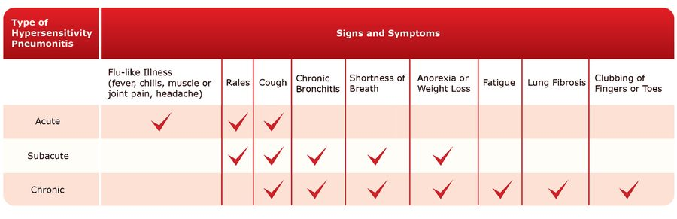
The original chart for the table above: only the acute type has the flu-like illness; only the chronic type has fatigue, lung fibrosis and clubbing. Slide 67
- Tests (slides 69–70): chest film and CT: little change acutely; subacute and chronic fibrotic changes; small nodular densities sparing the apices and bases. Blood: white count elevated with a left shift; hypoxia; antibodies to the agent in serum: their presence gives a definitive diagnosis. Pulmonary function: restrictive. Subacute or chronic: lung biopsy may be indicated. Histology: interstitial lymphocytes and plasma cells with non-caseating granulomas.
- Treatment (slide 71): ★ identify the agent responsible; avoid the agent; corticosteroids in severe cases; other immunosuppressants; supportive (oxygen, bronchodilators, pain medications); lung transplant.
Hypersensitivity pneumonitis, chronic (slide 70)
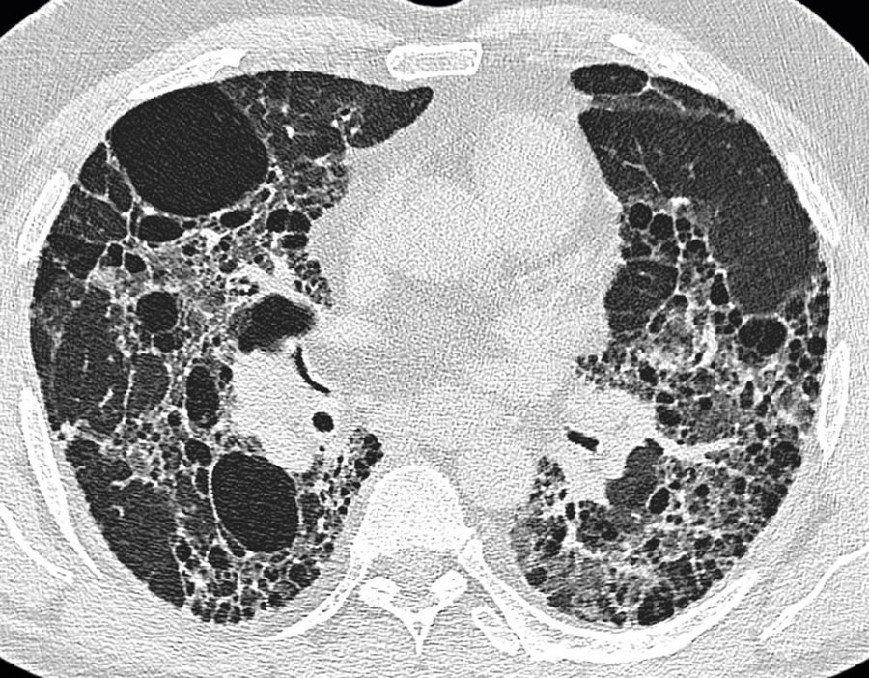  CT scan  Chronic fibrotic changes, small nodular densities or opacities  Slide 70 | 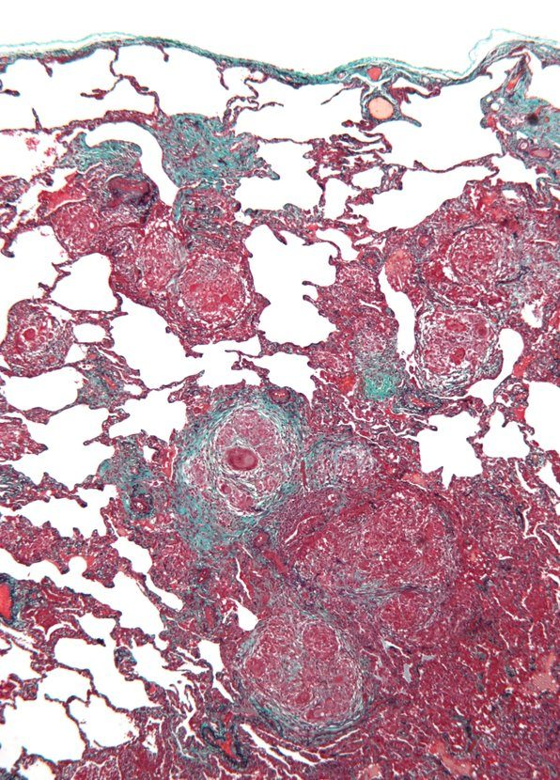  Histology  Lymphocytes and plasma cells in the interstitium, non-caseating granulomas  Slide 70

Hypersensitivity pneumonitis
Defining feature: fever, chills, cough and dyspnea hours after exposure to moldy hay, birds or another organic dust, better away from the exposure
DefinitionA non-atopic, non-asthmatic inflammatory lung disease caused by inhaled organic material (extrinsic allergic alveolitis).Who gets itFarmers (moldy hay), bird keepers (excreta, feathers), cheese makers, workers handling moldy products or infested grain.Risk factorsRepeated organic dust exposure; continued exposure worsens the disease.Classic signs & symptomsAcute: flu-like malaise, chills, fever, cough, dyspnea, nausea hours after exposure. Chronic: weight loss, fatigue, fibrosis, clubbing.Physical exam findingsBibasilar crackles, tachypnea, tachycardia, cyanosis.Diagnostics / testsSerum antibodies to the agent (definitive); white count up with a left shift; hypoxia; restrictive function; small nodular densities sparing apices and bases; biopsy if subacute or chronic.First-line treatmentIdentify and avoid the agent; corticosteroids if severe; supportive care; transplant.ComplicationsFibrosis with continued exposure (reversible if caught early).
Slides 22, 65–71

3.11 · Acute respiratory distress syndrome
Slides 72–74 are pictures; everything in this subsection is read from them.
Cause (slide 72) | Examples
Direct pulmonary | Aspiration of gastric contents, diffuse pneumonia, lung contusion; toxic gas (chlorine, nitrogen dioxide, sulfur dioxide, ammonia, smoke); near-drowning, high altitude, radiation, upper airway obstruction; fat, air, amniotic fluid or thrombus emboli
Systemic | Sepsis, severe pancreatitis, shock, nonthoracic trauma; overdoses (opioids, aspirin, phenothiazine, tricyclic antidepressants, cocaine); multiple blood transfusions, disseminated intravascular coagulation, cardiopulmonary bypass, protamine; chemotherapy, amiodarone, nitrofurantoin

- Epidemiology and prognosis (slide 72): about 30% overall mortality with low tidal volume ventilation; etiology drives survival: about 20% mortality after trauma, 80% with end-stage liver disease; about one-third of cases first present with sepsis; lung function generally recovers within 6–12 months, though functional deficits often remain.
- Mechanism (slide 72): pro-inflammatory cytokines damage the capillary endothelium and alveolar epithelium; increased vascular permeability leads to surfactant loss, alveolar collapse and refractory hypoxemia; a hyperinflammatory phenotype (high interleukin-6 and soluble tumor necrosis factor receptor) correlates with multiorgan failure and higher mortality.
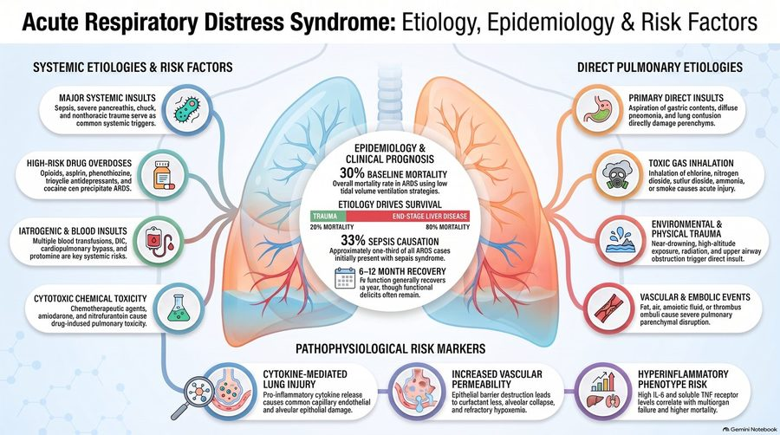
The picture the cause table and the two lists above are read from: systemic causes on the left, direct pulmonary causes on the right, prognosis in the center. Its typing errors are the slide’s (“chuck” for shock, “protomine” for protamine, “AROS” for ARDS). Slide 72
Core diagnostic criteria (slide 73)
Timing | Develops within 7 days of a known clinical insult
Imaging | Bilateral pulmonary opacities not explained by effusion, atelectasis or nodules
Origin | Non-cardiogenic: failure not fully explained by heart failure or fluid overload
Oxygenation | Arterial oxygen pressure to fraction of inspired oxygen ratio under 300 mm Hg (or oxygen saturation to inspired fraction under 315)

Severity (slide 73) | Arterial oxygen pressure ÷ fraction of inspired oxygen
Mild | 200–300 mm Hg
Moderate | 100–200 mm Hg
Severe | Under 100 mm Hg

Worked example: arterial oxygen 60 mm Hg on 50% oxygen (fraction 0.5): 60 ÷ 0.5 = 120, moderate.
- Presentation (slide 73): profound dyspnea 12–48 hours after the insult; tachypnea, labored breathing, intercostal retractions, crackles; marked hypoxemia refractory to supplemental oxygen; multiple organ failure (kidneys, liver, gut, central nervous system, cardiovascular).
- Imaging and tests (slide 73): bilateral infiltrates rapidly progress to confluent opacities; air bronchograms in about 80%; normal heart size with minimal or absent pleural effusions; echocardiography assesses cardiac function to exclude hydrostatic (cardiogenic) pulmonary edema.
- Differential (slide 73): cardiogenic pulmonary edema (cardiomegaly, vascular engorgement, batwing perihilar opacities); diffuse alveolar hemorrhage; severe bilateral pneumonia; autoimmune lung disease.
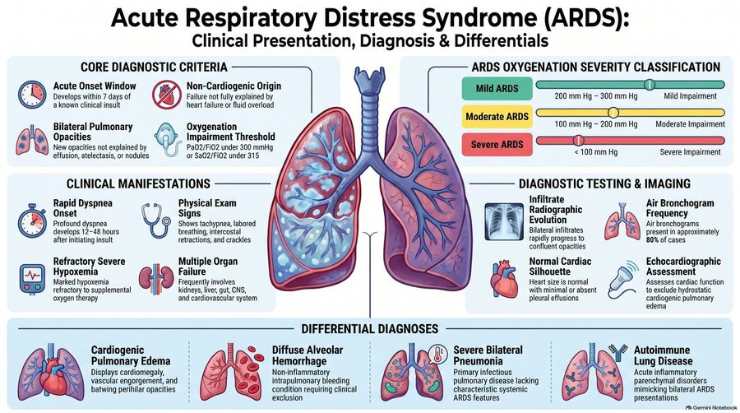
The picture the criteria and severity tables above are read from: core diagnostic criteria at top left, the mild / moderate / severe oxygenation bands at top right, findings and imaging in the middle, the differential along the bottom. Slide 73
Management (slide 74) | What the picture says
Ventilation and position | Treat the primary precipitant promptly; low tidal volumes; titrate positive end-expiratory pressure to keep arterial oxygen above 60 mm Hg; early prone positioning decreases mortality in moderate to severe disease; avoid high-frequency oscillatory ventilation (no proven benefit)
Fluids and blood | Conservative fluids (central venous pressure target under 4 mm Hg; restrictive fluids increase ventilator-free days, shorter intensive care stays); avoid routine pulmonary artery catheters (no clinical benefit); transfuse at hemoglobin 7 g/dL (higher targets do not improve outcomes); avoid supranormal oxygen delivery targets
Drugs and salvage | Corticosteroids conditionally supported within 14 days; sedatives, analgesics and antipyretics reduce oxygen demand; neuromuscular blockade is controversial (conflicting mortality data); extracorporeal membrane oxygenation for severe, refractory disease
Recovery | Lung function improves over 6–12 months; residual diffusion deficits and obstructive changes often persist; treat post-intensive-care muscle wasting, weakness and fatigue

Recovery after acute respiratory distress syndrome. Long-term recovery includes treating physical sequelae: post-intensive care muscle wasting, weakness and persistent fatigue. Rehabilitation addresses them while lung function continues to improve over 6 to 12 months.
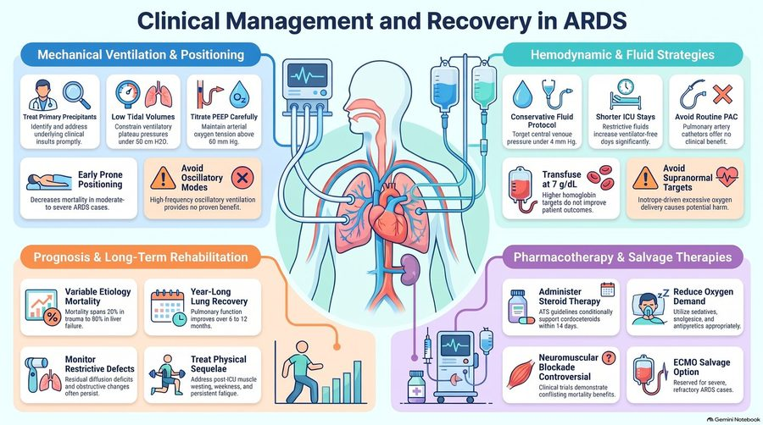
The picture the management table above is read from, in its four panels. The “Monitor Restrictive Defects” box speaks of diffusion deficits and obstructive changes, and the plateau-pressure number differs from current guidelines (box above). Slide 74

Acute respiratory distress syndrome
Defining feature: bilateral opacities and hypoxemia refractory to oxygen within 7 days of sepsis, aspiration, trauma or pancreatitis, with a normal-sized heart
DefinitionAcute non-cardiogenic lung injury: bilateral opacities and an arterial oxygen to inspired oxygen ratio under 300 within 7 days of an insult.Who gets itPatients after sepsis (about a third present this way), aspiration, pneumonia, trauma, pancreatitis, transfusions or overdoses.Risk factorsDirect lung insults (aspiration, pneumonia, contusion, toxic gas, near-drowning, emboli) and systemic ones (sepsis, pancreatitis, shock, trauma, overdoses, transfusions, drugs such as amiodarone and nitrofurantoin).Classic signs & symptomsProfound dyspnea 12–48 hours after the insult; hypoxemia refractory to supplemental oxygen.Physical exam findingsTachypnea, labored breathing, intercostal retractions, crackles; multiple organ failure.Diagnostics / testsBilateral infiltrates becoming confluent, air bronchograms, normal heart size; echocardiography to exclude cardiogenic edema; severity by ratio (mild 200–300, moderate 100–200, severe under 100).First-line treatmentTreat the cause; low tidal volume ventilation; early prone positioning (moderate to severe); conservative fluids; transfuse at 7 g/dL; corticosteroids within 14 days conditionally; extracorporeal membrane oxygenation as salvage.ComplicationsMultiple organ failure; mortality about 30% (20% after trauma to 80% with end-stage liver disease); residual diffusion deficits, weakness and fatigue.
Slides 72–74

3.12 · Adults and older adults; referral
Domain | Adults | Older adults
Who | Sarcoidosis begins in the third and fourth decades (slide 40); occupational disease follows years of exposure (asbestosis 10–20 years, presenting about 15 years later, slide 55) | Idiopathic pulmonary fibrosis: the four no-biopsy criteria apply to patients over 65 (slide 35)
History | The occupational and environmental history identifies the known causes (slide 13); drugs such as methotrexate, amiodarone and nitrofurantoin (slides 9, 12, 18) | The same, across a working lifetime
Supportive care | Oxygen, vaccinations (pneumococcal, influenza), rehabilitation and physiotherapy, smoking cessation (slides 54, 56, 64) | The same; lung transplant in severe pneumoconiosis or hypersensitivity pneumonitis (slides 54, 71)
Follow-up | Sarcoidosis: yearly exam, pulmonary function tests, chest film, electrocardiogram, chemistry panel and eye examination (slide 48); silicosis: tuberculosis skin test and a current chest film (slide 64) | Acute respiratory distress syndrome survivors: lung function recovers over 6–12 months, with residual diffusion deficits and post-intensive-care weakness (slide 74)

4 · Pulmonary Vascular Disorders
Lecture 42 · Rob Gray, DMSc, PA-C, Adjunct Instructor (guest lecturer, teaching remotely over Zoom) · Wednesday 4 November 2026, 8–10 AM
INSTRUCTIONAL OBJECTIVES
PULMONARY VASCULAR DISEASE — Rob Gray, DMSc, PA-C
- Compare and contrast the etiologies, epidemiology, risk factors, clinical manifestations, differential diagnosis, diagnostic testing (including ordering and interpretation), management (acute and chronic, including applicable rehabilitative and palliative care), appropriate referrals, patient education, and prognosis of the following pulmonary vascular diseases: 2. Cor pulmonale 3. Pulmonary embolism 4. Pulmonary hypertension 5. Pulmonary edema
- Identify medical care strategies for pulmonary vascular disease in the lecture topic list for the following populations. 7. adult 8. elderly
Quoted as the syllabus prints it (page 20, “Pulmonary Vascular Disease”), its own numbering kept (it numbers the diseases 2–5 and the populations 7–8). Answered in order: 1 across 4.1–4.13, in the lecture’s order rather than the list’s, because the deck teaches cor pulmonale and pulmonary hypertension as one story (cor pulmonale 4.1–4.3, pulmonary hypertension 4.4–4.7, pulmonary edema 4.8–4.10, pulmonary embolism 4.11–4.13; each disease ends with an eight-point summary); 2 in 4.14 (adults and older adults, referral and education), with population notes inside the sections too. Slides 3–62 are single AI-made pictures with typing errors; everything below is read from the pictures themselves.

NOTE
What Dr. Gray stressed, and what he said is and is not tested (Zoom recording of the live lecture, 2026-11-04, 106 minutes; he taught remotely with the flu; quotes from Zoom’s transcript, checked against the slides; every fact below still comes from the slides).
- The one thing to take away: about a quarter of pulmonary embolisms have no dyspnea. “Here’s the problem. Don’t rely on shortness of breath … about a quarter of people with, like, giant PEs don’t have dyspnea. … If you walk away with nothing else from this lecture today, y’all, walk away with that.” He repeated it in the summary: “Remember, 25% of patients don’t have dyspnea” (slide 50; 4.11).
- Board questions he named: “A classic finding, the one they tell you, oh, it’s a board question, is S1Q3T3 … a pattern for … right ventricular strain,” and the chest-film signs (Westermark, Hampton’s hump, Palla): “classical signs, great for board questions … but you don’t usually see them that much” (slide 51).
- Wells and PERC are fair game. “Big two tools we’re gonna use for PE is your Wells score and your PERC”; “4 or lower, PE’s unlikely. Score bigger than 4? So, 5 and up, PE likely”; PERC “is a rule-out tool … every single one of these has to be negative.” In the question time: “Wells first … if I got Wells low risk, then I can use PERC to rule out. It’s not an either-or. Wells first.” The same afternoon (Lecture 44) he added: “know your Wells, know your PERC … that’s fair game … because it’s easy math” (slides 53, 54, 57).
- Pulmonary embolism risk categories: “this is kind of what’s on the books for now, so that’s what you’re gonna learn, that’s what you’re gonna get on [the PANCE] … know the one in the middle, and you’re good” (submassive, slide 58). The same trick for the pulmonary hypertension risk table: “if I got 3 things, I look at the one in the middle,” and “When I start having signs of RV failure, I’m automatically at high risk” (slide 25).
- “PDE5 inhibitors, you should know. That’s your AFILs” (sildenafil, tadalafil, slide 26). The endothelin receptor antagonists and prostacyclins are “specialty sorcery a little bit … for completeness”: know them by class. “Remember your prostaglandins generally have PROST in the name.”
- Cor pulmonale: “COPD is the absolute leading cause” (slide 5); “alveolar hypoxia is the most important driver of that pulmonary hypertension when we get into our COPD patients” (slide 6); “the visual hallmark of bad right heart pressure overload is that septal flattening … a D shape” (slide 14).
- The tests he named as the standard: right heart catheterization for pulmonary hypertension (“Right heart is gonna be your gold standard”, slide 24) and CT pulmonary angiography for pulmonary embolism (“use CTPA as your gold standard. If you can’t use it, VQ’s okay”, slides 55, 62). Echo in pulmonary embolism: “It’s not for diagnosis, it’s for stratification” (slide 56). Thrombolysis: “We don’t really like doing it for submassive”; when it is off the table (recent surgery, active bleeding, a clot in transit) the clot comes out mechanically (slide 60). “The optimal management for CTEPH is surgical” (slide 61). Cardiogenic edema: “Over 18 to 20 is cardiogenic type failure” (slide 38).
- Do not sweat: the slide 20 stage charts (“I don’t expect you to read these charts”); the wedge-pressure detail on slide 24 and the slide 28 critical rule (“this is ICU stuff”); reading the slide 37 films yet (“you gotta see these a lot”; the descriptions still count); the slide 41 heart failure refresher; slide 44 (“don’t go crazy on this one”); the Bayesian wording on slide 52; and whole flowcharts: “Do I want you to memorize the entire flow chart? Absolutely not” (Lecture 44, about slides 57 and 61: know the decision points).
- His memory aids: LMNOP for acute pulmonary edema, “like my toolbox, not a checklist”; “pipes, pumps, or filter?” as the first question in edema; S3 = “a big floppy left ventricle”, S4 = “a stiffened … ventricle”; “I don’t need 15 risk factors, I just need a couple of good ones”; and on the AI typos: “Don’t be that guy … that was misspelled, so I get free points.”
- Time on topic (minutes of the 84 on slides, asides taken off): pulmonary embolism 23 (diagnosis 9, risk and presentation 7.5, treatment 6); cor pulmonale 22 (pathophysiology 11, diagnosis and management 8, definition 4); pulmonary hypertension 17 (treatment 5.5, presentation 5, classification 3.5, diagnosis 3); pulmonary edema 16 (management 6, diagnosis 5, mechanism 5). The question time (about 6 minutes) was all Wells and PERC. The practice sets follow these shares.

NOTE
Where the slides are loose or disagree
- Five “gold standards.” Slide 14 heads its echo panel “The Gold Standard” (cor pulmonale); slide 24 calls right heart catheterization “the mandatory gold standard” (pulmonary hypertension); slide 36 calls transthoracic echo “the gold standard for structural assessment” (pulmonary edema); slide 55 calls CT pulmonary angiography “the Modern Gold Standard” and slide 62 repeats it (pulmonary embolism); slide 60 calls thrombolysis “the gold standard for Massive PE.” Learned here as: echo = the most useful initial (screening) test for pulmonary hypertension and the best structural test in edema; right heart catheterization = the test that confirms pulmonary hypertension; CT pulmonary angiography = first-line imaging and the standard for pulmonary embolism; thrombolysis = the treatment for massive embolism.
- Two wedge-pressure cut-offs. Slides 4, 12 and 23 split at 15 mmHg (wedge ≤15 with a raised mean pulmonary artery pressure = pre-capillary disease or cor pulmonale; >15 = left heart failure). Slides 33, 38 and 45 split at 18 (cardiogenic edema >18–20, noncardiogenic ≤18). A wedge above 15 but not above 18 is “left heart” by slide 23 yet “noncardiogenic” by slide 33; learn each cut-off with its own question (cor pulmonale or not; cardiogenic edema or not).
- Two test orders for pulmonary hypertension. Slide 12 runs chest X-ray and pulmonary function tests first, then a ventilation/perfusion scan or CT pulmonary angiography, then right heart catheterization with echo; slide 24 runs echocardiography (screen), then the ventilation/perfusion scan (differentiate), then right heart catheterization (confirm). Neither is keyed as “the” order; echo is keyed as the most useful initial test (slide 24).
- Nitrates. Slide 39: “Immediate preload and afterload reduction via potent venodilation”; slide 40: venodilation lowers the capillary hydrostatic pressure; slide 46: “Use IV nitrates to rapidly reduce afterload.”
- Prior clot in Wells. Slide 53 files “Previous DVT or PE” under “Lower Weight Criteria” at +1.5, the same points as heart rate and immobilization in the “High Weight” box; he said “this is the same weight.” Learn the points, not the box label.
- Malignancy in Wells. In the question time he said “Malignancy is malignancy is malignancy”; slide 53 defines it as “on treatment, treated in last 6 months, or palliative.” The slide is keyed.
- Which comes first, PERC or Wells? At slide 54 he said “If I get a single positive, I jump to Wells”; the slide 57 algorithm (and his own answer in the question time, “Wells first”) runs Wells first and uses PERC only when embolism is unlikely. The slide order is keyed.
- Slide 19 mechanism for Group 3 is printed as a venous mechanism; slides 6 and 15 explain lung-disease pulmonary hypertension by hypoxic (arterial) vasoconstriction. The Group 3 mechanism word is not keyed.
- Spoken slips, not keyed: “4 or higher… 4 or lower” (corrected at once); positive airway pressure described as giving “oncotic pressure” (slide 40: it stents alveoli, pushes fluid back and lowers preload and afterload).
- Said aloud but not on any slide (never keyed): sinus tachycardia as the usual EKG finding in embolism (it reaches the slides only as the Wells heart-rate item); the interaction between phosphodiesterase-5 inhibitors and nitrates; calcium channel blocker names (slide 28 says only “high-dose oral CCBs”); flash edema after draining a pleural effusion; the everyday causes of a false-positive D-dimer; anticoagulant names. The slides name no anticoagulant and no thrombolytic drug.
- Picture noise: the vital-sign monitors drawn on slides 49–62, the graph numbers on slide 38 and the gauge on slide 31 are decoration. Typing errors are the pictures’: “reles” (rales), “causs”, “nonadhorence” (slide 46), “loprost” (iloprost, slide 26), “Advanced Directives” (advance directives, slide 29). Slide 44 prints “Marked symptoms” twice. Slide 49 adds a trauma-fracture rate and slide 61 a statistic for recurrent embolism; neither is keyed.
- Current guidelines differ: slide 22 measures jugular venous pressure from the left atrium with a centimeter cut-off, while it is measured as height above the sternal angle (no number is keyed). Slide 27’s two named pneumococcal vaccines are an older schedule (current adult schedules use newer conjugate vaccines; learn “annual influenza and pneumococcal”). Slide 39’s morphine: current heart failure guidelines advise against routine morphine. Slide 41’s mineralocorticoid receptor antagonist claim for preserved ejection fraction rests on a 2024 trial of one nonsteroidal agent (finerenone). Slide 58’s three tiers: the 2019 European (ESC) guideline splits the middle tier into intermediate-high and intermediate-low. Slide 53’s “>3 days” is “3 days or more” in the published Wells score; slide 54’s “O2 >94%” equals 95% or more, and published PERC limits surgery or trauma to the past 4 weeks needing hospitalization. Slide 61 leaves out the non-surgical options for chronic thromboembolic disease (balloon pulmonary angioplasty, riociguat).

4.1 · Cor pulmonale: definition and causes
Cor pulmonale is an alteration in the structure and function of the right ventricle (RV) (enlargement, hypertrophy, or dilation) caused exclusively by a primary disorder of the respiratory system or pulmonary vasculature (slide 4). Slide 18 says it the same way: RV hypertrophy, dilation, or failure secondary to pulmonary hypertension or primary lung disease. The hemodynamic picture is an elevated mean pulmonary artery pressure (mPAP) with a normal pulmonary capillary wedge pressure (PCWP).
- Group 2 pulmonary hypertension (left heart failure) is NOT cor pulmonale. The diagnostic rule: you must exclude elevated left-sided filling pressures (Group 2 pulmonary hypertension) to diagnose cor pulmonale (slide 4).
- The most common cause of RV failure overall is left ventricular (LV) failure; pure cor pulmonale isolates the lung–heart axis and needs a diagnostic and therapeutic approach distinct from standard heart failure management (slide 18).
The roots of resistance: parenchymal vs vascular disease (slide 5)
Parenchymal pathologies (primarily chronic) | Vascular pathologies (acute & chronic)
Chronic obstructive pulmonary disease (COPD): ★ the absolute leading cause. Cor pulmonale is present in >50% of patients with chronic obstructive lung disease. | Acute pulmonary thromboembolism (PE): sudden macroscopic occlusion.
Interstitial lung disease (ILD): fibrotic destruction of lung architecture. | Primary pulmonary arterial hypertension (PAH): idiopathic vascular remodeling (Group 1).
Sleep-disordered breathing: chronic nocturnal alveolar hypoventilation. | Chronic thromboembolic pulmonary hypertension (CTEPH): unresolved clot burden (Group 4).

4.2 · Cor pulmonale: pathophysiology and hemodynamics
★ PROFESSOR EMPHASIS
★ “Alveolar hypoxia is the most important driver” (slide 6)
Hypoxic pulmonary vasoconstriction (pathophysiology engine I). The protective reflex (targeted): in healthy lungs, localized hypoxia triggers focused vasoconstriction that shunts blood to better-oxygenated areas, optimizing the ventilation/perfusion (V/Q) ratio. The pathological trap (global bottleneck): in chronic lung disease (especially “Blue Bloaters” with chronic obstructive pulmonary disease (COPD)), global alveolar hypoxia and hypercapnia trigger diffuse, system-wide vasoconstriction → a massive increase in pulmonary vascular resistance (PVR) → a relentless increase in right ventricular afterload. Alveolar hypoxia is the single most important driver of pulmonary hypertension in COPD.

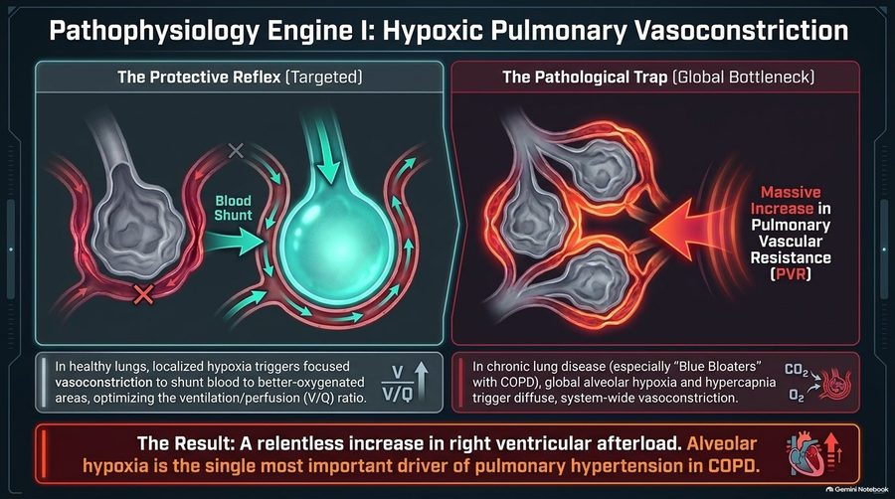
Targeted versus global hypoxic vasoconstriction: in one hypoxic area the reflex shunts blood away and helps ventilation/perfusion matching; when every alveolus is hypoxic and hypercapnic (the COPD “Blue Bloater”), every vessel constricts and pulmonary vascular resistance climbs, loading the right ventricle. Slide 6
Pathophysiology engine II: vascular bed obliteration (slide 7), shown for emphysema, interstitial lung disease (ILD)/fibrosis and pulmonary embolism (PE):
- Structural effacement: increased resistance isn’t just functional (constriction); it is anatomical.
- Loss of surface area: the total cross-sectional area of the pulmonary vascular bed is severely reduced, increasing resistance.
- The compounding factor: polycythemia (driven by chronic hypoxia) increases blood viscosity, further increasing cardiac workload against an obliterated vascular bed.
How the right ventricle (RV) responds to pressure (slide 8). The RV is intrinsically a thin-walled, high-compliance, low-pressure chamber, highly sensitive to sudden afterload changes. The acute crash (e.g., massive PE): sudden pressure outpaces adaptation; wall tension rises instantly → acute RV dilation, stretch and microinfarction. The chronic burden (e.g., chronic obstructive pulmonary disease, ILD): a gradual pressure rise allows time for compensatory RV hypertrophy; the walls thicken to maintain flow until eventual exhaustion.
The master matrix: acute vs chronic cor pulmonale (slide 9)
 | Acute cor pulmonale | Chronic cor pulmonale
Primary etiology | Massive pulmonary embolism | COPD, ILD, PAH (chronic obstructive pulmonary disease, interstitial lung disease, pulmonary arterial hypertension)
Time course | Minutes to hours | Months to years
RV adaptation | Sudden dilation & dysfunction | Concentric hypertrophy followed by late dilation
Classic presentation | Severe sudden dyspnea, sweating, rapid pulse, pallor, syncope | Unproductive cough, progressive exertional dyspnea, “Blue Bloater” phenotype
Key hemodynamic threat | Decreased LV filling & immediate cardiovascular collapse (shock) | Progressive volume overload, hypoxemia, and right heart failure

Acute manifestations: the chain of collapse (ventricular interdependence and shock, slide 10): massive pulmonary obstruction spikes RV wall tension → the RV acutely dilates under the sudden pressure → the shared interventricular septum bows leftward into the left ventricle (LV) → LV diastolic distensibility and filling drop drastically → LV cardiac output plummets, causing systemic hypotension and cardiovascular collapse. Clinical signs of the crash: distended neck veins (backed-up RV), tricuspid regurgitation murmur (stretched annulus), tachycardia and pallor.
Chronic manifestations: the plumbing backlog (slide 11). In chronic cor pulmonale the hypertrophied RV eventually decompensates; elevated diastolic pressures transmit backward into the systemic venous circulation, dramatically increasing hydrostatic pressure.
Physical exam hallmarks of chronic cor pulmonale (slide 11)
The heart | The systemic congestion
RV heave (parasternal lift along the left sternal border) | Tender hepatomegaly (hepatic congestion)
Intensified P2 (pulmonic valve closure slamming shut under high pressure) | Ascites (fluid in the peritoneal cavity)
Systolic murmur of tricuspid regurgitation | Dependent peripheral pitting edema

Signs that a hypertrophied right ventricle has decompensated. When a chronically hypertrophied right ventricle decompensates, its elevated diastolic pressure transmits backward: the liver congests and becomes tender, ascites forms and pitting edema spreads in dependent areas.

4.3 · Cor pulmonale: diagnosis and management
The diagnostic funnel (slide 12): evaluating pulmonary hypertension and cor pulmonale requires systematically separating parenchymal disease (Group 3), thromboembolic disease (Group 4) and primary vascular disease (Group 1).
Isolating the etiology: the clinical pathway for suspected pulmonary hypertension / cor pulmonale (slide 12)
Step | What it does | Result that sorts the patient
Step 1: chest X-ray (CXR) & pulmonary function tests (PFTs) | CXR: assess for interstitial markings (interstitial lung disease) or hyperinflation (chronic obstructive pulmonary disease) vs clear fields. PFTs: confirm obstructive vs restrictive patterns. | Interstitial lung disease or chronic obstructive pulmonary disease → parenchymal disease (Group 3); normal / non-diagnostic → step 2
Step 2: V/Q (ventilation/perfusion) scan or CT pulmonary angiography (CT-PA) | Exclude segmental defects (chronic thromboembolic pulmonary hypertension, pulmonary embolism). | Defects → thromboembolic disease (Group 4); no thromboembolism → step 3
Step 3: right heart catheterization (RHC) & echo | Echocardiogram and catheterization: confirm right ventricular strain and measure precise hemodynamics. | Elevated mean pulmonary artery pressure, wedge pressure ≤15 mmHg → primary vascular disease (Group 1)

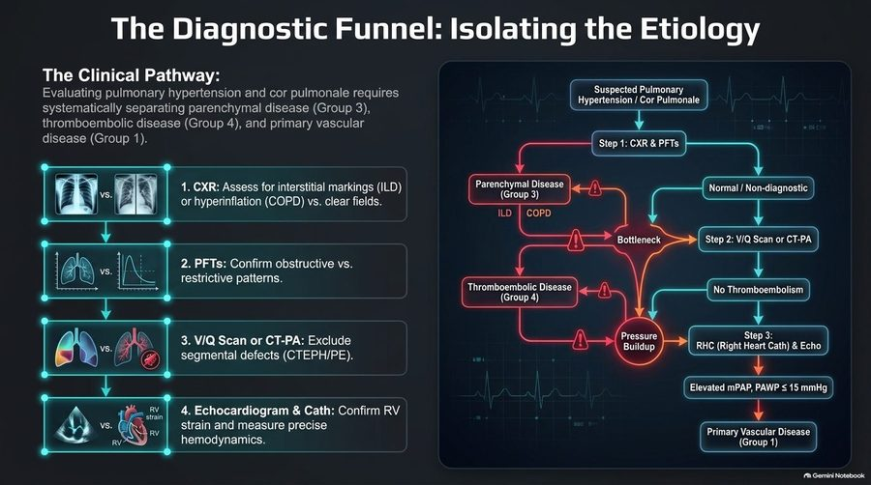
The funnel as drawn: each step peels off one group, lung disease (Group 3) at the chest film and pulmonary function tests, clots (Group 4) at the ventilation/perfusion scan or CT pulmonary angiography, and what is left with a raised mean pulmonary artery pressure and a wedge at or below 15 mmHg is primary vascular disease (Group 1). Slide 12
Assessing the lungs (slide 13). Pulmonary function tests (PFTs): the obstructive pattern (chronic obstructive pulmonary disease) = reduced FEV1/FVC (forced expiratory volume in 1 second over forced vital capacity), “the most common cause”; the restrictive pattern (interstitial lung disease) = reduced total lung capacity (TLC). PFTs are crucial for classifying Group 3 pulmonary hypertension. Chest X-ray hallmarks: flattened diaphragms (hyperinflation in chronic obstructive pulmonary disease) and enlarged central pulmonary arteries (high pressure). In patients with pulmonary arterial hypertension or pulmonary embolism, the peripheral lung fields may appear deceptively “clear” despite severe, life-threatening vascular disease.
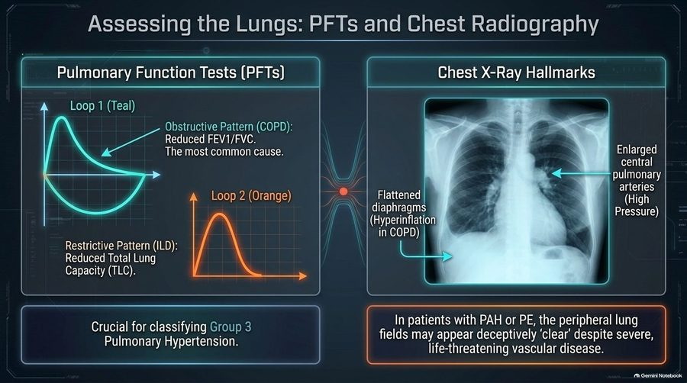
Left: the obstructive loop (chronic obstructive pulmonary disease, reduced FEV1/FVC) and the restrictive loop (interstitial lung disease, reduced total lung capacity). Right: the chest film arrows mark flattened diaphragms (hyperinflation) and enlarged central pulmonary arteries (high pressure). Slide 13
Assessing the right heart (slide 14). Electrocardiogram (EKG): peaked P waves indicate right atrial enlargement; a tall R wave in V1 indicates right ventricular hypertrophy; the EKG is abnormal in 70% of acute pulmonary embolism cases; in chronic cor pulmonale look for severe right axis deviation. Echocardiography evaluates right ventricular enlargement and estimates pulmonary artery systolic pressure. ★ The visual hallmark of severe right heart pressure overload is septal flattening during systole, deforming the left ventricle into a “D-shape.”
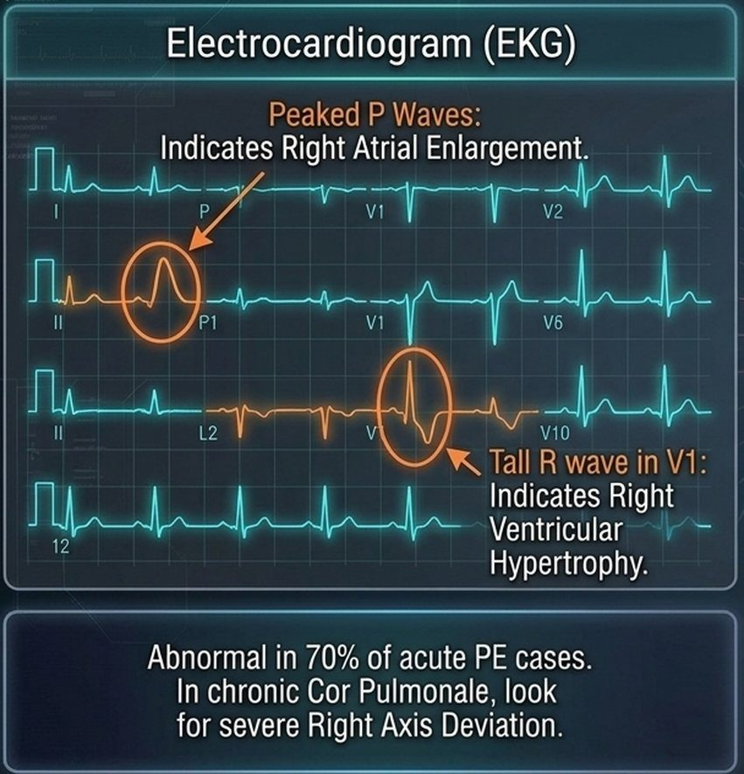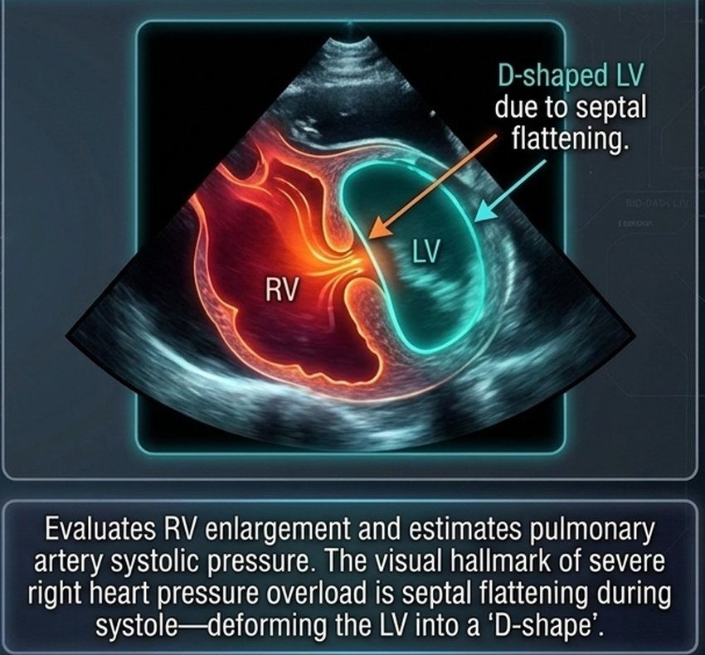
Left, the EKG: peaked P waves (right atrial enlargement) and a tall R wave in V1 (right ventricular hypertrophy); in chronic cor pulmonale, severe right axis deviation. Right, the echocardiogram: the enlarged right ventricle (RV) flattens the septum in systole, the D-shaped left ventricle (LV). Slide 14
Management principles: treat the root cause (slide 15). The prime directive: you cannot fix cor pulmonale without addressing the underlying pulmonary pathology.
- “Oxygen is a drug” (reversing hypoxic vasoconstriction): for Group 3 pulmonary hypertension (chronic obstructive pulmonary disease, interstitial lung disease), continuous supplemental oxygen is paramount; it directly reverses alveolar hypoxic vasoconstriction, mechanically lowering pulmonary resistance.
- Targeted etiologic therapies: chronic obstructive pulmonary disease = bronchodilators and aggressive treatment of underlying respiratory infections; acute pulmonary embolism = thrombolytics and anticoagulation (expanding blood volume if hypotensive); pulmonary arterial hypertension (Group 1) = specialized targeted therapies including phosphodiesterase-5 (PDE5) inhibitors, endothelin receptor antagonists and prostacyclins (4.7).
Fluid management: the preload tightrope (slide 16). Too much fluid (overload) = hepatic congestion and severe edema; too little fluid (under-filled) = decreased left ventricular filling and a catastrophic drop in cardiac output; the answer is careful diuresis.
- The goal: diuretics (loop diuretics, spironolactone) treat fluid retention, diminishing hepatic congestion and peripheral edema.
- The danger: the damaged right ventricle strictly relies on elevated filling pressures (preload) to push blood past the high pulmonary resistance.
- The consequence: decreasing right ventricular preload too aggressively starves the left ventricle of blood, giving a disastrous drop in systemic cardiac output. Furthermore, hypokalemia can trigger lethal arrhythmias.

Cor pulmonale
Defining feature: right ventricular hypertrophy, dilation or failure from lung or pulmonary vascular disease, with a raised mean pulmonary artery pressure and a normal wedge pressure (left heart failure excluded)
DefinitionAlteration in the structure and function of the right ventricle (enlargement, hypertrophy, or dilation) caused exclusively by a primary disorder of the respiratory system or pulmonary vasculature; elevated mean pulmonary artery pressure with normal pulmonary capillary wedge pressure. Left heart failure (Group 2) is not cor pulmonale. Acute (massive pulmonary embolism, minutes to hours, sudden dilation) vs chronic (chronic obstructive pulmonary disease, interstitial lung disease, pulmonary arterial hypertension; months to years; concentric hypertrophy, then late dilation).Who gets itPatients with chronic obstructive pulmonary disease above all (the absolute leading cause; present in >50% of them); interstitial lung disease; sleep-disordered breathing; acute pulmonary embolism; pulmonary arterial hypertension; chronic thromboembolic pulmonary hypertension.Risk factorsGlobal alveolar hypoxia and hypercapnia (the “Blue Bloater”); loss of the vascular bed (emphysema, fibrosis, emboli); polycythemia from chronic hypoxia (raises blood viscosity).Classic signs & symptomsAcute: severe sudden dyspnea, sweating, rapid pulse, pallor, syncope. Chronic: unproductive cough, progressive exertional dyspnea, “Blue Bloater” phenotype.Physical exam findingsAcute: distended neck veins, tricuspid regurgitation murmur, tachycardia, pallor. Chronic: right ventricular heave (parasternal lift, left sternal border), intensified P2, systolic tricuspid regurgitation murmur; tender hepatomegaly, ascites, dependent peripheral pitting edema.Diagnostics / testsStepwise: chest X-ray and pulmonary function tests (Group 3), then ventilation/perfusion scan or CT pulmonary angiography (Group 4), then right heart catheterization and echo (Group 1: raised mean pulmonary artery pressure, wedge ≤15 mmHg). EKG: peaked P waves, tall R in V1, severe right axis deviation (chronic). Echocardiography: right ventricular enlargement, estimated pulmonary artery systolic pressure, systolic septal flattening (D-shaped left ventricle). Chest film: flattened diaphragms, enlarged central pulmonary arteries; fields may look deceptively clear in pulmonary arterial hypertension or embolism.First-line treatmentTreat the underlying lung disease (the prime directive). Continuous supplemental oxygen in Group 3 (oxygen is a drug: it reverses hypoxic vasoconstriction); bronchodilators and aggressive treatment of infection in chronic obstructive pulmonary disease; thrombolytics and anticoagulation (volume if hypotensive) in acute embolism; targeted therapy in pulmonary arterial hypertension. Careful diuresis (loop diuretics, spironolactone), never aggressive.ComplicationsAcute: decreased left ventricular filling and immediate cardiovascular collapse (shock) from the septum bowing into the left ventricle. Chronic: progressive volume overload, hypoxemia and right heart failure. Over-diuresis: a disastrous drop in cardiac output; hypokalemia: lethal arrhythmias.
Slides 4–16, 18

4.4 · Pulmonary hypertension: classification and pathophysiology
The core axiom: the lung dictates the fate of the right heart (slide 18). Cor pulmonale is right ventricular hypertrophy, dilation, or failure secondary to pulmonary hypertension or primary lung disease; although the most common cause of right ventricular failure overall is left ventricular failure, pure cor pulmonale isolates the lung–heart axis.
The etiologies matrix: World Health Organization (WHO) classification by mechanism (slide 19)
Site | Group | Mechanism | Examples
Pre-capillary | Group 1 (PAH) (pulmonary arterial hypertension) | Obliterative / proliferative | Idiopathic, connective tissue disease, HIV (human immunodeficiency virus), schistosomiasis
Group 3 (lung disease / hypoxia) | (printed as a venous mechanism; not keyed: slides 6 and 15 give hypoxic vasoconstriction) | COPD (chronic obstructive pulmonary disease), interstitial lung disease, sleep apnea
Group 4 (CTEPH) (chronic thromboembolic pulmonary hypertension) | Obstructive | Chronic thromboembolic occlusion
Post-capillary | Group 2 (left heart disease) | Passive | Obstruction to pulmonary venous outflow (e.g., HFrEF (heart failure with reduced ejection fraction), HFpEF (heart failure with preserved ejection fraction), mitral stenosis)
(drawn apart) | Group 5 (unclear / multifactorial) | Complex | Hematologic, systemic, metabolic disorders (e.g., sarcoidosis)

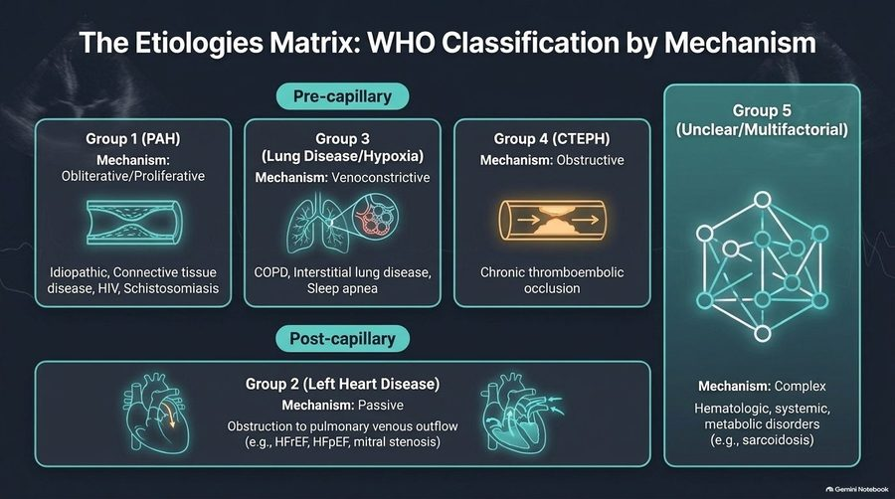
The chart the table above transcribes. His spoken shorthand: “Group 1 … arterial … Group 3, lung disease … Group 4 is clots. Group 2 is left heart failure.” Slide 19
How pressure destroys the pump (slide 20; he asked only for the sequence, not the charts):
- Stage 1, compensatory hypertrophy: the right ventricular wall thickens to overcome rising pulmonary vascular resistance.
- Stage 2, dilation & failure: the Starling mechanism fails; the chamber dilates as end-diastolic volume increases.
- Stage 3, ventricular interdependence: the dilated, pressure-overloaded right ventricle bows the interventricular septum into the left ventricle.
Clinical consequence: septal bowing mechanically impairs left ventricular diastolic filling, reducing systemic cardiac output and causing exertional syncope, despite normal left ventricular contractility.

4.5 · Pulmonary hypertension: presentation and examination
From vague dyspnea to fixed cardiac output (slide 21)
Stage (World Health Organization functional class) | Symptoms
Early / mild (WHO class I–II) | Exertional dyspnea and fatigue: often the only early symptom; frequently dismissed or misattributed to deconditioning.
Moderate (WHO class III) | Dizziness and lightheadedness; marked limitation of physical activity.
Severe (WHO class IV) | Syncope / presyncope: an ominous sign indicating a fixed, low cardiac output incapable of increasing with exertion. End-stage: abdominal bloating, early satiety, edema; present even at rest.

Signs of venous congestion on examination (slide 22):
- The jugular vein: elevated jugular venous pressure (JVP); look for large “a” waves (early) or regurgitant “v” waves (tricuspid insufficiency).
- Cardiac auscultation and palpation: palpable parasternal lift (right ventricular heave), accentuated pulmonic valve closure (P2), and a right ventricular S3 gallop (indicating right ventricular dysfunction).
- The hepatojugular reflux: applying sustained moderate pressure on the liver increases the jugular venous pressure by >1 cm, correlating with elevated right-sided filling pressures.
- The extremities: peripheral pitting edema (extends to hips/sacrum in severe cases); cool extremities due to low cardiac output and peripheral vasoconstriction.
His memory aid for the gallops: the S3 is “a big floppy left ventricle,” the S4 “a stiffened, filled ventricle.”
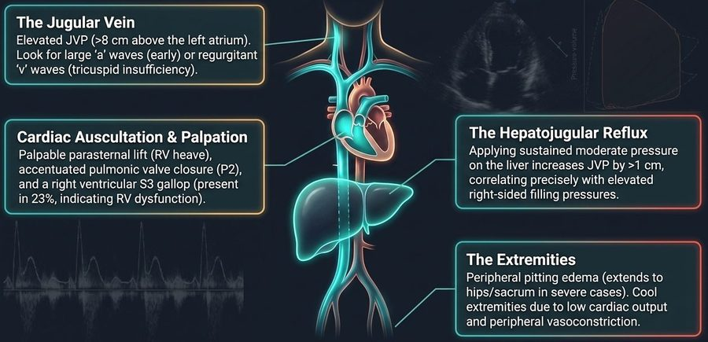
The four places to look: neck veins (a and v waves), the precordium (right ventricular heave, loud P2, right-sided S3), the liver (hepatojugular reflux, >1 cm rise) and the legs (pitting edema, cool extremities). The venous-pressure number and reference point printed in the first box are not keyed (box above). Slide 22
The hemodynamic matrix: left heart failure vs right heart failure (slide 23)
 | Left heart failure | Right heart failure / cor pulmonale
Predominant symptoms | Orthopnea, paroxysmal nocturnal dyspnea | Abdominal bloating, early satiety, profound fatigue, exertional syncope
Pulmonary exam & CXR (chest X-ray) | Bibasilar crackles, wheezing, Kerley B lines, pleural effusions | Lungs typically clear to auscultation; CXR shows enlarged central pulmonary arteries with peripheral pruning (attenuation)
Key hemodynamics | Elevated pulmonary capillary wedge pressure (PCWP >15 mmHg) | Normal/low PCWP (≤15 mmHg) with elevated mean pulmonary arterial pressure (mPAP)

4.6 · Pulmonary hypertension: diagnosis and prognosis
The diagnostic funnel: from screening to hemodynamic confirmation (slide 24)
Screening: echocardiography | The most useful initial test. Estimates right ventricular size, function (TAPSE, tricuspid annular plane systolic excursion) and pulmonary pressures. Crucial for identifying left-sided valvular or myocardial disease mimics.
Differentiation: V/Q (ventilation/perfusion) scan | Essential test to exclude chronic thromboembolic pulmonary hypertension (CTEPH). Clinical pearl: do not rely solely on CT angiography; a high-probability V/Q mismatch dictates a completely different surgical pathway (thromboendarterectomy).
Confirmation: right heart catheterization | The mandatory gold standard. Directly measures mean pulmonary artery pressure, pulmonary capillary wedge pressure and pulmonary vascular resistance to definitively confirm pre-capillary pulmonary hypertension.

★ PROFESSOR EMPHASIS
★ “When I start having signs of RV failure, I’m automatically at high risk” (slide 25)
Prognostic risk stratification in pulmonary hypertension (estimated 1-year mortality) (slide 25)
Determinant | Low risk (<5% mortality) | Intermediate risk (5–10% mortality) | High risk (>10% mortality)
Clinical signs of right ventricular (RV) failure | Absent | Absent | Present
Progression | Slow | Moderate | Rapid
Syncope | No syncope | Occasional syncope | Repeated syncope
WHO functional class (World Health Organization) | I or II | III | IV
6-minute walk distance | >440 meters | 165–440 meters | <165 meters

His rule for a three-column table: learn the middle column, and the others are better or worse.

4.7 · Pulmonary hypertension: treatment
★ PROFESSOR EMPHASIS
★ “PDE5 inhibitors, you should know. That’s your AFILs” (slide 26)
The treatment target map: reversing endothelial dysfunction (slide 26)
Pathway | What it does | Examples
1. Endothelin receptor antagonists (ERAs) | Block the binding of endothelin-1, preventing potent vasoconstriction and smooth muscle proliferation. | Ambrisentan, bosentan, macitentan
2. Phosphodiesterase-5 (PDE-5) inhibitors | Prevent the degradation of cGMP (cyclic guanosine monophosphate), enhancing the endogenous nitric oxide (NO) pathway to promote smooth muscle relaxation. | Sildenafil, tadalafil (the “AFILs”)
3. Prostacyclins / IP receptor agonists (prostacyclin receptor) | Increase intracellular cAMP (cyclic adenosine monophosphate). The most potent class for vasodilation and anti-platelet aggregation; essential for severe disease. | Epoprostenol, treprostinil, iloprost, selexipag (“PROST in the name”)

The endothelin receptor antagonists and prostacyclins he gave “for completeness” (“specialty sorcery”): know them by class and example.

Foundational management: fluid, oxygen and conditioning (slide 27):
- Fluid management: careful diuresis is central to managing right ventricular volume overload. Intravenous loop diuretics produce venodilation prior to diuresis. Avoid aggressive over-diuresis, which can drop preload and crash cardiac output.
- Oxygen therapy: maintain PaO2 (arterial oxygen pressure) >60 mmHg. Hypoxia is a potent pulmonary vasoconstrictor; supplemental oxygen is critical, especially during sleep or exertion.
- Exercise and conditioning: avoid strict bedrest. Regular, steady aerobic exercise in a supervised rehabilitation program is safe, prevents muscle deconditioning and improves fatigue.
- Preventive care: annual influenza and pneumococcal immunizations are mandatory to prevent acute respiratory decompensations.
Therapeutic algorithm: from functional class to pharmacy (slide 28; top level)
Decision 1: vasoreactive? Yes | High-dose oral calcium channel blockers (CCBs)
No → proceed to risk stratification: low / intermediate risk (WHO class II/III) | Initiate oral combination therapy (e.g., endothelin receptor antagonist + phosphodiesterase-5 inhibitor). Early combination therapy is superior to sequential monotherapy.
No → high risk (WHO class IV or rapid clinical decline) | Initiate continuous intravenous or subcutaneous parenteral prostanoids (e.g., epoprostenol).
Critical rule: no single variable determines therapy (the slide’s worked example is intensive care detail he set aside: “this is ICU stuff”).

End-stage management and the limits of the pump (slide 29):
- Advance directives: because sudden death or lethal syncope can be the first indication of disease progression, early palliative care discussions and advance directives are essential.
- 6% survival at 90 days following cardiopulmonary resuscitation (CPR) in pulmonary arterial hypertension: the hypertrophied, failed right ventricle rarely recovers from arrest.
- Ultimate interventions: for highly selected patients refractory to maximal medical therapy (or those with pulmonary veno-occlusive disease (PVOD)), lung transplantation remains the only definitive therapeutic option; continuous intravenous support may serve as a bridge to transplant.

Pulmonary hypertension
Defining feature: exertional dyspnea and fatigue (often blamed on deconditioning) with a loud P2, right ventricular heave and clear lungs; the echo screens, right heart catheterization confirms
DefinitionRaised pressure in the pulmonary circulation that loads the right ventricle; classified by the World Health Organization into five groups by mechanism: pre-capillary Group 1 (pulmonary arterial hypertension), Group 3 (lung disease/hypoxia), Group 4 (chronic thromboembolic); post-capillary Group 2 (left heart disease); Group 5 (unclear/multifactorial). No pressure threshold is on the slides.Who gets itGroup 1: idiopathic, connective tissue disease, HIV, schistosomiasis; Group 2: heart failure (reduced or preserved ejection fraction), mitral stenosis; Group 3: chronic obstructive pulmonary disease, interstitial lung disease, sleep apnea; Group 4: chronic thromboembolic occlusion; Group 5: hematologic, systemic, metabolic (e.g., sarcoidosis).Risk factorsChronic hypoxia (a potent pulmonary vasoconstrictor); chronic lung disease; previous pulmonary embolism (chronic thromboembolic disease); left heart disease.Classic signs & symptomsExertional dyspnea and fatigue (often the only early symptom, misattributed to deconditioning, class I–II); dizziness, lightheadedness, marked limitation (class III); syncope or presyncope (ominous: fixed low output) and end-stage abdominal bloating, early satiety, edema at rest (class IV).Physical exam findingsElevated jugular venous pressure with large a waves or regurgitant v waves; right ventricular heave; accentuated P2; right ventricular S3; hepatojugular reflux (>1 cm); pitting edema to hips and sacrum; cool extremities; lungs typically clear.Diagnostics / testsEchocardiography = the most useful initial (screening) test (right ventricular size, TAPSE, pulmonary pressures, left-sided mimics); ventilation/perfusion scan = essential to exclude chronic thromboembolic pulmonary hypertension (do not rely on CT angiography alone); right heart catheterization = mandatory confirmation (mean pulmonary artery pressure, wedge pressure, pulmonary vascular resistance; wedge ≤15 mmHg in pre-capillary disease). Chest film: enlarged central pulmonary arteries with peripheral pruning.First-line treatmentCareful diuresis (no aggressive over-diuresis); oxygen to keep PaO2 >60 mmHg, especially in sleep or exertion; supervised aerobic rehabilitation (no strict bedrest); annual influenza and pneumococcal vaccines. Vasoreactive: high-dose oral calcium channel blockers. Not vasoreactive: low/intermediate risk = oral combination (endothelin receptor antagonist + phosphodiesterase-5 inhibitor); high risk = continuous intravenous or subcutaneous prostanoids (epoprostenol). Refractory: lung transplantation.ComplicationsRight ventricular hypertrophy, then dilation and failure; septal bowing with exertional syncope; sudden death or lethal syncope (may be the first sign of progression); 6% survival at 90 days after cardiopulmonary resuscitation. Prognosis by the slide 25 table: right ventricular failure signs, rapid progression, repeated syncope, class IV or walk <165 m = high risk (>10% 1-year mortality). Referral: transplantation; early palliative care and advance directives.
Slides 18–29

4.8 · Pulmonary edema: mechanism and causes
The Starling forces (slide 32):
- Outward force: elevated capillary hydrostatic pressure (Pc), the engine of cardiogenic edema.
- Inward force: plasma oncotic pressure, the failing counter-balance.
- The barrier: the semi-permeable capillary membrane, intact but overwhelmed.
Pulmonary edema fundamentally manifests when the outward hydrostatic pressure exceeds inward oncotic pressure, or when the barrier itself shatters, flooding the alveolar airspace.
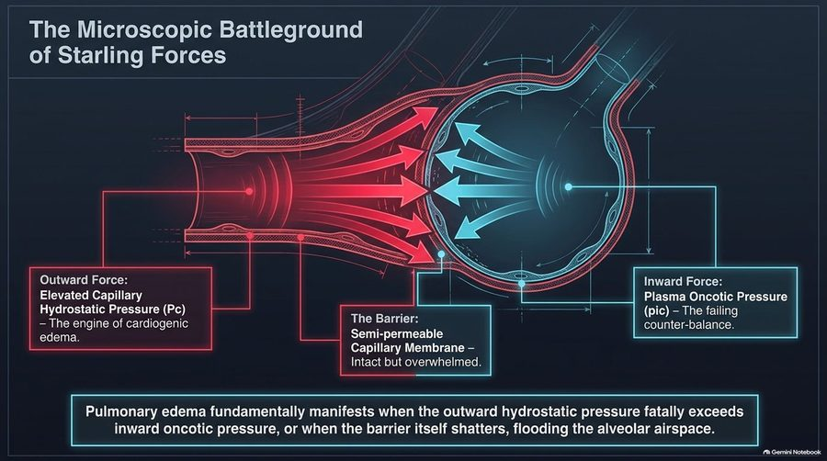
Push out (hydrostatic pressure) against pull in (oncotic pressure) across an intact membrane: edema comes when the push wins, or when the membrane itself breaks. Slide 32
The great divide: identifying the source of the flood (slide 33)
 | Cardiogenic (the pressure problem) | Noncardiogenic (the permeability problem)
Mechanism | Intact capillaries subjected to extreme hydrostatic backup | Shattered capillary endothelium leaking protein-rich fluid
Hemodynamic signature | PCWP >18–20 mmHg (pulmonary capillary wedge pressure) | PCWP ≤18 mmHg
Primary defect | The pump is failing. | The pipe is leaking.

His first question in any edema: “pipes, pumps, or filter? … your differentials all spring from the answer to that question.”
Tracing the crisis to its etiology (slide 34)
Cardiogenic roots | Noncardiogenic roots
Systolic dysfunction: ischemic loss of functioning myocardium (HFrEF, heart failure with reduced ejection fraction) | ARDS (acute respiratory distress syndrome): severe inflammatory capillary destruction
Diastolic dysfunction: myocardial stiffening and aging (HFpEF, heart failure with preserved ejection fraction) | Sepsis: systemic vasodilation and endothelial leak
Valvular lesions: chronic aortic or mitral regurgitation / severe stenosis | Toxins: inhaled chemical injury to the alveolar-capillary membrane

4.9 · Pulmonary edema: presentation and diagnosis
At the bedside (slide 35; “not a shopping list, not a checklist”):
- Pink, frothy sputum: the visual proof of profound alveolar fluid shift and microvascular hemorrhage (he called it a late sign).
- Bilateral rales / crackles and wheezing: the acoustic signature of fluid-filled airways and peribronchial cuffing.
- S3 gallop: the marker of an overloaded, failing ventricle.
- Acute dyspnea, diaphoresis, tripoding: the catecholamine surge and extreme work of breathing.
Triangulating the diagnosis (slide 36)
Test | Function | Utility
Biomarkers: BNP / NT-proBNP (B-type natriuretic peptide / N-terminal pro-B-type natriuretic peptide) | Proves ventricular stretch and volume overload | Substantial elevation differentiates cardiogenic dyspnea from pulmonary mimics
Non-invasive imaging: transthoracic echo (TTE) | The best test for structural assessment | Defines left/right ventricular size, ejection fraction (LVEF, left ventricular ejection fraction) and valvular integrity
Invasive hemodynamics: PAC / RHC (pulmonary artery catheter / right heart catheterization) | The ultimate hemodynamic arbiter | Directly quantifies left-sided filling pressures when the etiology remains uncertain

Radiographic signatures of wet lungs (slide 37):
- “Batwing” opacities: the central, perihilar distribution of alveolar edema.
- Peribronchial cuffing: edema thickening the walls of the bronchioles, causing characteristic blurring.
- Kerley B lines: horizontal peripheral lines indicating fluid engorgement of the interlobular septa.
- Bilateral pleural effusions: fluid escaping the visceral pleura due to extreme hydrostatic pressure.
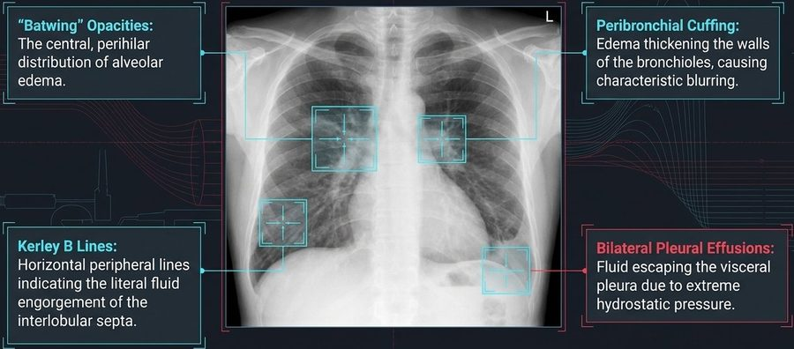
The wet-lung film: haze around both hila ( batwing ), blurred thick-walled airways ( peribronchial cuffing ), short horizontal lines at the lung edge ( Kerley B ), and blunted bases ( bilateral effusions ). He does not expect you to read films yet; the four descriptions are what is tested. Slide 37
Pulmonary capillary wedge pressure (PCWP) (slide 38): inflating the balloon and wedging the catheter creates a static column of blood that “looks forward” through the pulmonary capillary bed to measure left atrial pressure. The diagnostic threshold: >18–20 mmHg confirms cardiogenic hydrostatic failure.
The mimics: the crowded room of acute dyspnea (slide 43). Shared by all three: dyspnea, hypoxemia, tachycardia
Heart failure (cardiogenic edema) | Distinguished by highly elevated BNP (B-type natriuretic peptide); echo abnormalities; Kerley B lines on chest X-ray
Pulmonary embolism (“the blocked pipe”) | Often presents with clear lungs on chest X-ray; normal BNP initially; distinct S1Q3T3 on EKG or right ventricular strain
COPD exacerbation (chronic obstructive pulmonary disease, “the inflamed airway”) | Distinguished by wheezing / hyperinflation on chest X-ray; hypercapnia; usually normal BNP

4.10 · Pulmonary edema: management and prognosis
Acute emergency management: the LMNOP rescue (slide 39) — “like my toolbox, not a checklist”
L – Loop diuretics (IV) | Rapid volume reduction; aggressive diuresis (furosemide, bumetanide, torsemide).
M – Morphine | Use with caution. Historically used for venodilation and anxiolysis, but carries respiratory depression risks.
N – Nitrates (IV) | Immediate preload and afterload reduction via potent venodilation.
O – Oxygen / upright positioning | Optimizing ventilation/perfusion (V/Q) matching and physically dropping venous return via gravity.
P – Positive airway pressure (NIPPV) (noninvasive positive pressure ventilation) | Mechanical alveolar stenting and preload reduction.

Mechanisms of rescue (slide 40). Noninvasive positive pressure ventilation: more than just oxygenation; positive pressure mechanically stents open flooded alveoli, forces fluid back across the membrane, and decreases intrathoracic preload and afterload. Nitrate venodilation: rapidly shifts volume into the peripheral venous capacitance system, directly lowering the outward capillary hydrostatic pressure (Pc) in the lungs.
Chronic heart failure optimization (slide 41, a refresher): moving from acute volume management to long-term mortality reduction requires blocking deleterious neurohormonal activation. “Quadruple therapy” provides the greatest mortality reduction in HFrEF (heart failure with reduced ejection fraction):
- ARNI (angiotensin receptor–neprilysin inhibitor; sacubitril-valsartan): vasodilation and natriuresis.
- Beta-blockers: halting sympathetic toxicity and remodeling.
- MRA (mineralocorticoid receptor antagonists): now proven effective in both reduced and preserved/mildly reduced ejection fraction (HFpEF/HFmrEF).
- SGLT-2 inhibitors (sodium-glucose cotransporter-2): the newest class for mortality reduction.
Adult vs elderly strategy (slide 42) is in 4.14.
Prognosis and the stage D cliff (slide 44)
Stages A & B | At risk and pre-symptomatic: focus on prevention and risk modification.
Stage C | Clinical heart failure: the domain of quadruple therapy.
Stage D (the break point) | Marked symptoms at rest despite maximal medical therapy; frequent hospitalizations.
The referral trigger | Reaching stage D mandates immediate evaluation for advanced therapies: heart transplant, mechanical circulatory support / LVAD (left ventricular assist device), or palliative hospice care.

The complete picture (slide 45), in four phases: (1) microscopic failure, disrupted Starling forces (capillary hydrostatic pressure exceeds oncotic pressure); (2) hemodynamic crisis, elevated wedge pressure (>18 mmHg) triggering alveolar flooding; (3) acute rescue, LMNOP shifts volume out of the central circulation and stents alveoli; (4) chronic rebuilding, quadruple therapy remodels the neurohormonal landscape to prevent recurrence. “Survival depends on recognizing the failure at the membrane, measuring the pressure at the wedge, and architecting the rescue at the bedside.”
Flash pulmonary edema (slide 46):
- Precipitating causes: underlying cardiac causes, triggered by acute MI (myocardial infarction), severe ischemia or severe hypertension; chronic heart failure exacerbations caused by nonadherence, excess salt or rapid arrhythmias; noncardiac causes are differentiated by a normal wedge pressure.
- Recognition: severe dyspnea, cyanosis, diaphoresis and pink frothy sputum; diffuse bilateral rales, rhonchi and expiratory wheezing; chest X-ray shows butterfly pattern edema and vascular blurring; key biomarkers elevated BNP (B-type natriuretic peptide), elevated wedge pressure, hypoxemia.
- Acute emergency interventions: position the patient upright with legs dangling over the bed; oxygen or noninvasive ventilation to maintain oxygenation; IV furosemide for immediate venodilation and diuresis; IV nitrates to rapidly reduce afterload.
- Pharmacologic strategy and transition: temporarily hold outpatient therapy during acute kidney injury; continue oral beta-blockers unless the patient presents in shock; cautious morphine: reduces anxiety but risks severe ventilatory drive reduction.
Diagnostic differentiation in flash pulmonary edema (slide 46)
 | Cardiogenic | Noncardiac pulmonary edema
PCWP (pulmonary capillary wedge pressure) | Elevated | Normal or low
Primary underlying drivers | Acute MI (myocardial infarction), severe HTN (hypertension), chronic heart failure decompensation | ARDS (acute respiratory distress syndrome), high altitude, sepsis, toxins
Cardiac status | Cardiac enlargement / dysfunction common | Underlying cardiac function typically normal

Pulmonary edema
Defining feature: acute dyspnea with bilateral crackles, pink frothy sputum and an S3, batwing opacities and Kerley B lines, a high B-type natriuretic peptide and a wedge pressure >18–20 mmHg (cardiogenic)
DefinitionFluid flooding the alveolar airspace when outward capillary hydrostatic pressure exceeds inward oncotic pressure (cardiogenic, the pressure problem, “the pump is failing”: wedge >18–20 mmHg) or the capillary barrier shatters (noncardiogenic, the permeability problem, “the pipe is leaking”: wedge ≤18 mmHg).Who gets itCardiogenic: systolic dysfunction (ischemic, reduced ejection fraction), diastolic dysfunction (stiffening and aging, preserved ejection fraction), valvular lesions. Noncardiogenic: acute respiratory distress syndrome, sepsis, inhaled toxins, high altitude.Risk factorsFlash edema triggers: acute myocardial infarction, severe ischemia, severe hypertension; chronic heart failure exacerbation from nonadherence, excess salt or rapid arrhythmias.Classic signs & symptomsAcute dyspnea, diaphoresis, tripoding; pink frothy sputum (late); cyanosis.Physical exam findingsBilateral rales/crackles and wheezing (diffuse rales, rhonchi, expiratory wheezing in flash edema); S3 gallop.Diagnostics / testsB-type natriuretic peptide (substantial elevation separates cardiogenic dyspnea from pulmonary mimics); transthoracic echo (structure, ejection fraction, valves); pulmonary artery catheter / right heart catheterization when the cause is uncertain (wedge >18–20 mmHg = cardiogenic). Chest X-ray: batwing opacities, peribronchial cuffing, Kerley B lines, bilateral effusions (butterfly pattern and vascular blurring in flash edema). Mimics: pulmonary embolism (clear lungs, normal natriuretic peptide initially), chronic obstructive pulmonary disease exacerbation (wheeze, hyperinflation, hypercapnia, usually normal natriuretic peptide).First-line treatmentLMNOP: IV loop diuretics (furosemide, bumetanide, torsemide), morphine only with caution, IV nitrates, oxygen and upright positioning (legs dangling), positive airway pressure (noninvasive ventilation). Continue oral beta-blockers unless in shock; hold outpatient therapy during acute kidney injury. Long term: quadruple therapy (ARNI, beta-blocker, mineralocorticoid receptor antagonist, SGLT-2 inhibitor) for reduced ejection fraction. Elderly (preserved ejection fraction): gentle, precise diuresis.ComplicationsAlveolar flooding and hypoxemia; morphine-related respiratory (ventilatory drive) depression; over-diuresis hypotension in the elderly, recurrent flooding with under-diuresis; progression to stage D (marked symptoms at rest despite maximal therapy, frequent hospitalizations), which triggers referral for heart transplant, mechanical circulatory support (left ventricular assist device) or palliative hospice care.
Slides 32–46

4.11 · Pulmonary embolism: risk factors and presentation
The VTE (venous thromboembolism) continuum (slide 48): deep venous thrombosis (DVT) and pulmonary embolism (PE) are a continuum of the same disease process. The physiologic effects and clinical consequences vary widely, from asymptomatic disease to hemodynamic collapse and death.
The origins of thrombosis: Virchow’s triad, clinical drivers (slide 49)
Hypercoagulability | Venous stasis | Endothelial injury
Malignancy  Estrogen therapy  Pregnancy  Genetic thrombophilias  Sepsis | Prolonged immobilization (>8 hr flights)  Bed rest  Paralysis  Heart failure (NYHA III/IV, New York Heart Association class) | Recent surgery  Central venous catheters  Pacemaker wires  Pelvic / lower limb trauma
“Inability to identify a known clinical predisposition should never dissuade an objective evaluation if the presentation is consistent with embolism.” His version: “I don’t need 15 risk factors, I just need a couple of good ones.”

Clinical presentation: the three syndromes (slide 50)
Isolated dyspnea | Sudden onset over minutes to hours; can occur at rest or solely with exertion.
Pleuritic pain & hemoptysis | Indicates distal, pleural-based pulmonary infarction; often accompanied by a localized friction rub.
Circulatory collapse | Syncope, severe hypotension, obstructive shock; indicates massive, proximal occlusion.

★ PROFESSOR EMPHASIS
★ “If you walk away with nothing else from this lecture today, walk away with that” (slide 50)
The dyspnea trap: do not rely on shortness of breath. Approximately 25% of patients with proven pulmonary embolism completely lack dyspnea. (Repeated on slide 62: “Beware the 25% of patients without dyspnea.” He also warned that test questions usually give “textbook” embolisms.)

★ PROFESSOR EMPHASIS
★ “The one they tell you, oh, it’s a board question, is S1Q3T3” (slide 51)
Classic clues on the EKG and the chest film (slide 51)
S1Q3T3 pattern (EKG) | (1) Deep S wave in lead I, (2) Q wave in lead III, (3) inverted T wave in lead III. Suggests severe right ventricular (RV) strain, not purely PE. Highly specific, but low sensitivity.
Westermark sign | Focal peripheral oligemia (decreased vascularity).
Hampton’s hump | Wedge-shaped, pleural-based opacity indicating infarction.
Palla sign | Enlarged right descending pulmonary artery.
Most patients with pulmonary embolism have abnormal but non-specific chest X-ray findings (e.g., atelectasis, effusion). Classic signs are highly suggestive but infrequent.

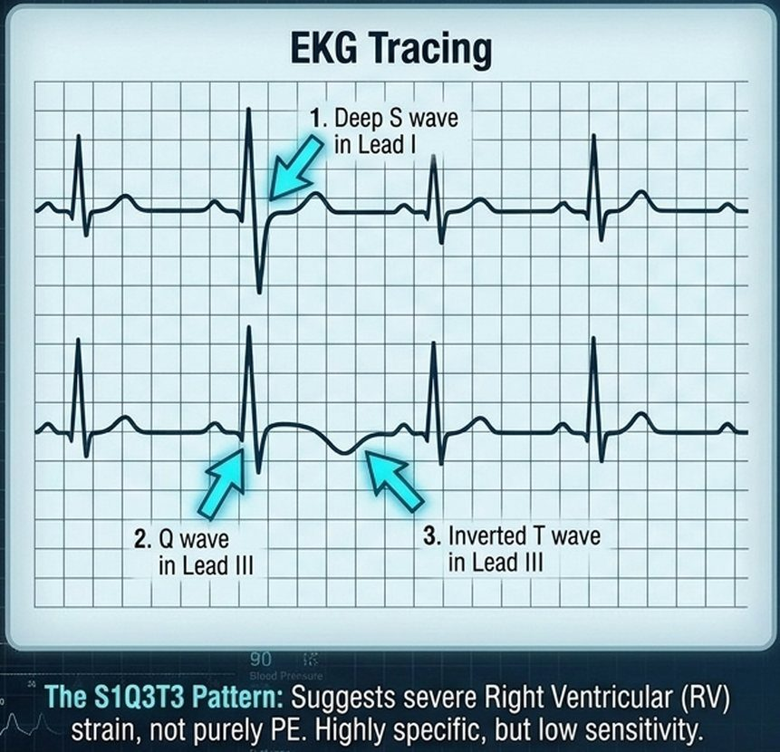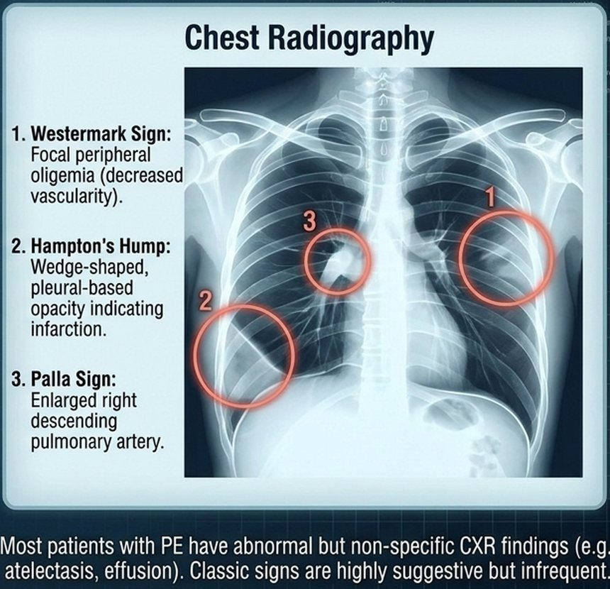
Left, S1Q3T3 : a deep S wave in lead I, a Q wave and an inverted T wave in lead III (right ventricular strain; highly specific, low sensitivity). Right, the classic film signs: 1 Westermark (focal oligemia), 2 Hampton’s hump (wedge-shaped pleural-based opacity, infarction), 3 Palla (enlarged right descending pulmonary artery). Slide 51

4.12 · Pulmonary embolism: diagnosis
The Bayesian shift (slide 52): modern pulmonary embolism (PE) diagnosis has moved from a technique-oriented approach to a Bayesian analysis. The pre-test probability, derived from clinical scoring (e.g., Wells criteria) independently of any test, dictates which diagnostic test is chosen and how its results are interpreted to give a final post-test probability. The tests: D-dimer, CT pulmonary angiography (CTPA) or a ventilation/perfusion (V/Q) scan.
★ PROFESSOR EMPHASIS
★ “Know your Wells, know your PERC … that’s fair game” (slide 53)
The Wells clinical prediction score for pulmonary embolism (slide 53)
Points | Criterion
High weight criteria
+3.0 | Clinical signs and symptoms of DVT (deep venous thrombosis)
+3.0 | PE is the #1 diagnosis (more likely than alternatives)
+1.5 | Heart rate >100 bpm (beats per minute)
+1.5 | Immobilization (>3 days) or surgery in previous 4 weeks
Lower weight criteria
+1.5 | Previous DVT or PE
+1.0 | Hemoptysis
+1.0 | Malignancy (on treatment, treated in last 6 months, or palliative)
Total score | Meaning
≤4 | PE unlikely
>4 | PE likely
Validated, rapid bedside assessment. Used to determine if the next step is a biomarker (D-dimer) or direct imaging (CTPA).

His reading: “4 or lower, PE’s unlikely … 5 and up, PE likely.” “Wells first,” then PERC only when the score says unlikely.

A Wells score of 4.5 makes embolism likely. The rule-out criteria come after the Wells score and are used when it is 4 or less. A score of 4.5 makes embolism likely, so the D-dimer and the rule-out criteria are bypassed: directly to computed tomographic pulmonary angiography.
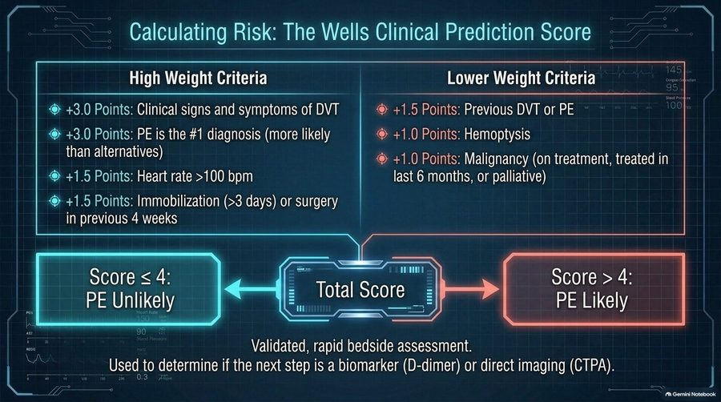
The Wells chart: the two 3-point items (signs of deep venous thrombosis; embolism the leading diagnosis), the 1.5-point items (heart rate, immobilization or surgery, previous clot), the 1-point items (hemoptysis, malignancy), and the cut at 4. The monitor numbers drawn in the picture are decoration. Slide 53
Wells points: heart rate above 100 = 1.5, hemoptysis = 1. Estrogen use is a risk factor and a PERC (Pulmonary Embolism Rule-out Criteria) item, but it is not on the Wells list. A score of 4 or less means embolism is unlikely.
★ PROFESSOR EMPHASIS
★ “A rule-out tool … every single one of these has to be negative” (slide 54)
The gatekeepers: PERC and D-dimer (slide 54)
Layer 1: the PERC rule (Pulmonary Embolism Rule-out Criteria), for very low clinical gestalt (<15%). If all true, STOP workup.
Age <50 | No exogenous estrogen
HR <100 (heart rate) | No prior VTE (venous thromboembolism)
O2 >94% (oxygen saturation) | No surgery/trauma
No hemoptysis | No unilateral leg swelling
Layer 2: highly sensitive D-dimer, for low/intermediate probability patients who fail PERC. High sensitivity, low specificity. A negative ELISA (enzyme-linked immunosorbent assay) D-dimer safely excludes PE. Positive D-dimer: proceed to imaging.
These tools are designed to rule OUT disease in outpatients. D-dimer has limited utility in inpatients due to universally high false-positive rates.

Estrogen use fails the PERC. All eight PERC (Pulmonary Embolism Rule-out Criteria) items must be true to stop the workup: age under 50, heart rate under 100, oxygen saturation above 94%, no hemoptysis, no exogenous estrogen, no prior venous thromboembolism, no surgery or trauma and no unilateral leg swelling. Estrogen use fails the rule.
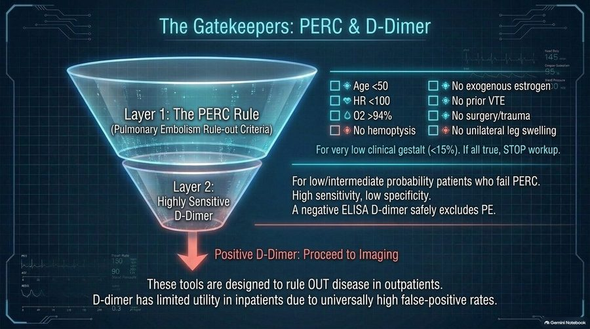
Two gates in a row: all eight PERC items true → stop; any one failed → D-dimer (negative excludes, positive → imaging). Both are outpatient rule-out tools. Slide 54
The imaging arsenal: CTPA vs V/Q scanning (slide 55)
 | CTPA (computed tomographic pulmonary angiography) — “the Modern Gold Standard” | V/Q scanning (ventilation/perfusion)
Technology | Multidetector row CT with sub-millimeter resolution of small peripheral arteries in a single breath-hold | Gamma scintillation camera evaluating for multiple, segmental-sized mismatched perfusion defects
Limitations | Requires IV iodinated contrast. Radiation exposure. Risk of overdiagnosing clinically insignificant subsegmental PE. | Frequently non-diagnostic if underlying cardiopulmonary disease exists (e.g., chronic obstructive pulmonary disease, severe heart failure).
Best used for | First-line imaging for almost all patients. | Renal dysfunction, severe contrast allergy, or critically ill patients (via portable bedside perfusion scan).
Clinical note: a completely negative V/Q scan excludes PE with the exact same certainty as a negative pulmonary angiogram.

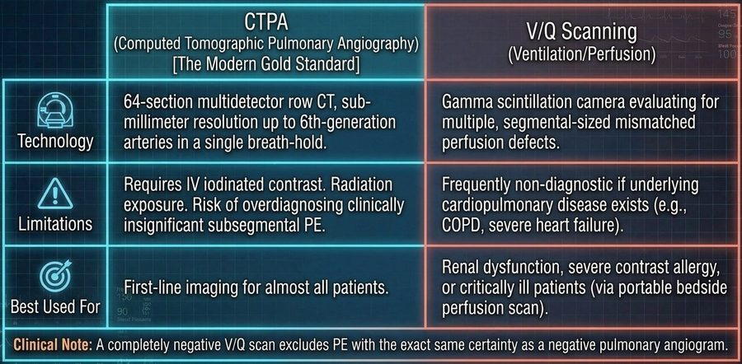
CT pulmonary angiography first for almost everyone; the ventilation/perfusion scan when contrast is the problem (renal dysfunction, severe contrast allergy) or the patient is too sick to move, but it is often nondiagnostic in chronic obstructive pulmonary disease or severe heart failure. The scanner figures in the technology row are not keyed. Slide 55
Echocardiography and right ventricular strain (slide 56). The hemodynamic cascade: (1) massive PE causes acute right ventricular pressure overload; (2) the septum bows into the left ventricle; (3) decreased left ventricular end-diastolic volume; (4) reduced left ventricular filling equals crashed cardiac output and circulatory collapse. ★ Diagnostic caveat: transthoracic echo (TTE) has poor sensitivity (~50%) for diagnosing acute PE, but extremely high specificity for right ventricular strain. It is a tool for risk stratification, not primary diagnosis (“It’s not for diagnosis, it’s for stratification”).
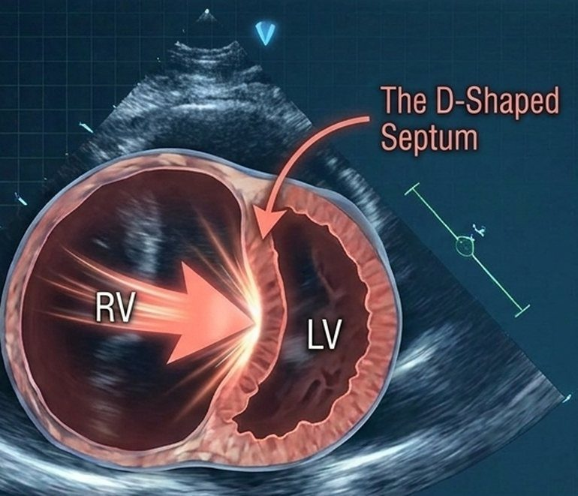
The D-shaped septum in massive embolism: the pressure-loaded right ventricle (RV) pushes the septum into the left ventricle (LV), which then fills poorly. Slide 56
The VTE diagnostic algorithm: decision points (slide 57)
Suspected PE → calculate the Wells score
PE unlikely (score ≤4) → PERC criteria | Pass: stop workup. Fail: obtain D-dimer → negative: rule out; positive: proceed to CTPA.
PE likely (score >4) | Bypass D-dimer: direct to CTPA (or V/Q if contrast contraindicated).
Positive CTPA / high-probability V/Q | Diagnosis confirmed → next step: assess hemodynamic stability / right ventricular strain (4.13).

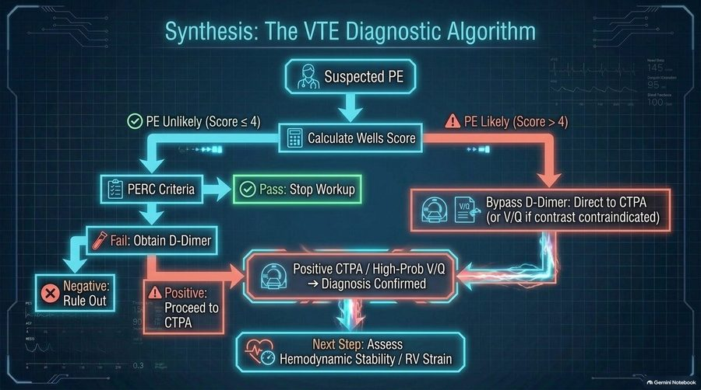
The algorithm the decision-point table above reads: Wells first; the unlikely branch goes through PERC and the D-dimer, the likely branch goes straight to imaging. He wants the decision points, not every box. Slide 57

4.13 · Pulmonary embolism: risk stratification and treatment
★ PROFESSOR EMPHASIS
★ “That’s what you’re gonna get on [the PANCE] … know the one in the middle” (slide 58)
Sizing up the threat: pulmonary embolism risk stratification (slide 58)
Category | Criteria | Implication
Low-risk | Normotensive, NO right ventricular dysfunction, negative cardiac biomarkers. | Excellent prognosis, standard anticoagulation.
Submassive / intermediate-risk | Normotensive (systolic BP >90) (blood pressure), BUT evidence of RV dysfunction (on echo/CTPA) or myocardial necrosis (elevated troponin/BNP) (right ventricular; CT pulmonary angiography; B-type natriuretic peptide). | At high risk for sudden deterioration.
Massive / high-risk | Sustained hypotension (systolic BP <90 for >15 mins), pulselessness, or profound bradycardia. Circulatory collapse. | High mortality. Requires immediate advanced intervention.

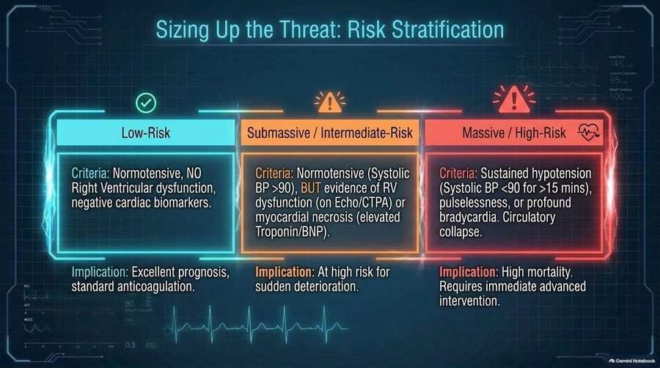
Three tiers: blood pressure decides massive; with a normal pressure, right ventricular strain or a raised troponin or natriuretic peptide makes it submassive (the one in the middle). Slide 58
The baseline defense: anticoagulation (slide 59)
Phase 1: acute management | Immediate initiation upon confirmed diagnosis (or high clinical suspicion while awaiting imaging).
Phase 2: the 3-month decision point — transient / provoked risk (recent surgery, trauma, hospitalization, estrogen therapy) | Consider stopping anticoagulation after 3 months.
Persistent / unprovoked risk (active malignancy, hypercoagulable states, no identifiable risk factor) | Indefinite anticoagulation favored to prevent recurrence.
Deep venous thrombosis and pulmonary embolism are managed with identical baseline pharmacological principles. The goal is to halt clot propagation and allow endogenous fibrinolysis to occur. (The slides name no anticoagulant drug.)

Advanced interventions: thrombolysis and thrombectomy (slide 60)
 | Systemic & catheter-directed thrombolysis | Mechanical thrombectomy & surgical embolectomy
Mechanism | Pharmacological clot dissolution | Physical extraction or maceration of the thrombus
Indication | The gold standard for massive PE (hemodynamically unstable) | Reserved for massive PE with absolute contraindications to thrombolytics (e.g., recent surgery, active bleeding) or a right heart “clot in transit”
Caveat | Highly controversial in submassive PE: weighs rapid right ventricular recovery against major bleeding and intracranial hemorrhage risk
Aggressive interventions scale directly with the risk of hemodynamic collapse, balancing the certainty of cardiopulmonary failure against the risk of catastrophic bleeding.

The long tail: chronic thromboembolic pulmonary hypertension (CTEPH) (slide 61; know the decision points):
- Screen for persistent or worsening dyspnea after 3 months of anticoagulation for PE. No dyspnea → determine the length of anticoagulation based on the risk for recurrent venous thromboembolism. Persistent dyspnea → obtain a V/Q scan (ventilation/perfusion). Normal perfusion → back to the length decision. Abnormal perfusion → obtain transthoracic echo, right heart catheterization and pulmonary angiogram, then refer to an expert center for evaluation of chronic thromboembolic disease (CTED or CTEPH); continue anticoagulation during the workup.
- Risk factors for CTEPH: unprovoked PE; delay in diagnosis >2 weeks; right ventricular dysfunction on the initial CT pulmonary angiogram; recurrent PE.
- ★ Treatment note: the optimal management for CTEPH is surgical (pulmonary thromboendarterectomy).
The VTE masterclass: clinical pathway summary (slide 62)
1. Suspect (the threat) | Recognize Virchow’s triad. Beware the 25% of patients without dyspnea. Watch for S1Q3T3 on EKG.
2. Calculate (the math) | Apply the Wells score. Score ≤4? Use PERC and D-dimer to rule out. Score >4? Proceed directly to imaging.
3. Locate (the hunt) | Use CTPA as the gold standard. Use V/Q for renal failure/allergy. Use echo to identify the D-shaped septum (right ventricular strain).
4. Stratify (the severity) | Categorize as massive (obstructive shock), submassive (right ventricular strain/biomarkers), or low-risk (stable).
5. Treat (the response) | Anticoagulate all. Thrombolyze or thrombectomize the unstable. Screen for CTEPH if dyspnea persists at 3 months.

Pulmonary embolism
Defining feature: sudden dyspnea (absent in about 25%), pleuritic pain with hemoptysis, or collapse in a patient with Virchow risk factors; Wells decides D-dimer or CT pulmonary angiography
DefinitionEmbolic occlusion of the pulmonary arteries, one continuum with deep venous thrombosis (venous thromboembolism), ranging from asymptomatic disease to hemodynamic collapse and death; massive embolism causes acute cor pulmonale.Who gets itPatients with Virchow’s triad drivers; an objective evaluation is still owed when no predisposition is found.Risk factorsHypercoagulability (malignancy, estrogen therapy, pregnancy, genetic thrombophilias, sepsis); venous stasis (prolonged immobilization such as flights over 8 hours, bed rest, paralysis, heart failure class III/IV); endothelial injury (recent surgery, central venous catheters, pacemaker wires, pelvic/lower limb trauma).Classic signs & symptomsThree syndromes: isolated dyspnea (sudden, minutes to hours, at rest or only with exertion); pleuritic pain and hemoptysis (distal pleural-based infarction); circulatory collapse (syncope, severe hypotension, obstructive shock = massive proximal occlusion). About 25% have no dyspnea.Physical exam findingsLocalized friction rub (infarction); in massive embolism, distended neck veins, tricuspid regurgitation murmur, tachycardia and pallor (acute cor pulmonale); hypotension or pulselessness.Diagnostics / testsWells first (≤4 unlikely, >4 likely). Unlikely: PERC (all eight true = stop), else a highly sensitive D-dimer (negative excludes; positive → CT pulmonary angiography); outpatient tools, D-dimer of limited use in inpatients. Likely: straight to CT pulmonary angiography (first-line for almost all), or a ventilation/perfusion scan for renal dysfunction, severe contrast allergy or the critically ill (a completely negative scan excludes embolism; often nondiagnostic in chronic obstructive pulmonary disease or severe heart failure). EKG: S1Q3T3 (right ventricular strain; highly specific, low sensitivity); chest film usually abnormal but nonspecific, classic Westermark, Hampton’s hump, Palla. Echo: risk stratification (D-shaped septum), not diagnosis.First-line treatmentAnticoagulate all, immediately on diagnosis or on high suspicion while awaiting imaging; provoked = consider stopping at 3 months, unprovoked or persistent risk = indefinite. Massive (unstable): thrombolysis (systemic or catheter-directed); if thrombolytics are absolutely contraindicated (recent surgery, active bleeding) or a right heart clot is in transit: mechanical thrombectomy or surgical embolectomy. Submassive: thrombolysis highly controversial.ComplicationsRight ventricular failure, septal shift and obstructive shock; death (massive: high mortality); pulmonary infarction; recurrence; chronic thromboembolic pulmonary hypertension (screen for dyspnea at 3 months; risk: unprovoked, diagnosis delayed >2 weeks, right ventricular dysfunction on the first CT, recurrent embolism; treated by pulmonary thromboendarterectomy at an expert center). Thrombolysis: major bleeding, intracranial hemorrhage.
Slides 8–10, 48–62

4.14 · Adults and older adults; referral and education
Precision care: adult vs elderly hemodynamic strategies in heart failure and pulmonary edema (slide 42)
 | Adult phenotype (HFrEF focus) (reduced ejection fraction) | Elderly phenotype (HFpEF focus) (preserved ejection fraction)
Pathology | Usually ischemia-driven loss of pump function | Age-related myocardial stiffening; the pressure-volume loop shifts upward (the slide’s text is cut off after “upward/l”), representing elevated end-diastolic pressure
Reserve | Higher physiological reserve | Extreme sensitivity to preload changes. Narrow therapeutic margin.
Strategy | Aggressive diuresis generally well-tolerated to clear volume | Requires gentle, precise diuresis. Over-diuresis causes precipitous hypotension; under-diuresis causes recurrent drowning.

Domain | Adults | Older adults
Recognition | Early pulmonary hypertension: exertional dyspnea and fatigue are often misattributed to deconditioning (slide 21); PERC applies only under age 50 (slide 54); estrogen therapy and pregnancy are clot risks (slide 49) | An older patient cannot pass PERC (age <50 is one of its items), so a low Wells score goes to the D-dimer (slides 54, 57); diastolic stiffening (preserved ejection fraction) drives edema (slides 34, 42)
Fluids | Aggressive diuresis tolerated in reduced ejection fraction (slide 42); in right ventricular failure, careful diuresis only (slides 16, 27) | Gentle, precise diuresis; over-diuresis = precipitous hypotension (slide 42)
Rehabilitation and education | Avoid strict bedrest; supervised steady aerobic rehabilitation; oxygen to keep PaO2 >60 mmHg, especially in sleep or exertion; annual influenza and pneumococcal vaccines (slide 27); anticoagulation length (provoked 3 months, unprovoked indefinite) and the 3-month dyspnea check (slides 59, 61) | The same
Palliative care and referral | Pulmonary hypertension: early palliative care discussions and advance directives (sudden death or lethal syncope may come first); lung transplantation for refractory disease (slide 29); thromboendarterectomy pathway after a high-probability mismatch (slide 24); expert center for chronic thromboembolic disease (slide 61) | Heart failure stage D: immediate evaluation for heart transplant, mechanical circulatory support (left ventricular assist device) or palliative hospice care (slide 44)

5 · Pulmonary Nodules and Neoplasms
Lecture 43 · Rob Gray, DMSc, PA-C, Adjunct Instructor (guest lecturer) · Wednesday 4 November 2026, 10 AM–12 PM
INSTRUCTIONAL OBJECTIVES
PULMONARY NODULES AND NEOPLASMS — Rob Gray, DMSc, PA-C
- Compare and contrast the etiologies, epidemiology, risk factors, clinical manifestations, differential diagnosis, diagnostic testing (including ordering and interpretation), management (acute and chronic, including applicable rehabilitative and palliative care), appropriate referrals, patient education, and prognosis of the following pulmonary neoplasms: 2. Pulmonary nodule 3. Lung cancer (bronchogenic carcinoma) a. Non-small-cell lung cancer (NSCLC) b. Small-cell lung cancer (SCLC) c. Lung neuroendocrine (carcinoid) tumors 4. Paraneoplastic Neoplasm Associated Syndromes a. SIADH b. Hypercalcemia
- Discuss relationship between small cell lung cancer and paraneoplastic syndromes.
- Identify medical care strategies for pulmonary nodules and neoplasms in the lecture topic list for the following populations. 7. adult 8. elderly
Quoted as the syllabus prints it, its own numbering kept (it numbers the whole list 1–8: the neoplasms 2–4, the small cell link 5, the populations 6–8; SIADH is the syndrome of inappropriate antidiuretic hormone). Answered in order: 1 across 5.1–5.16 (pulmonary nodule 5.1–5.4; lung cancer 5.5–5.15, with non-small cell 5.10–5.13, small cell 5.14 and carcinoid tumors 5.15; the paraneoplastic syndromes, SIADH and hypercalcemia, 5.16); 2 in 5.17; 3 in 5.18.

NOTE
What Dr. Gray stressed, and what he said is and is not tested (the Zoom recording of the live lecture, Wednesday 4 November 2026: he taught remotely for about 55 minutes and showed every slide; quotes checked in Zoom’s transcript and in ours; every fact below still comes from the slides).
- His exam list is slide 49, “Things to Know” (the starred box below): screening criteria, a benign nodule, a worrying nodule, staging and how it changes treatment, central versus peripheral cancers, recognizing squamous cell and small cell, the cancer that benefits most from radiotherapy, and the paraneoplastic signs. On the staging line: “Do you need to know every circumstance? No. Like, big picture, guys.”
- Board pointer, said three times: “Small and squamous are central … Adenocarcinoma, large cell, usually periphery … So now that I know those two, I know where the other two are.”
- “Magic number is 6.” “Greater than 6 millimeters, I’m suspicious … Especially if I’m located in the upper lobes, hilar structures. Especially if I’ve got a spiculated appearance … Spiculated is spiky.” At the recap: “you don’t usually see a lot of benign stuff that’s described as spiculated.”
- Test-question pointer, large cell: it “tends to met to the gut. Small intestine, bowel … that’s specific to large cell, so I would say stuff that, like, is unique to a thing makes a great test question.”
- Squamous cell: “Cavitation is big with that one. Strongest association with smoking. Central location originates in the bronchus … Cough, wheezing, hemoptysis are huge”; it can look like a chronic obstructive pulmonary disease (COPD) patient “constantly in exacerbation”; “you might be able to catch [it] with sputum testing”; “your squamous cell will make your calcium, a big deal.”
- Small cell and radiation: “does better with chemo and radiation than the other types. If the cancer’s pretty limited, you can radiate it really effectively”; prophylactic cranial irradiation: “We’re literally gonna radiate the brain just in case there’s metastasis.”
- Paraneoplastic syndromes, set up early (the neuroendocrine cells lining the bronchioles: “I’m calling the shot now, that’s where it comes from”) and repeated: with small cell, the syndrome of inappropriate antidiuretic hormone “that’s real … that patient may show up in the [emergency department] because of the confusion and seizures, and you work it up, and you’re like, oh, that’s lung cancer.”
- Not to memorize: the Fleischner tables (reports “literally will publish the Fleischner table … I don’t want you freaking out and being like, oh god, I have to memorize this table. I mean, you can!”; he then read the solid-nodule rows aloud); the probability-of-malignancy tables (“Don’t lose sleep over that, just know you’re gonna work it up”); the staging charts in detail (“I bring this up not to, like, make you memorize the charts”); lymph node station numbers (“nobody’s expecting you to, like, number these”); the genes (“don’t go crazy about details on this”); drug-by-marker choices (“I do not expect you to know absolutely specific drugs … Your job as a primary care PA … is be able to screen and figure out risk for that patient, and then refer”); the small cell follow-up schedule (“don’t memorize that”).
- Time on topic (minutes of teaching): epidemiology, risk factors and spread 7.5; incidental nodules and presenting symptoms 7.1; staging 5.25; workup and biopsy 4.25; benign versus concerning nodules 4.25; screening and follow-up 3.25; small cell and radiotherapy 3.0; paraneoplastic syndromes 2.5; squamous cell 2.2; adenocarcinoma 2.0; large cell 1.75; non-small cell treatment 1.5; central versus peripheral 1.0; and 2.5 on the slide 49 recap. The practice sets follow these shares.

★ PROFESSOR EMPHASIS
★ “Things to Know”: his own exam list (slide 49)
He walked this list at the end of class: “So stuff I would consider when I’m looking back over this lecture.” Each bullet is quoted from the slide, with his words under it; the middle column is the answer from the slides.
Slide 49 (verbatim) and his recap | The answer, from the slides | See
the criteria for screening an asymptomatic and at-risk patient for lung cancer  “Criteria for screening, like, who am I worried about, who am I not worried about, who am I less worried about?” | No symptoms and no known nodule; age 55–80; at least a 30 pack-year history; smokes now or quit within the last 15 years → low-dose chest computed tomography (CT) every year (slide 18). | 5.3
a benign nodule’s appearance  “Things that would make me feel better about a [benign] nodule are a reasonable thing to kind of walk out of here with.” | Well-defined (smooth) borders; fat (hamartoma); calcification that is diffuse, central, popcorn (hamartoma) or concentric; next to a fissure; smaller than 6 mm in a patient who is not high risk (slides 12, 16, 21). | 5.2
what makes you concerned for a malignant nodule  “What word would I see in an x-ray report or a CT report and be like, ugh, you just ruined my day? … Spiculated.” | Greater than 6 mm; upper lobes or hilar; spiculated (spikes, deviations or lobulations in the border); more than 3 nodules; enlarging; contrast-enhancing on CT; cavitated or nonsolid; a high-risk patient; ground-glass or eccentric calcification; uptake on positron emission tomography (slides 16, 17). | 5.2
your lung cancer staging based on sizes, lymph involvement and metastasis (TNM) · Also know how this will affect treatment (surgery plus chemo vs chemo only, for example)  “Again, do we do surgery? Do we do chemo? Is it just better for chemo? Do you need to know every circumstance? No. Like, big picture, guys.” | Tumor size and invasion, nodes (N2 or N3 makes it stage 3), metastasis (the other lung, the pleura or pericardium, or outside the chest = stage 4). Non-small cell: stages 1–2 surgical resection; stage 4 chemotherapy (surgery only for a single metastasis with a resectable primary); chemotherapy and radiation are adjuncts because non-small cell cancers respond poorly to them (slides 22–29, 35). | 5.8, 5.13
which lung cancers present in periphery or central locations  “Which lung cancers are peripheral? Which ones are central? See, you already know the answer to that.” | Central: small cell and squamous cell. Peripheral: adenocarcinoma and large cell (slide 30). | 5.9
how to recognize squamous cell carcinoma from the other NSCLC (non-small cell lung cancer)  “How to recognize squamous cell from the others” | Strongest link to smoking; central, arising in a bronchus; silent until it obstructs, then cough, wheezing, hemoptysis; frequent cavitation; atelectasis and pneumonia; the one sputum cytology can catch; hypercalcemia (slides 30, 39, 40, 46). | 5.12
how to recognize small cell lung carcinoma (SCLC)  “how to recognize small cell from the others, you can usually differentiate that” | Small cell (oat cell): central, infiltrates the mucosa; over 70% metastatic (liver, bone, brain) before detection; neuroendocrine paraneoplastic syndromes such as SIADH (syndrome of inappropriate antidiuretic hormone); small cells with no nucleoli and a high nuclear-to-cytoplasm ratio, crushed at biopsy (slides 41, 42, 48). | 5.14
which cancer receives the most benefit from radiotherapy  “Which cancer benefits most from radiotherapy?” | Small cell: it responds better to chemotherapy and radiation than the three non-small cell types; radiation works best in limited stage; prophylactic cranial irradiation (slides 41, 43). | 5.14
the signs and symptoms of a paraneoplastic associated symptoms in a patient lung carcinoma (i.e. small cell)  “the weirdness that goes, like, oh, if I got that patient … maybe I accidentally find lung cancer. That’s what happens with your paraneoplastic stuff.” | SIADH (small cell): hyponatremia and low serum osmolality → confusion, seizures, ataxia, no edema. Hypercalcemia (squamous). Lambert-Eaton myasthenic syndrome (progressive leg weakness); cerebellar degeneration or encephalitis; acanthosis nigricans, dermatomyositis; carcinoid syndrome from a bronchial carcinoid (slides 4, 46–48). | 5.16, 5.17

NOTE
Where the slides are loose or disagree
He corrected no slide out loud, so the slides are what is tested. Points the slides state two ways are not asked either way.
- Adenocarcinoma’s share. Slide 4 says 35–40%, slide 31 says 30–40%. Both make it the most common lung cancer; learn that, not a number.
- Treatment by stage (slide 35). The text says “Surgical resection (I–IIIB)” and “Chemo and radiation are only an adjunct to surgery or if the patient is stage IV”; the slide’s own table gives stage 3A “Chemoradiotherapy, surgical resection in selected patients” and 3B “Chemoradiotherapy.” They agree on stages 1–2 (surgical resection) and stage 4 (chemotherapy); stage 3 is left open. He read the text.
- Squamous cell and immunotherapy. Slides 37–38 are titled “NSCLC (excluding squamous cell)” (NSCLC: non-small cell lung cancer); slide 40 lists immunotherapy in squamous management “(as it is a NSCLC).” Gene-marker (targeted) therapy is for the non-squamous types (“Squamous is its own thing”).
- Neurologic paraneoplastic labels. Slide 46 tags Lambert-Eaton myasthenic syndrome “central” and cerebellar degeneration or encephalitis “peripheral”; slide 47 puts Lambert-Eaton at the nerve endings, at the neuromuscular junction, so the tags read reversed. Learn the slide 47 mechanism, not the tags.
- The pleura. Slide 16: “Close to a fissure or the pleura indicates something usually benign”; slide 32’s peripheral spiculated nodule “involved the pleura” and proved an invasive adenocarcinoma, which “may invade the pleura.” Next to a fissure is the reassuring sign (slide 21); pleural contact is not.
- Where tumors form. Slide 9 says most masses “form a mass in or near the hilum, but some form in the periphery”; slide 30 puts adenocarcinoma (the most common type) and large cell carcinoma in the periphery, and small cell and squamous cell centrally. Both are stated as the slides give them; no question keys “most lung cancers are central” or “most are peripheral.”
- Cavitation is a concerning feature (slide 16) and appears with large cell (slides 33–34), squamous cell (slide 39) and small cell once large (slide 41): it does not point to one cell type.
- Small cell and immunotherapy. Slide 41: “less effective on small cell … but is becoming an option”; slide 43: “Two adjunct immunotherapies are also approved for SCLC” (small cell lung cancer). Consistent: an added option, not the mainstay.
- “Metastatic (T4M1 or 2)” on slide 31: slide 22’s table has no M2 (M1a, M1b, M1c).
- “Near the lung without the primary tumor” (stage 3B and 3C pictures, slides 27–28) means the contralateral side, the other lung’s mediastinal or hilar nodes, as slide 25 (“mediastinal or contralateral lymph involvement”) and slide 22’s N3 (“Contralateral mediastinal or hilar”) put it. Same-side mediastinal nodes are N2.
- Slide 13 lists adrenal insufficiency under the heading “Kidneys.” Slide 20 repeats slide 19’s title (“Solid Nodules”) over the subsolid table (table B).
- Typing slips: “SLLC” for small cell (objectives slide); “Hight” (slide 11 algorithm); “Alkaline phosphatate” (slide 14); “Ciplatin” for cisplatin (slide 35); “National Comprehensive Network” for the National Comprehensive Cancer Network (slide 43).
- He said it differently (slides kept): “T4 is huge, 7 centimeters” (slide 22: more than 7 cm), and he skipped N2; stage 2 “or … cancer’s really small, but it’s in the peribronchial nodes” (slide 24: no more than 5 cm); metastases go to “liver, lungs, bone, and brain, LLBB,” the lung there being the organ that catches other cancers (slides 9 and 41 give lung cancer’s own spread as liver, brain and bone); squamous cell is “generally central, but it doesn’t have to be” (slide 39: central, often from a bronchus); atrial fibrillation after chest radiation (not on slide 45); alkaline phosphatase as a liver or bone marker (slide 14 only lists it in the lab workup).
- Current guidelines differ: the 2021 US Preventive Services Task Force update screens adults 50–80 with at least a 20 pack-year history (still smoking or quit within 15 years), and Medicare now covers 50–77; slide 18 gives 55–80, 30 pack-years and Medicare 55–77. The practice questions use patients who qualify, or fail, under both versions.
- Current guidelines differ: slide 3 ranks lung cancer second to breast cancer for cancer deaths in women; current US data rank it first in women as well.
- Other references differ: slide 39 gives squamous cell carcinoma the strongest association with smoking; many references rank small cell carcinoma as the most strongly smoking-linked type. The questions key the slide.
- Current guidelines differ: the staging slides (22–29) are the 8th edition; the 9th edition (2024) splits N2 and M1c.
- Current guidelines differ: current classification has shrunk large cell carcinoma (slide 33): tumors with adenocarcinoma or squamous markers are reclassified as those types.

5.1 · Pulmonary nodule: found by chance, or worked up for symptoms
- Found incidentally (slide 12): lung nodules turn up when a patient has a chest X-ray or chest computed tomography (CT) for another reason. The first evaluation is size: generally anything smaller than 6 mm is not concerning unless the patient is at high risk. Solitary nodules seen on a chest X-ray are sometimes called coin lesions.
- Most nodules are benign: the main examples are a granuloma (inflammatory) or a hamartoma (connective tissue growth). But if the patient is at high risk for lung cancer, the nodule is screened and worked up to exclude malignancy (slide 12). He put the size rule plainly: “Anything smaller than 6, I’m not worried about it unless … I smoked 2 packs a day for the last 40 years.”
- Symptomatic patients are different (slide 12): those who present with symptoms are worked up for possible lung cancer: persistent cough, hemoptysis, dysphagia, wheezing or shortness of breath, and systemic symptoms (weight loss, fever or fatigue, pain in bone or chest, endocrine disorders).
- Why lung cancer is so deadly (slide 12): patients do not present with symptoms until the disease is advanced or already metastatic. ★ “By the time you get symptoms, we’re way late in the game … Especially … if somebody has COPD [chronic obstructive pulmonary disease] … you might miss it, because they’re like, I don’t know, man, it’s an exacerbation.”
- The workup of a new solid nodule 8–30 mm (slide 11) begins by assessing the clinical probability of malignancy, by clinical judgment and/or a validated model; the branch decides the next step. He: the probability tables are “Don’t lose sleep over that, just know you’re gonna work it up.”
Lung nodule evaluation: a new, solid pulmonary nodule 8 to 30 mm in diameter (slide 11)
Clinical probability of malignancy* | Next step | Then
Very low (< 5%) | CT surveillance at 3 to 6, 9 to 12, 18 to 24 months (low-dose, thin sections, noncontrast CT)
Low/moderate (5% to 65%) | Fludeoxyglucose positron emission tomography (FDG-PET) to assess the nodule | Negative or mild uptake → CT surveillance at 3 to 6, 9 to 12, 18 to 24 months  Moderate or intense uptake† → nonsurgical biopsy (transthoracic needle biopsy, endoscopic biopsy) or video-assisted thoracoscopic surgery with resection
High† (> 65%) | Standard stage evaluation (with or without FDG-PET) | No metastases identified → video-assisted thoracoscopic surgery with resection
* Clinical probability of malignancy: qualitatively by clinical judgment and/or quantitatively using a validated model, such as the one developed by Mayo Clinic (eTable A). † Referral to a subspecialist such as a pulmonologist, thoracic surgeon, interventional radiologist, or oncologist is recommended.

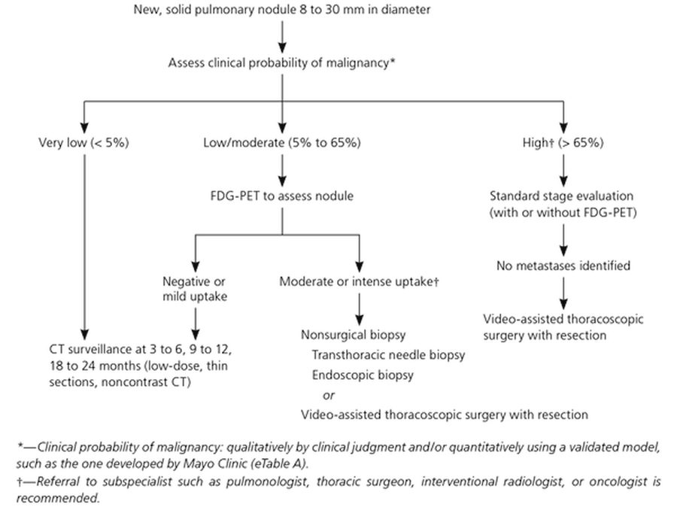
The slide’s algorithm for the table above: three probability branches; the dagger marks the two branches where referral to a subspecialist is recommended. Slide 11

5.2 · Benign versus concerning nodules
★ PROFESSOR EMPHASIS
★ “Magic number is 6 … Spiculated is spiky” (slide 16)
Concerning nodules are (slide 16) | Benign nodules tend to (slides 12, 16, 21)
Greater than 6 mm  Located in the upper lobes or hilar structures  Abnormal spiculated appearance (spikes or deviations or lobulations in the border)  More than 3 nodules are seen  Enlarging in size over time  Contrast enhanced on the computed tomography (CT) (high differentiation seen on the image)  Appear cavitated or nonsolid  Exist in patients at high risk of lung cancer | Have well-defined borders  Have fatty tissue (hamartoma)  Have calcifications (popcorn-looking = hamartoma; central calcification = healed granuloma)  Sit close to a fissure (“usually benign”; the slide adds “or the pleura”, see the box above)  Be smaller than 6 mm in a patient who is not high risk  Be granulomas (inflammatory) or hamartomas (connective tissue growth): most nodules are benign

His words: “Greater than 6 millimeters, I’m suspicious, you now have my attention … Especially if I’m located in the upper lobes, hilar structures. Especially if I’ve got a spiculated appearance. You’re gonna see this word a lot.” Risk matters too: “if I find a nodule in one of you guys in the classroom, I’m probably not super-duper worried about it” (genetics and smoking history raise the stakes). Spiculated is “our fancy, like, $5 word for spiky”; “I don’t like anything that looks like an angry star in my chest.”

Well-defined borders, a benign sign. Benign nodules tend to have well-defined borders, and they may contain fatty tissue or popcorn-looking calcification, both pointing to a hamartoma. On computed tomography the benign examples are smoothly marginated solid nodules.
Calcification pattern (slide 16 drawing) | Benign or malignant | What the drawing shows
Diffuse | Benign | The whole nodule is white (calcified)
Central | Benign | A white core in the middle
Popcorn | Benign (hamartoma, slide 16 text) | Clustered rounded white blobs
Concentric | Benign | Rings of calcium
Ground-glass | Malignant | Fine specks scattered through the nodule (stippled)
Eccentric | Malignant | One off-center white fleck


Calcification patterns: diffuse, central, popcorn and concentric are benign ; ground-glass (stippled) and eccentric are malignant . Slide 16
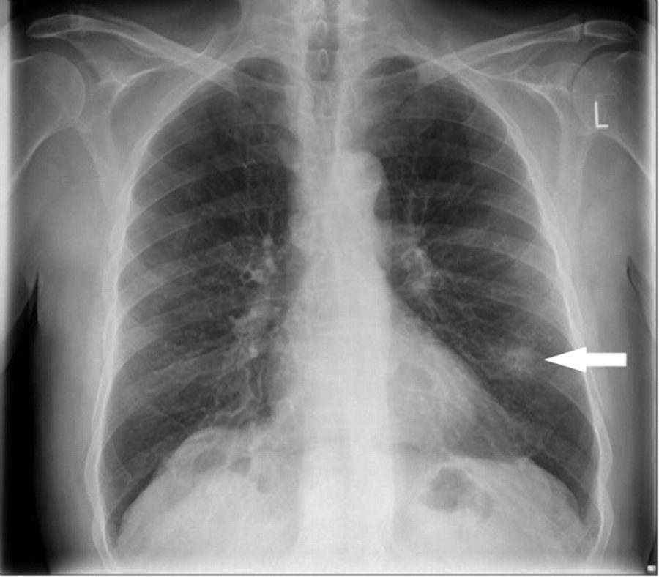
“Incidental nodule seen on CXR [chest X-ray] that will need further workup (> 6 mm)”, the slide’s own label: the white arrow marks the nodule in the left lung. Slide 16
Benign findings on CT (slide 21): each caption is the slide’s own
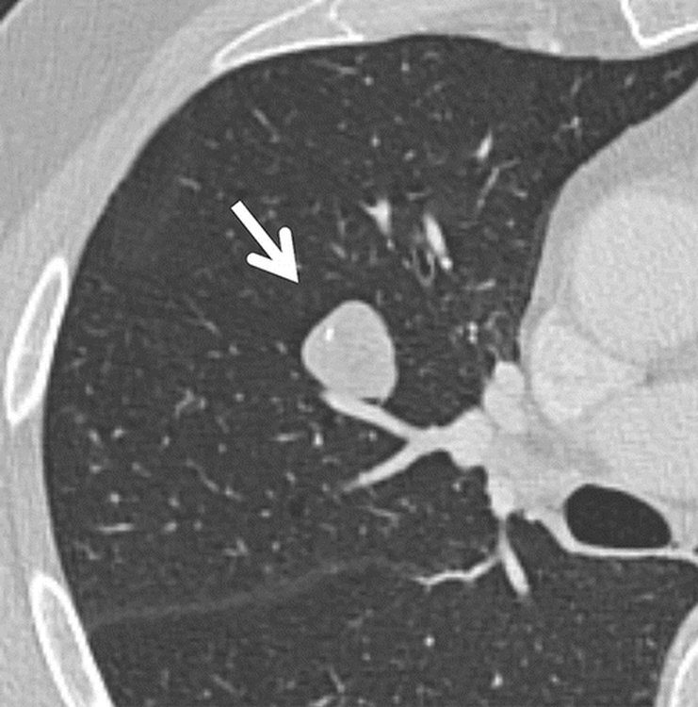  Hamartoma  Smoothly marginated solid nodule with internal fat and calcification, consistent with a hamartoma  Slide 21 | 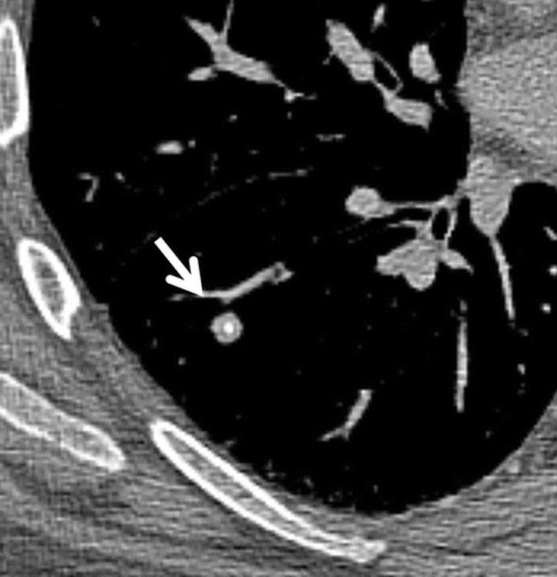  Healed granuloma  Smoothly marginated solid nodule with central calcification, typical of a healed granuloma  Slide 21 | 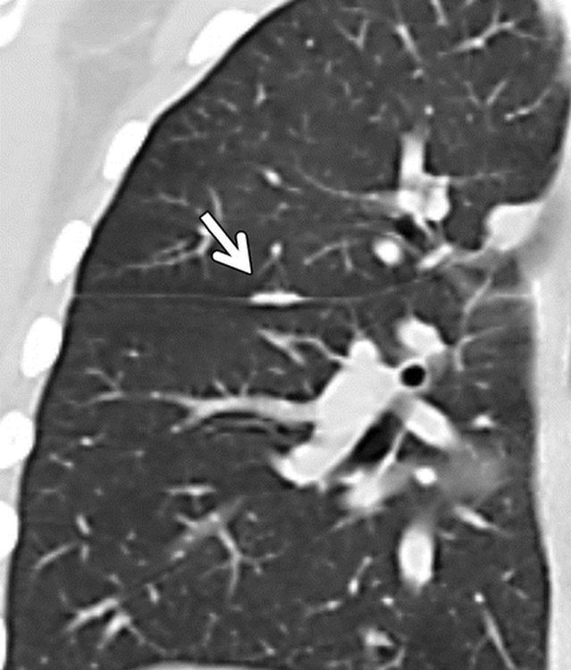  Next to the minor fissure  Nodular opacity adjacent to the minor fissure, typical of a linear scar or lymphoid tissue  Slide 21

- Positron emission tomography (PET) uptake also raises concern: highly metabolic cells take up the radioactive sugar, while low or normal uptake is a good sign (slide 17; see 5.4).

5.3 · Screening and nodule follow-up
★ PROFESSOR EMPHASIS
★ Screening criteria: bold on the slide, “30 pack-year” underlined in class (slide 18)
Lung cancer screening, US Preventive Services Task Force recommendation as slide 18 gives it
Who | Certain high-risk individuals without symptoms or finding of a nodule (found beneficial through the National Lung Cancer Screening Trial)
Age | Adults between the ages of 55 and 80
Smoking history | At least a 30 pack-year smoking history
Smoking status | Currently smoke, or have quit within the last 15 years
Test | Screened annually with a low-dose chest computed tomography (CT): a lower dose of radiation than a standard chest CT (to reduce radiation exposure), which works because lung tissue has high contrast resolution between air and lung nodules
Coverage | Medicare only covers 55 to age 77
Upside | Early detection, which can lead to rapid intervention, improving prognosis
Downside | A high incidence of false positives that prove benign, and patients receive an unnecessary workup that could have complications (such as a biopsy)

His reading: “Adults between 55 and 80, so a little older. Who have at least a 30-pack year smoking history, who currently smoke. Or, if they quit in the last 15 years. We’re gonna screen them every year with a low-dose chest CT. Again, lower dose than a standard chest.” Screening is for people without symptoms; a patient with symptoms (5.1) gets a diagnostic workup instead. Current guidelines differ: the 2021 update uses 50–80 and 20 pack-years (box at the top of this section); learn the slide’s numbers.

- Follow-up of incidental nodules (slide 18): the Fleischner Society has maintained guidelines (last updated 2017) for the follow-up and imaging tracking of lung nodules. ★ He said not to memorize the tables: “most of the places that produce chest CT reports, they literally will publish the Fleischner table in those reports … So don’t be like, I need to know all my Fleischner rules.” He read the solid-nodule rows aloud (and underlined the multiple, high-risk, 6–8 mm cell); of the subsolid table he said only “there’s rules, you’re fine.”
Fleischner Society (2017), A: Solid nodules* (slide 19)
Nodule type | <6 mm (<100 mm³) | 6–8 mm (100–250 mm³) | >8 mm (>250 mm³) | Comments
Single, low risk† | No routine follow-up | CT at 6–12 months, then consider CT at 18–24 months | Consider CT at 3 months, PET/CT (positron emission tomography with CT), or tissue sampling | Nodules <6 mm do not require routine follow-up in low-risk patients (recommendation 1A).
Single, high risk† | Optional CT at 12 months | CT at 6–12 months, then CT at 18–24 months | Consider CT at 3 months, PET/CT, or tissue sampling | Certain patients at high risk with suspicious nodule morphology, upper lobe location, or both may warrant 12-month follow-up (recommendation 1A).
Multiple, low risk† | No routine follow-up | CT at 3–6 months, then consider CT at 18–24 months | CT at 3–6 months, then consider CT at 18–24 months | Use most suspicious nodule as guide to management. Follow-up intervals may vary according to size and risk (recommendation 2A).
Multiple, high risk† | Optional CT at 12 months | CT at 3–6 months, then at 18–24 months (underlined in class) | CT at 3–6 months, then at 18–24 months | Use most suspicious nodule as guide to management. Follow-up intervals may vary according to size and risk (recommendation 2A).
† Consider all relevant risk factors (see Risk Factors). * Dimensions are average of long and short axes, rounded to the nearest millimeter (slide 20 footnote).

Fleischner Society (2017), B: Subsolid nodules* (slide 20)
Nodule type | <6 mm (<100 mm³) | ≥6 mm (>100 mm³) | Comments
Single, ground glass | No routine follow-up | CT at 6–12 months to confirm persistence, then CT every 2 years until 5 years | In certain suspicious nodules < 6 mm, consider follow-up at 2 and 4 years. If solid component(s) or growth develops, consider resection. (Recommendations 3A and 4A).
Single, part solid | No routine follow-up | CT at 3–6 months to confirm persistence. If unchanged and solid component remains <6 mm, annual CT should be performed for 5 years. | In practice, part-solid nodules cannot be defined as such until ≥6 mm, and nodules <6 mm do not usually require follow-up. Persistent part-solid nodules with solid components ≥6 mm should be considered highly suspicious (recommendations 4A–4C).
Multiple | CT at 3–6 months. If stable, consider CT at 2 and 4 years. | CT at 3–6 months. Subsequent management based on the most suspicious nodule(s). | Multiple <6 mm pure ground-glass nodules are usually benign, but consider follow-up in selected patients at high risk at 2 and 4 years (recommendation 5A).

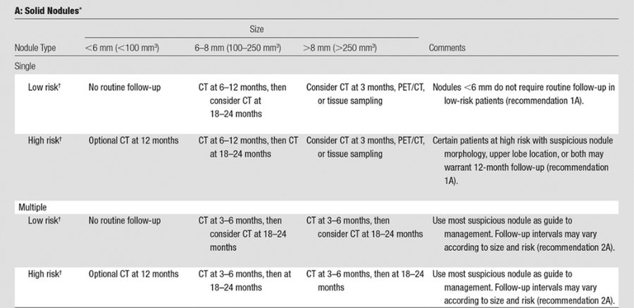
Fleischner table A, solid nodules, as the slide shows it (transcribed above). Slide 19
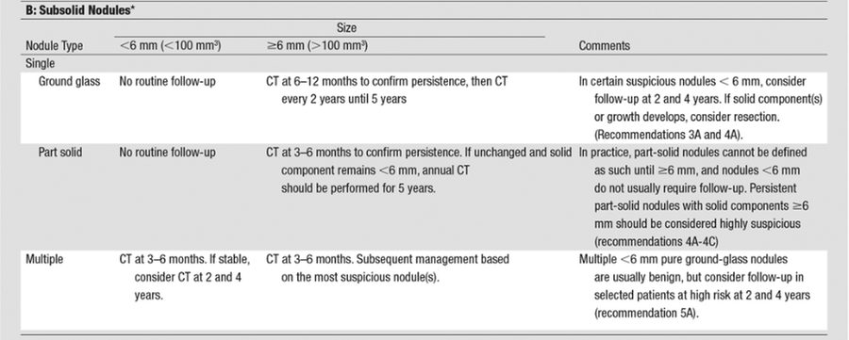
Fleischner table B, subsolid nodules (ground glass, part solid, multiple), as the slide shows it under a repeat of slide 19’s “Solid Nodules” title (transcribed above). Slide 20

5.4 · Workup of a suspicious nodule or symptoms; positron emission tomography; biopsy
- Chest X-ray is not a good tool here (slide 14): it might be the first thing to see a nodule, but otherwise it is used as a screening tool for ruling out other pathology.
- The standards (slide 14): computed tomography (CT) scan with contrast of the chest and upper abdomen, followed by biopsy or interventional treatment. Biopsy is by bronchoscopy, transthoracic, or thoracoscopy depending on the location of the nodule; it can be CT guided and involve excision. Also a positron emission tomography (PET) scan and genetic testing.
- Additional considerations (slide 14): lab workup: complete blood count (CBC) with differential; comprehensive metabolic panel (CMP) including calcium; alkaline phosphatase (ALP); pulmonary function tests (PFTs); sputum cytology, not sensitive though. He: “usually we don’t do sputum testing,” with one exception, squamous cell carcinoma (5.12).
- How PET works (slide 17): a radioactive sugar (fludeoxyglucose, FDG); highly metabolic cells take up the sugar, suggesting the nodule may be malignant. Low or normal uptake with the nodule is a good sign. It does not rule out inflammatory conditions, as they may also have high uptake. Memory aid (his): tumor tissue is a “hungry, hungry hippo” for sugar, and “This thing shouldn’t be glowing compared to the stuff around it.” So a nodule that lights up still needs tissue: inflammation can glow too.
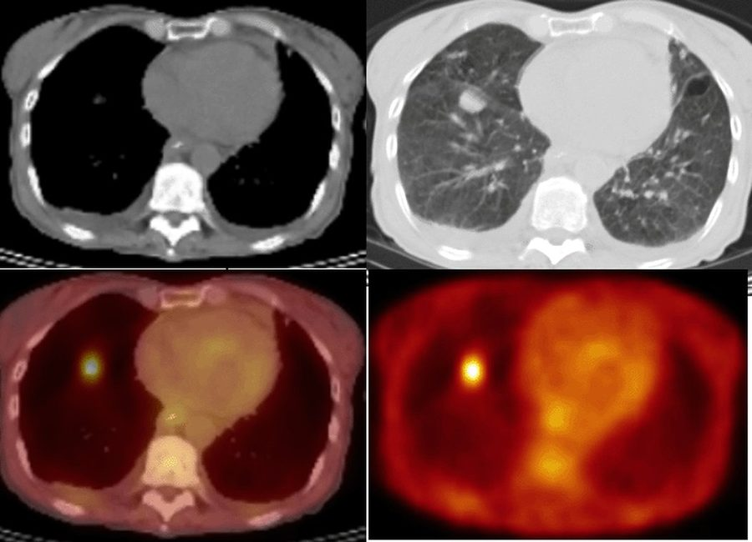
The nodule on the CT (top) is the bright spot on the PET-CT and PET images (bottom): high uptake of the radioactive sugar suggests the nodule may be malignant , though inflammation can take it up too. Slide 17
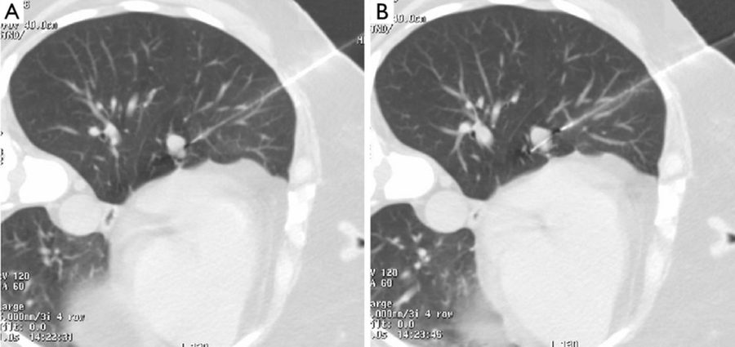
CT pictures A and B sit beside “Can be CT guided”; the slide gives them no caption: a needle passes through the chest wall toward a small nodule (A) and into it (B). Slide 14
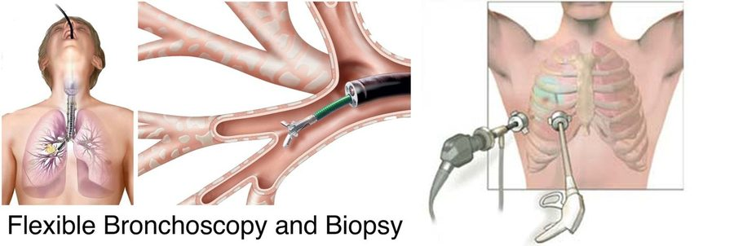
“Flexible Bronchoscopy and Biopsy” (the slide’s label): forceps passed through the scope take tissue from inside the airway. The unlabeled drawing on the right shows instruments passed through the chest wall. Slide 14
Lung cancer biopsy / investigation with intervention (slide 15): excision or non-surgical treatment considered → PET-CT scan for staging (if not already performed) → fit for surgery?
Fit for surgery? | Path | End point
Yes → choose between | Wedge resection with on-table frozen section | Proceed to completion lobectomy during the same anesthetic
Directly (no biopsy first) | Anatomical segmentectomy if unfit for lobectomy
Image-guided lung biopsy → malignancy confirmed? Yes | Lobectomy, or anatomical segmentectomy if unfit for lobectomy
Image-guided lung biopsy → malignancy confirmed? No | Consider repeat biopsy or proceeding to excision/non-surgical treatment if concern about a false-negative biopsy
No → image-guided lung biopsy possible and safe? | Yes: image-guided lung biopsy → malignancy confirmed? Yes | SABR (stereotactic ablative radiotherapy), RFA (radiofrequency ablation) or conventional radical radiotherapy
Yes: image-guided lung biopsy → malignancy confirmed? No | Consider repeat biopsy or proceeding to excision/non-surgical treatment if concern about a false-negative biopsy
No (biopsy not possible or not safe) | Straight to SABR, RFA or conventional radical radiotherapy

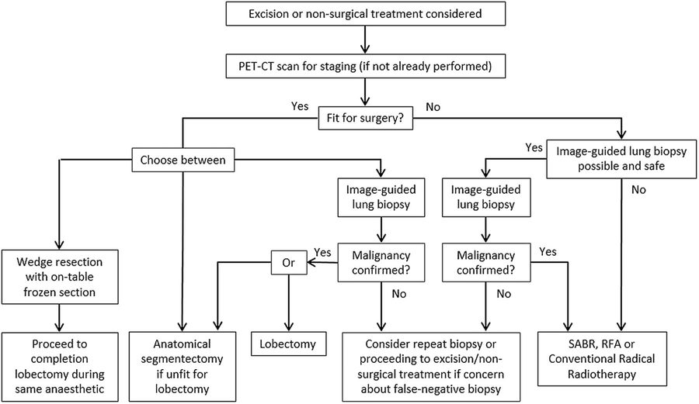
The slide’s algorithm for the table above. The split that matters is fit for surgery : fit patients go to resection (lobectomy, or a smaller anatomical segmentectomy if unfit for lobectomy); unfit patients go to radiotherapy or ablation , with a biopsy first only if it is possible and safe. Slide 15

Pulmonary nodule
Defining feature: a nodule seen by chance on a chest X-ray or CT; size comes first, and over 6 mm, upper lobe or hilar, spiculated, growing, or in a high-risk patient means work it up
DefinitionA nodule seen on a chest X-ray or CT; a solitary nodule on a chest X-ray is a “coin lesion.” Most are benign (granuloma, inflammatory; hamartoma, connective tissue growth); some are the start of cancer.Who gets itFound incidentally when a chest X-ray or chest CT is done for another reason.Risk factorsFor malignancy: a patient at high risk of lung cancer (smoking above all, 5.5); size over 6 mm; upper lobe or hilar location.Classic signs & symptomsUsually none (an incidental finding). Persistent cough, hemoptysis, weight loss and the other symptoms of 5.1 call for a lung cancer workup instead.Physical exam findingsNot covered on the slides.Diagnostics / testsEstimate size; CT with contrast of the chest and upper abdomen; PET (low or normal uptake is a good sign); biopsy by bronchoscopy, transthoracic needle or thoracoscopy; the probability-of-malignancy algorithm for a new solid nodule 8–30 mm; the Fleischner tables for follow-up.First-line treatmentBy probability: very low → CT surveillance at 3–6, 9–12 and 18–24 months; low/moderate → PET, then surveillance or biopsy/resection; high → staging, then video-assisted thoracoscopic surgery with resection. Refer for high probability or moderate/intense uptake.ComplicationsA cancer found late (symptoms come only when advanced); screening false positives leading to an unnecessary workup with complications such as a biopsy.
Slides 11, 12, 14, 16–21

5.5 · Lung cancer: epidemiology and risk factors
- Deaths (slide 3): responsible for more than 30% of cancer deaths in males (highest mortality of all cancers in men) and more than 25% of cancer deaths in females (second highest mortality in women, after breast cancer; see the guidelines note above).
- Prognosis (slide 3): one of the lowest five-year survivals: 17–18% of patients in the US survive five years after diagnosis (and it is even worse in the rest of the world).
- Smoking (slide 3): implicated in 85 to 90% of cases (second-hand smoke: 20%). The packs per day and years of smoking compound the risk (5x to 10x to 20x, and so on). Smoking is not always involved: adenocarcinoma occurs without it (slide 31), and squamous cell has the strongest link (slide 39).
- Other risk factors (slide 3): exposure to radiation (and radon), air pollution, environmental and chemical toxins, tuberculosis or human immunodeficiency virus (HIV) infection, genetics, diet, and alcohol intake.
- Numbers (slide 3): more than 200,000 new cases yearly in the US and 2 million worldwide. Most occur in people older than 50 (about 4% under 40). ★ “You can’t take it off entirely from your differentials.”

5.6 · The cell types, where they start, and how they spread
- Two main types of lung carcinoma (malignancies that result from epithelial cells, slide 4): small cell lung carcinoma (SCLC, or oat cell; 15–20% of lung cancers) and non-small cell lung carcinoma (NSCLC), subdivided by histology into adenocarcinoma (35–40% on this slide), squamous cell (20–30%) and large cell carcinoma (9 to 10%).
- Mixed and rare types (slide 4): carcinoid tumors, bronchial gland carcinoma, sarcomatoid carcinoma, Pancoast tumors. Otherwise the deck looks at pulmonary nodules in general: benign versus the start of cancer.
- Paraneoplastic syndromes (slide 4): a consequence of a growing tumor, typically the small cell type, is the paraneoplastic neoplasm associated syndromes (5.16–5.17).
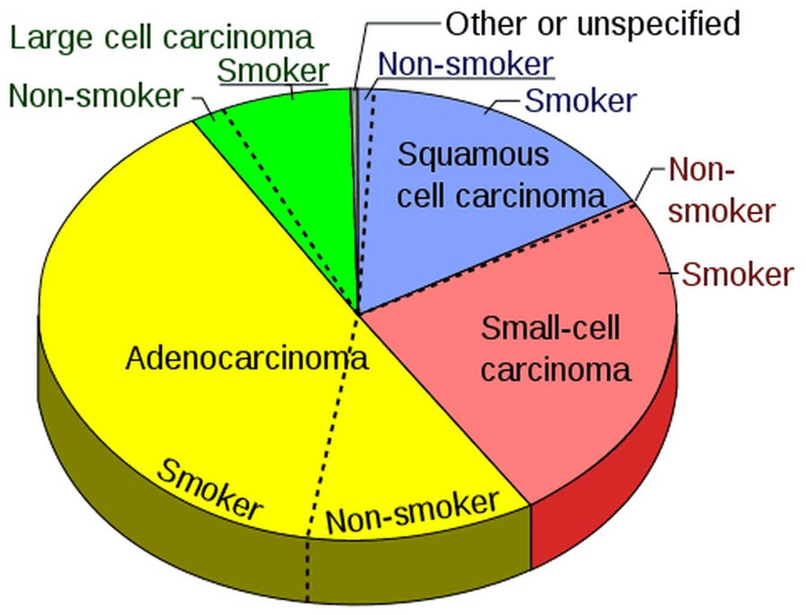
Lung cancer by cell type, each slice split into smokers and non-smokers ; adenocarcinoma is the largest slice (the chart prints no numbers). Slide 4
- Neuroendocrine cells line the bronchioles (slide 6 drawing). ★ “If I’ve got a tumor and it’s sitting in the neighborhood of those neuroendocrine cells, and that cancer starts acting like a neuroendocrine cell, I’m gonna start getting weird neuroendocrine symptoms … I’m calling the shot now, that’s where it comes from.” That is the root of the paraneoplastic syndromes (5.17).
- Pneumocytes (slide 8): type I are squamous and extremely thin, cover about 95% of the alveolar surface and do gas exchange; type II are granular and roughly cuboidal, cover about 5% of the surface and secrete pulmonary surfactant. Type II pneumocytes are more common: 60% of the cells in the alveolar epithelium, but only 3 to 5% of the surface area. Type II cells are the usual origin of adenocarcinoma (5.10).
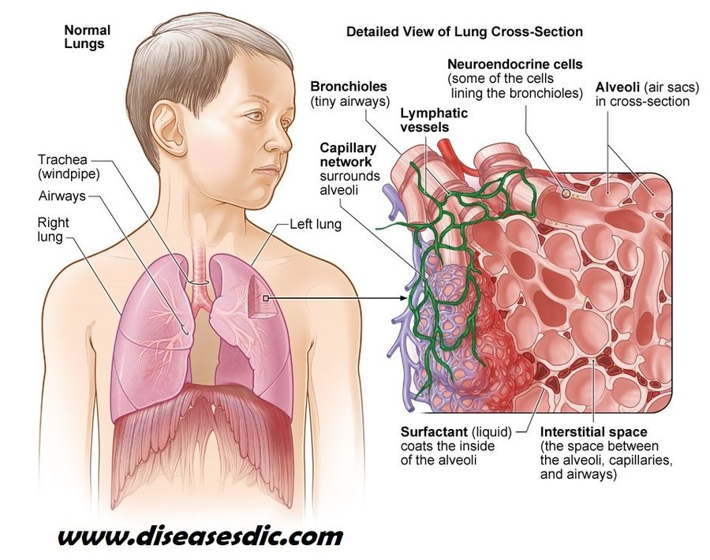  Neuroendocrine cells  “Some of the cells lining the bronchioles”: where the paraneoplastic story starts  Slide 6 | 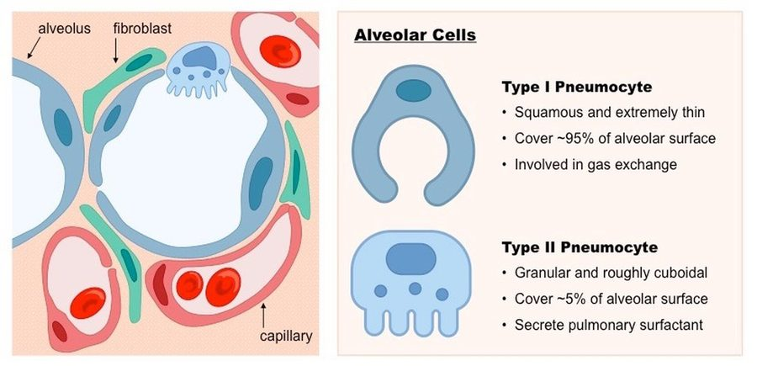  Type I and type II pneumocytes  Type I: thin, ~95% of the surface, gas exchange. Type II: cuboidal, ~5%, surfactant  Slide 8

- Pathophysiology (slide 9): carcinogens (or other reasons for the genetic mutation) activate oncogenes in lung cells, and further mutations or loss of regulatory control inactivate the tumor-suppressing genes. Atypical cells proliferate, start locally and spread. Atypical epithelial cells in the bronchial mucosa may grow into the bronchial lumen, along the mucosa, or into the bronchial wall and adjacent lung parenchyma.
- Where (slide 9): most form a mass in or near the hilum, but some form in the periphery, making them difficult to diagnose.
- Spread (slide 9): to regional lymph nodes and distant organs (liver, brain and bone), as the cancer produces angiogenesis to exceed its boundaries and its cells become poorly differentiated and transition from epithelial to other cell types. (Lymph node station numbers on slide 5 were cut: “nobody’s expecting you to, like, number these.”)
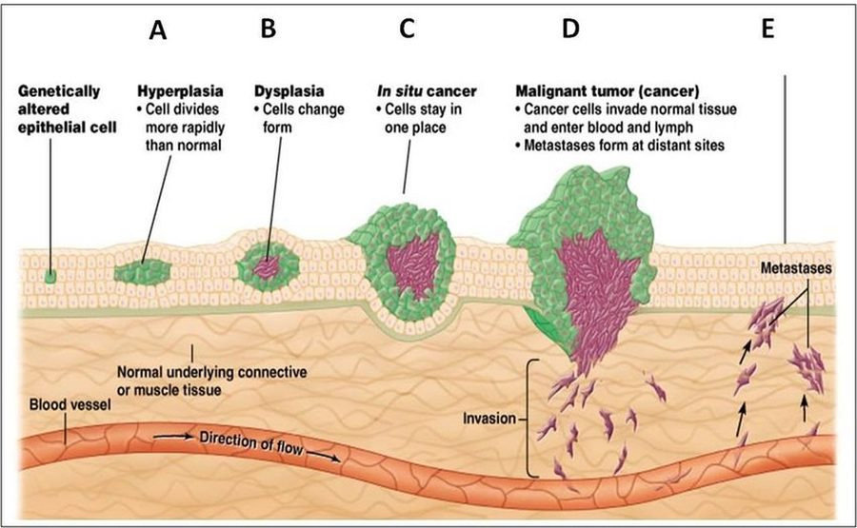
Lung cancer growth and spread: a genetically altered cell → hyperplasia (A, divides faster) → dysplasia (B, cells change form) → in situ cancer (C, stays in one place) → malignant tumor (D, invades and enters blood and lymph) → metastases (E). Slide 10

5.7 · How lung cancer presents, including metastatic disease
- Symptoms that call for a lung cancer workup (slide 12): persistent cough, hemoptysis, dysphagia, wheezing or shortness of breath; systemic symptoms: weight loss, fever or fatigue, pain (bone or chest), endocrine disorders. They arrive late, once the disease is advanced or metastatic.
- Metastatic disease (slide 13): patients may have no respiratory symptoms and instead present with other complaints from the metastasis spreading to other regions:
Metastatic site (slide 13) | Signs and symptoms
Brain | Headaches, vision changes, nausea, vomiting, syncopal episodes, seizures. If increased intracranial pressure: papilledema and other changes on fundoscopic exam. If close to the midbrain/pons: cranial nerve involvement (such as defunct extraocular movements).
Liver | Right upper quadrant pain (dull ache), hepatomegaly with a firm edge, lack of appetite, jaundice, hepatic failure
Bones (can be anywhere, including the spine) | Bone pain; fractures, not even from falls (a cough can cause a spinal fracture); spinal cord compression and peripheral neurological dysfunction
“Kidneys” (the slide’s heading): adrenal insufficiency | Fatigue, weight loss, dizziness, hypotension, and electrolyte imbalances (hyponatremia/hyperkalemia)

Two slides give a low sodium. With high potassium, low blood pressure, fatigue and dizziness, it is adrenal insufficiency from a metastasis (slide 13). With confusion, seizures, ataxia, low serum osmolality and no edema, it is SIADH (syndrome of inappropriate antidiuretic hormone) from small cell cancer (slide 48, 5.16).

Lung cancer (bronchogenic carcinoma)
Defining feature: a smoker over 50 with a persistent cough, hemoptysis or weight loss, or a complaint from a metastasis (headache, seizure, bone pain, a cough fracture), and a mass on computed tomography (CT)
DefinitionMalignancies of the lung’s epithelial cells: small cell (15–20%) and non-small cell (adenocarcinoma, squamous cell, large cell). Carcinogens activate oncogenes and inactivate tumor-suppressing genes.Who gets itMore than 200,000 new US cases a year (2 million worldwide); most over 50 (about 4% under 40); more than 30% of cancer deaths in men (highest mortality of all cancers in men) and more than 25% in women.Risk factorsSmoking in 85–90% (second-hand smoke 20%), compounding with packs per day and years (5x, 10x, 20x); radiation and radon; air pollution; environmental and chemical toxins; tuberculosis or human immunodeficiency virus (HIV) infection; genetics; diet; alcohol.Classic signs & symptomsOften none until advanced or metastatic; then persistent cough, hemoptysis, dysphagia, wheezing or shortness of breath, weight loss, fever or fatigue, bone or chest pain, endocrine disorders.Physical exam findingsFrom metastases: papilledema (raised intracranial pressure), cranial nerve findings, hepatomegaly with a firm edge, jaundice, hypotension (adrenal). A scalene or supraclavicular node is N3 disease (slide 22).Diagnostics / testsCT with contrast of the chest and upper abdomen, then biopsy (bronchoscopy, transthoracic, thoracoscopic; can be CT guided); positron emission tomography (PET); genetic testing; complete blood count with differential, metabolic panel with calcium, alkaline phosphatase, pulmonary function tests; sputum cytology (not sensitive). Staged by TNM (tumor, node, metastasis) once CT, PET and biopsy are back.First-line treatmentNon-small cell: surgical resection for stages 1–2 if the patient can tolerate it, chemotherapy for stage 4. Small cell: chemotherapy and radiation, with prophylactic cranial irradiation.ComplicationsSpread to lymph nodes, liver, brain, bone and adrenal glands; paraneoplastic syndromes; five-year survival only 17–18% in the US.
Slides 3, 4, 9, 12–14, 22, 35, 41

5.8 · Staging: TNM and the stage pictures
- When and how (slide 22): lung cancer is staged once the initial computed tomography (CT) scan, positron emission tomography (PET) scan and biopsy results are received: CT identifies location and size; PET looks at lymph involvement; biopsy classes the type of tumor. It follows the classic TNM (tumor, node, metastasis) system: primary tumor, lymph node involvement, distant metastasis.
- Two rules (slide 25): N2 or N3 (mediastinal or contralateral lymph involvement) automatically moves it to stage 3; all stage 1–3 tumors are M0 (no distant metastasis). Tx and Nx are used only if no information at all is available about T or N; Mx is not allowed, because symptoms and physical exam information are always available.
★ PROFESSOR EMPHASIS
★ Staging, big picture: “badness” (slides 22–29)
“Stuff that crosses over to the other lung is badness … Size of the tumor is badness. Lymph node involvement, badness. Metastasis, worse badness … that’s kind of your slidey scale.” “I bring this up not to, like, make you memorize the charts”; “tumor, lymph node involvement, metastasis, that’s how you stage it out.” (“7 centimeters is like the size of your hand.”)
- Bigger tumor, higher T: 3 cm or less (T1), more than 3 to 5 (T2), more than 5 to 7 (T3), more than 7 (T4); invasion of nearby structures also raises T.
- Nodes further away, higher N: same-side peribronchial or hilar (N1) → same-side mediastinal or subcarinal (N2) → other side, or any scalene or supraclavicular (N3). N2 or N3 = stage 3.
- Spread, M1 = stage 4: the other lung, the pleura or pericardium, a malignant effusion, or one site outside the chest (4A); multiple sites outside the chest (4B).

Stage 2B with a same-side hilar node. A tumor no more than 5 cm that has spread to the peribronchial, hilar or intrapulmonary nodes is stage 2B. A 2.8-cm tumor would be stage 1A without nodes, but an involved same-side hilar node, scored N1, moves it to stage 2B; mediastinal nodes would have made it stage 3.
Stage 3A with same-side mediastinal nodes. A tumor no more than 5 cm that has spread to the mediastinal lymph nodes, subcarinal nodes included, on the side of the tumor is stage 3A. Mediastinal involvement, N2, automatically moves a cancer to stage 3, whatever the size of the tumor.
TNM 8th edition (slide 22)
Primary tumor characteristics
Tx | Tumor in sputum/bronchial washings but not be assessed in imaging or bronchoscopy
T0 | No evidence of tumor
Tis | Carcinoma in situ
T1 | ≤ 3 cm surrounded by lung/visceral pleura, not involving main bronchus  T1a(mi): minimally invasive carcinoma · T1a: ≤ 1 cm · T1b: > 1 to ≤ 2 cm · T1c: > 2 to ≤ 3 cm
T2 | > 3 to ≤ 5 cm or involvement of main bronchus without carina, regardless of distance from carina, or invasion of visceral pleura, or atelectasis or post-obstructive pneumonitis extending to hilum  T2a: >3 to ≤4 cm · T2b: >4 to ≤5 cm
T3 | >5 to ≤7 cm in greatest dimension, or tumor of any size that involves chest wall, pericardium, phrenic nerve, or satellite nodules in the same lobe
T4 | > 7 cm in greatest dimension, or any tumor with invasion of mediastinum, diaphragm, heart, great vessels, recurrent laryngeal nerve, carina, trachea, esophagus, spine, or a separate tumor in a different lobe of the ipsilateral lung
Lymph nodes
N1 | Ipsilateral peribronchial and/or hilar nodes and intrapulmonary nodes
N2 | Ipsilateral mediastinal and/or subcarinal nodes
N3 | Contralateral mediastinal or hilar; ipsilateral/contralateral scalene/supraclavicular
Distant metastasis
M1 | Distant metastasis
M1a | Tumor in contralateral lung or pleural/pericardial nodule/malignant effusion
M1b | Single extrathoracic metastasis, including a single non-regional lymph node
M1c | Multiple extrathoracic metastases in one or more organs

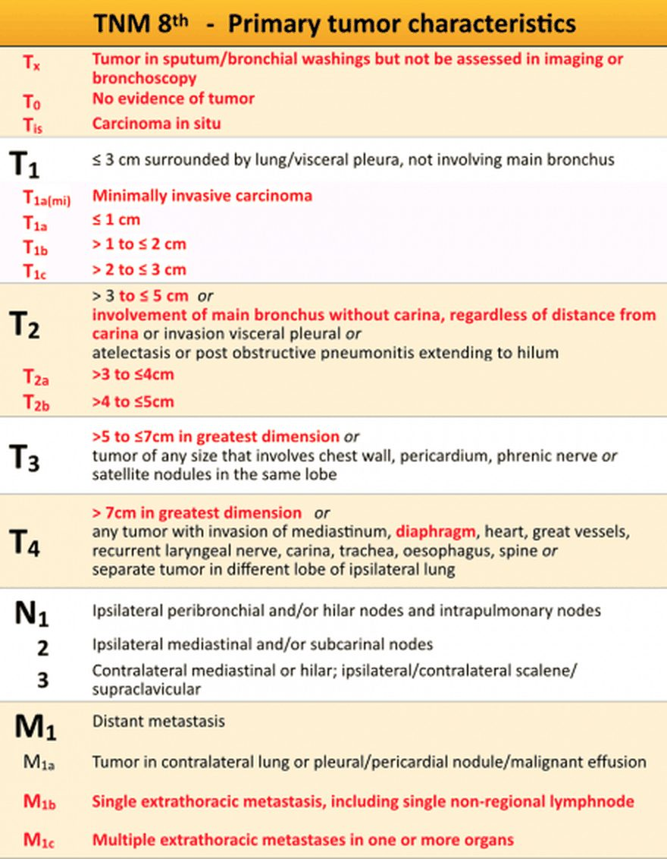
The slide’s TNM table, transcribed above. Slide 22
The stages, as the slide pictures state them (slides 23–29; 8th edition)
Stage | Tumor | Lymph nodes | And
1A | No more than 3 cm in the greatest dimension | Not spread to any lymph nodes | —
1B | More than 3 cm but no more than 4 cm | Not spread to any lymph nodes | May or may not have grown into the main bronchus or the lung’s inner lining, or have caused lung collapse or swelling
2A | More than 4 cm but no more than 5 cm | Not spread to any lymph nodes | May or may not have grown into the main bronchus or the lung’s inner lining, or have caused lung collapse or swelling
2B | More than 5 cm but no more than 7 cm | Not spread to any lymph nodes | Grown into the lung’s outer lining or nearby sites including the chest wall, phrenic nerve, or the heart’s lining, or primary and secondary tumors in the same lobe
Or no more than 5 cm | Spread to the peribronchial nodes or hilar/intrapulmonary nodes | (slide 24 note)
3A | More than 7 cm | Not spread to nearby lymph nodes | Grown into the diaphragm, mediastinum, heart or its major blood vessels, windpipe, recurrent laryngeal nerve, carina, esophagus, or spine, or secondary tumors in the same lung but a different lobe
More than 5 cm | Spread to the peribronchial nodes and/or the hilar and intrapulmonary nodes of the lung with the primary tumor | Grown into the outer lining or nearby sites (chest wall, phrenic nerve, heart’s lining) or a same-lobe tumor; and/or into the mediastinum, heart or major vessels, windpipe, recurrent laryngeal nerve, carina, esophagus or spine, or a tumor in a different lobe of the same lung
Or no more than 5 cm | Spread to the mediastinal lymph nodes (and subcarinal nodes) | (slide 26 note)
3B | More than 5 cm | Spread to mediastinal lymph nodes, which include subcarinal nodes, near the lung with the primary tumor | Grown into the outer lining or nearby sites, and/or the mediastinal structures, or a tumor in a different lobe (as 3A)
No more than 5 cm | Spread to mediastinal or hilar nodes near the lung without the primary tumor, or to any supraclavicular or scalene lymph nodes | May or may not have grown into the main bronchus or the lung’s inner lining, or caused lung collapse or swelling
3C | More than 5 cm | Spread to mediastinal or hilar nodes near the lung without the primary tumor, or to any supraclavicular or scalene lymph nodes | Grown into the outer lining or nearby sites, and/or the mediastinal structures, or a tumor in a different lobe
4A | Any size | May or may not have spread to any lymph nodes | Spread from one lung into the other lung; into the lung’s lining or the heart’s lining with secondary nodules; or into the fluid around the lungs or the heart; and/or one site outside the chest (for example, the adrenal gland)
4B | Any size | May or may not have spread to any lymph nodes | Spread to multiple sites outside the chest (for example, the adrenal gland and bones)

Stage 2A by size alone. Stage 2A is a tumor more than 4 cm but no more than 5 cm in its greatest dimension that has not spread to any lymph nodes. A 4.5 cm node-negative tumor without metastasis fits exactly, T2b N0 M0.
Stage (slide 25) | TNM groups shown on the 8th-edition classification drawing
0 | Tis N0 (adenocarcinoma in situ; squamous carcinoma in situ)
1A | T1a N0 (≤1 cm), T1b N0 (>1–2 cm), T1c N0 (>2–3 cm), T1a(mi) N0, T1a(ss) N0 (superficial mucosal tumor)
1B | T2a N0 (central), T2a N0 (visceral pleura), T2a N0 (>3 ≤4 cm)
2A | T2b N0 (>4 ≤5 cm)
2B | T1a,b,c N1; T2a N1; T2b (>4–5) N1; T3 N0 (invasion); T3 N0 (>5–7 cm); T3 N0 (satellite nodule)

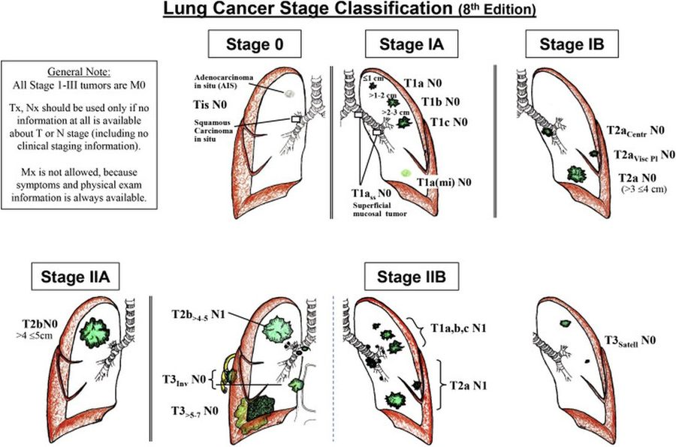
Stage classification (8th edition) for stages 0 to 2B, with its general note (“All Stage I–III tumors are M0”) and the slide’s reminder that N2 or N3 moves it to stage 3 . Slide 25
The stage pictures (slides 23–29): the label on each picture states the stage
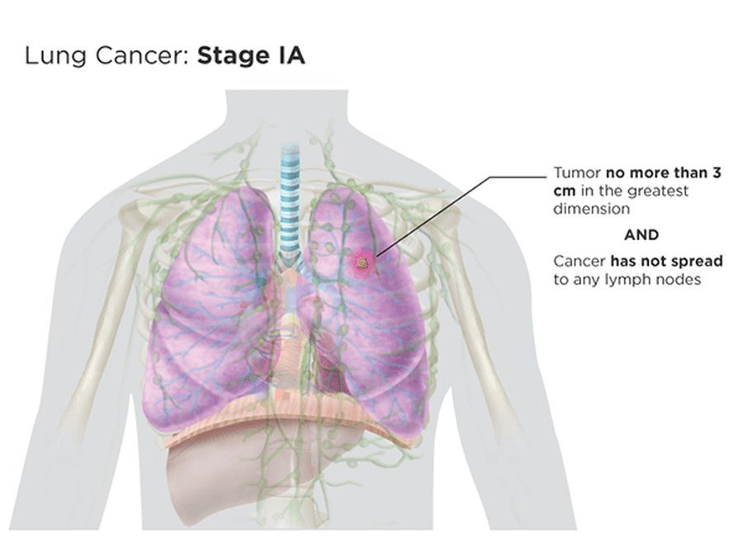  Stage 1A  ≤ 3 cm, no nodes  Slide 23 | 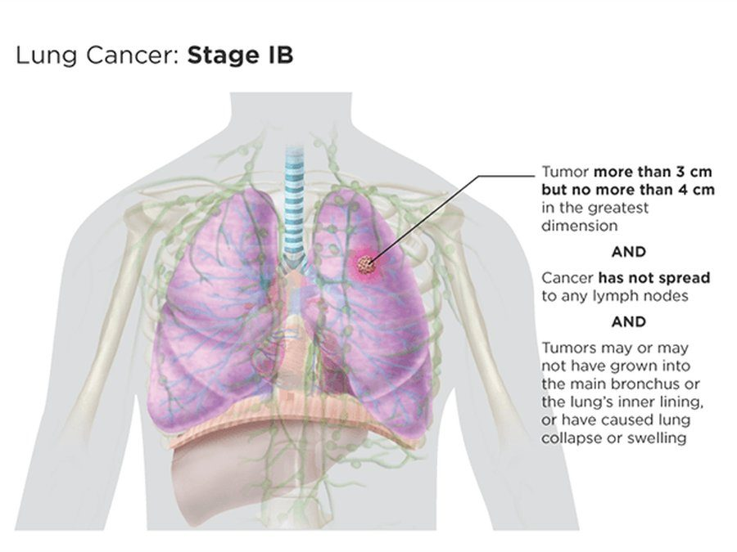  Stage 1B  > 3 to 4 cm, no nodes  Slide 23 | 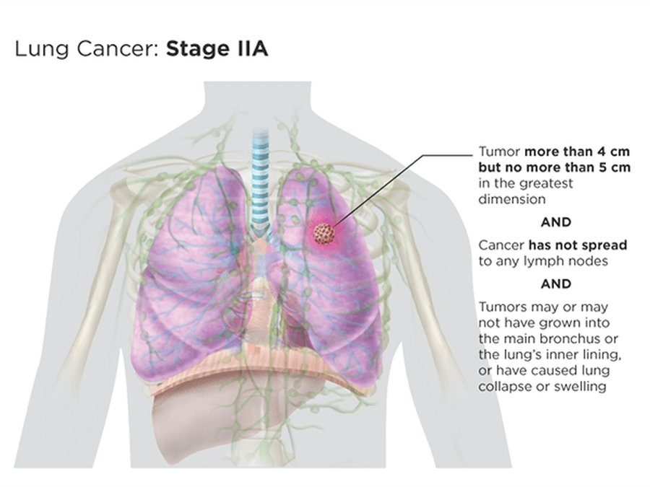  Stage 2A  > 4 to 5 cm, no nodes  Slide 24
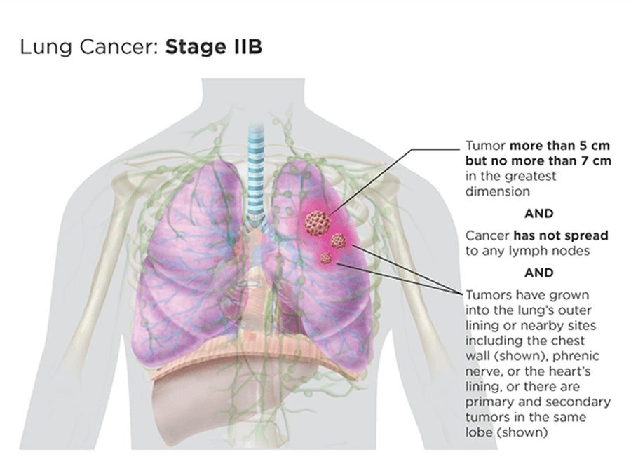  Stage 2B  > 5 to 7 cm, no nodes, chest wall or same-lobe tumor  Slide 24 | 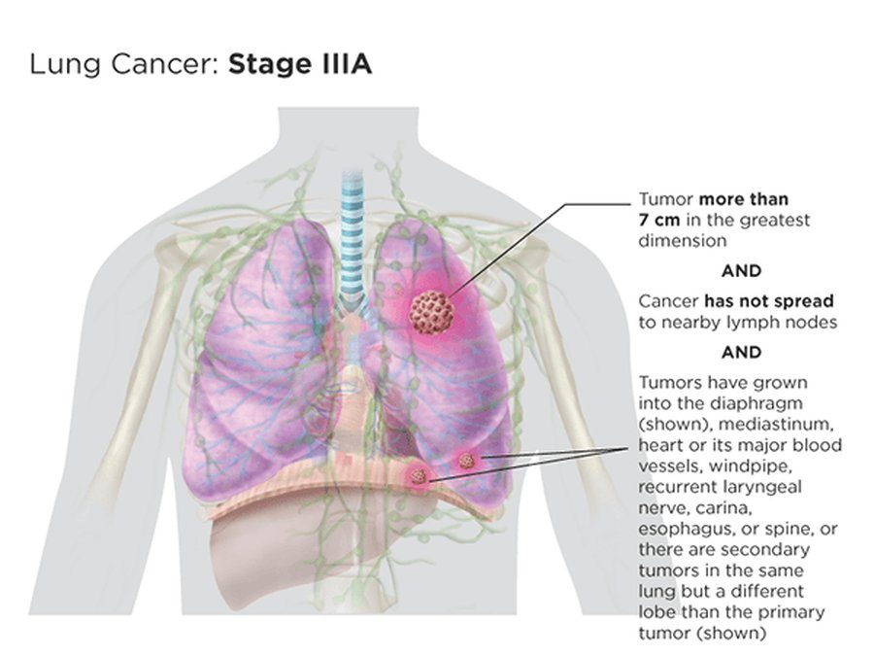  Stage 3A  > 7 cm, no nodes, diaphragm or other-lobe tumor  Slide 26 | 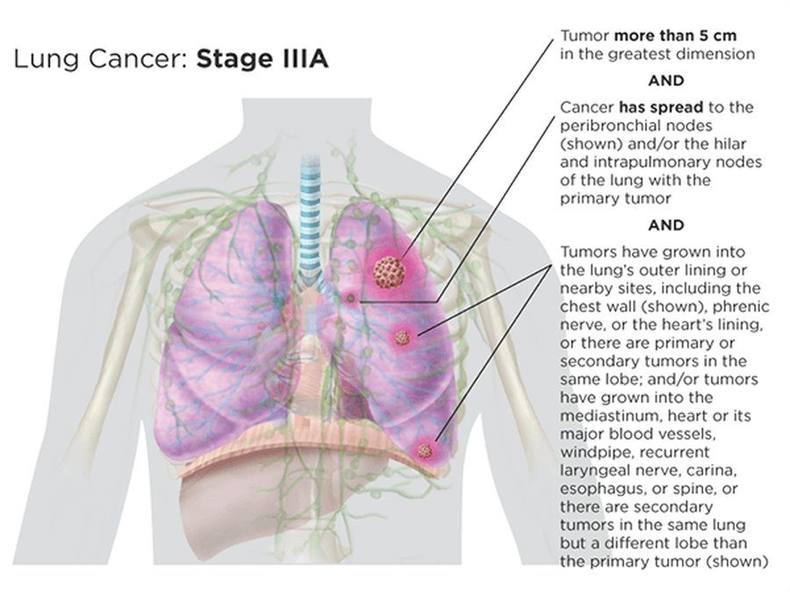  Stage 3A  > 5 cm with same-side peribronchial or hilar nodes  Slide 26
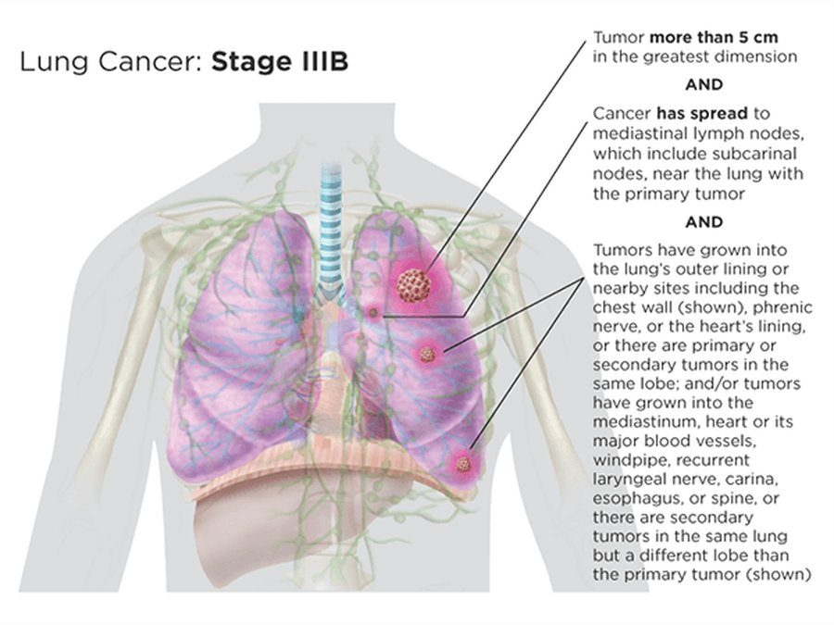  Stage 3B  > 5 cm with mediastinal nodes on the tumor’s side  Slide 27 | 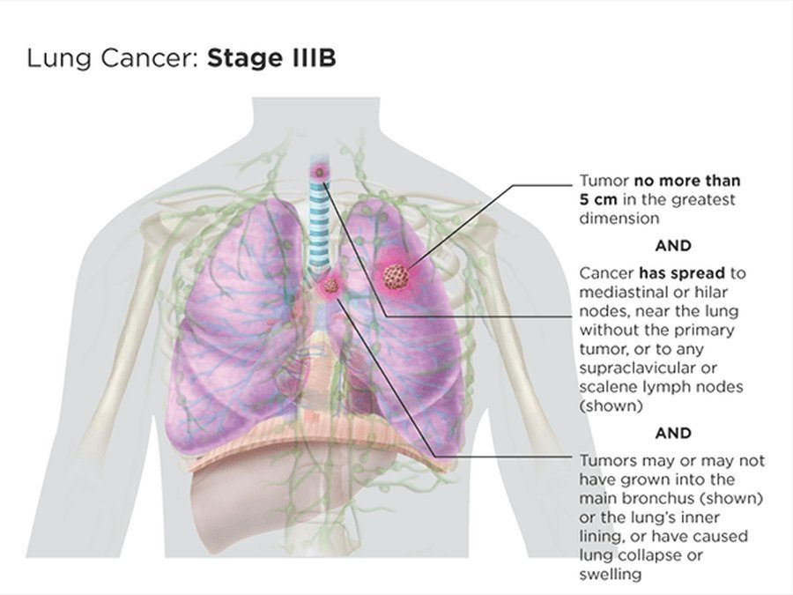  Stage 3B  ≤ 5 cm with other-side or supraclavicular nodes  Slide 27 | 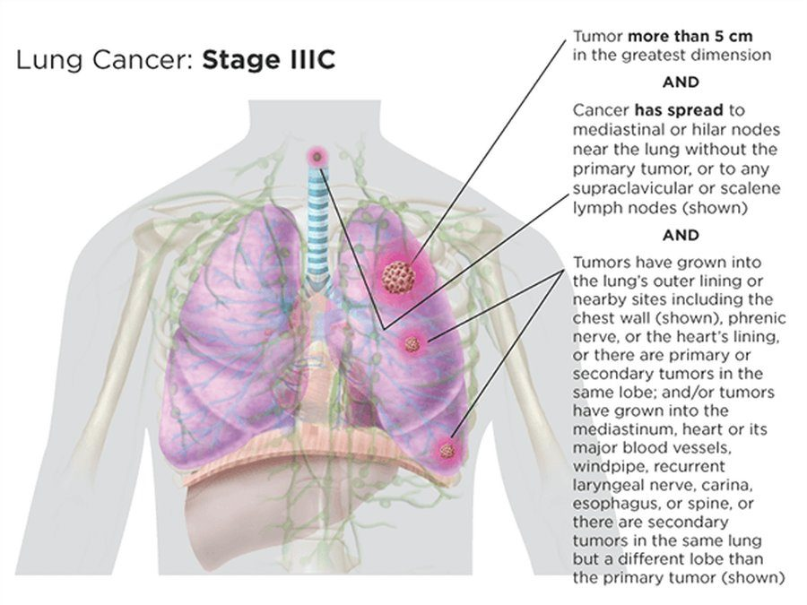  Stage 3C  > 5 cm with other-side or supraclavicular nodes  Slide 28
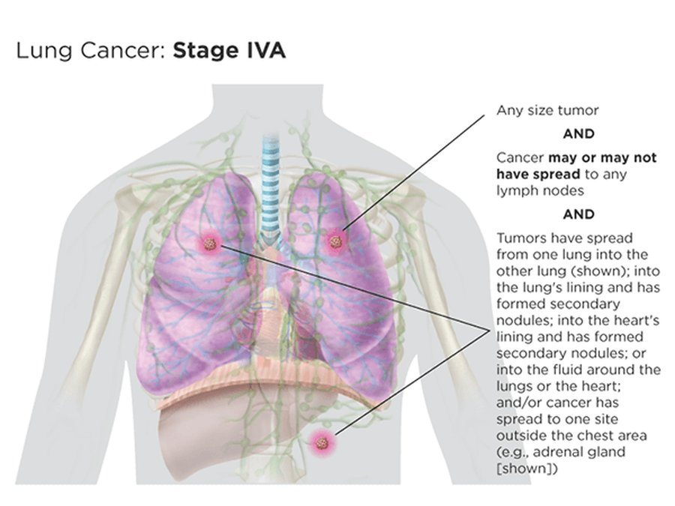  Stage 4A  Other lung, pleura or pericardium, fluid, or one site outside the chest  Slide 29 | 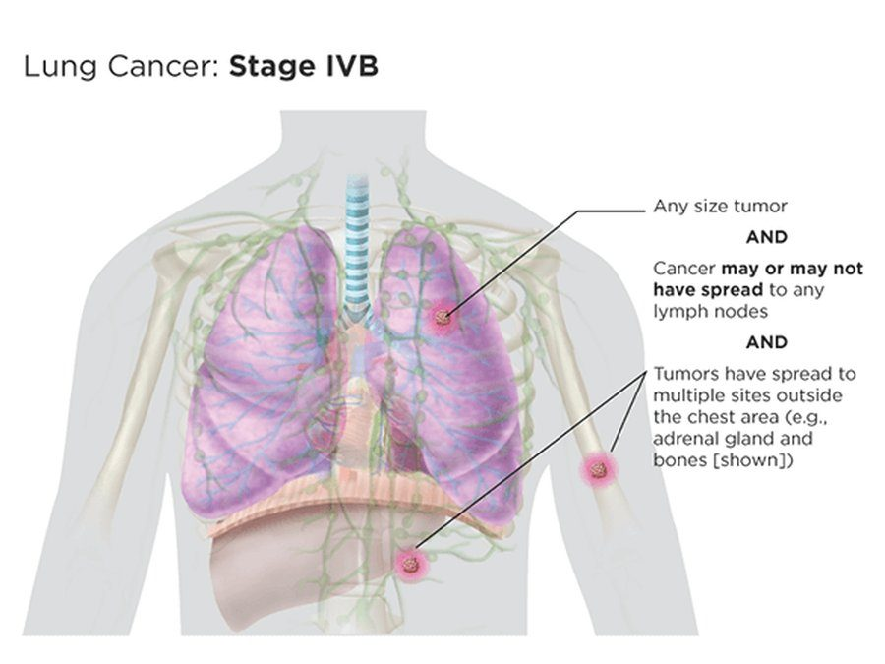  Stage 4B  Multiple sites outside the chest  Slide 29

5.9 · Central versus peripheral cancers
★ PROFESSOR EMPHASIS
★ Board pointer, said three times: “Small and squamous are central” (slide 30)
Cancer type (slide 30) | Most common location
Small cell | Central, but usually metastatic by the time of diagnosis
Adenocarcinoma | Periphery (not amenable to early detection)
Squamous cell carcinoma | Central bronchi; can diagnose via sputum cytology
Large cell carcinoma | Periphery (not amenable to early detection)
Lung carcinomas also have mixed types, such as adenosquamous or combined small cell lung carcinoma.

“Couple of things I’ll point out to you, just because this is stuff that comes up on [board review] … small cell, squamous cell, central … Adenocarcinoma, large cell, usually periphery … See, there you go, you got half of it then. So now that I know those two, I know where the other two are.” Memory aid (his): the two S’s sit in the center (Small, Squamous); the other two go to the edges.

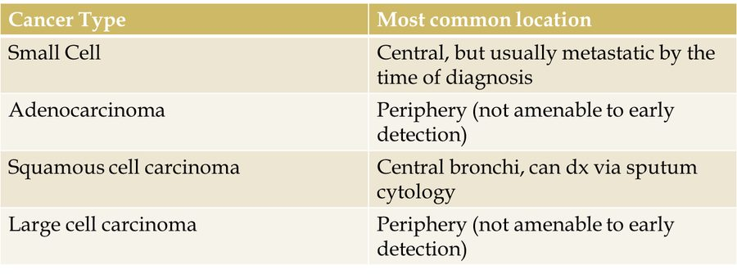
The slide’s location table, transcribed above: small cell and squamous cell central , adenocarcinoma and large cell peripheral . Slide 30
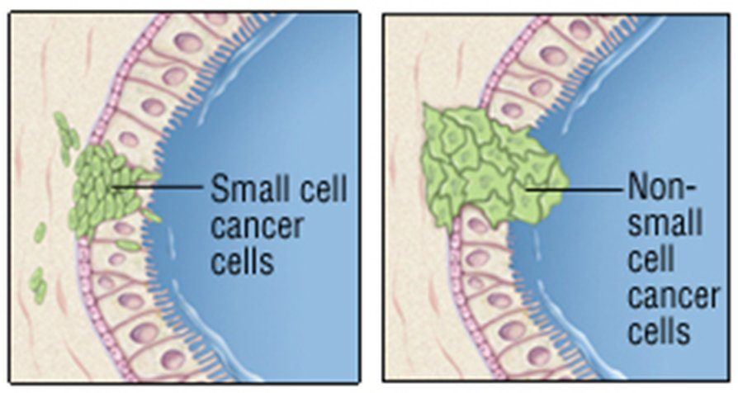
Drawings labeled “Small cell cancer cells” and “Non-small cell cancer cells” in an airway wall, shown with the location table. Slide 30

5.10 · Adenocarcinoma (a non-small cell cancer)
- The most common lung cancer (slide 31). Frequently located in the mid-lung and periphery. Initial metastases are to the lymphatics before advancing out of the lungs. Frequently associated with peripheral scars. Described as noninvasive, minimally invasive, or invasive.
- Common presenting details (slide 31): over 50 years old with a history of smoking (true of all these lung cancers), but smoking is not always associated with lung cancer; persistent cough and shortness of breath without signs of infection.
- Late presentation (slide 31): many patients (2/3) present only in advanced disease (T2 or higher with N1–3) or when metastatic; most are initially asymptomatic while the cancer progresses. It usually presents with respiratory symptoms first: cough, shortness of breath, chest tightness or pain, hemoptysis, fatigue. Later signs: bone pain, weight loss (underlined in class) and other systemic (paraneoplastic) issues.
- Origin and growth (slide 32): type II pneumocytes are usually the origin, starting with atypical adenomatous hyperplasia (AAH), and the tumor grows initially in situ. Then it either enlarges (lepidic growth across the alveolar lining) or begins to invade the stroma (minimally invasive adenocarcinoma). As it grows it may invade the pleura and then vasculature, or form its own vasculature (invasive adenocarcinoma). Memory aid (his): “adeno” = gland; type II pneumocytes are the glandular cells that make surfactant.
- Histology (slide 32): a mucicarmine stain shows mucin production, which is related to adenocarcinoma; negative staining may point to a large cell carcinoma.
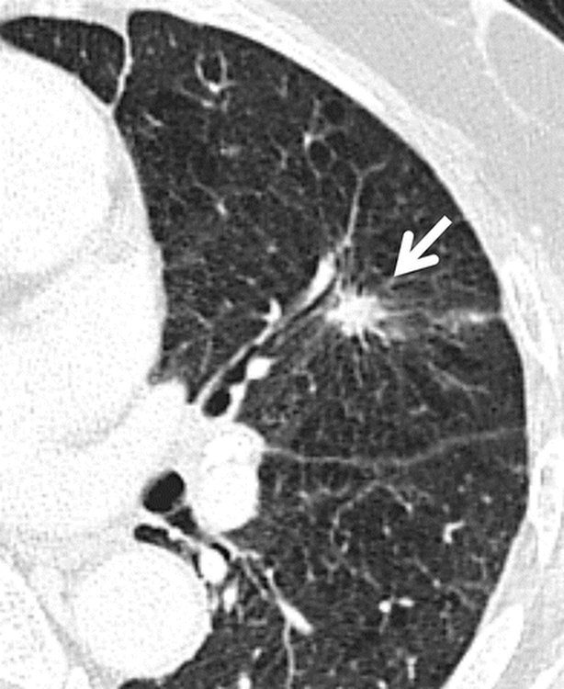
“Left upper lobe shows a suspicious solid spiculated nodule (arrow) in the periphery that involved the pleura; identified later as an invasive adenocarcinoma ” (the slide’s caption; he circled the nodule in class). Slide 32

Adenocarcinoma
Defining feature: a peripheral, spiculated nodule, sometimes in a nonsmoker or at a peripheral scar, that stains for mucin
DefinitionA non-small cell carcinoma usually arising from type II pneumocytes (by way of atypical adenomatous hyperplasia), growing in situ, then lepidic (along the alveolar lining) or into the stroma; noninvasive, minimally invasive or invasive.Who gets itThe most common lung cancer; usually over 50 with a smoking history, but smoking is not always associated.Risk factorsSmoking; frequently associated with peripheral scars.Classic signs & symptomsMostly asymptomatic early; persistent cough and shortness of breath without signs of infection; respiratory symptoms first (cough, shortness of breath, chest tightness or pain, hemoptysis, fatigue); later bone pain, weight loss, paraneoplastic issues.Physical exam findingsNot covered on the slides.Diagnostics / testsComputed tomography (CT): a peripheral (mid-lung or periphery) spiculated nodule, which may involve the pleura; histology with a positive mucicarmine stain (mucin).First-line treatmentAs for non-small cell cancer: resection by stage; targeted therapy and immunotherapy by markers (non-squamous disease).ComplicationsTwo-thirds present only when advanced (T2 or higher with N1–3) or metastatic; spreads to the lymphatics first; may invade the pleura and vessels.
Slides 4, 30–32, 35–38

5.11 · Large cell carcinoma (a non-small cell cancer)
- A diagnosis of exclusion (slide 33): it lacks specific characteristics for genetic or histology markers, and is a diagnosis of exclusion for non-small cell carcinoma. Anaplastic and undifferentiated: pleomorphic (variable characteristics), which separates it from adenocarcinoma or squamous cell types.
- Large cells (slide 33): cells about 3 times greater than baseline cell types; it is classed away from small cell carcinoma because their treatments differ. Subtypes: giant-cell carcinoma (a sarcomatoid rare type), basaloid, rhabdoid, neuroendocrine.
- Where and how it looks (slide 33): tends to form in the periphery and forms necrosis or hemorrhages more readily than other non-small cell types. It shows as a large, cavitated mass on chest computed tomography (CT), typically peripheral, as opposed to central like a squamous cell carcinoma, but you still have to wait for biopsy with histology.
- ★ Metastasis to rare areas such as the small intestine and bowel (slide 33): “that’s specific to large cell, so I would say stuff that, like, is unique to a thing makes a great test question.”
- Treatment (slide 33): large cell cancers have no standardized treatments, due to their variety and rarity.
- CT and histology (slide 34): the tumor is in the periphery with cavitation and angiogenesis (it established its own blood flow and spread out); histology still has to confirm a large amount of anaplastic tissue.
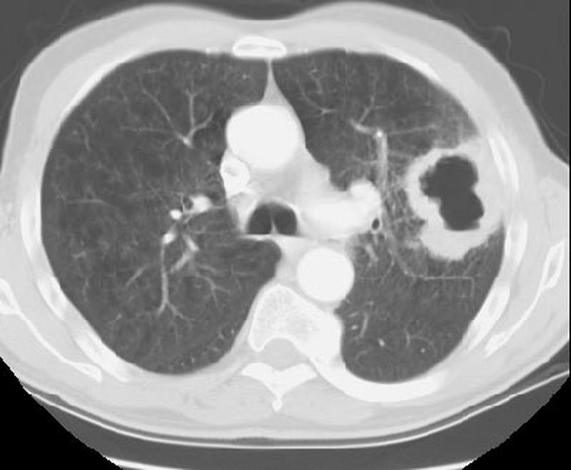  Large cell carcinoma on CT  In the periphery with cavitation and angiogenesis  Slide 34 | 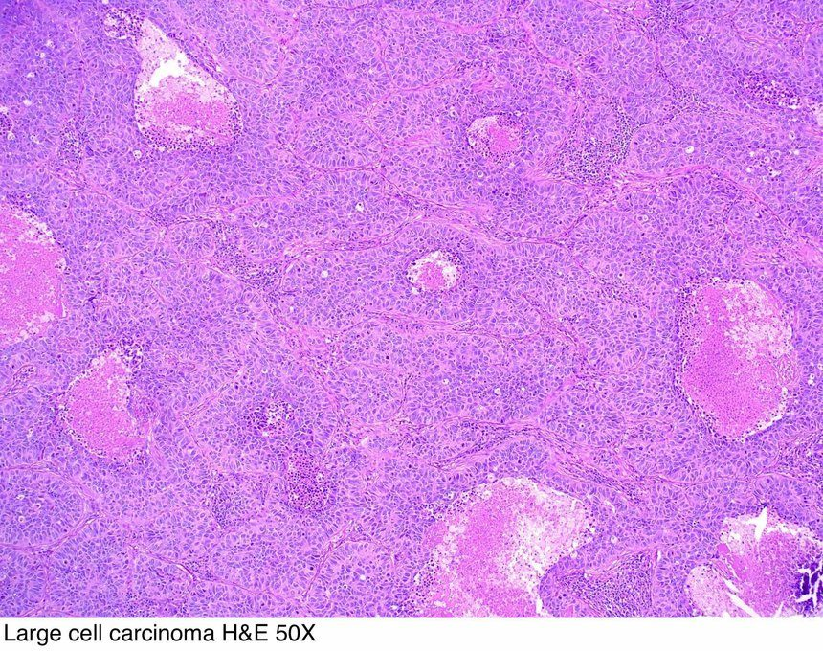  Histology, low power  “Large cell carcinoma H&E 50X” (the picture’s label)  Slide 34 | 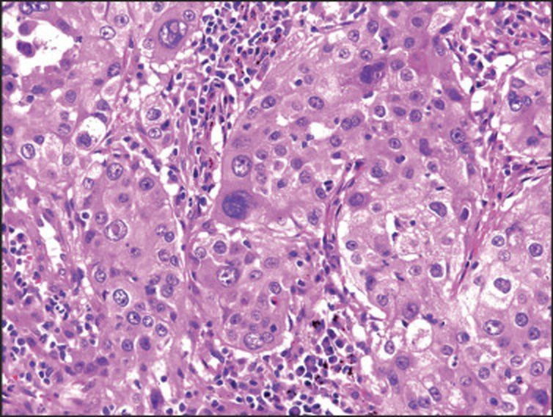  Histology, higher power  Large, anaplastic tumor cells  Slide 34

Large cell carcinoma
Defining feature: a large, cavitated peripheral mass in a non-small cell cancer with no marker, which can metastasize to the small intestine and bowel
DefinitionA non-small cell carcinoma of exclusion: no specific genetic or histology markers; anaplastic, undifferentiated and pleomorphic, with cells about 3 times larger than baseline.Who gets it9 to 10% of lung cancers (slide 4).Risk factorsNot covered on the slides for this type (lung cancer risk factors, 5.5).Classic signs & symptomsNot covered on the slides for this type.Physical exam findingsNot covered on the slides.Diagnostics / testsCT: a large, cavitated peripheral mass with angiogenesis; biopsy with histology must confirm anaplastic tissue; a negative mucicarmine stain may point to it.First-line treatmentNo standardized treatment (variety and rarity).ComplicationsNecrosis and hemorrhage more readily than other non-small cell types; metastasis to rare sites such as the small intestine and bowel.
Slides 4, 30, 32–34

5.12 · Squamous cell carcinoma (a non-small cell cancer)
★ PROFESSOR EMPHASIS
★ How to recognize squamous cell (slides 39–40, 46)
- Second most common lung cancer (20–30%), with the strongest association with smoking, and frequent cavitation and obstructive phenomena (slide 39).
- Central location, often originating in the bronchus (slide 39).
- Asymptomatic at first until the tumor begins to obstruct the bronchus; then cough, wheezing and hemoptysis are more likely (slide 39). If the obstruction is large enough, part of the lung no longer fills: atelectasis and increased risk of infection (pneumonia).
- Metastasis by local invasion: later signs such as dysphagia and voice changes (it can spread to the laryngeal nerves) (slide 39).
- Lymphangitic spread into the regional lymph nodes, typically in the hilar region (slide 40).
- Unlike the other cancers, it can be caught with sputum testing (slide 40; “Central bronchi, can diagnose via sputum cytology,” slide 30).
- Hypercalcemia is the paraneoplastic syndrome “particularly” of squamous cell (slide 46).
“Cavitation is big with that one. Strongest association with smoking … Cough, wheezing, hemoptysis are huge. This is one of those things where it almost looks like a COPD [chronic obstructive pulmonary disease] … it just looks like their COPD has taken off … constantly in exacerbation. If you CT them, you’d find the tumor.” “This one you might be able to catch with sputum testing. That’s why I say, usually we don’t do sputum testing.” “A lot of times, your squamous cell will make your calcium, a big deal.”

- Management (slide 40): a combination of surgery, chemotherapy, immunotherapy (“as it is a NSCLC”; see the box at the top on slides 37–38) and radiation.
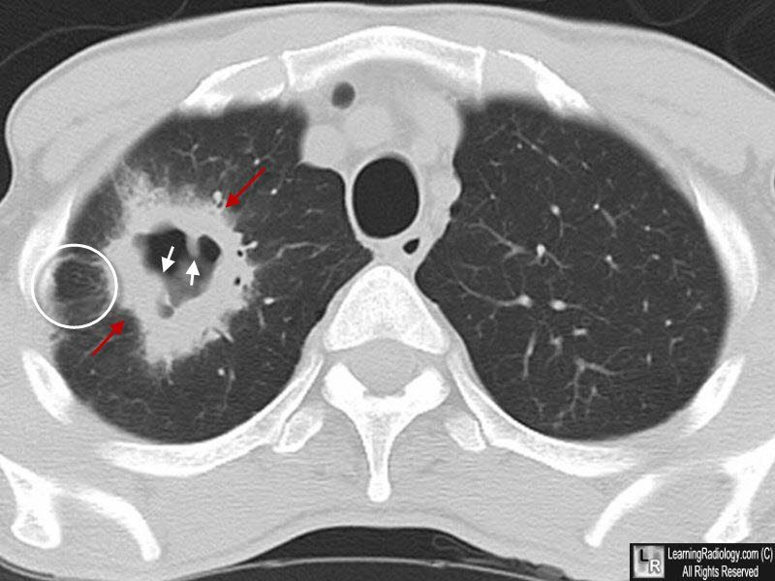
Squamous cell bronchogenic carcinoma: a large, cavitated lesion with spiculated appearance (red arrows), nodular inner margins (white arrows) and lymphangitic spread (circle), the slide’s own caption. Slide 40

Squamous cell carcinoma
Defining feature: a heavy smoker with cough, wheezing and hemoptysis like a chronic obstructive pulmonary disease (COPD) flare that never settles, a central cavitating mass from a bronchus, and a high calcium
DefinitionA non-small cell carcinoma in a central location, often originating in the bronchus, with frequent cavitation and obstructive phenomena.Who gets itThe second most common lung cancer (20–30%).Risk factorsSmoking: the strongest association of any type.Classic signs & symptomsSilent until it obstructs the bronchus, then cough, wheezing and hemoptysis; later dysphagia and voice changes from local invasion (laryngeal nerves).Physical exam findingsNot covered on the slides.Diagnostics / testsComputed tomography (CT): a large, cavitated, spiculated lesion with nodular inner margins and lymphangitic spread; unlike the others, can be caught by sputum cytology; calcium (hypercalcemia).First-line treatmentSurgery, chemotherapy, immunotherapy (slide 40) and radiation in combination.ComplicationsAtelectasis and pneumonia behind the obstruction; lymphangitic spread to hilar nodes; dysphagia and voice change; hypercalcemia.
Slides 4, 30, 39, 40, 46

5.13 · Non-small cell treatment by stage; targeted therapy and immunotherapy
★ PROFESSOR EMPHASIS
★ How staging affects treatment, big picture (slides 35, 49)
- Surgical resection, based on the size and lymph involvement, is a wedge/segment resection or lobectomy (open or by thoracoscopy) or a pneumonectomy (slide 35).
- The patient must be able to tolerate the surgery (that is, survive and recover) (slide 35).
- Chemotherapy and radiation are only an adjunct to surgery, or used if the patient is stage 4, as non-small cell cancers do not respond well to chemotherapy or radiation (slide 35). However, chemotherapy and immunotherapy can now be targeted to specific markers based on genetics and proteins.
- So: stages 1–2 → surgical resection; stage 4 → chemotherapy, with surgery only if there is a solitary metastatic lesion with a resectable primary tumor (the table below). Stage 3 is where the slide’s text and its table differ (box at the top).
“Chemo and radiation we’re doing as an adjunct to surgery, or if you’re in stage 4.” At the recap: “do we do surgery? Do we do chemo? Is it just better for chemo? … big picture, guys.”

Treatment recommendations and future research directions for non-small cell lung cancer (slide 35)
Stage | Standard management | Future directions | Survival
1A and B | Surgical resection | Adjuvant therapy (chemotherapy/radiation or combination); chemoprevention | 75% (1A), 55% (1B)
2A and B | Surgical resection | Same as stage 1 | 50% (2A), 40% (2B)
3A | Chemoradiotherapy, surgical resection in selected patients | Neoadjuvant combined-modality therapy to downstage primary tumor | 10–35%
3B | Chemoradiotherapy | Same as stage 3A | 5%
4 | Cisplatin-based chemotherapy (the slide prints “Ciplatin”), surgical resection if solitary metastatic lesion with resectable primary tumor | More efficacious single-agent and combination chemotherapy | <5%
The survival column was not narrated, and no question asks it.

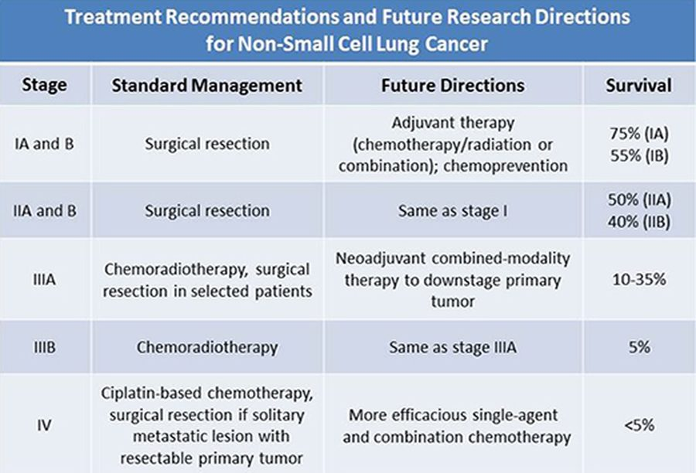
The slide’s stage-treatment table, transcribed above: surgical resection for stages 1–2 , chemotherapy for stage 4 . Slide 35
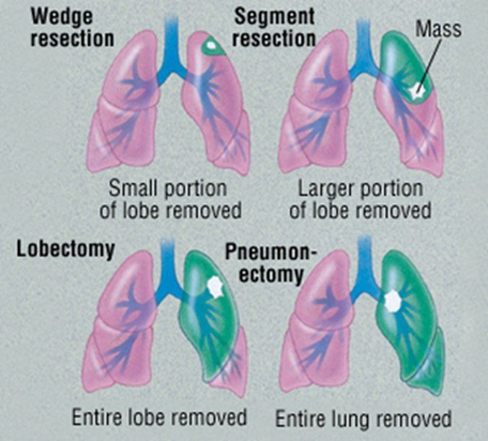
Resection types: wedge = small portion of a lobe; segment = larger portion of a lobe; lobectomy = entire lobe; pneumonectomy = entire lung. Slide 35
- Molecular and genetic screening (slide 36): molecular analysis and genomic testing of the tumor look for specific mutations and proteins that help the oncologist tailor the therapy. Genes named: TP53 (tumor protein 53), a gene for tumor suppression that allows cancer to grow if damaged or mutated; EGFR (epidermal growth factor receptor); KRAS (the Kirsten rat sarcoma gene), a protein promoting cell growth and survival; ALK (anaplastic lymphoma kinase), a gene making a kinase that promotes cell growth and fuses into other genes. The slide’s pie of mutations in adenocarcinoma (reference only) shows KRAS 30%, EGFR 15%, ALK 5%, ROS1 2%, with TP53 among “unknown and others.” He: “don’t go crazy about details on this, I’m just giving you some examples.”
- Targeted therapy for non-small cell cancer excluding squamous cell (slide 37): based on genetic markers, certain chemotherapy drugs are used; based on protein markers, immunotherapy (checkpoint inhibitors) is used, in combination with or after a poor response to chemotherapy. (The slide’s drug-by-marker flowchart is not reproduced: “I do not expect you to know absolutely specific drugs for, like, this marker, this drug.”)
- Immunotherapy (slide 38): monoclonal antibodies (the “-mab” drugs) for some patients, depending on the markers of their cancer (genes), how they respond to traditional treatments, or if they are not a surgical candidate (stage 4 or metastatic patients, for example). They are classed as targeted antibodies or immunomodulator antibodies. Examples: nivolumab (Opdivo) and pembrolizumab (Keytruda) for some time; newer, ipilimumab (Yervoy) with nivolumab; pembrolizumab now also in stage 3 and small cell; nivolumab and atezolizumab (Tecentriq) approved in some small cell cases. Others, less common, are chosen due to the subset (genetic variant) of the cancer (underlined in class).
- How a checkpoint inhibitor works (slide 38): drugs such as nivolumab or pembrolizumab work on the PD-1 (programmed cell death protein 1) pathway: the immune T cell is no longer inactivated by the cancer cell through PD-1 (less T-cell death), so it attacks and kills the tumor cells.
- ★ Referral: “you’re not doing oncology. Your job as a primary care PA, as an emergency medicine PA … is be able to screen and figure out risk for that patient, and then refer.”
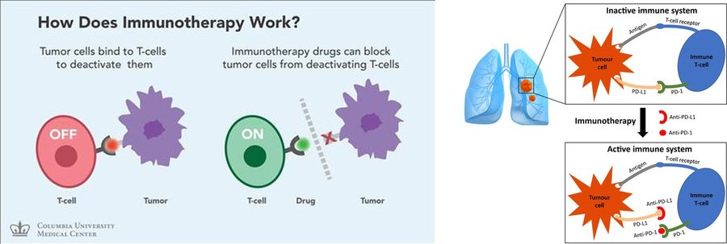
Checkpoint inhibitors: tumor cells bind T cells to switch them off ; the drug blocks that binding (anti-PD-1 or anti-PD-L1, programmed death-ligand 1), so the T cell stays on and attacks the tumor. Slide 38

Non-small cell lung cancer (adenocarcinoma, squamous cell, large cell)
Defining feature: one of the three histology types, staged by TNM and treated by stage: surgery when it can be resected and the patient can tolerate it, chemotherapy for stage 4
DefinitionNon-small cell lung carcinomas, divided by histology into adenocarcinoma, squamous cell carcinoma and large cell carcinoma.Who gets itAdenocarcinoma is the most common, squamous cell 20–30%, large cell 9–10%; usually over 50 with a smoking history.Risk factorsSmoking (strongest for squamous cell; not always present with adenocarcinoma); the general lung cancer risks (5.5).Classic signs & symptomsRespiratory symptoms first (cough, shortness of breath, chest tightness or pain, hemoptysis, fatigue); later bone pain, weight loss and paraneoplastic issues.Physical exam findingsNot covered on the slides beyond metastatic findings (5.7).Diagnostics / testsComputed tomography (CT), positron emission tomography (PET), biopsy with histology (mucicarmine: mucin = adenocarcinoma, negative may point to large cell); molecular and genetic testing (TP53, EGFR, KRAS, ALK); sputum cytology can catch squamous cell.First-line treatmentSurgical resection (wedge or segment, lobectomy, pneumonectomy) by size and nodes if tolerated; chemotherapy and radiation as adjuncts or for stage 4 (they respond poorly); targeted chemotherapy and immunotherapy (checkpoint inhibitors) by markers.ComplicationsMetastasis; two-thirds of adenocarcinomas present advanced or metastatic; obstruction with atelectasis and pneumonia (squamous); hypercalcemia (squamous).
Slides 4, 30–40

5.14 · Small cell (oat cell) carcinoma and radiotherapy
- Three categories, based on the presence of metastasis (slide 41): limited stage (confined to one area with only local lymph nodes involved); extensive stage (spread away from the local area); combined (different histological types, mixed with non-small cell).
- Central location; infiltrates the mucosa (slide 41). The result is an insidious development: most patients (over 70%) are metastatic (liver, bone, brain) before detection.
- Neuroendocrine paraneoplastic symptoms (slide 41) can develop, if the carcinoma develops from the APUD (amine precursor uptake and decarboxylation) cells that secrete polypeptide hormones (5.17).
- Once the tumor is large enough for symptoms, it also has a high cavitation rate (slide 41).
- Immunotherapy is less effective on small cell because of its genetic variability, but is becoming an option with more targeted therapy (slide 41). Genetic risk: associated with a lesion of the short arm of chromosome 3 (slide 41).
- Histology (slide 42): small cell lung carcinoma is a fragile tumor, often crushed during biopsy; the small size of the tumor cells and lack of nucleoli can still be appreciated, and the high nuclear-to-cytoplasm ratio is demonstrated.
★ PROFESSOR EMPHASIS
★ Which cancer benefits most from radiotherapy: small cell (slides 41, 43)
- Small cell responds better to chemotherapy and radiation than the three non-small cell cancers (slide 41).
- Radiation works best if the cancer is in limited stage (slide 41).
- Prophylactic cranial irradiation (PCI) after a complete or partial response: given in limited stage, considered in extensive stage (slide 43).
“This one does better with chemo and radiation than the other types. If the cancer’s pretty limited, you can radiate it really effectively.” “PCI is prophylactic cranial irradiation. We’re literally gonna radiate the brain just in case there’s metastasis. You’ve got such a high chance of mets from something like this.”

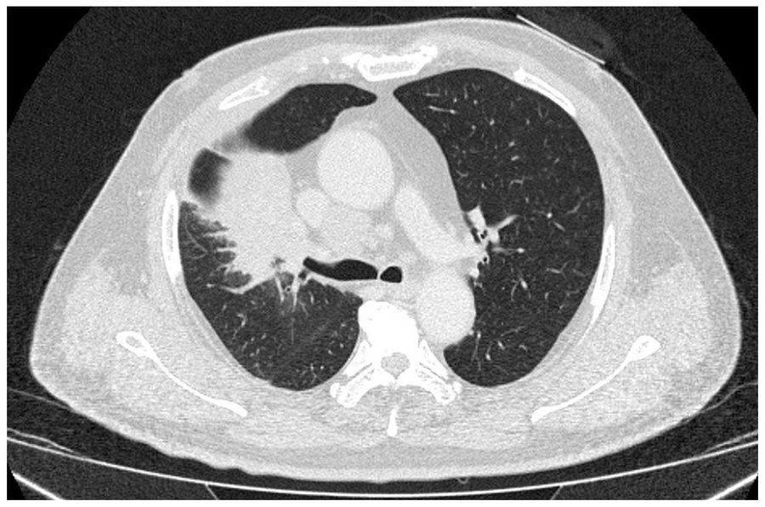  Computed tomography (CT)  Shown on the small cell slide without a caption: a central mass  Slide 42 | 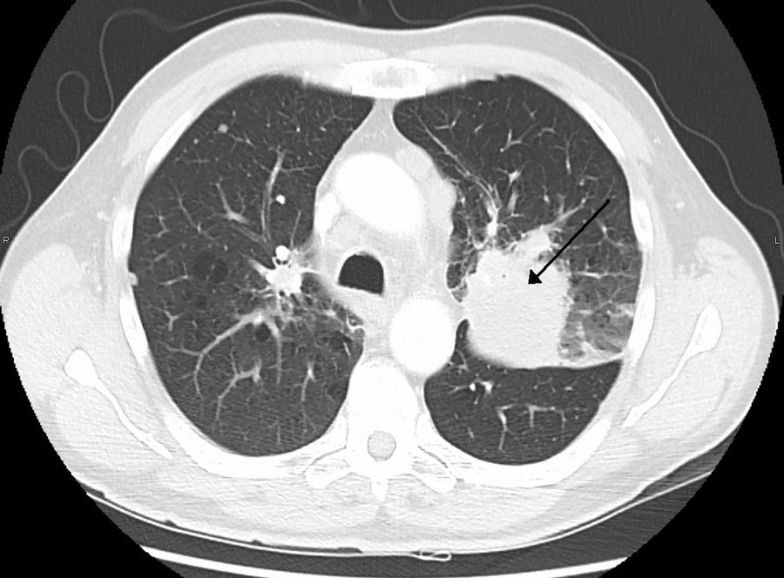  CT with an arrow  The arrow marks a mass at the hilum (central); he circled it in class  Slide 42 | 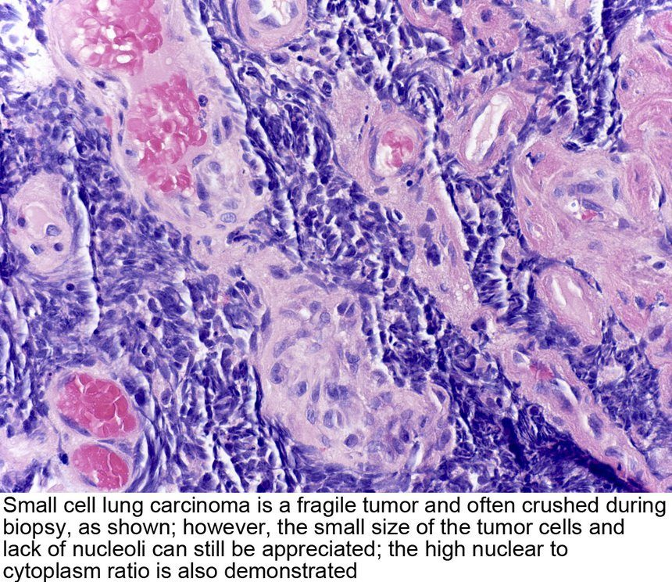  Histology  Crushed at biopsy; small cells, no nucleoli, high nuclear-to-cytoplasm ratio (the picture’s caption)  Slide 42

Small cell management is determined by the NCCN (National Comprehensive Cancer Network; slide 43). Two adjunct immunotherapies are also approved for small cell: nivolumab (Opdivo) and atezolizumab (Tecentriq). PCI = prophylactic cranial irradiation. He said not to memorize the follow-up schedule (“don’t memorize that”).
Small cell lung cancer: response assessment following initial therapy (slide 43 flowchart)
Assessment: chest X-ray (optional); chest/abdomen CT with contrast; brain magnetic resonance imaging (MRI) (preferred) or CT with contrast, if prophylactic cranial irradiation (PCI) is to be given; complete blood count; electrolytes, liver function tests, blood urea nitrogen, creatinine
Response | Stage | Adjuvant treatment | Follow-up after completion of initial therapy
Complete or partial response | Limited | PCI (category 1) | Oncology follow-up visits every 3 months during years 1–2, every 6 months during year 3, then annually
Extensive | Consider PCI ± thoracic radiotherapy | Every 2 months during year 1, every 3–4 months during years 2–3, every 6 months during years 4–5, then annually
Stable disease | Limited | — | Every 3 months during years 1–2, every 6 months during year 3, then annually
Extensive | — | Every 2 months during year 1, every 3–4 months during years 2–3, every 6 months during years 4–5, then annually
Primary progressive disease | See subsequent therapy / palliative therapy
Surveillance: at every visit, history and physical, CT chest/abdomen; bloodwork only as clinically indicated · if PCI not given, MRI (preferred) or CT brain with contrast every 3–4 months during years 1–2 · a new pulmonary nodule should initiate workup for a potential new primary · smoking cessation intervention · positron emission tomography (PET)/CT is not recommended for routine follow-up · for relapse, see subsequent therapy
Footnotes: brain MRI is more sensitive than CT for identifying brain metastases and is preferred over CT; PCI is not recommended in patients with poor performance status or impaired neurocognitive function; sequential radiotherapy to the thorax in selected patients, especially with residual thoracic disease and low-bulk extrathoracic metastatic disease that has responded to systemic therapy.

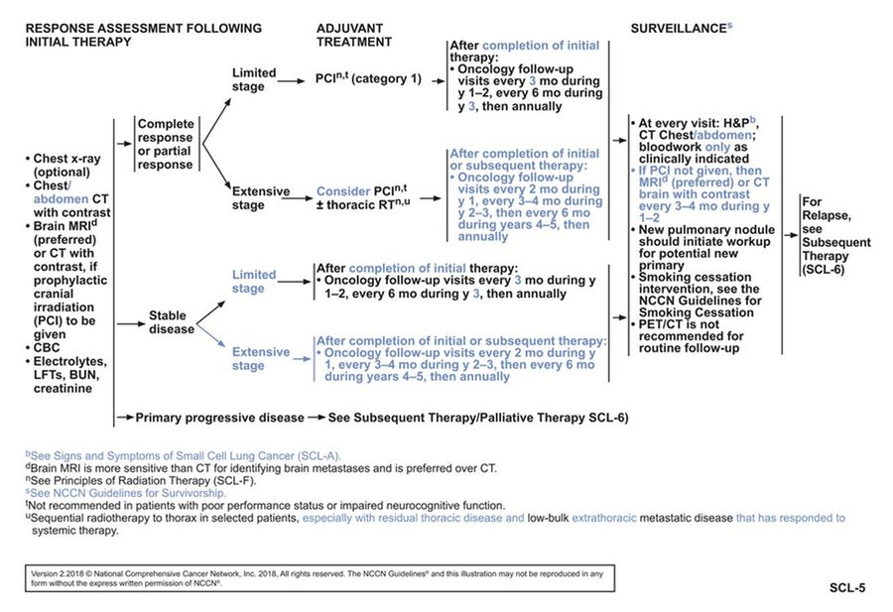
The slide’s flowchart for the table above. The point to carry: after a complete or partial response , limited stage gets prophylactic cranial irradiation and extensive stage considers it. Slide 43
- How radiotherapy is given (slide 44): a linear accelerator has single to multiple beams that fire photons or charged particles at the targeted area, limiting the amount of radiation to the whole body.
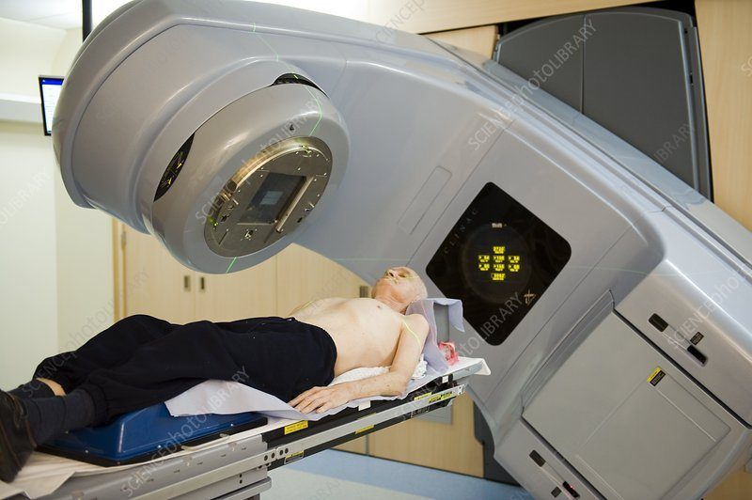  Linear accelerator  Beams aimed at the targeted area  Slide 44 | 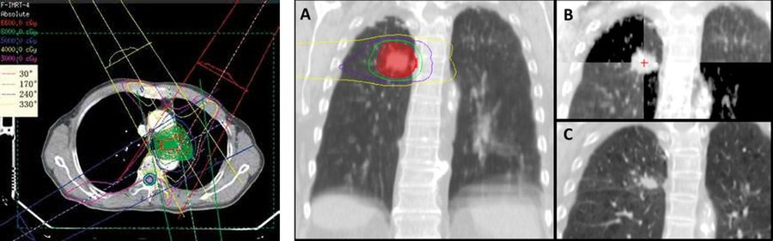  Treatment planning  Several beams cross at the tumor, limiting radiation to the rest of the body  Slide 44

Consequences of lung radiotherapy (slide 45) | What they are
Acute effects | Localized skin, mucosa and tissue changes (erythema and hyperpigmentation of skin; at risk for ulcerations); inflammation; hair loss. Less systemic effects than chemotherapy, so limited nausea and vomiting typically.
Chronic effects and changes | Pulmonary fibrosis and scarring of affected tissues; cardiovascular fibrosis and other damage to the myocardium resulting in coronary artery disease, valvular disease, or cardiomyopathy; hair loss (less systemic than chemotherapy, localized to the targeted area); lymphedema and fluid retention from damage to the lymphatic system (think axillary); neuropathy.

Small cell lung cancer (oat cell)
Defining feature: a smoker with a central mass already spread to liver, bone or brain, or who arrives confused and seizing from a low sodium (SIADH); the cancer that radiation helps most
DefinitionSmall cell (oat cell) carcinoma: central, infiltrating the mucosa, from neuroendocrine (APUD) cells; limited, extensive or combined.Who gets it15–20% of lung cancers; the type that typically causes paraneoplastic syndromes.Risk factorsGenetic risk: a lesion of the short arm of chromosome 3 (and the general lung cancer risks, 5.5).Classic signs & symptomsInsidious: over 70% are metastatic (liver, bone, brain) before detection; neuroendocrine paraneoplastic symptoms such as SIADH (confusion, seizures, ataxia).Physical exam findingsNot covered on the slides.Diagnostics / testsBiopsy: fragile, often crushed; small cells, no nucleoli, high nuclear-to-cytoplasm ratio. Staged limited versus extensive; brain MRI preferred over CT.First-line treatmentChemotherapy and radiation (it responds better than the three non-small cell types; radiation best in limited stage); prophylactic cranial irradiation after a complete or partial response (limited stage; considered in extensive); nivolumab or atezolizumab as adjunct immunotherapy.ComplicationsEarly metastasis to liver, bone and brain; high cavitation rate once large; paraneoplastic syndromes; radiotherapy effects (acute skin changes; chronic fibrosis, heart disease, lymphedema, neuropathy).
Slides 4, 30, 41–45, 48

5.15 · Lung neuroendocrine (carcinoid) tumors
- Carcinoid tumors are listed among the mixed and rare lung cancers (slide 4).
- Carcinoid syndrome (slide 48): for lung causes, it comes mainly only from a bronchial carcinoid. The release of serotonin from the cancer cells leads to multiple other symptoms, by system (the slide’s diagram):
Carcinoid syndrome (slide 48 diagram) | Findings
Skin | Cutaneous flushes; apparent cyanosis
Heart | Pulmonic and tricuspid valve thickening and stenosis; endocardial fibrosis
Respiratory | Cough, wheezing, dyspnea
Liver | Hepatomegaly
Gastrointestinal | Diarrhea, cramps, nausea, vomiting
Elsewhere | Retroperitoneal and pelvic fibrosis

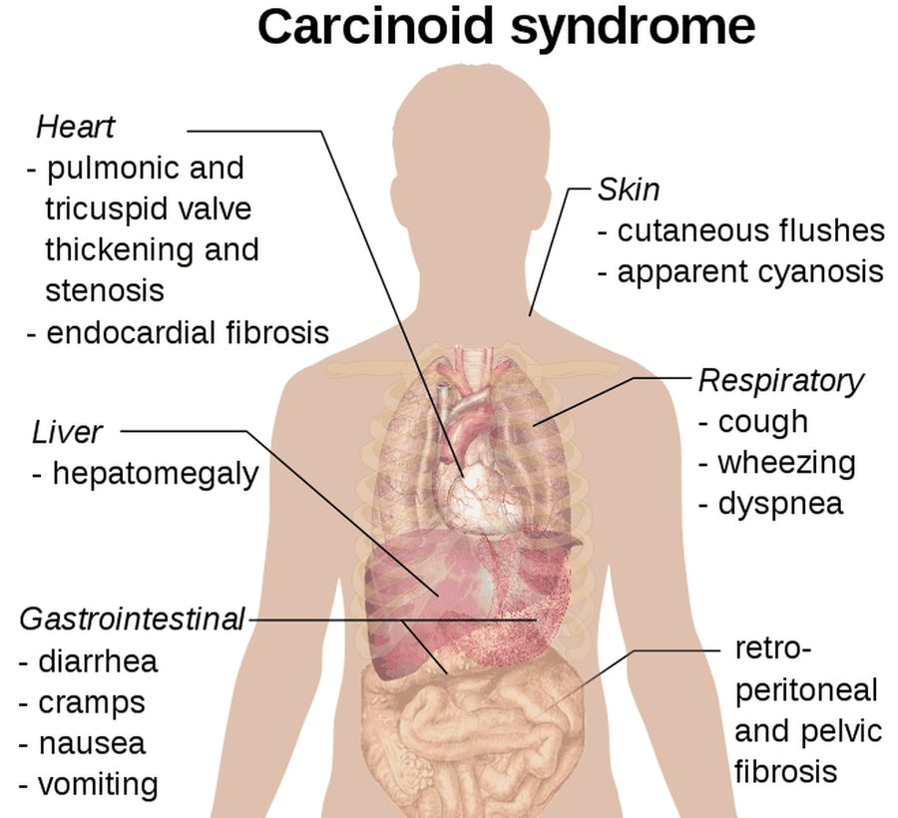
Carcinoid syndrome by system: flushing , right-sided (pulmonic and tricuspid) valve thickening , wheezing , hepatomegaly and diarrhea , with retroperitoneal and pelvic fibrosis. Slide 48
The slides give carcinoid tumors no epidemiology, imaging, diagnostic test, management or prognosis; the guide adds none.

Lung neuroendocrine (carcinoid) tumor
Defining feature: flushing, diarrhea and wheezing from serotonin, with pulmonic and tricuspid valve thickening: carcinoid syndrome from a bronchial carcinoid
DefinitionA lung neuroendocrine (carcinoid) tumor, one of the mixed and rare lung cancers; for lung causes, carcinoid syndrome comes mainly only from a bronchial carcinoid.Who gets itNot covered on the slides.Risk factorsNot covered on the slides.Classic signs & symptomsCarcinoid syndrome from serotonin release: cutaneous flushes, apparent cyanosis; diarrhea, cramps, nausea, vomiting; cough, wheezing, dyspnea.Physical exam findingsFlushing and apparent cyanosis of the skin; wheezing; hepatomegaly (the slide 48 diagram).Diagnostics / testsNot covered on the slides.First-line treatmentNot covered on the slides.ComplicationsPulmonic and tricuspid valve thickening and stenosis, endocardial fibrosis; retroperitoneal and pelvic fibrosis.
Slides 4, 48

5.16 · Paraneoplastic syndromes: SIADH, hypercalcemia and the others
★ PROFESSOR EMPHASIS
★ Paraneoplastic signs: “maybe I accidentally find lung cancer” (slides 46–48)
Paraneoplastic neoplasm associated syndromes result from secreted hormonal or cytokine effects from tumor tissue (either the primary or a metastasis); lung cancer may present with different systems involved (slide 46):
System (slide 46) | Syndrome
Endocrine | Syndrome of inappropriate antidiuretic hormone (SIADH) (small cell, slide 48); hypercalcemia (particularly squamous cell)
Neurological | Lambert-Eaton myasthenic syndrome (autoimmune); cerebellar degeneration or brain encephalitis (autoimmune). (The slide’s “central” and “peripheral” tags are not used: box at the top.)
Dermatological | Acanthosis nigricans or dermatomyositis
Hematological | Listed; the slide gives no example

“Big thing to consider, this is … we kind of hinted at this earlier … I’m gonna start getting tumors that look like neuroendocrine problems, not lung problems. So sometimes, it looks like SIADH … You can get hypercalcemia. A lot of times, your squamous cell will make your calcium, a big deal.” And: “Small cell lung cancer, you can get SIADH, because that’s real … you end up with all the same things you get with SIADH, hyponatremia, changes [to] the osmolality … that patient may show up in the [emergency department] because of the confusion and seizures, and you work it up, and you’re like, oh, that’s lung cancer.”

- SIADH from small cell (slide 48): small cell lung cancer produces carcinoma cells that also produce SIADH, through development from neuroendocrine cells in the tumor. This leads to excessive antidiuretic hormone (ADH, vasopressin) production, and the body retains too much water. The mechanisms: hyponatremia and decreased serum osmolality, resulting in confusion, seizures, ataxia and other neurological dysfunction, but no signs of peripheral or pulmonary edema (because it is insidious over time). The slides give no diagnostic criteria and no treatment for it.
- Hypercalcemia (slide 46): an endocrine paraneoplastic syndrome, particularly of squamous cell carcinoma; calcium is part of the lung cancer lab workup (the comprehensive metabolic panel including calcium, slide 14). The slides give no symptoms, mechanism or treatment for it.
- Lambert-Eaton myasthenic syndrome (slide 47): a rare autoimmune disorder causing progressive, debilitating muscle weakness, particularly in the legs. The immune system attacks calcium channels on nerve endings; the non-functioning calcium channels prevent the release of acetylcholine (ACh), the chemical that sends messages between nerves and muscles; without enough acetylcholine, muscles cannot contract properly, giving weakness. It is caused by an immune attack at the neuromuscular junction. Rare: a yearly prevalence of only 3000 patients.
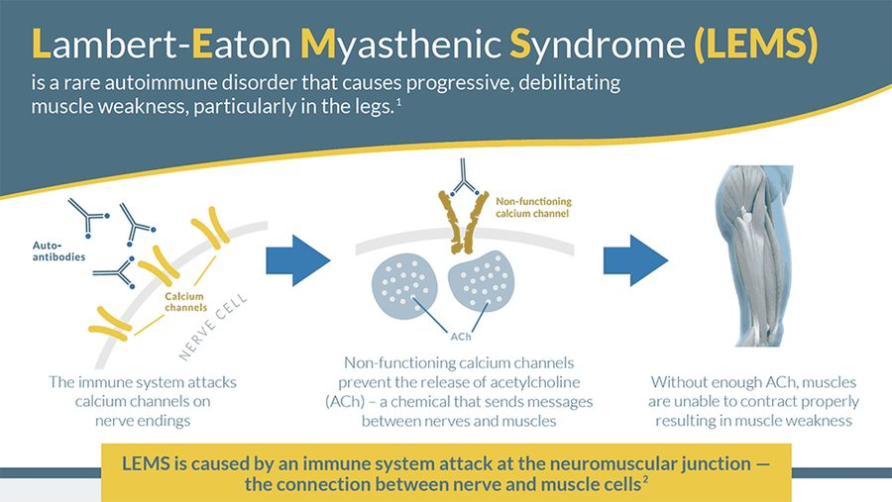
Lambert-Eaton myasthenic syndrome, left to right: autoantibodies attack the calcium channels on the nerve ending → no acetylcholine release → muscle weakness, particularly in the legs ; the attack is at the neuromuscular junction . Slide 47

SIADH (paraneoplastic, small cell)
Defining feature: a patient with small cell lung cancer, confusion, seizures or ataxia, a low sodium and low serum osmolality, and no edema
DefinitionSyndrome of inappropriate antidiuretic hormone: excessive antidiuretic hormone (vasopressin) makes the body retain too much water.Who gets itPatients with small cell lung cancer, through the tumor’s neuroendocrine cells.Risk factorsSmall cell lung cancer (an endocrine paraneoplastic syndrome).Classic signs & symptomsConfusion, seizures, ataxia and other neurological dysfunction.Physical exam findingsNo signs of peripheral or pulmonary edema (it develops insidiously).Diagnostics / testsHyponatremia and decreased serum osmolality; the slides give no diagnostic criteria.First-line treatmentNot covered on the slides.ComplicationsSeizures; it may be how the lung cancer is found (“oh, that’s lung cancer”).
Slides 46, 48

Hypercalcemia (paraneoplastic, squamous cell)
Defining feature: a high calcium in a smoker with a central squamous cell lung cancer
DefinitionAn endocrine paraneoplastic syndrome of lung cancer: a raised calcium from the tumor’s secreted effects.Who gets itParticularly patients with squamous cell carcinoma.Risk factorsSquamous cell lung cancer.Classic signs & symptomsNot covered on the slides.Physical exam findingsNot covered on the slides.Diagnostics / testsCalcium on the comprehensive metabolic panel in the lung cancer lab workup.First-line treatmentNot covered on the slides.ComplicationsNot covered on the slides.
Slides 14, 46

5.17 · Small cell lung cancer and the paraneoplastic syndromes: the link
- Where it starts: neuroendocrine cells line the bronchioles (slide 6). A tumor among them that “starts acting like a neuroendocrine cell” gives “weird neuroendocrine symptoms” (his words).
- Which cancer: the paraneoplastic syndromes are a consequence of a growing tumor, typically the small cell type (slide 4). Small cell can develop neuroendocrine paraneoplastic symptoms if the carcinoma develops from the APUD (amine precursor uptake and decarboxylation) cells that secrete polypeptide hormones (slide 41).
- How: the syndromes come from secreted hormonal or cytokine effects from tumor tissue, the primary or a metastasis (slide 46).
- The classic example: small cell → neuroendocrine cells in the tumor → excess antidiuretic hormone (vasopressin) → water retention → hyponatremia and low serum osmolality → confusion, seizures, ataxia, with no edema (slide 48).
- Why it matters: small cell is insidious and over 70% are metastatic before detection (slide 41), so the paraneoplastic picture may be the first sign: “maybe I accidentally find lung cancer.” Slide 49 asks for the paraneoplastic signs “(i.e. small cell).”
- Not every syndrome is small cell: hypercalcemia is particularly squamous cell (slide 46); carcinoid syndrome is from a bronchial carcinoid (slide 48).
Memory aid (ours): “Small cell Secretes Sodium-lowering hormone; Squamous Spikes calcium.” Small cell → SIADH (syndrome of inappropriate antidiuretic hormone: low sodium); squamous → hypercalcemia; carcinoid → serotonin (flushing, diarrhea, wheeze). Where it breaks: the neurologic and skin syndromes (Lambert-Eaton, cerebellar degeneration, encephalitis, acanthosis nigricans, dermatomyositis) are not tied to one type on the slides.

5.18 · Adults and older adults; referral and education
Domain | Adults | Older adults
Who | About 4% of lung cancers occur under 40: keep it on the differential (slide 3) | Most occur over 50 (slide 3); adenocarcinoma’s usual patient is over 50 with a smoking history (slide 31)
Screening | Symptoms at any age mean a diagnostic workup, not screening (slides 12, 18) | 55–80, at least 30 pack-years, smoking now or quit within 15 years: low-dose chest computed tomography every year; Medicare covers 55–77 (slide 18)
Treatment | Resection if the patient can tolerate surgery (survive and recover) (slide 35) | Unfit for lobectomy → anatomical segmentectomy; unfit for surgery → image-guided biopsy if possible and safe, then stereotactic ablative radiotherapy, radiofrequency ablation or conventional radical radiotherapy (slide 15)
Radiotherapy | Acute effects: skin changes (risk of ulceration), inflammation, hair loss, little nausea (slide 45) | Chronic effects: pulmonary fibrosis, coronary artery disease, valvular disease, cardiomyopathy, lymphedema, neuropathy (slide 45); prophylactic cranial irradiation is not recommended with poor performance status or impaired neurocognitive function (slide 43)
Referral | High probability of malignancy, or moderate/intense uptake on positron emission tomography: pulmonologist, thoracic surgeon, interventional radiologist or oncologist (slide 11). His framing of primary care’s job: screen, figure out risk, and refer.
Education and prognosis | Smoking drives 85–90% of cases and the risk compounds with packs per day and years (slide 3); smoking cessation is part of small cell surveillance (slide 43); screening’s upside is earlier intervention, its downside false positives and unnecessary workups (slide 18); five-year survival is only 17–18% (slide 3), because symptoms come late (slide 12).

6 · Pleural Disorders
Lecture 44 · Rob Gray, DMSc, PA-C, Adjunct Instructor (guest lecturer) · Wednesday 4 November 2026, 1–3 PM
INSTRUCTIONAL OBJECTIVES
PLEURAL DISORDERS — Rob Gray, DMSc, PA-C
- Compare and contrast the etiologies, epidemiology, risk factors, clinical manifestations, differential diagnosis, diagnostic testing (including ordering and interpretation), management (acute and chronic, including applicable rehabilitative and palliative care), appropriate referrals, patient education, and prognosis of the following: 2. Pneumothorax 3. Spontaneous 4. Traumatic 5. Hemothorax 6. Chylothorax 7. Pleural effusion 8. Pneumomediastinum 9. Pleurodynia 10. Pleurisy 11. Empyema
- Identify medical care strategies for pleural disorders in the lecture topic list for the following populations. 2. adult 3. elderly
Quoted as the syllabus prints it, its own numbering kept (it numbers the disorders 2–11 and restarts the population objective at 1, numbering the populations 2–3). Answered in order: 1 across 6.1–6.15 in the deck’s order (the pleura 6.1; pleurisy 6.2; pneumothorax and its spontaneous type 6.3–6.7; traumatic pneumothorax, with tension, 6.8; hemothorax 6.9; pneumomediastinum 6.10; pleural effusion 6.11–6.12 and 6.14; chylothorax and empyema 6.13; pleurodynia 6.15); 2 in 6.16.

NOTE
What Dr. Gray stressed, and what he said is and is not tested (the Zoom recording of the live lecture, Wednesday 4 November 2026: 1 hour 38 minutes, about 76 minutes of teaching; quotes from Zoom’s transcript, placed against the slide on screen; every fact below still comes from the slides).
- Light’s criteria (slide 101, which carries a lightbulb icon, as does the transudate slide 110): “it’s gotta meet at least one of these … And we bring it up because that makes great test questions.”
- Tension pneumothorax is recognized at the bedside, not on a film. Hypotension, a trachea pushed to one side, neck veins distended, decreased or absent breath sounds: “At that point, I don’t have to prove it … It is reasonable to act.” Of the slide 65 X-ray: “You should never ever see this before recognizing it. I will hear about it, I will find you.” Of the needle: “This needle does not solve the problem, this needle buys moments.” The class poll (slide 80) answer was tracheal deviation away from the collapsed lung: “That’s the tracheal deviation we’re looking for … test questions … gotta be pretty specific.”
- Needle decompression site (slide 67), second intercostal space over the third rib, midclavicular line: “For test purposes for now, that would be the right answer, however,” and then a patient with a large body habitus may need the fourth or fifth space (“that’s why we say typical site, not only site”; slide 68 says the same).
- The board trap on spontaneous pneumothorax (slide 20): “Your classic board question for … a secondary spontaneous pneumothorax is like … tall, skinny, Marfan … 22-year-old.” Marfan syndrome is a connective tissue disease, so the pneumothorax is secondary even in a tall, thin young man.
- Numbers he likes: the 3 cm apex-to-cupola size (“I like having a nice, easy number”; again on slide 55, “I love having a number”) and the stability list (slide 51: “You can get two sentences, and look at the vitals … So don’t overthink it”). Imaging: “don’t confuse gold standard with best initial test” (CT is the gold standard; the upright chest radiograph comes first).
- Patient education after a spontaneous pneumothorax (slides 58–60): “this may be a question you get. So, explain why it happened … recurrence can be about 50% within 3 years.”
- Effusions: “malignancy and CHF [congestive heart failure] are gonna be your frequent flyers” (slide 83); of transudates, “Most of it’s gonna be CHF … Like, 90%” (slides 110–111).
- Lighter touch, by his own words: the causes of pleurisy (“I don’t worry too much about the cause”); the procedures, a drive-by before next summer’s procedures course (“I want to introduce you, but I don’t want to make you an expert … Recognize the problem, know what the toolbox looks like … Doesn’t say ignore it”; slide 73: “don’t worry too hard about specifics at this point”); chest tube sizes (“don’t worry about it”); the slide 97 laboratory thresholds (“Don’t go crazy about this, these are all possibilities for lab testing out of the textbook”); nephrotic syndrome and pulmonary embolism as transudates (“really, really down the rabbit hole”); and the flow charts (“Do I want you to memorize the entire flow chart for things? Absolutely not, but I want you to have a reference”).
- Time on topic (minutes of teaching): pneumothorax took about 60% of the lecture: procedures 9.5, spontaneous treatment and education 9, imaging and size 8.25, types and presentation 8, traumatic and tension 7.75. Then the pleura and pleurisy 7, effusion causes and examination 6.25, effusion imaging and fluid analysis 6, hemothorax 3.75, pneumomediastinum 3.75, exudates (chylothorax, empyema) 3, pleurodynia 2, transudates and treatment 1.75. The practice sets follow these shares.

NOTE
Where the slides are loose or disagree
- The 3 cm boundary. Slide 28 calls a pneumothorax small under 3 cm and large at 3 cm or more; slide 55 puts moderate or large primary pneumothorax at “>3 cm” and slide 56 puts small secondary pneumothorax at “≤3 cm.” Exactly 3 cm is therefore never asked.
- The stability heart rate has two bounds. Slide 51 asks for a heart rate under 120 and over 60 beats per minute, so by the slide’s definition a rate below 60 counts as unstable, although a slow rate can be normal in a fit young adult. Learn the slide’s range.
- Large symptomatic primary pneumothorax. Slide 55 treats it with a chest tube; the slide 58 picture calls simple needle aspiration the “first-line evacuation method for symptomatic primary spontaneous pneumothorax” and its table lists “Simple Aspiration or Small-Bore Catheter” for “Symptomatic, large (>25% lung collapse)”. He said chest tube aloud. The picture’s percentages (<20%, >25%) are not taught as testable.
- Tension: tube or needle first? Slide 66: immediate chest tube placement is ideal; if a chest tube is not readily available, immediate needle decompression, followed by a moderate or large chest tube. The slide 58 picture puts urgent needle decompression first, then “Immediate Chest Tube.” Both agree that a chest tube follows the needle.
- Timings. Slide 53 repeats the chest film at 6–12 hours (and 24–48 hours); the slide 58 picture observes stable patients “for four to six hours.” Slide 58 sends air leaks over 72 hours (its table: “>72–96 hours”) to surgery; slide 60 seeks surgical evaluation for an air leak lasting over 4 days. Learn slide 53’s numbers.
- Recurrence figures are different windows, not a contradiction: slide 59, approaches 50% within three years; slide 60, one-third of primary cases within one to two years, over 60% after a second episode, over 75% of recurrences on the original side.
- Pulmonary embolism effusion. Slide 111 lists it among transudates; the slide 112 chart lists it among exudative common causes; the slide 83 picture calls it “variable”; slide 81 gives it altered permeability. Its class is never asked. Likewise the slide 83 picture calls malignancy, sarcoidosis, chylothorax and pancreatitis “variable,” while slides 102–106 and 112 file malignancy, pancreatic disease and chylothorax under exudates.
- First imaging for an effusion. Slide 90 opens with the upright chest radiograph; the slide 97 picture calls thoracic point-of-care ultrasound the “Preferred initial imaging modality”; slide 95 says ultrasound replaced the decubitus film.
- Pleurodynia. Slide 118: symptoms resolve in 2–4 days; the slide 119 picture: most recover in 4–6 days (no duration is keyed). Slides 116 and 118 give an elevated creatine kinase; the slide 119 picture says routine laboratory tests show no characteristic pathognomonic abnormalities. Learn the creatine kinase.
- Drug lists differ by condition: pleurisy (slide 10) methotrexate, amiodarone, hydralazine; effusion (slide 83 picture) amiodarone, methotrexate, beta blockers.
- Chest tube site. Slides 41, 68 and 73: fourth or fifth intercostal space, midaxillary line (typical); slide 73 adds the second to third intercostal space at the midclavicular line for anterior access, less common and specific to pneumothorax.
- Mechanical ventilation. Slide 17 files it under iatrogenic pneumothorax (an injury from a medical intervention); slide 61 lists it, with cardiopulmonary resuscitation, under traumatic pneumothorax. Either label can appear.
- Most common exudate. Slide 102: pneumonia is the most common cause of exudative effusion; slide 103: tuberculosis is the leading cause worldwide. Read the stem for “worldwide.”
- Secondary pneumothorax and thoracoscopic surgery. Slide 49 lists secondary pneumothorax as an indication for video-assisted thoracoscopic surgery (high recurrence, greater consequences); slide 56 observes a small asymptomatic secondary pneumothorax in hospital. Size and symptoms decide the first step; surgery is about preventing recurrence.
- Persistent air leak or a failed chest tube. Slide 49 sends a failed tube thoracostomy (persistent air leak) to video-assisted thoracoscopic surgery; the slide 58 picture says “Surgical Referral (VATS) or Heimlich Valve”; slide 50 keeps open thoracotomy for complicated cases, since it lets the surgeon examine the lung for the site of the leak.
- Recurrent malignant effusion. Slide 113 gives pleurodesis (palliative care) and the indwelling tunneled catheter for short prognoses; the slide 97 picture gives chemical pleurodesis for expandable lungs and the indwelling catheter for non-expandable lungs or rapidly recurring fluid. Both tools appear on both slides; the picture adds when to pick which.
- Where he and the slides differ (no slide was corrected, so the slides are learned): pleurodesis — he said the irritation makes “a little more extra fluid … We don’t want them to stick”; slide 45 says the irritant causes adhesions that obliterate the space. Fremitus — he said “Air speeds it up”; slide 22 gives decreased/absent fremitus in pneumothorax (and slide 87 decreased in effusion). Hemothorax film — he said a hemothorax is a straight line with no meniscus; slide 71 labels the straight line on a hemopneumothorax. Catheter aspiration — he called it “a little pigtail chest tube”; slide 38 describes a large-gauge needle on a catheter with a 3-way stopcock and a large syringe. Family history in primary pneumothorax — he linked it to connective tissue disorders; slide 19 says only “Family history (inherited association?)”. Light’s criteria — he read two of the three; all three are on slides 101 and 112.
- Slides 34, 58, 60, 74, 83, 97 and 119 are generated pictures with typing errors (“costophronic,” “pneumothorex,” “tolc,” “scute hepotension,” “Cossackievirus,” “Screoidosis,” “Einpyoma,” “NT-proBHP,” “Triglyserides”). Read for meaning; the tables below transcribe them with the spelling fixed.
- Current guidelines differ: (1) needle decompression — Advanced Trauma Life Support (10th edition, 2018) moves the adult site to the fourth or fifth intercostal space just anterior to the midaxillary line; the course teaches the second intercostal space, midclavicular line. (2) Pneumothorax size — the British Thoracic Society (2023) leans on symptoms and risk rather than size and allows conservative or ambulatory care for some large primary pneumothoraces; the course teaches the American College of Chest Physicians 3 cm rule. (3) Hemothorax — trauma guidelines also use 1500 mL or more on tube insertion, or more than 200 mL per hour sustained over 2–4 hours, before thoracotomy; the slide teaches “blood loss >200 ml/hr → thoracotomy.”

6.1 · The pleura: anatomy, normal fluid and intrapleural pressure
Pleura: anatomy (slide 3) | Parietal pleura | Visceral pleura
Where | Lines the internal surface of the thoracic cavity, diaphragm, and mediastinum | Covers the lungs
Blood supply | Systemic circulation | Pulmonary circulation
Hydrostatic pressure | Higher | Lower
Sensory innervation | Intercostal and phrenic nerve fibers | None

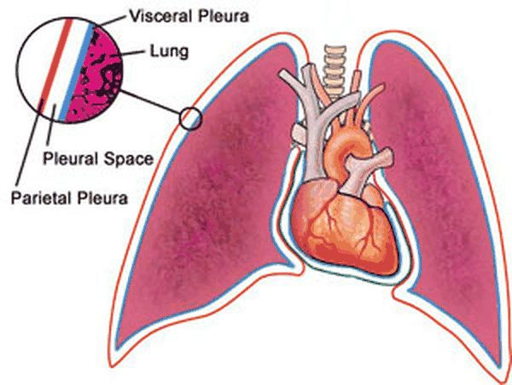
The two layers: parietal pleura outside, visceral pleura on the lung, the pleural space between them. Slide 3
- The pleural cavity (slide 4) creates a potential space and contains 10 mL of fluid (2 teaspoons). Its functions: lubrication and maintaining coupling with the chest wall.
- Normal pleural fluid (slides 5 and 98) is a clear ultrafiltrate of plasma that originates mainly from parietal pleura capillaries and is removed via parietal pleura lymphatics. Fluid inflow = fluid reabsorption; production and resorption depend on the balance of hydrostatic and oncotic pressure differences.
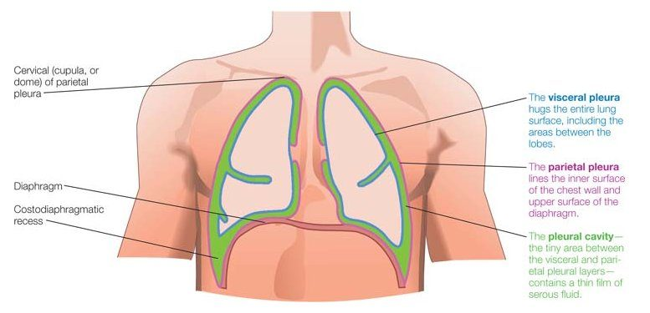
The visceral pleura hugs the whole lung surface (between the lobes too); the parietal pleura lines the chest wall and the upper surface of the diaphragm; the pleural cavity between them holds a thin film of serous fluid. Note the cervical cupula (dome) of the parietal pleura, the landmark for sizing a pneumothorax (slide 28). Slide 4
Normal pleural fluid: characteristics (slides 5, 98)
pH | 7.60–7.64
Protein | Less than 1–2 g/dL
White blood cells | Under 1000 (mostly macrophages)
Glucose | Similar to plasma
Lactate dehydrogenase (LDH) | Under 50% of plasma

- Breathing mechanics (slide 6): gases (air) travel from an area of high pressure to an area of low pressure (like diffusion).
- Intrapleural pressure (slides 7–8): pressure within the pleural cavity is always negative, slightly less than atmospheric pressure (about −4 mm Hg: 756 mm Hg against an atmospheric and intrapulmonary 760 mm Hg; transpulmonary pressure 760 − 756 = 4 mm Hg). It fluctuates during inspiration and expiration and creates suction to keep the lungs inflated: the chest wall’s inherent tendency is to expand, the lungs’ inherent tendency is to collapse (elastic recoil).
The pressures (slides 6–7)
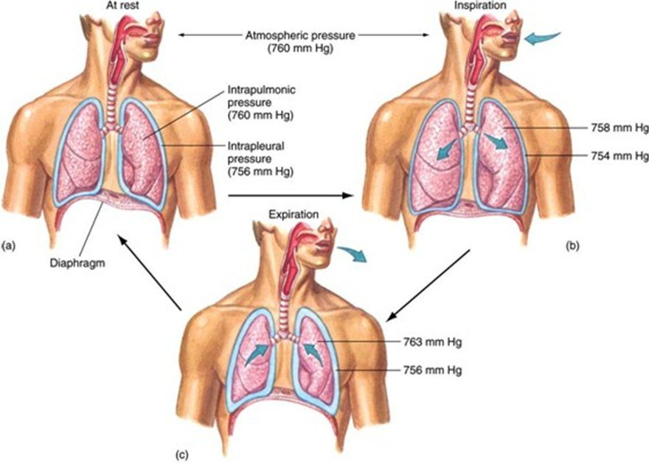  Breathing mechanics  At rest 760 / 760 / 756 mm Hg; inspiration and expiration pressures labeled  Slide 6 | 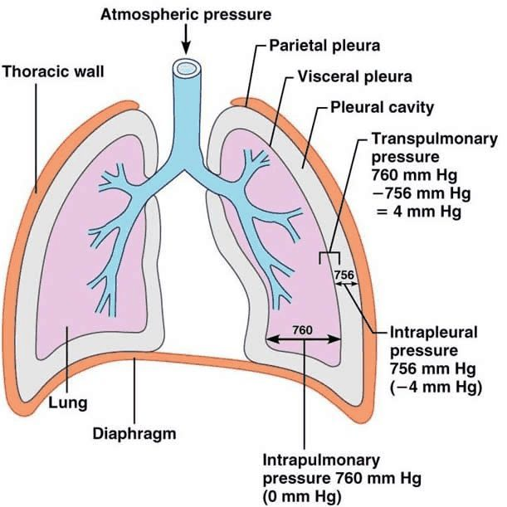  Intrapleural pressure  756 mm Hg (−4 mm Hg) against intrapulmonary 760 (0)  Slide 7

6.2 · Pleurisy
- Overview (slide 9): inflammation of the parietal pleura. It causes pleuritic pain: the pleural layers rub together, stimulating pain fibers in the parietal pleura. Not a diagnosis but rather a symptom.
- Etiology (slide 10): idiopathic; trauma; infectious (bacteria, viral); inflammatory disorders (systemic lupus erythematosus, rheumatoid arthritis); pneumothorax; pulmonary embolism; malignancy; drug reactions: chemotherapy (methotrexate), antiarrhythmics (amiodarone), antihypertensives (hydralazine). He did not dwell on the causes: “If you can identify it and treat the underlying thing, great.”
- History (slide 11): well localized (specific to a certain area) sharp or stabbing pain over the chest wall, exacerbated by deep breathing, coughing, movement, or sneezing. Inflammation of the parietal pleura on the central diaphragm (innervated by phrenic nerve fibers) may cause ipsilateral (same side) shoulder or neck pain.
- Examination (slide 12): inspection: tachypnea with limited chest wall expansion on the affected side; palpation and percussion depend on the underlying condition; auscultation: pleural friction rub — intensity varies; the sound may be grating, scratching, creaking; it may be heard during both phases of respiration; it disappears when the patient holds the breath (this differentiates it from a pericardial friction rub).
Pleurisy: differential diagnosis (slide 13) | Conditions
Need to immediately consider (“big scary things”) | Myocardial infarction, pericarditis, aortic dissection, pneumonia, pneumothorax, pulmonary embolism
Other causes to consider | Rib fracture; costochondritis (inflammation of costal cartilage); vertebral fracture; nerve root pain from herpes zoster

- Testing and treatment (slide 14): diagnostic testing depends on the underlying condition; treatment: treat the underlying condition and NSAIDs (nonsteroidal anti-inflammatory drugs).

Pleurisy
Defining feature: well-localized, sharp chest wall pain that worsens with breathing, coughing, movement or sneezing, with a pleural friction rub that disappears when the breath is held
DefinitionInflammation of the parietal pleura causing pleuritic pain; a symptom, not a diagnosis.Who gets itPatients with an underlying cause: infection, trauma, lupus or rheumatoid arthritis, pneumothorax, pulmonary embolism, malignancy, a drug reaction; or no cause found (idiopathic).Risk factorsThose conditions; drugs: methotrexate (chemotherapy), amiodarone (antiarrhythmic), hydralazine (antihypertensive).Classic signs & symptomsWell-localized sharp or stabbing chest wall pain worse with deep breathing, coughing, movement or sneezing; central diaphragmatic involvement (phrenic nerve) refers pain to the ipsilateral shoulder or neck.Physical exam findingsTachypnea with limited chest wall expansion on the affected side; pleural friction rub (grating, scratching, creaking; both phases of respiration; gone when the breath is held, unlike a pericardial rub).Diagnostics / testsDepend on the underlying condition; first consider myocardial infarction, pericarditis, aortic dissection, pneumonia, pneumothorax and pulmonary embolism.First-line treatmentTreat the underlying condition; NSAIDs (nonsteroidal anti-inflammatory drugs).ComplicationsNot covered on the slides.
Slides 9–14

6.3 · Pneumothorax: definition, types and risk factors
- Pneumothorax (slide 16): accumulation of air in the pleural space causing partial or complete lung collapse. The clinical presentation depends on the degree of lung collapse. Air can enter the intrapleural space two ways: (1) from a communication through the chest wall (for example, trauma); (2) from a communication in the lung parenchyma through the visceral pleura.
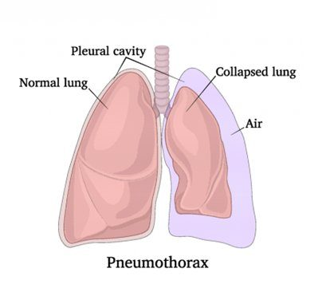
Pneumothorax: air in the pleural cavity and a collapsed lung beside a normal lung. Slide 15
Classification (slide 17) | Definition | Examples on the slide
Spontaneous, primary | No thoracic trauma; no underlying lung abnormality | (Tall, thin young males: slide 19)
Spontaneous, secondary | No thoracic trauma; underlying lung abnormality | Chronic obstructive pulmonary disease (COPD) most common; pneumonia, bronchogenic carcinoma, mesothelioma, sarcoidosis, tuberculosis, cystic fibrosis
Traumatic | History of thoracic trauma | Blunt or penetrating trauma to the thorax
Iatrogenic | Injury to the pleura secondary to a medical intervention | Thoracentesis, subclavian vein catheter placement, bronchoscopy, mechanical ventilation

His memory aid (slide 17): “primary is … this thing just blew … has a flat tire. And secondary is, I can explain the flat tire.” Iatrogenic is “like trauma, but somebody with a license did it to you.”
- Spontaneous pneumothorax: pathophysiology (slide 18). It usually involves the lung apex and is caused by a rupture of apical blebs/bullae. Bleb: small (<1 cm) air spaces within the visceral pleura (subpleural). Bulla (plural bullae): larger than blebs (>1 cm) air spaces under the visceral pleura (subpleural).
Blebs and bullae (slide 18)
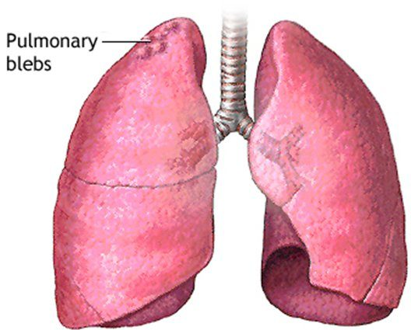  Pulmonary blebs  Small blisters at the lung apex  Slide 18 | 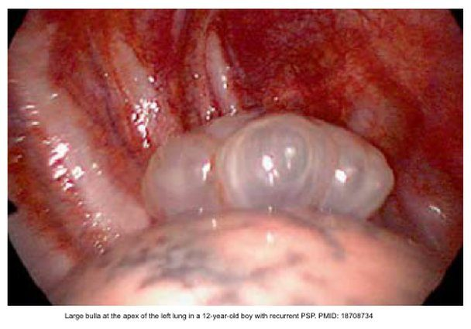  Large apical bulla  Its caption: the apex of the left lung in a 12-year-old boy with recurrent primary spontaneous pneumothorax  Slide 18 | 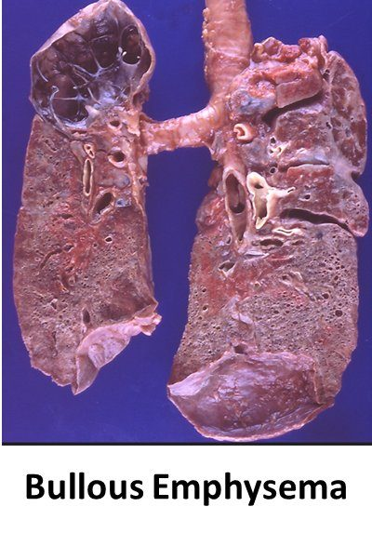  Bullous emphysema  Gross specimen with large air spaces  Slide 18

Spontaneous pneumothorax: who gets it | Primary (slide 19): no underlying lung abnormality | Secondary (slide 20): underlying lung abnormality
Risk factors | Classically in tall, thin young males; 20–40 years of age; male > female; smoking = significant risk factor; family history (inherited association?) | COPD (most common; rupture of apical blebs); lung malignancy (may be the initial symptom); cystic fibrosis; infectious disease (pneumonia or tuberculosis); interstitial lung disease (sarcoidosis); connective tissue disease (Marfan syndrome)
Severity | Patients typically have good pulmonary reserve; severe respiratory distress not common | More serious event due to the underlying lung disease: diminished pulmonary reserve can be life-threatening and requires more immediate intervention

★ PROFESSOR EMPHASIS
★ “Your classic board question” (slide 20)
A tall, thin young man looks like the primary picture (slide 19), but Marfan syndrome is a connective tissue disease, an underlying abnormality, so his pneumothorax is secondary (slide 20). Any listed lung disease (COPD, malignancy, cystic fibrosis, pneumonia, tuberculosis, sarcoidosis) makes it secondary; a tall, thin young male with none of them is primary.

6.4 · Spontaneous pneumothorax: history, examination and differential
- Primary spontaneous pneumothorax, history (slide 21): often occurs at rest; may occur during strenuous exercise. There may be a history of previous pneumothorax, as recurrence is common. May be asymptomatic (if small) or complain of fatigue. Acute onset dyspnea; ipsilateral acute pleuritic chest pain (severe stabbing pain that increases with deep breathing). Cough is less commonly observed.
- Primary spontaneous pneumothorax, examination (slides 22–23): the presentation may range from mild tachycardia to life-threatening respiratory distress, depending on the size of the pneumothorax.
- Inspection: tachypnea; decreased chest excursion on the affected side.
- Palpation: decreased/absent tactile fremitus (the transmission of vibrations from the larynx to the surface of the chest is impeded).
- Percussion: hyperresonance.
- Auscultation: tachycardia; diminished/absent breath sounds on the affected side (poor transmission of sound); decreased/absent voice sounds on the affected side (pleural air blocks the transmission of sound).
- Percussion and fremitus over a pneumothorax. Over a pneumothorax, percussion is hyperresonant and tactile fremitus is decreased or absent, because pleural air impedes the transmission of vibrations from the larynx to the chest surface. Breath and voice sounds are diminished or absent on the affected side as well.
- Secondary spontaneous pneumothorax (slide 24): occurs as a complication of underlying lung disease. The same symptoms as primary, although generally greater, because of less pulmonary reserve. An infectious cause may also bring cough, fever, chills, or fatigue. Physical examination: the same as primary spontaneous pneumothorax.
- Differential diagnoses (slide 25): myocardial infarction; pulmonary embolism; dissecting aortic aneurysm; pericarditis; pleurisy; muscle strain; costochondritis.

6.5 · Pneumothorax: imaging, size and blood gas
- Initial test (slide 26): standard upright chest radiograph. The diagnosis is established by demonstrating the visceral pleural line, which defines the interface of lung and pleural air: thin, sharp lines that are convex (curved surface) outward toward the chest wall; bronchovascular markings are not typically visible beyond the visceral pleural edge. ★ “Don’t confuse gold standard with best initial test”: the radiograph comes first; CT is the gold standard.
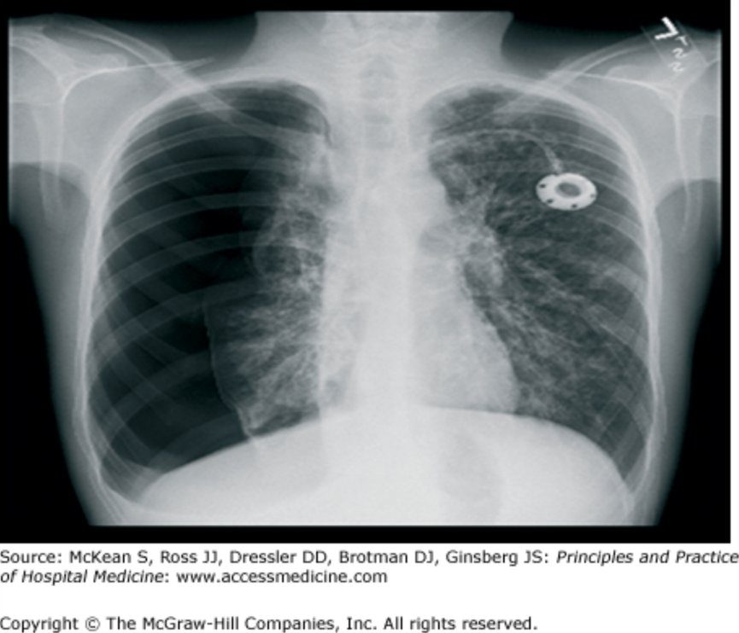
Upright chest X-ray: the right lung (left of the image) has pulled away from the chest wall. Its edge is the thin, sharp visceral pleural line , convex toward the chest wall, and the dark space beyond it has no bronchovascular markings . Slide 26
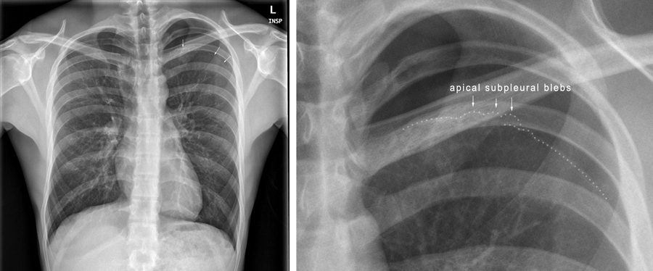
The magnified apex (right) labels the apical subpleural blebs along the dotted line, the blisters whose rupture causes spontaneous pneumothorax (slide 18). Slide 27
★ PROFESSOR EMPHASIS
★ “I like having a nice, easy number” (slide 28)
Pneumothorax size, American College of Chest Physicians (slide 28) | Apex-to-cupola distance
Small | <3 cm
Large | ≥3 cm
The picture: a = apex-to-cupola distance (American guidelines); b = interpleural distance at the level of the hilum (British guidelines). Treatment slides 53–56 word the cut slightly differently (see the box at the top).

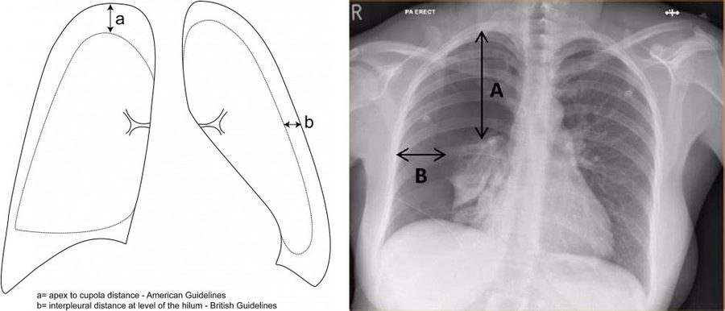
Measuring size: a/A = apex to cupola (the American guideline the course uses: under 3 cm small, 3 cm or more large); b/B = the interpleural distance at the hilum (British guidelines). Slide 28
- Deep sulcus sign (slide 29): on a film taken in the supine position, a dark and deep costophrenic angle, caused by a lateral collection of pleural air.
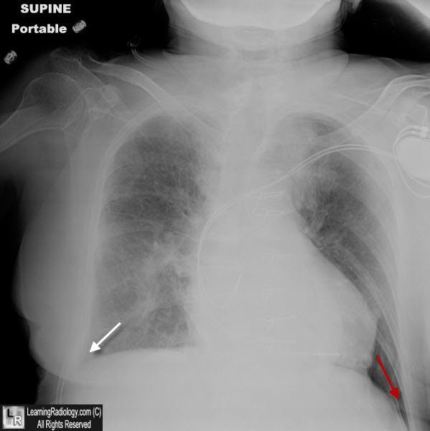
Supine portable film: look for the deep sulcus sign , a dark, deep costophrenic angle from air collecting laterally. The slide does not key its two arrows. Slide 29
- Ultrasound (slide 30): lung point-of-care ultrasound is becoming an indispensable bedside tool for rapid diagnosis of pneumothorax (beneficial for the unstable patient). It does not assess pneumothorax size. Normal: lung sliding present. Pneumothorax: lung sliding absent. (Slides 31–32 were ultrasound videos.)
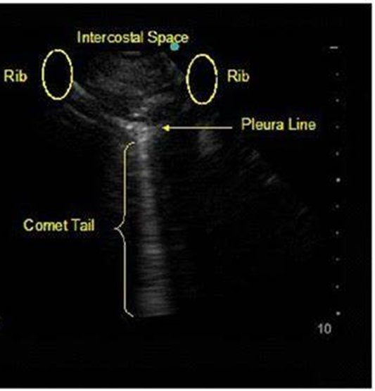
Lung ultrasound landmarks: two ribs , the intercostal space between them, the bright pleura line , and a vertical comet tail . Sliding at the pleura line is normal; its absence means pneumothorax. Slide 30
- Thoracic CT (slide 33): the best modality for determining presence, size, and location of pneumothorax, but impractical in a time-critical situation. It assesses underlying disease and detects blebs and bullae.
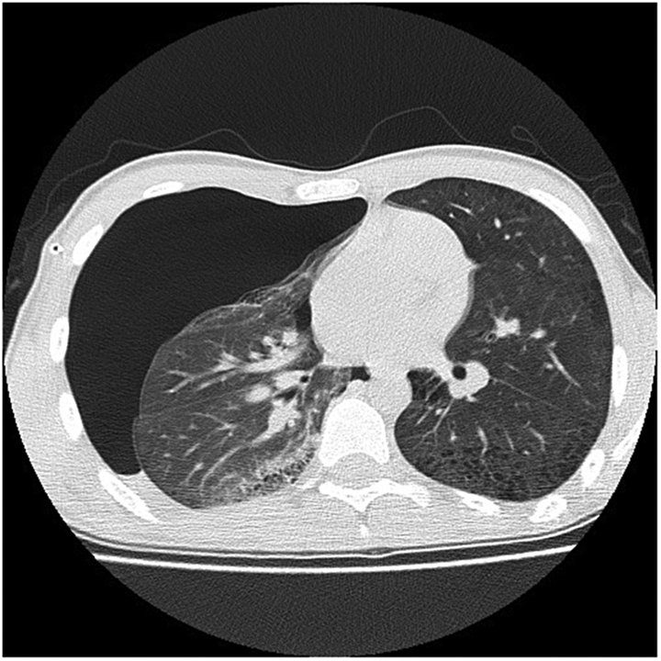
CT locates and sizes the air: the black, markings-free space in front of and beside the collapsed right lung (left of the image) is intrapleural air. Slide 33
Diagnostic testing and severity (slide 34 picture, with slides 26, 29, 30, 33)
Test | When | What it shows
Plain chest radiograph | Rapid initial triage; upright symptomatic patient screening (the initial test, slide 26) | Visceral pleural line; deep sulcus sign: lucency in the costophrenic angle on supine films
CT | Diagnostic gold standard; definitive volumetric evaluation; trauma, intensive care, complex pathology (impractical when time is critical, slide 33) | Bullae vs pneumothorax: bulla cysts show concave margins; pneumothorax lines are convex. Emphysema-like changes: identifies subpleural blebs in 80% of primary spontaneous pneumothorax cases
Lung ultrasound (point-of-care) | Bedside (under 1 minute); unstable trauma, intensive care bedside evaluation (does not size it, slide 30) | Absent lung sliding (loss of apposed pleural movement); stratosphere sign on M-mode (parallel horizontal lines replace the normal seashore pattern); the presence of B-lines rules out pneumothorax
Radiographic tension signs: mediastinal shift and diaphragmatic depression signal life-threatening tension (on screen he added: “radiographic tension signs you should not see, because you should be recognizing this”).

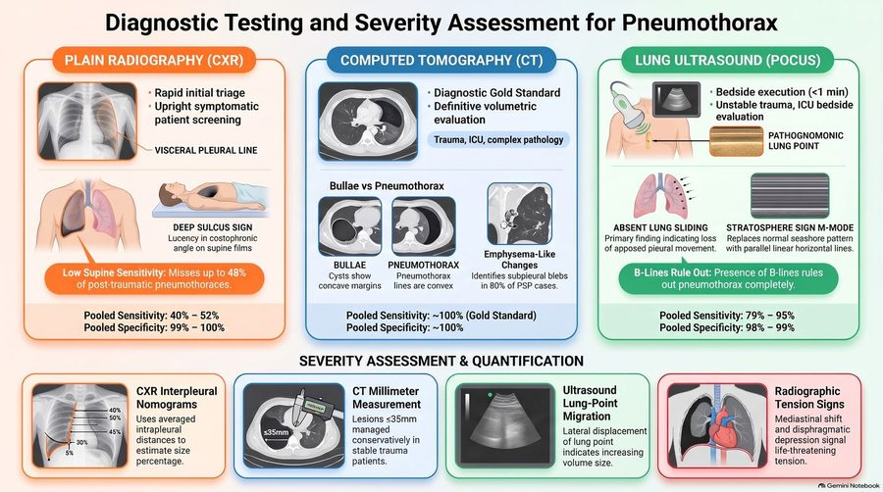
The picture the table above is read from. Its pooled sensitivity and specificity figures, the nomograms, the CT millimeter rule and the “lung point” boxes were not taught and are not keyed. Slide 34
- Arterial blood gas (slide 35): often unnecessary. Indications: severe underlying lung disease; persistent respiratory distress (tachypnea, accessory muscle use, oxygen saturation <92%) despite treatment. The result depends on ventilation status and compensatory response, and usually reveals hypoxemia and respiratory alkalosis.

6.6 · Treatment goals and the procedures
He called this part a drive-by before next summer’s procedures course: “Recognize the problem, know what the toolbox looks like.”
- Goals of therapy (slide 36): evacuate the space; achieve closure of the leak; prevent or reduce the risk of recurrence. Therapy depends on: severity (size and symptoms); clinical status of the patient; cause; underlying lung disease; prior history of pneumothorax; risk of recurrence; availability of therapeutic options; clinician expertise.
- The options (slide 37), “sometimes we’ll do more than one”: catheter aspiration; Heimlich valve; chest tube (thoracostomy tube) insertion; pleurodesis; operative therapy: video-assisted thoracoscopic surgery and open thoracotomy.
- Catheter aspiration (slide 38): sterile technique; a large-gauge needle attached to a catheter with a 3-way stopcock attached to a large syringe. Site: side of the pneumothorax, 2nd intercostal space, over the 3rd rib, midclavicular line. If more than 2 liters are removed, consider a persistent air leak. Obtain a post-procedure chest X-ray.
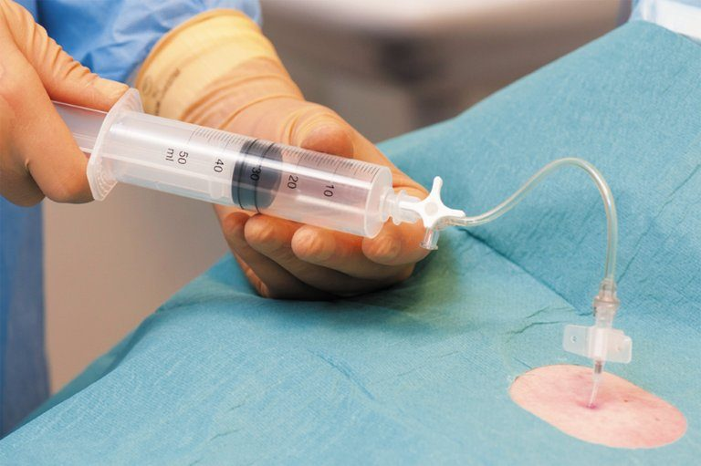
Catheter aspiration under sterile drapes: a large syringe connected through a stopcock to the catheter in the chest wall. Slide 38
Catheter aspiration: contraindications (slide 39)
Traumatic pneumothorax · Tension pneumothorax · Hemodynamic instability · Underlying pulmonary disease · Recurrent pneumothorax · Bilateral pneumothoraces · Bleeding disorders

- Heimlich valve (slide 40): a one-way flutter valve; the device is small and portable (promotes ambulation). It is attached to a tube inserted in the chest and is open to air or attached to a drainage bag.
Heimlich valve (slide 40)
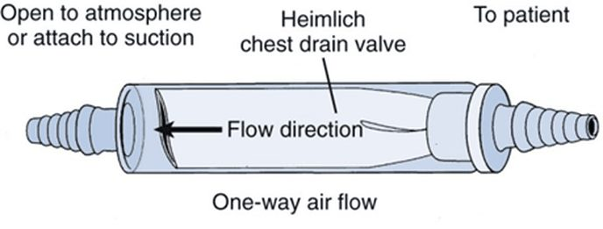  The valve  One-way air flow from the patient end; open to atmosphere or suction  Slide 40 | 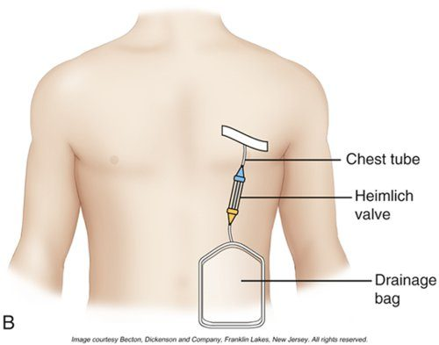  In use  Chest tube, Heimlich valve, drainage bag  Slide 40

- Chest tube (thoracostomy tube) (slide 41): a clear plastic tube in various diameters with a series of holes at the distal end. Chest tube thoracostomy = placement of a chest tube to drain fluid or air from the pleural space. Indications: pneumothorax or pleural effusion. Most common site: fourth or fifth intercostal space, midaxillary line. (The slide 42 video was not played; tube sizes: “don’t worry about it.”)
Chest tube drainage collection systems (slides 43–44), shown for reference: he passed over them (“I don’t want to make you an expert”) and no question asks about the chambers
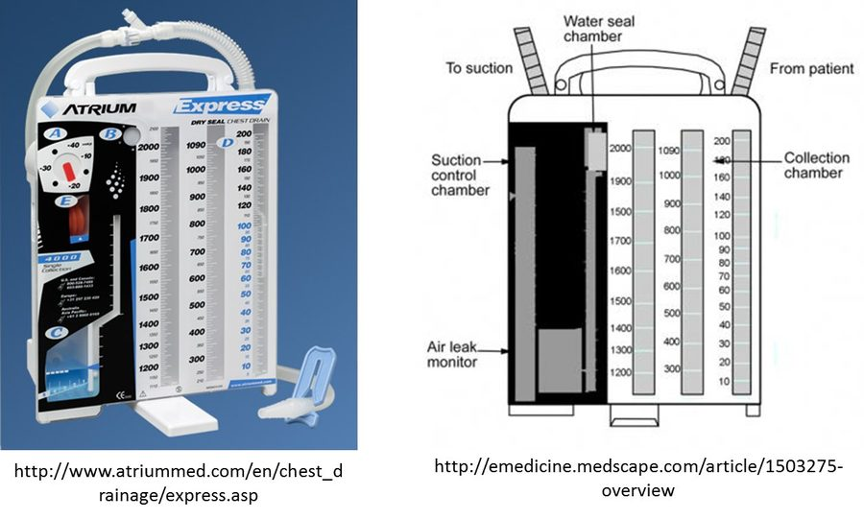  Drainage unit  Collection, water seal and suction control chambers  Slide 43 | 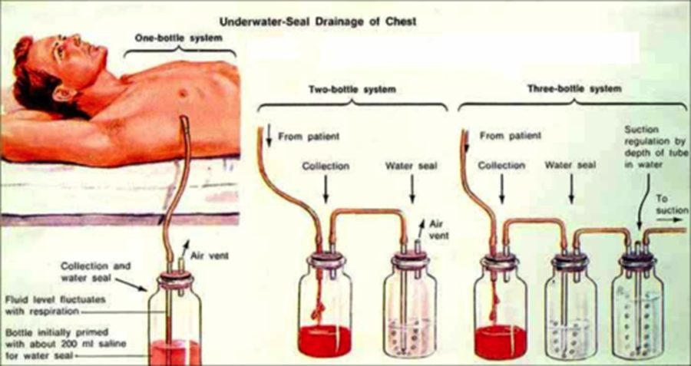  Bottle systems  One-, two- and three-bottle underwater-seal drainage  Slide 44

- Pleurodesis (slide 45), mechanism: obliterates the pleural space by inducing intrapleural space inflammation; the irritant causes adhesions of the two layers of pleura, which helps keep the lung inflated (pneumothorax) and leaves no room for additional fluid to accumulate (pleural effusion). Indications: prevent recurrent or treat resistant pneumothorax; pleural effusion. The most common indication is malignant pleural effusion (breast or lung cancer in the majority of cases).
Pleurodesis types (slide 46) | What is done | How
Mechanical | Manual abrasion to the pleura | Via surgical intervention
Chemical | Instillation of a sclerosant (drugs or talc) into the pleural space | Via chest tube or thoracoscopically

The thoracoscopic views under each column (slide 46)
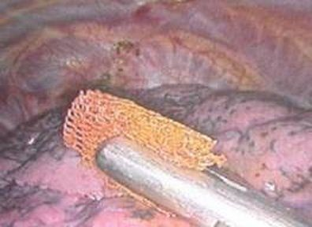  Mechanical  Abrasion pad on the pleura  Slide 46 | 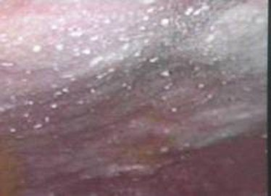  Chemical  Pleura dusted with white particles  Slide 46

- Video-assisted thoracoscopic surgery (slide 47): an endoscopic procedure through small incisions in the chest that gives access for stapling/resection of blebs and pleurodesis; it has largely replaced open biopsy; robotic approaches are increasing in use.
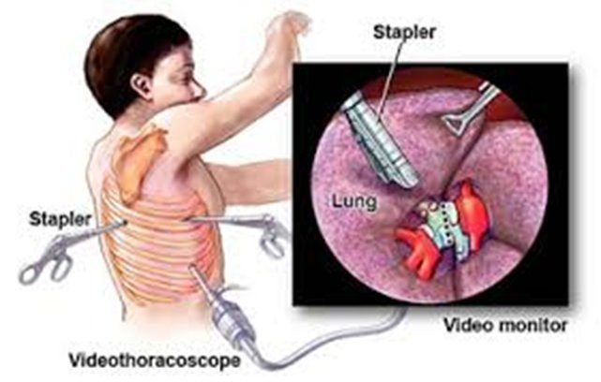
Video-assisted thoracoscopic surgery: a videothoracoscope and staplers through small incisions, the lung seen on the video monitor. Slide 48
Video-assisted thoracoscopic surgery (slide 49)
Indications | Recurrences of spontaneous pneumothorax; bilateral pneumothorax; failure of tube thoracostomy (failure of the lung to expand or a persistent air leak); secondary pneumothorax, because of high recurrence rates and greater consequences of recurrence
Risks | Patient discomfort; risks of general anesthesia; greater financial cost

- Open thoracotomy (slide 50): video-assisted thoracoscopic surgery has supplanted thoracotomy as surgical treatment of pneumothorax, but open thoracotomy remains a valuable option for complicated cases. Benefits: examination of the lung for the site of the air leak; lysis of previous adhesions. Drawbacks: general anesthesia risks, increased costs, significant patient discomfort.

6.7 · Spontaneous pneumothorax: stability, treatment and education
★ PROFESSOR EMPHASIS
★ “So don’t overthink it” (slide 51)
Definition of stability, American College of Chest Physicians (slide 51): all of the following
Respiratory rate <24 breaths per minute
Heart rate <120 and >60 beats per minute
Normal blood pressure (not defined)
Room air oxygen saturation >90 percent
Ability to speak in whole sentences
All other patients are considered unstable.

Treatment depends on the size of the pneumothorax, the patient’s clinical symptoms, and whether it is a first or recurrent episode (slide 52). His rule of thumb: “small is small, large is large.”
Spontaneous pneumothorax: presentation | Treatment
Primary, small (<3 cm at apex), asymptomatic or minimal symptoms (for example, pain, dyspnea) (slide 53) | Observation; adequate analgesia; oxygen at 100% via non-rebreather mask (accelerates resorption of air); repeat chest X-ray in 6–12 hours to assure the pneumothorax has not expanded; discharge if the pneumothorax is stable and the patient asymptomatic; repeat chest X-ray in 24–48 hours
Primary, small (<3 cm at apex) with significant dyspnea after analgesia (slide 54) | Catheter aspiration; Heimlich valve or chest tube insertion. A chest tube is indicated for failure of observation (enlarging pneumothorax, persistent tachypnea >30 breaths per minute, saturation <90% on room air) or of catheter aspiration
Primary, moderate or large (>3 cm at apex), moderate or severe symptoms (for example, significant chest pain, dyspnea) (slide 55) | Chest tube insertion
Primary, recurrent (slide 55) | Surgical therapy (video-assisted thoracoscopic surgery) with pleurodesis
Secondary, small (≤3 cm at apex-cupola), asymptomatic or mild symptoms (slide 56) | Observation for a small asymptomatic pneumothorax; chest tube insertion for symptoms or persistent air leak; hospitalization for monitoring and supportive care
Secondary, in general: more life-threatening because of the lack of pulmonary reserve (slide 57) | Most are treated with chest tube insertion; may be treated with video-assisted thoracoscopic surgery or thoracotomy with bleb stapling and pleural abrasion (mechanical pleurodesis); if surgery is not an option, chemical pleurodesis via chest tube

Quick differential matrix: presentation to primary management (slide 58 picture)
Presentation type | Severity / clinical features | Primary management strategy
Primary spontaneous | Small (<20%), minimal symptoms, physiologically stable | Observation + high-flow oxygen
Symptomatic, large (>25% lung collapse) | Simple aspiration or small-bore catheter
Secondary spontaneous | Underlying disease (chronic obstructive pulmonary disease (COPD), cystic fibrosis), low reserve | Tube thoracostomy (+ chemical pleurodesis)
Persistent air leak | Unresolved air egress >72–96 hours | Surgical referral (video-assisted thoracoscopic surgery) or Heimlich valve
Tension pneumothorax | Hypotension, tracheal shift, acute distress | Immediate decompression then chest tube
The picture’s five columns add: clinical observation of stable patients and high-flow oxygen therapy (speeds pleural gas absorption by lowering nitrogen pressure); simple needle aspiration (“first-line evacuation method for symptomatic primary spontaneous pneumothorax”) and small-bore pigtail catheter placement; formal tube thoracostomy (“required initial intervention for secondary pneumothorax like COPD”) and one-way flutter valves (outpatient management of leaks); chemical sclerosant pleurodesis (talc) and operative stapling for persistent leaks; urgent needle decompression then an immediate large-bore chest tube for tension. The percentages and hour counts differ from slides 53–55 and are not keyed (box at the top).

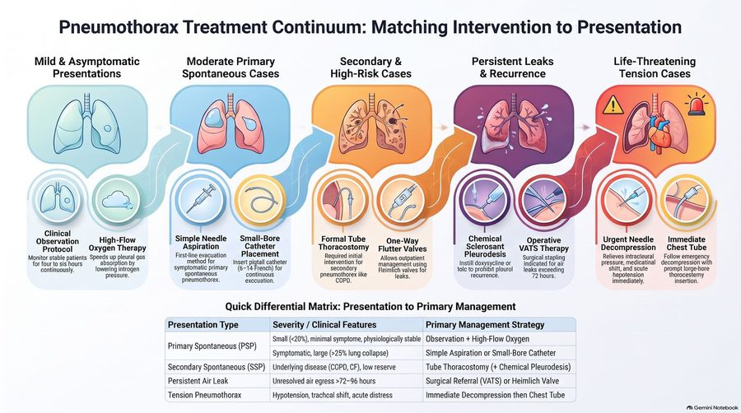
The picture the matrix above is read from: the continuum runs from observation and oxygen, through aspiration and catheters, tube thoracostomy and flutter valves, pleurodesis and surgery, to needle decompression and chest tube for tension. Slide 58
★ PROFESSOR EMPHASIS
★ “this may be a question you get” (slides 58–60)
Patient education (slide 59): explain the condition to the patient. Recurrence approaches 50% within three years after an initial spontaneous pneumothorax. The best preventive procedure: video-assisted thoracoscopic surgery with pleurodesis. Discuss the importance of smoking cessation; help if willing to quit.
Patient recovery guide: lifestyle, follow-up and referrals (slide 60 picture)
Lifestyle and activity | Stop tobacco use: smoking increases recurrence risk up to 100-fold; quitting lowers risk. Delay air travel: wait 7–14 days after resolution and confirm with a chest X-ray. Avoid scuba diving: high-pressure activities like diving carry severe recurrence dangers. Pause positive pressure: hold positive-pressure therapies during active air leaks.
Follow-up and recurrence | Confirm lung resolution with follow-up chest X-rays (complete re-expansion). One-third of primary cases recur within one to two years; recurrence risk jumps above 60% after a second episode; over 75% of recurrent pneumothoraces occur on the original side.
Referrals and surgery | Surgical evaluation if an air leak lasts over 4 days; pilots and divers need early surgical evaluation for safety; refer to genetics if the family history reveals spontaneous pneumothorax; consider video-assisted surgery, which closes leaks to prevent future collapses.

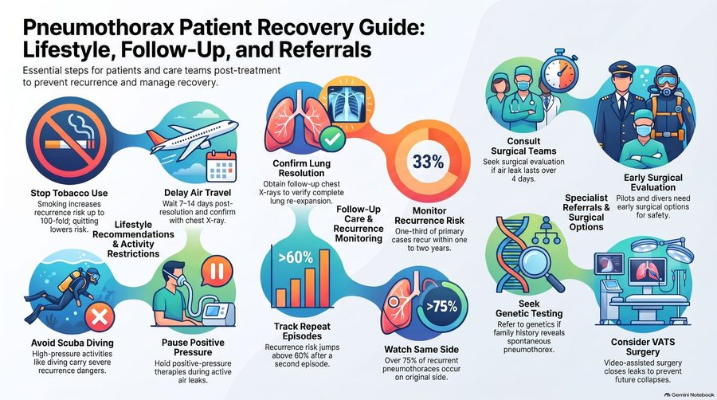
The picture the recovery table above is read from: lifestyle on the left, follow-up and recurrence in the middle, referrals on the right. Slide 60

Primary spontaneous pneumothorax
Defining feature: a tall, thin young man (20–40) who smokes, with sudden dyspnea and one-sided pleuritic chest pain at rest, hyperresonance and absent breath sounds on that side, and no lung disease
DefinitionAir in the pleural space with no thoracic trauma and no underlying lung abnormality, usually from rupture of apical blebs or bullae.Who gets itClassically tall, thin young males, 20–40 years of age; male > female; good pulmonary reserve.Risk factorsSmoking (significant); family history (inherited association?); apical blebs.Classic signs & symptomsAcute onset dyspnea and ipsilateral acute pleuritic chest pain (severe, stabbing, worse with deep breathing), often at rest; may be asymptomatic if small; cough less common; recurrence common.Physical exam findingsTachypnea, tachycardia, decreased chest excursion, decreased/absent tactile fremitus, hyperresonance, diminished/absent breath and voice sounds on the affected side.Diagnostics / testsUpright chest radiograph first (visceral pleural line); size by apex-to-cupola distance (<3 cm small); ultrasound at the bedside (absent lung sliding); CT is the gold standard; blood gas often unnecessary.First-line treatmentSmall with minimal symptoms: observation, analgesia, 100% oxygen by non-rebreather, films at 6–12 and 24–48 hours. Small with significant dyspnea: catheter aspiration, Heimlich valve or chest tube. Large (>3 cm) and symptomatic: chest tube. Recurrent: video-assisted thoracoscopic surgery with pleurodesis.ComplicationsRecurrence (approaches 50% within three years); persistent air leak.EducationSmoking cessation; delay air travel 7–14 days after resolution with a confirming film; avoid scuba diving; early surgical evaluation for pilots and divers; genetics referral for a family history of spontaneous pneumothorax.
Slides 17–19, 21–23, 26–35, 51–55, 58–60

Secondary spontaneous pneumothorax
Defining feature: a pneumothorax in a patient with lung disease (COPD most often, or cancer, cystic fibrosis, pneumonia, tuberculosis, sarcoidosis, Marfan syndrome), sicker than the primary picture because of poor reserve
DefinitionAir in the pleural space with no thoracic trauma but with an underlying lung abnormality.Who gets itPatients with COPD (most common), lung malignancy, cystic fibrosis, pneumonia or tuberculosis, sarcoidosis, or connective tissue disease such as Marfan syndrome.Risk factorsThe underlying disease; in COPD, rupture of apical blebs.Classic signs & symptomsThe same symptoms as primary, generally greater (less reserve); an infectious cause adds cough, fever, chills or fatigue; in lung cancer it may be the initial symptom.Physical exam findingsThe same as primary spontaneous pneumothorax.Diagnostics / testsThe same imaging; arterial blood gas for severe underlying lung disease or persistent distress (saturation <92%) despite treatment, usually hypoxemia and respiratory alkalosis.First-line treatmentMost: chest tube insertion. Small (≤3 cm) and asymptomatic: observation, chest tube for symptoms or persistent air leak, hospitalization. Surgery (video-assisted or thoracotomy with bleb stapling and pleural abrasion); chemical pleurodesis via chest tube if surgery is not an option. Catheter aspiration is contraindicated with underlying pulmonary disease.ComplicationsLife-threatening because of diminished reserve; high recurrence rates with greater consequences (an indication for video-assisted surgery).
Slides 17, 20, 24, 35, 39, 49, 56–58

6.8 · Traumatic and tension pneumothorax; needle decompression
- Traumatic pneumothorax (slide 61): penetrating (gunshot or stab) wound or blunt chest trauma (rib fracture tears lung), CPR (cardiopulmonary resuscitation), or mechanical ventilation. Ask: “Have you had any trauma?”
Types of traumatic pneumothorax (slide 62) | Wound | How air gets in
Closed | No external wound | Air enters the pleural space from the lung due to broken ribs or internal injuries
Open | Direct wound in the chest wall | Allows air to enter the pleural space during inhalation; can lead to a sucking chest wound

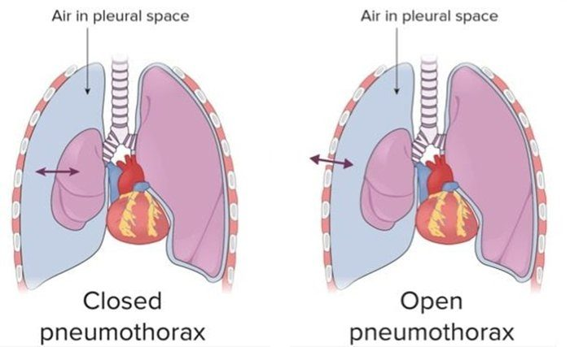
Closed pneumothorax (left): air from the lung, no wound. Open pneumothorax (right): air through the chest wall. Slide 62
- Tension pneumothorax (slide 63) is a life-threatening complication that occurs when air enters the pleural space but cannot escape: a one-way valve traps air in the pleural space.
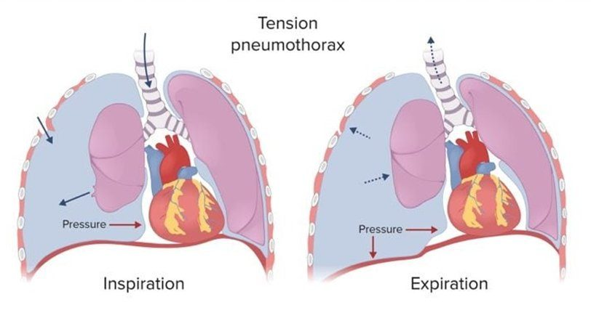
The one-way valve: air enters on inspiration and cannot leave on expiration , so pressure builds and pushes the mediastinum toward the other side. Slide 63
★ PROFESSOR EMPHASIS
★ “It is reasonable to act”: tension pneumothorax (slides 64–66; the slide 80 poll)
- Slide 64: severe ventilatory compromise; mediastinal shift to the contralateral side → decreased venous return to the heart and decreased cardiac output; hypotension, tracheal deviation, and neck vein distention; decreased/absent breath sounds.
- The poll he ran (slide 80): “Which of the following is most associated with a tension pneumothorax?” Hypertension, tracheal deviation away from the collapsed lung, bradycardia, subcutaneous emphysema in the neck. He confirmed the tracheal deviation. (Subcutaneous emphysema in the neck is the pneumomediastinum finding of slide 77; the tension slides give hypotension, not hypertension, and do not list bradycardia.)
- Slide 66: medical emergency. Clinical diagnosis: time is critical (you don’t have time for the X-ray). Immediate chest tube placement is ideal; if a chest tube is not readily available, perform immediate needle decompression, followed by moderate or large-size chest tube insertion; admission.

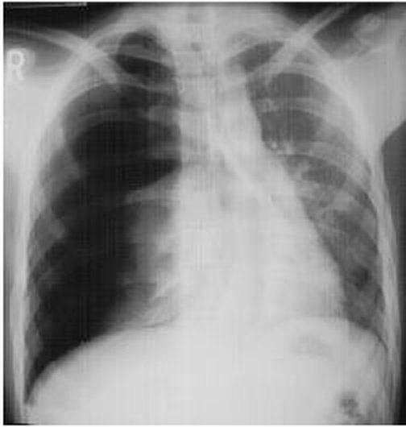
“Nice picture, right? PURELY ACADEMIC. You should never, ever see this before recognizing it and acting to fix it.” The right chest is black with no lung markings and the mediastinum is pushed to the other side. Slide 65
- Needle decompression (slide 67), also known as needle thoracostomy: insertion of a needle into the pleural space to decompress a tension pneumothorax.
★ PROFESSOR EMPHASIS
★ “For test purposes for now, that would be the right answer” (slide 67)
Procedure sites (slides 38, 41, 67, 68, 73) | Site
Needle decompression (needle thoracostomy), the typical site (slides 67; 68, “A”) | Thoracic side of the pneumothorax; 2nd intercostal space; over the 3rd rib; midclavicular line
Catheter aspiration (slide 38) | Side of the pneumothorax; 2nd intercostal space; over the 3rd rib; midclavicular line
Chest tube (slides 41; 68, “B”; 73) | 4th or 5th intercostal space, midaxillary line (most common, typical); slide 73: between the 2nd and 3rd intercostal space at the midclavicular line for anterior access (less common, specific to pneumothorax)
Slide 68: “You have options; consider patient body habitus and choose wisely!” He added that in a large patient the needle at the second or third space may not reach, so the 4th or 5th space may be used: “typical site, not only site.”

Needle decompression (slides 67–68)
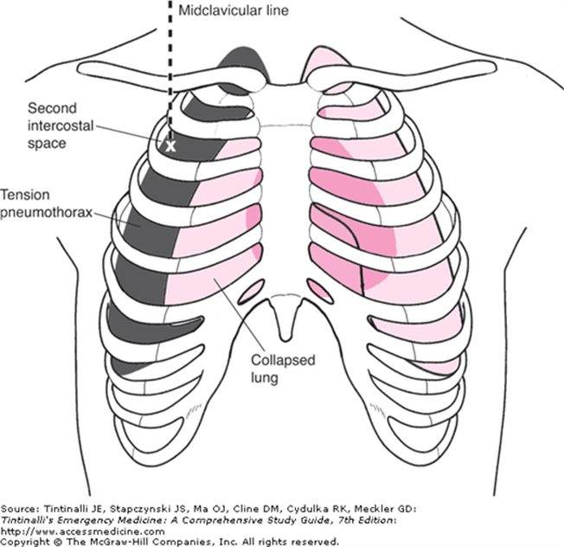  The typical site  Second intercostal space at the midclavicular line, on the tension side  Slide 67 | 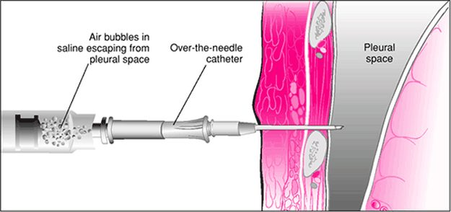  Over-the-needle catheter  Air bubbles in the saline show air escaping from the pleural space  Slide 67

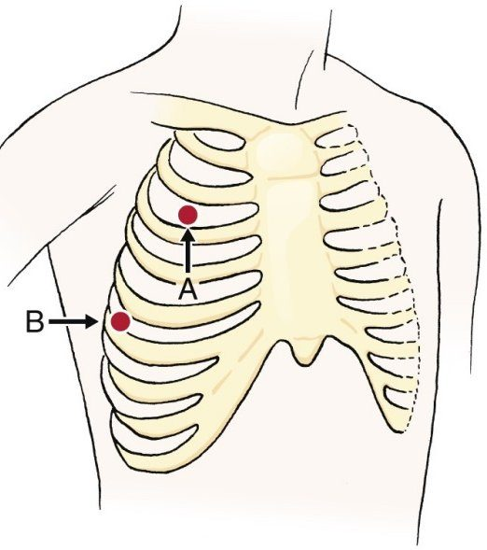
A = needle decompression: second intercostal space, midclavicular line . B = chest tube: fourth or fifth intercostal space, midaxillary line . Slide 68

Traumatic pneumothorax (closed and open)
Defining feature: a pneumothorax after a stab or gunshot wound, blunt chest trauma with rib fractures, CPR or mechanical ventilation; an open chest-wall wound that draws air in on inhalation (sucking chest wound)
DefinitionPneumothorax with a history of thoracic trauma, blunt or penetrating: closed (no external wound; air from the lung via broken ribs or internal injury) or open (a chest-wall wound lets air in during inhalation).Who gets itPatients with penetrating (gunshot, stab) or blunt chest trauma, after CPR, or on mechanical ventilation; iatrogenic cases follow thoracentesis, subclavian vein catheter placement, bronchoscopy or mechanical ventilation.Risk factorsChest trauma; rib fracture tearing the lung; medical interventions near the pleura.Classic signs & symptomsA trauma history (“Have you had any trauma?”); presentation depends on the degree of lung collapse.Physical exam findingsAn open wound may become a sucking chest wound; the pneumothorax findings of slides 22–23; tension signs if a one-way valve forms.Diagnostics / testsBedside ultrasound in unstable trauma; CT in trauma when time allows; upright radiograph.First-line treatmentChest tube (thoracostomy) to drain air or fluid; catheter aspiration is contraindicated in traumatic pneumothorax.ComplicationsTension pneumothorax (life-threatening); hemopneumothorax.
Slides 16–17, 30, 34, 39, 41, 61–63

Tension pneumothorax
Defining feature: hypotension, tracheal deviation away from the collapsed lung, distended neck veins and absent breath sounds on one side: a clinical diagnosis, treated before any film
DefinitionA life-threatening complication of pneumothorax: air enters the pleural space but cannot escape (a one-way valve).Who gets itPatients with a pneumothorax, taught under traumatic pneumothorax (trauma, CPR, mechanical ventilation).Risk factorsTraumatic pneumothorax; mechanical ventilation.Classic signs & symptomsSevere ventilatory compromise with hypotension, tracheal deviation and neck vein distention.Physical exam findingsTrachea deviated away from the collapsed lung (mediastinal shift to the contralateral side); distended neck veins; decreased/absent breath sounds; hypotension from decreased venous return and cardiac output.Diagnostics / testsClinical diagnosis: no time for the X-ray (radiographic signs, mediastinal shift and diaphragmatic depression, should never be seen first).First-line treatmentImmediate chest tube is ideal; if not readily available, immediate needle decompression (2nd intercostal space, over the 3rd rib, midclavicular line), followed by a moderate or large chest tube; admission. Catheter aspiration is contraindicated.ComplicationsSevere ventilatory compromise; decreased venous return and cardiac output with hypotension; life-threatening if not recognized and treated at once.
Slides 34, 39, 58, 63–68

6.9 · Hemothorax
- Etiology (slide 69): trauma is the most common cause: injury to the heart or vasculature, lung parenchyma, intercostal/pulmonary/internal thoracic arteries; also neoplasms.
- Treatment (slide 69): chest tube — evacuate and quantify the bleeding. If blood loss >200 mL/hr → thoracotomy (an open approach to gain access to the intrathoracic space).
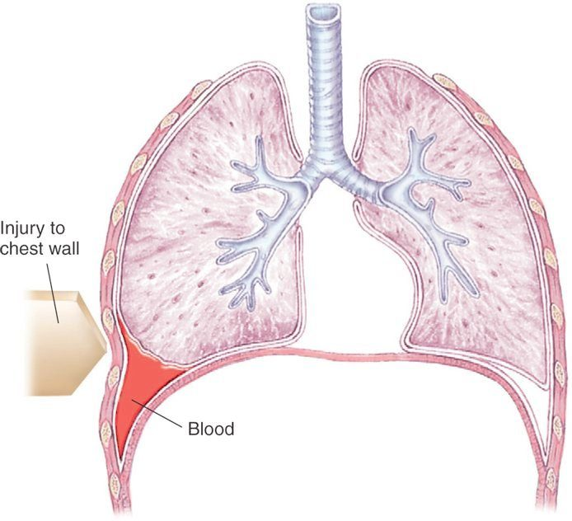
Hemothorax: an injury to the chest wall and blood collecting in the pleural space at the base. Slide 70
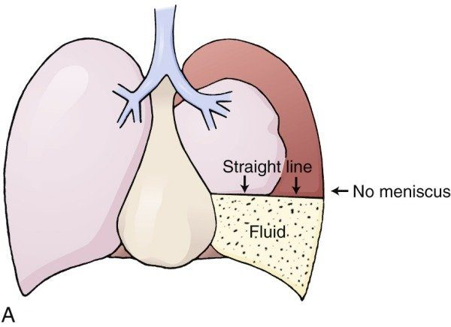
Hemopneumothorax: air above fluid in the pleural space makes a straight line, no meniscus . Slide 71
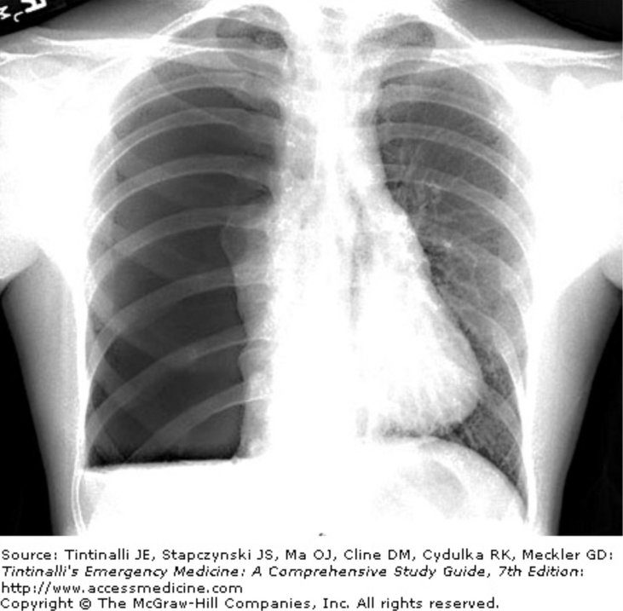
Hemopneumothorax on the film: a horizontal straight fluid line at the right base (left of the image) with air above it. Slide 72
- Chest tube placement (slide 73): inserted between the fourth or fifth intercostal space at the midaxillary line (typically); it can be placed between the 2nd and 3rd intercostal space at the midclavicular line for anterior access (less common, specific to pneumothorax). “There are options, don’t worry too hard about specifics at this point.”
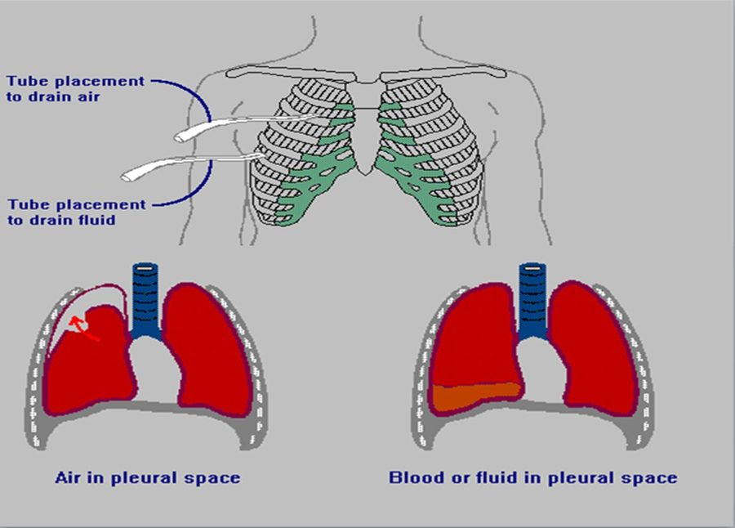
Tube placement to drain air (higher) against tube placement to drain fluid (lower); the drawings below show air in the pleural space and blood or fluid in the pleural space . Slide 73
Hemothorax: the slide 74 picture
Diagnostic cutoff | Pleural fluid hematocrit must exceed 50% of the peripheral blood hematocrit = hemothorax; bloody fluid with a hematocrit under 50% indicates a hemorrhagic effusion
Classification | Hemothorax is strictly an exudative effusion
Causes | Traumatic injuries predominate (blunt or penetrating trauma causes the majority); iatrogenic (thoracic surgery and invasive procedures); spontaneous vascular disruption (torn adhesions, ruptured bullae, aberrant vessels); systemic (aneurysms, coagulopathies, arteriovenous malformations, endometriosis, neurofibromatosis); hemopneumothorax occurs in 2% to 3% of spontaneous pneumothoraces
Testing | Bedside ultrasound detects pleural fluid rapidly in emergency settings; an effusion that enlarges during anticoagulation requires thoracentesis to rule out hemothorax
Management | Immediate tube thoracostomy: the essential first step; surgery for persistent hemorrhage or persistent hemodynamic shock
Complications | Undrained blood is a primary nidus for infection; retained hemothorax leads to empyema, fibrothorax and trapped lung

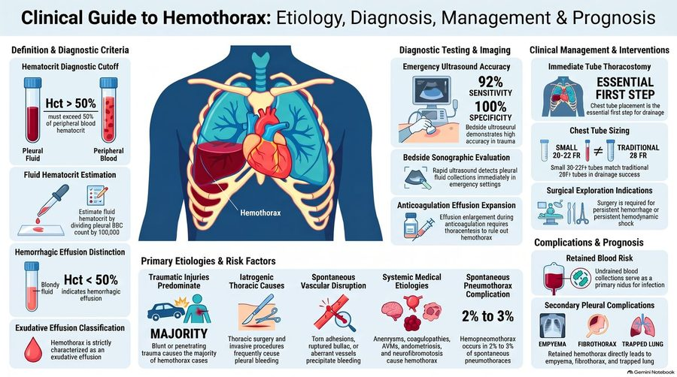
The picture the hemothorax table is read from. Its ultrasound accuracy figures, its red-cell estimate and its chest tube sizes were not taught as testable (“You got sizes … don’t worry about it”). Slide 74

Hemothorax
Defining feature: blood in the pleural space after chest trauma, confirmed by a pleural fluid hematocrit over 50% of the blood hematocrit; a chest tube drains it and measures the bleeding
DefinitionBlood in the pleural space; pleural fluid hematocrit over 50% of the peripheral blood hematocrit (under 50% is a hemorrhagic effusion); strictly an exudative effusion.Who gets itTrauma patients (blunt or penetrating, the majority); after thoracic surgery or invasive procedures; patients with neoplasms; 2–3% of spontaneous pneumothoraces (hemopneumothorax).Risk factorsTrauma to the heart, great vessels, lung or the intercostal, pulmonary or internal thoracic arteries; anticoagulation; coagulopathies, aneurysms, arteriovenous malformations, endometriosis, neurofibromatosis.Classic signs & symptomsNot detailed on the slides beyond the trauma history.Physical exam findingsNot detailed on the slides (the effusion findings of slides 87–88 apply to fluid in the pleural space).Diagnostics / testsBedside ultrasound; with air, a straight air-fluid line with no meniscus (hemopneumothorax); thoracentesis for an effusion enlarging on anticoagulation; pleural fluid hematocrit.First-line treatmentChest tube (4th or 5th intercostal space, midaxillary line) to evacuate and quantify the bleeding; blood loss >200 mL/hr → thoracotomy; surgery for persistent hemorrhage or shock.ComplicationsRetained hemothorax: infection, empyema, fibrothorax, trapped lung.
Slides 69–74

6.10 · Pneumomediastinum
- Pathophysiology (slide 75): air collects in the mediastinal tissues; it occurs spontaneously or following procedures/trauma. Possible etiologies: (1) excessive intra-alveolar pressures lead to rupture of alveoli bordering the mediastinum; (2) esophageal perforation; (3) esophageal or bowel rupture with dissection of air from the neck or abdomen into the mediastinum.
- History (slide 76): spontaneous occurrence; may have a history of a sudden increase in intrathoracic pressure: violent coughing, vomiting, inhalation drug abuse (Valsalva). Symptoms: nonspecific pleuritic chest or neck pain, sore throat, dyspnea, cough.
- Examination (slide 77): palpable subcutaneous emphysema in the neck. “Hamman crunch”: auscultatory substernal crackling or crepitance caused by air in the mediastinum; crepitations heard with each heartbeat, caused by the heart beating against air-filled tissues: synchronous with the heartbeat. (His aid: the cereal-box “snap, crackle, and pop.”)
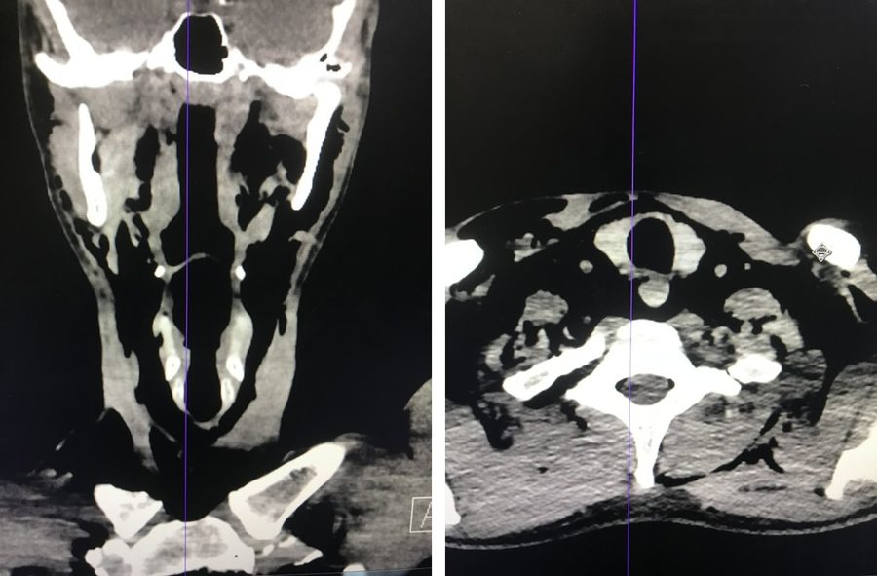
The pictures on slide 78 (his patient’s CT; the slide carries no labels): coronal and axial views of the neck with dark streaks of air through the neck soft tissues , the subcutaneous emphysema that slide 77 says is palpable in the neck. Slide 78
- Treatment (slide 79): assess and maintain the airway; treat the underlying cause, if identified. Conservative treatment: air is often gradually absorbed from the mediastinum; oxygen may increase air absorption; avoidance of physical activity; analgesics. If severe, emergently consult cardiothoracic surgery.

Pneumomediastinum
Defining feature: chest or neck pain and sore throat after violent coughing, vomiting or inhaled drug use, with crackling under the skin of the neck and a substernal crunch synchronous with the heartbeat (Hamman crunch)
DefinitionAir collected in the mediastinal tissues, spontaneous or after procedures or trauma.Who gets itPatients with a sudden rise in intrathoracic pressure (violent coughing, vomiting, inhalation drug abuse with Valsalva), or after procedures or trauma.Risk factorsExcessive intra-alveolar pressure rupturing alveoli bordering the mediastinum; esophageal perforation; esophageal or bowel rupture with air dissecting from the neck or abdomen.Classic signs & symptomsNonspecific pleuritic chest or neck pain, sore throat, dyspnea, cough.Physical exam findingsPalpable subcutaneous emphysema in the neck; Hamman crunch (substernal crackling or crepitance synchronous with the heartbeat).Diagnostics / testsNot specified on the text slides; slide 78 shows CT of the neck with air in the soft tissues.First-line treatmentAssess and maintain the airway; treat the cause; conservative care (air absorbs gradually, oxygen speeds it, avoid physical activity, analgesics); if severe, emergent cardiothoracic surgery consult.ComplicationsNot covered on the slides beyond “if severe.”
Slides 75–79

6.11 · Pleural effusion: mechanisms, causes, history and examination
Normally, fluid enters the pleural space from capillaries in the parietal pleura and is removed via lymphatics in the parietal pleura (slide 81). An effusion forms when one of these goes wrong:
Pleural effusion: cause (slides 81–82) | Mechanism
Inflammation, malignancy, pulmonary embolism | Altered permeability of pleural membranes
Hypoalbuminemia (nephrotic syndrome or cirrhosis) | Reduction in intravascular oncotic pressure
Trauma, malignancy, inflammation, infection | Increased capillary permeability
Heart failure | Increased capillary hydrostatic pressure
Malignancy, trauma | Decreased lymphatic drainage or complete lymphatic vessel blockage
Cirrhosis, peritoneal dialysis | Increased peritoneal fluid leaking across the diaphragm via microperforations

Memory aid (his “pipes, pumps, or filters”, filled in from slides 81–82 and 111): a failing pump (heart failure) raises hydrostatic pressure; a failing filter (the liver in cirrhosis, the kidney in nephrotic syndrome) lets albumin and oncotic pressure fall; and peritoneal fluid can cross the diaphragm (cirrhosis with ascites, peritoneal dialysis). All three make transudates (slide 111). Damaged pipes leak (inflammation, infection, malignancy, trauma raise permeability) or block (malignancy, trauma close the lymphatics): leaky pipes make exudates (slides 101–103). Where it breaks: malignancy sits in more than one row, and cirrhosis is both a filter problem and a diaphragm leak.
- Epidemiology (slide 83 picture): affects over 1.5 million patients a year in the United States; present in up to 62% of critically ill intensive care patients; up to 30% of patients have multiple concurrent causes. Estimated annual cases: congestive heart failure 500,000 (the leading cause), infection 300,000, malignancy 200,000, pulmonary embolism 150,000, viral illness 100,000, cirrhosis 50,000, post-cardiac surgery 50,000. ★ “malignancy and CHF [congestive heart failure] are gonna be your frequent flyers”
Always transudative (slide 83 picture): increased pressure or decreased oncotic force | Variable classification | Always exudative: direct pleural injury or inflammation
Heart failure, hepatic hydrothorax, nephrotic syndrome, atelectasis, hypoalbuminemia | Malignancy, pulmonary embolism, sarcoidosis, chylothorax, pancreatitis, thyroid disease | Parapneumonic effusions, empyema, connective tissue disease, hemothorax, asbestos

- Specific etiologies and risk factors (slide 83 picture): heart failure: left atrial pressure drives 85% of bilateral effusions. Infection risk factors: diabetes, alcoholism, immunosuppression, poor dental hygiene. Malignant effusion occurs in 15% of cancer cases (hyperpermeability). Hepatic hydrothorax: peritoneal ascites crosses the diaphragm, 80% right-sided. Nephrotic syndrome causes effusions when albumin falls below 2 g/dL. Drug-induced: amiodarone, methotrexate, beta blockers.
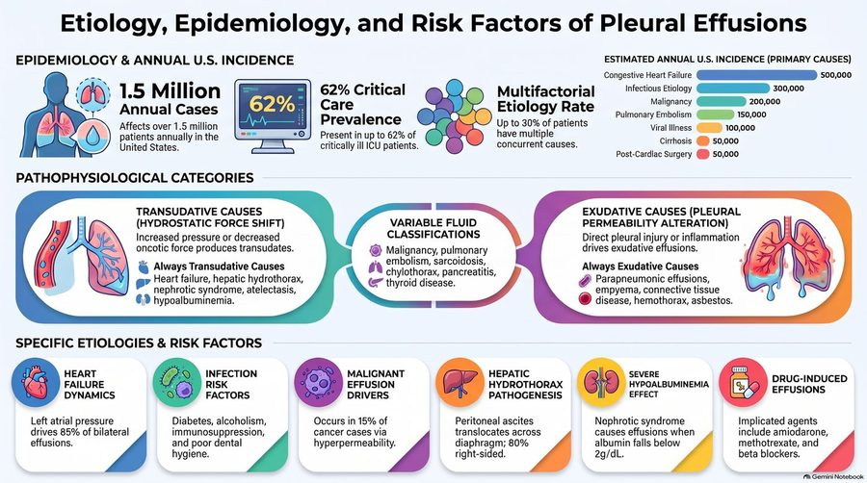
The picture the epidemiology lines and the three-column table are read from. Slide 83
- History (slide 84): past medical history; trauma; heart failure; hepatic disease; history of cancer (malignant effusions can occur years after the diagnosis); occupational history (asbestos exposure).
- Symptoms (slide 85): asymptomatic (if small). Most common: dyspnea, dry cough, chest pain — due to pleural irritation; mild or severe; sharp or stabbing; exacerbated by deep inspiration; localized to the chest wall or referred to the ipsilateral shoulder or upper abdomen (due to diaphragmatic irritation).
Extrapulmonary symptoms (slide 86) | Think of
Lower extremity edema, orthopnea, paroxysmal nocturnal dyspnea | Congestive heart failure
Fever, purulent sputum, pleuritic chest pain | Pneumonia
Hemoptysis | Malignancy
Fever, night sweats, hemoptysis, weight loss | Tuberculosis

- Examination (slides 87–88): small effusions (<300 mL): no physical exam findings. Inspection: asymmetrical thoracic expansion; shift of the trachea away from the involved side (effusion >1000 mL). Palpation: decreased tactile fremitus (fluid obstructs transmission of vibrations). Percussion: dullness over fluid. Auscultation: diminished/absent breath sounds over the effusion; bronchial breath sounds increased toward the top of the effusion; transmitted voice sounds decreased to absent but may be increased toward the top; pleural friction rub.
Examination | Pneumothorax (slides 22–23) | Pleural effusion (slides 87–88)
Inspection | Tachypnea; decreased chest excursion on the affected side | Asymmetrical expansion; trachea shifted away if >1000 mL; nothing if <300 mL
Tactile fremitus | Decreased/absent | Decreased
Percussion | Hyperresonance | Dullness over fluid
Breath sounds | Diminished/absent on the affected side | Diminished/absent over the effusion; bronchial toward its top
Voice sounds | Decreased/absent | Decreased to absent; may be increased toward the top
Also | Tachycardia | Pleural friction rub

Examining an effusion (slides 87–89)
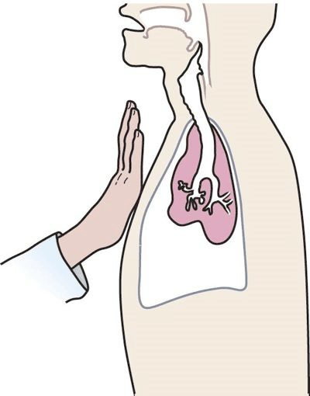  Tactile fremitus  Vibrations from the larynx felt at the chest wall; fluid obstructs them  Slide 87 | 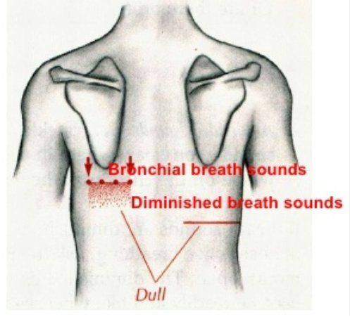  Map over an effusion  Dull and diminished over the fluid; bronchial breath sounds at its top  Slide 88 | 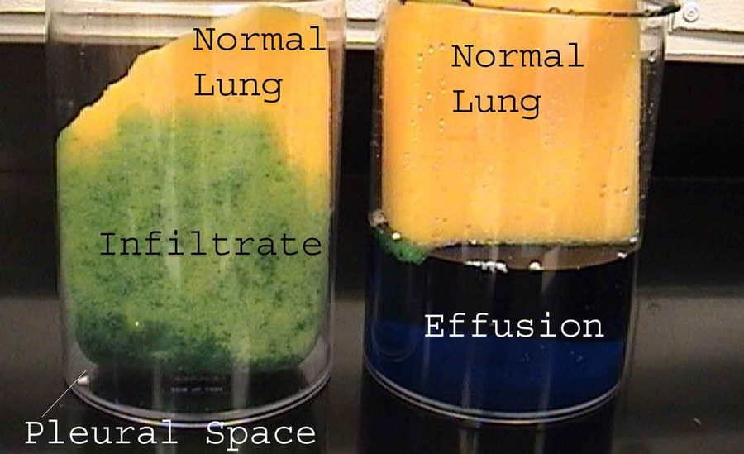  Infiltrate vs effusion  Infiltrate soaks the lung itself; effusion is fluid in the pleural space  Slide 89

His reading tip for slide 89: an infiltrate is fluid in the alveoli “like this sponge”; an effusion is fluid in the pleural space pushing the lung around.

6.12 · Pleural effusion: imaging, thoracentesis and fluid analysis
- Chest radiograph, upright position (slide 90): 75 mL of fluid blunts the posterior costophrenic angle; 175 mL of fluid blunts the lateral costophrenic angle.
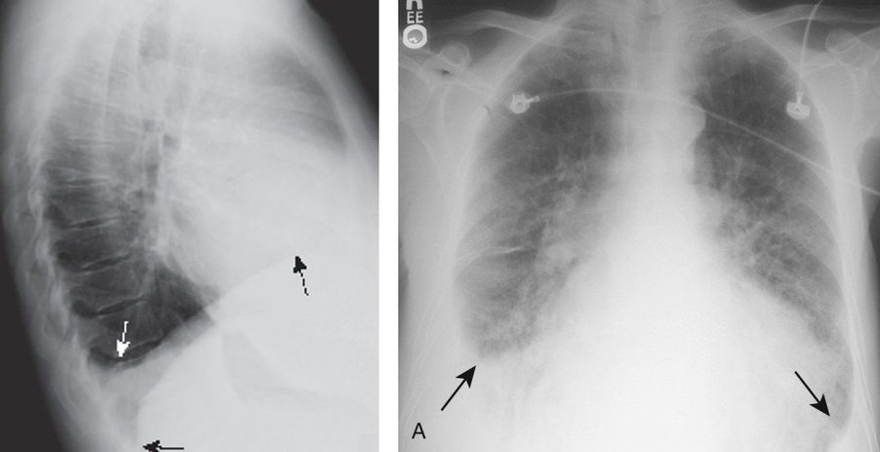
Lateral view (left): fluid fills the posterior costophrenic angle first (75 mL). Frontal view (right): the lateral costophrenic angles blunt at 175 mL. Slide 90
- Lateral decubitus film (slide 91): visualizes small amounts of fluid layering against the dependent parietal pleura; taken with the patient lying on their side, effusion side down. Note: decubitus films are almost never performed in institutions with bedside ultrasonography.
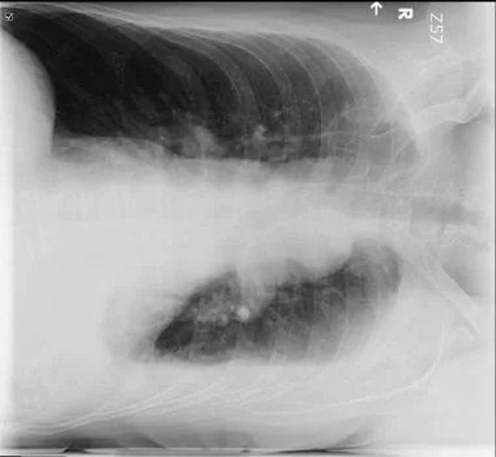
Lateral decubitus film : the patient lies on the side, effusion side down , so small amounts of fluid layer against the dependent parietal pleura. Slide 91
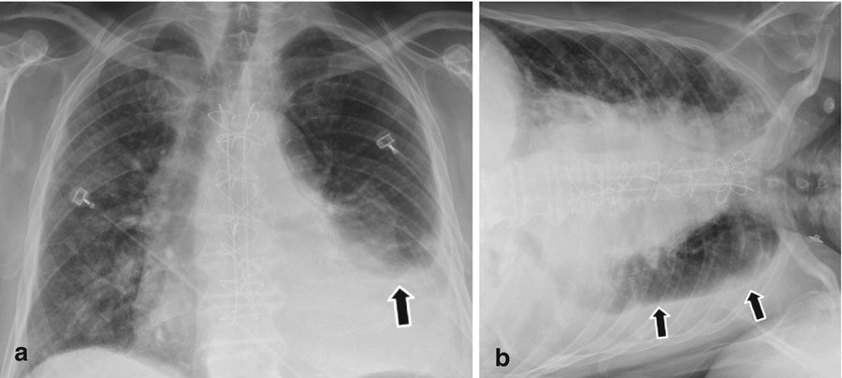
“Free-Flowing Effusion vs Loculated Fluid”: (a) upright, fluid at the left base; (b) lying on the side, fluid layering along the lower chest wall. The slide says no more. Slide 92
- Chest CT with contrast (slide 93): provides great detail; may identify as little as 10 mL of fluid; can help characterize the fluid; identifies associated pathology such as pneumonia, tumors, or pulmonary embolus.
- Loculations (slide 94): fluid-filled compartments within the pleural space, occurring when there are adhesions between the visceral and parietal pleurae; associated with conditions that cause pleural inflammation (for example, empyema).
- Ultrasound (slide 95): has replaced the lateral decubitus X-ray in the evaluation of suspected pleural effusions; used to guide thoracentesis.
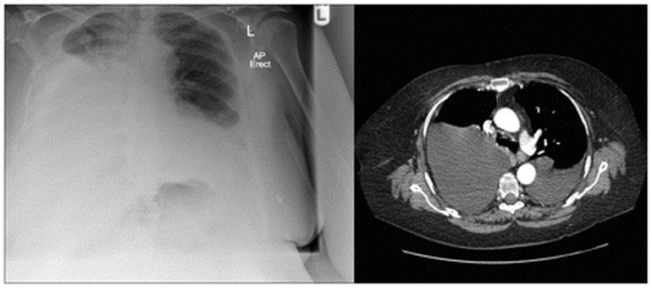
Radiograph and contrast CT side by side; the slide’s caption: bilateral pleural effusions . Slide 93
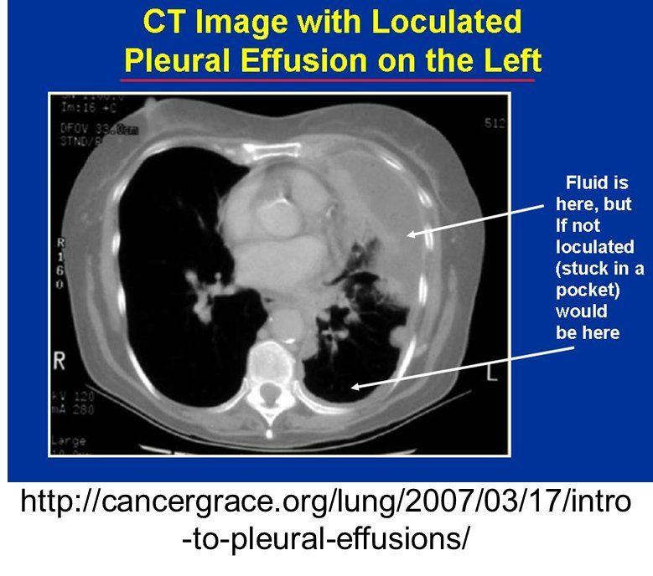
Loculated pleural effusion on the left : “Fluid is here, but if not loculated (stuck in a pocket) would be here.” Slide 94
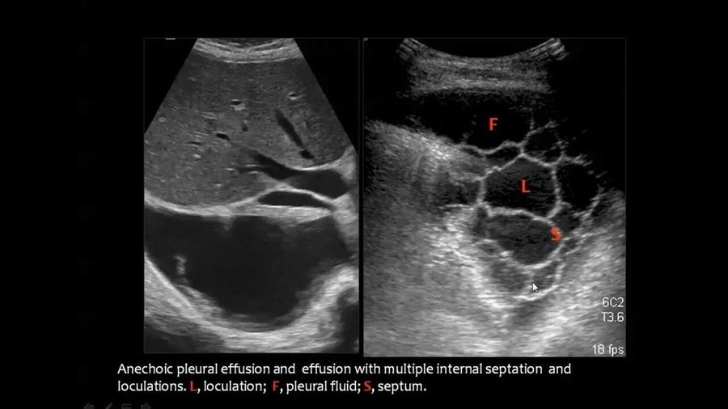
Ultrasound: an anechoic effusion (left); septations and loculations (right): L loculation, F fluid, S septum. Slide 95
- Thoracentesis (slide 96): diagnostic thoracentesis removes 50–100 mL, allows visualization and analysis of the fluid, and is performed when there is a new pleural effusion with no clinical cause. Therapeutic thoracentesis: removing fluid relieves symptoms.
- Send the fluid for (slide 99): protein; lactate dehydrogenase (LDH); white blood cell count (total and differential); Gram stain; cytology (detects malignant effusions); microbiological culture.
Pleural fluid color guide (slides 98–99 picture) | Usually means
Clear / straw | Usually a transudative effusion
Cloudy | Inflammatory exudative effusion
Purulent | Empyema (infected pleural fluid)
Bloody | Hemothorax or malignancy
Milky white | Chylothorax
Black | Rare fungal infection
Pleural fluid appearance alone is not diagnostic; always interpret it with laboratory analysis and clinical findings.


The six appearances: clear/straw, cloudy, purulent, bloody, milky white, black. Slide 98
★ PROFESSOR EMPHASIS
★ “that makes great test questions”: Light’s criteria (slides 101, 110, 112)
Exudate (slide 101): high protein, due to increased vascular permeability from inflammation (fluid, protein and cytokines leak, or exude, out). Transudate (slide 110): low protein, due to increased hydrostatic pressure or reduced oncotic pressure (fluid moves across, trans, a membrane). An effusion is an exudate if it meets AT LEAST ONE of Light’s criteria and a transudate if ALL are absent.
Light’s criteria (slides 101, 112) | Transudative | Exudative
Mechanism (slide 112) | ↑ Capillary hydrostatic pressure; ↓ capillary oncotic pressure | ↑ Capillary permeability
1. Protein (pleural fluid) ÷ protein (serum) | ≤ 0.5 | > 0.5
2. LDH (pleural fluid) ÷ LDH (serum) | ≤ 0.6 | > 0.6
3. LDH (pleural fluid) | ≤ 2/3 the upper limit of normal serum LDH | > 2/3 of the upper limit of normal serum LDH
Rule | All three absent (slide 110) | At least one (slide 101)
Common causes (slide 112) | Heart failure, cirrhosis, nephrotic syndrome | Infection, malignancy, pulmonary embolism, autoimmune

Worked examples: pleural protein 4.0 g/dL with serum protein 6.0 g/dL gives 0.67, over 0.5: an exudate, whatever the LDH shows, because one criterion is enough. Pleural protein 2.0 with serum 7.0 (0.29), pleural LDH 60 with serum LDH 200 (0.30), and an upper limit of normal serum LDH of 220 (two-thirds = 147, and 60 is below it): all three absent, a transudate.

Light’s criteria worked example: a transudate from cirrhosis. Protein ratio 1.2 / 5.8 = 0.21 (pleural fluid over serum), lactate dehydrogenase ratio 70 / 180 = 0.39, and fluid lactate dehydrogenase 70 is under two-thirds of 280 (the top of the normal 140-280 units/L), about 187: all of Light’s criteria are absent, a transudate. Cirrhosis with ascites sends peritoneal fluid across the diaphragm and lowers oncotic pressure.
Light’s criteria worked example: an exudate from pneumonia. Protein ratio 4.4 / 7.2 = 0.61 (pleural fluid over serum), above 0.5; lactate dehydrogenase ratio 240 / 210 = 1.14, above 0.6; fluid lactate dehydrogenase 240 exceeds two-thirds of 280 (the top of the normal 140-280 units/L), about 187. The fluid is an exudate, pneumonia is the most common cause of exudative effusion, and fever with purulent sputum and pleuritic pain is its clue set.
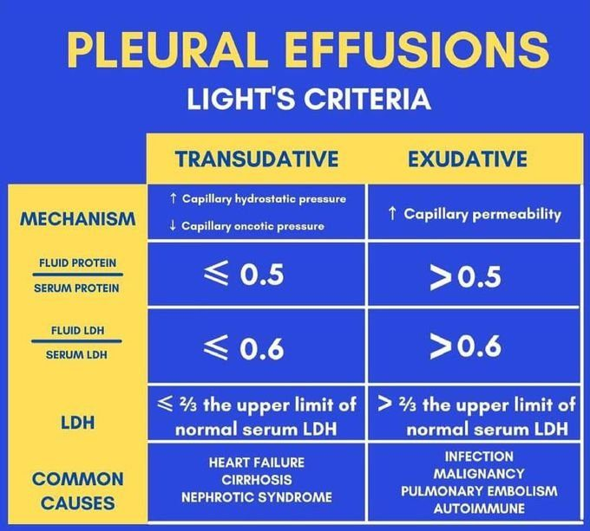
The slide 112 chart the table above transcribes (he left it on screen for seconds: “it’s just lights criteria again”). Its exudative causes include pulmonary embolism, which slide 111 lists as a transudate. Slide 112
- The slide 97 picture, steps 1–2: upright chest radiography (upright preferred; supine films underestimate fluid volume); thoracic point-of-care ultrasound (“preferred initial imaging modality”; identifies septations and thickening); contrast chest CT (pleural nodularity, mass lesions, tumor extent). Light’s criteria classify an exudate by the protein ratio or the LDH ratios; non-serum alternative criteria use fluid protein, cholesterol or LDH limits alone.
The slide 97 laboratory table is a reference, not test material: “Don’t go crazy about this, these are all possibilities for lab testing out of the textbook.” Its thresholds are not keyed.
Interpreting key pleural fluid results (slide 97 picture, step 3; reference only)
Fluid test result | Target threshold | Associated clinical diagnosis
High neutrophils | >50,000 /µL | Bacterial empyema
High lymphocytes | >85%–95% | Tuberculosis, sarcoidosis, or lymphoma
High eosinophils | >10% | Air or blood in the pleural space, asbestos
Low glucose / low pH | Glucose ratio <0.5 / pH <7.30 | Complicated parapneumonic effusion, empyema, rheumatoid arthritis
Elevated adenosine deaminase | >40 IU/dL with lymphocytosis | Tuberculous pleurisy
Elevated N-terminal pro-B-type natriuretic peptide | >1500 pg/mL | Congestive heart failure (exudate misclassification)
Elevated triglycerides | >110 mg/dL | Chylothorax

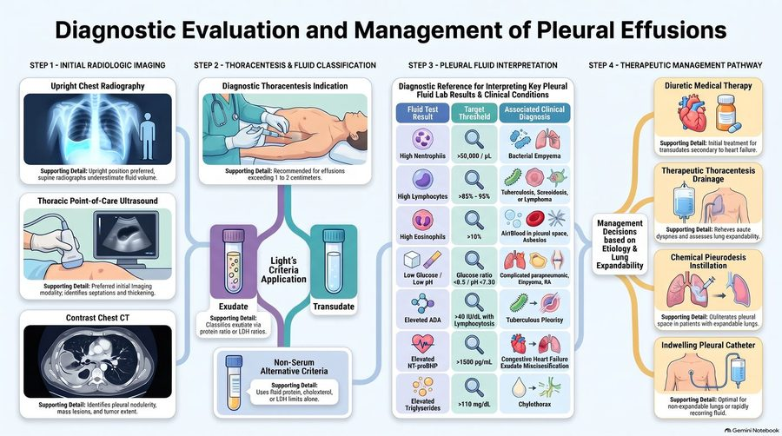
The picture the lab table above and the management table in 6.14 are read from, step 1 at left to step 4 at right. Slide 97

6.13 · Exudates: causes, chylothorax and empyema
- Possible associated disorders (slides 102–103): pneumonia: the most common cause of exudative effusion; malignancy: the second most common, 75% caused by breast carcinoma, lung carcinoma, lymphoma; tuberculosis (the leading cause worldwide); viral, bacterial, fungal, and parasitic infections; connective tissue disease; asbestosis; pancreatic disease; chylothorax.
- Chylothorax (slide 104): thoracic duct disruption causing accumulation of lipid from chyle (lymph fluid) in the pleural space.
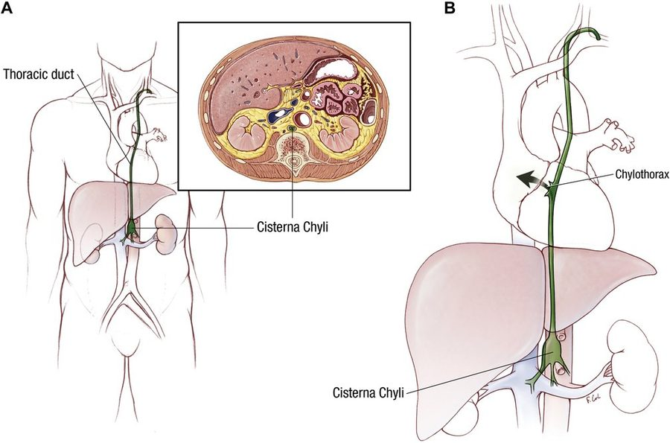
The thoracic duct carries chyle up from the cisterna chyli ; disrupt it and chyle collects in the pleural space as a chylothorax (B). Slide 104
- Etiology (slide 105): trauma (for example, thoracic surgery) is most common; tumors in the mediastinum. Diagnosis: thoracentesis shows milky fluid with elevated triglycerides; if there is no obvious trauma, a lymphangiogram and CT scan to assess the mediastinum.
- Treatment (slide 106): chest tube placement or intermittent thoracentesis; avoid excessive drainage — excessive loss can impact nutritional status. Pharmacologic: octreotide (mimics somatostatin; slows gastrointestinal secretions → decreases chyle drainage). Nutrition: decreasing long-chain triglycerides in the diet decreases chyle drainage, because long-chain triglycerides are absorbed via the lymphatic system.
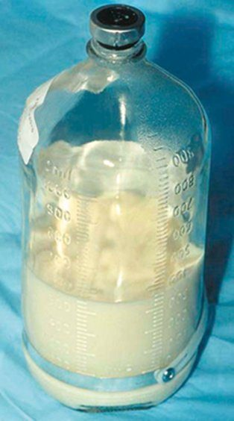
Chyle: milky fluid drained from the pleural space. Slide 105

Chylothorax
Defining feature: milky pleural fluid with elevated triglycerides, usually after thoracic surgery or other chest trauma
DefinitionLipid from chyle (lymph fluid) collecting in the pleural space after thoracic duct disruption; an exudate on slides 103–106.Who gets itPatients after trauma, most commonly thoracic surgery; patients with mediastinal tumors.Risk factorsThoracic surgery or other chest trauma; tumors in the mediastinum.Classic signs & symptomsThose of a pleural effusion (dyspnea, dry cough, chest pain); the defining clue is the milky fluid.Physical exam findingsEffusion findings: dullness, decreased fremitus and breath sounds.Diagnostics / testsThoracentesis: milky fluid, elevated triglycerides; with no obvious trauma, lymphangiogram and CT of the mediastinum.First-line treatmentChest tube or intermittent thoracentesis without excessive drainage; octreotide to decrease chyle drainage; cut long-chain triglycerides from the diet.ComplicationsExcessive chyle loss impairs nutritional status.
Slides 98, 103–106
- Empyema (slides 107–108): purulent fluid in the pleural space. Bacterial pneumonia with a parapneumonic effusion is the most common precursor. A parapneumonic effusion is a pleural effusion that forms in the pleural space in relation to pneumonia; if microorganisms infect the pleural space, a complicated parapneumonic effusion or empyema may result. Prompt therapy is critical. Suspect empyema if pneumonia symptoms do not resolve with therapy. Diagnosis: purulent material on thoracentesis. Treatment: drainage and antibiotics; treat the underlying disease; analgesia for pleuritic pain.
Empyema (slides 107, 109)
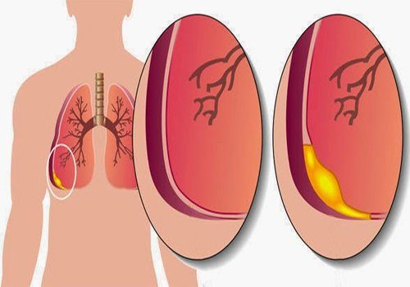  Parapneumonic effusion  Pleural fluid forming beside a pneumonia  Slide 107 | 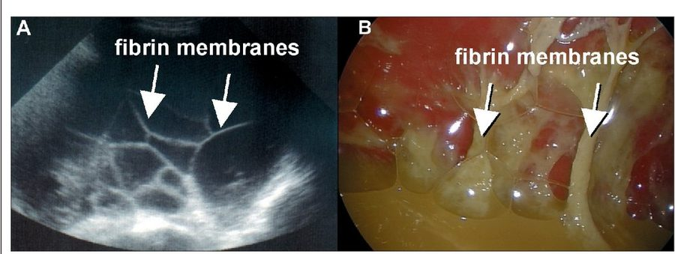  Fibrin membranes  On ultrasound (A) and at thoracoscopy (B)  Slide 109

Empyema
Defining feature: a pneumonia that does not resolve with therapy, with pus on thoracentesis
DefinitionPurulent fluid in the pleural space; an exudative effusion.Who gets itPatients with bacterial pneumonia and a parapneumonic effusion (the most common precursor).Risk factorsPneumonia with a parapneumonic effusion; infection risk factors diabetes, alcoholism, immunosuppression, poor dental hygiene (slide 83); a retained hemothorax (slide 74).Classic signs & symptomsPneumonia symptoms that do not resolve with therapy; pleuritic pain.Physical exam findingsEffusion findings (dullness, decreased fremitus and breath sounds).Diagnostics / testsPurulent material on thoracentesis; loculations and fibrin membranes on imaging (slides 94, 109).First-line treatmentDrainage and antibiotics, promptly; treat the underlying disease; analgesia for pleuritic pain.ComplicationsLoculation (adhesions between the visceral and parietal pleurae).
Slides 74, 83, 94, 98, 107–109

6.14 · Transudates and treating an effusion
- Transudate (slide 110): low protein, due to increased hydrostatic pressure or reduced oncotic pressure; considered a transudate if all of Light’s criteria are absent.
- Possible associated disorders (slide 111): ★ congestive heart failure (>90% of cases); cirrhosis with ascites; pulmonary embolism; nephrotic syndrome; peritoneal dialysis.
Common causes | Exudate (slides 102–103) | Transudate (slide 111)
Most common | Pneumonia (malignancy second: breast, lung, lymphoma 75%); tuberculosis the leading cause worldwide | Congestive heart failure (>90%)
Others | Viral, bacterial, fungal and parasitic infections; connective tissue disease; asbestosis; pancreatic disease; chylothorax | Cirrhosis with ascites; nephrotic syndrome; peritoneal dialysis; (pulmonary embolism: see the box at the top)

- Treatment (slide 113): diagnostic/therapeutic thoracentesis; managed by treating the underlying medical disorder; chest tube placement. Pleurodesis is often used for recurrent malignant pleural effusions (lung, breast, ovarian cancer) = palliative care. Indwelling tunneled pleural catheters: the catheter is placed in the outpatient setting and intermittently drained at home, which minimizes time in hospital for patients with short prognoses.
Therapeutic management pathway (slide 97 picture, step 4): decisions based on etiology and lung expandability
Diuretic medical therapy | Initial treatment for transudates secondary to heart failure
Therapeutic thoracentesis drainage | Relieves acute dyspnea and assesses lung expandability
Chemical pleurodesis instillation | Obliterates the pleural space in patients with expandable lungs
Indwelling pleural catheter | Optimal for non-expandable lungs or rapidly recurring fluid

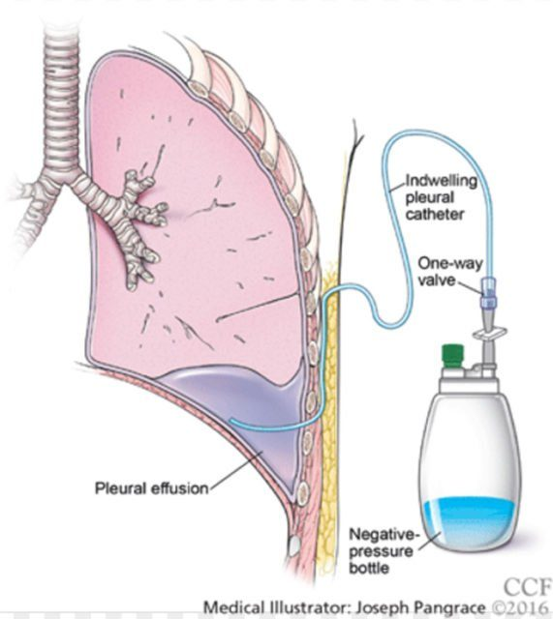
Indwelling tunneled pleural catheter: the catheter drains the pleural effusion through a one-way valve into a negative-pressure bottle , at home. Slide 114

Pleural effusion
Defining feature: dyspnea with dullness, decreased fremitus and diminished breath sounds over a blunted costophrenic angle; Light’s criteria sort it into exudate or transudate
DefinitionFluid accumulating in the pleural space through altered permeability, low oncotic pressure, high hydrostatic pressure, blocked lymphatics or peritoneal fluid crossing the diaphragm; a transudate (low protein) or an exudate (high protein).Who gets itOver 1.5 million patients a year in the United States; up to 62% of critically ill intensive care patients; congestive heart failure the leading cause.Risk factorsHeart failure; pneumonia (infection risk factors diabetes, alcoholism, immunosuppression, poor dental hygiene); malignancy (even years after the diagnosis); cirrhosis; nephrotic syndrome; trauma; asbestos exposure; drugs (amiodarone, methotrexate, beta blockers).Classic signs & symptomsDyspnea, dry cough and pleuritic chest pain (referred to the ipsilateral shoulder or upper abdomen); none if small; clue sets: edema, orthopnea and paroxysmal nocturnal dyspnea (heart failure), fever and purulent sputum (pneumonia), hemoptysis (malignancy), night sweats and weight loss (tuberculosis).Physical exam findingsNone under 300 mL; asymmetrical expansion; dullness; decreased fremitus; diminished breath sounds with bronchial sounds at the top; trachea away if over 1000 mL; friction rub.Diagnostics / testsUpright film (75 mL blunts the posterior, 175 mL the lateral angle); ultrasound (replaced the decubitus film, guides thoracentesis); contrast CT (10 mL); diagnostic thoracentesis (50–100 mL) for a new effusion with no clinical cause: protein, lactate dehydrogenase (LDH), cell count, Gram stain, cytology, culture; Light’s criteria.First-line treatmentTreat the underlying disorder (diuretics first for heart failure transudates); therapeutic thoracentesis; chest tube; pleurodesis for recurrent malignant effusions (palliative); indwelling tunneled catheter for short prognoses or a non-expandable lung.ComplicationsLoculation (adhesions, as in empyema); infection of a parapneumonic effusion (empyema); recurrence of malignant effusions.
Slides 81–99, 101–103, 110–114

6.15 · Pleurodynia
- Overview (slide 116): a viral myalgia. Etiology: often coxsackie B virus (an RNA, ribonucleic acid, enterovirus), typically following an upper respiratory or gastrointestinal infection. Pathophysiology: the virus targets striated intercostal muscles, causing inflammation or necrosis, which leads to frequent elevations in serum creatine kinase.
- Presentation (slide 117): acute onset of fever and pleuritic pain (adults) or abdominal pain (children); paroxysms of severe, knife-like pain lasting 15–30 minutes, with diaphoresis and tachypnea. Examination: fever; tachypnea, diaphoresis and splinting of the chest during an attack; involved muscles usually tender.
- Testing and treatment (slide 118): elevated serum creatine kinase; chest radiograph usually normal (it rules out other causes of chest pain). Treatment is supportive: NSAIDs (nonsteroidal anti-inflammatory drugs) and application of heat to the affected muscles; symptoms resolve but may recur a few days later (the two slides give different durations; box at the top). (His aid: “it’s a dynia, it’s an itis, we treat it with NSAIDs, apply heat.”)
Pleurodynia (Bornholm disease): the slide 119 picture
Etiology and spread | Mainly coxsackievirus group B (serotypes B1–5) and echoviruses; summer peak; fecal-oral contamination and contaminated water
Manifestations | Acute, sharp pleuritic chest pain; fever, headache, sore throat, malaise, nausea; tenderness, hyperesthesia and swelling over the diaphragmatic muscles; orchitis and aseptic meningitis in under 10%
Testing | Routine laboratory tests show no characteristic pathognomonic abnormality (slides 116 and 118 keep the creatine kinase); enterovirus RNA polymerase chain reaction; viral culture from throat washings or stool; neutralizing antibodies rise in convalescence
Management and prognosis | Supportive pain and fever care; self-limited, benign course without long-term sequelae
Prevention | Thorough hand hygiene; pool chlorination and pH control

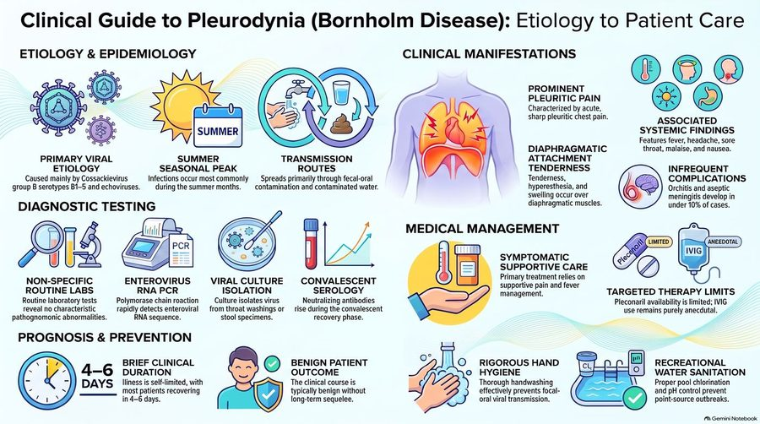
The picture the Bornholm table is read from. Its targeted-therapy box was not taught. Slide 119

Pleurodynia
Defining feature: sudden fever with paroxysms of knife-like pleuritic pain (abdominal pain in a child) lasting 15–30 minutes, tender chest muscles, a raised creatine kinase and a normal chest film, after a viral illness in summer
DefinitionA viral myalgia of the striated intercostal muscles, usually coxsackie B virus (an RNA enterovirus); also called Bornholm disease.Who gets itAdults (pleuritic pain) and children (abdominal pain), typically after an upper respiratory or gastrointestinal infection; peaks in summer.Risk factorsCoxsackie B virus or echovirus exposure by the fecal-oral route or contaminated water.Classic signs & symptomsAcute fever with paroxysms of severe, knife-like pain lasting 15–30 minutes, with diaphoresis and tachypnea.Physical exam findingsFever; tachypnea, diaphoresis, splinting of the chest during attacks; tender involved muscles.Diagnostics / testsElevated serum creatine kinase; chest radiograph usually normal (rules out other causes).First-line treatmentSupportive: NSAIDs and heat to the affected muscles.ComplicationsRecurrence a few days later; orchitis and aseptic meningitis in under 10%; benign course.
Slides 116–119

6.16 · Adults and older adults; referral and education
Domain | Adults | Older adults
Who | Primary spontaneous pneumothorax in tall, thin young males, 20–40, with good reserve (slide 19); pleurodynia brings pleuritic pain in adults and abdominal pain in children (slide 117) | Secondary spontaneous pneumothorax from chronic obstructive pulmonary disease (COPD) or lung cancer (may be the first sign), with less reserve and more danger (slides 20, 24, 57); malignant effusions years after a cancer diagnosis (slide 84); heart failure behind over 90% of transudates (slide 111)
Education | Recurrence approaches 50% in three years; stop smoking; delay air travel 7–14 days after resolution with a confirming film; avoid scuba diving; pilots and divers need early surgical evaluation; genetics referral for a family history (slides 59–60) | Hold positive-pressure therapies during an active air leak (slide 60); a small secondary pneumothorax is admitted for monitoring (slide 56)
Referral | Video-assisted thoracoscopic surgery for recurrence, bilateral pneumothorax, failed tube thoracostomy (slide 49); surgical evaluation for a persistent air leak (slide 60); thoracotomy for hemothorax bleeding over 200 mL/hr (slide 69); emergent cardiothoracic surgery for severe pneumomediastinum (slide 79) | Video-assisted surgery for secondary pneumothorax (high recurrence, greater consequences, slide 49); chemical pleurodesis via chest tube if surgery is not an option (slide 57)
Palliative care | — | Pleurodesis for recurrent malignant effusions (lung, breast, ovarian) = palliative; indwelling tunneled catheter placed as an outpatient and drained at home for short prognoses (slide 113) or a non-expandable lung (slide 97)

7 · Acid-Base Disorders II
Lecture 45 · Megan B. Finck, MMS, PA-C · Monday 9 November 2026, 1–3 PM
INSTRUCTIONAL OBJECTIVES
ACID - BASE: PART II — Megan B. Finck, MMS, PA-C
- Describe the major buffer systems of the body.
- Explain how acid-base disorders affect electrolytes and oxygenation.
- Explain mechanisms for maintaining acid-base homeostasis.
- Compare and contrast the etiologies, clinical manifestations, and management of simple and mixed acid-base disorders, including: a. Respiratory acidosis b. Respiratory alkalosis c. Metabolic acidosis d. Metabolic alkalosis
- Compare and contrast compensatory mechanisms for simple and mixed acid-base disorders.
- Identify simple and mixed acid-base disorders by interpreting diagnostic test results and patient presentations
Quoted as the syllabus prints them (page 21, “Acid - Base: Part II”; the four disorders of d joined in the syllabus’s own order). Answered in order: a in 7.4; b in 7.1; c in 7.4–7.5; d in 7.7 (mixed) and 7.8–7.11 (the four disorders, each with an eight-point block); e in 7.6, 7.7 and the Winter formula in 7.10; f in 7.2, 7.3, 7.7 and 7.12. This lecture is the second half of Lecture 34 (Exam 6): it repeats those foundations and adds the albumin-corrected anion gap, the mixed-disorder tables, the change in anion gap against the change in bicarbonate, and the step-by-step method.

NOTE
What Prof. Finck stressed (live recording, Monday 9 November; about 106 minutes of teaching). About two-thirds of the lecture was mixed-disorder reasoning: the tables on slides 28–30, the Winter formula and the change in anion gap (slides 49–50), and about 41 minutes of worked cases, six of which used the example values printed on slides 28–30. She gave almost no “this is on the test” lines; her emphasis is by repetition:
- Compensation never fully corrects the pH in a simple disorder (“tattoo on the inside of your eyeballs”), so a normal pH does not rule out a mixed disorder.
- Only one respiratory disorder at a time, but more than one metabolic disorder; a big anion gap is always metabolic.
- The Winter formula and how to read it; the change in anion gap against the change in bicarbonate; the albumin correction; acute against chronic respiratory acidosis from the bicarbonate rise.
- “Always, always, always circle back to our patient,” and the “golden rule”: find and treat the underlying condition.
- On the exam she expects you to calculate (not read the nomogram), with lab values given with their reference ranges and the albumin.
Lower weight: she said the kidney physiology (slides 19–21) is not for reading beyond “urine bicarbonate should be zero” and hydrogen phosphate as the titratable acid; plasma cell dyscrasias and bromide are “pretty much zebra conditions”; licorice is “a rare one.” She did not read aloud the slide 12 limits, the slide 36 thresholds, the slide 37 complications, the slide 39–40 lists, the slide 51 urine chloride numbers, slide 55, or the respiratory alkalosis and 1.3 rows of the slide 24 table. All of it is still on the slides and still in this guide. Not in the deck: the two warm-up cases at the start of the case section (a young woman with vomiting, an older man with two weeks of dyspnea) are on no slide, so nothing here is built on them.

NOTE
Where the slides are loose or disagree
- Normal carbon dioxide. Slide 6 (arterial) gives 36–44 mm Hg; slide 10 gives 35–45; slide 59’s flowchart splits at 40. Questions quote 35–45 and never turn on the ends of the range.
- Normal bicarbonate. 22–26 mEq/L (slides 6, 10); 25 is “an accepted value” for the change in bicarbonate (slides 27, 50); slide 59’s flowchart splits at 24. Use 25 for the change in bicarbonate, as slides 27 and 50 say.
- Anion gap cut-offs. Normal 6–12 (slides 7, 47; average about 10); “Think: AG [anion gap] > 12” (slide 44); “AG >20 mEq/L suggests primary metabolic disorder” (slide 26); decreased below 6 (slide 48). A gap between 13 and 20 sits between two slides; no question asks whether such a gap is “primary.”
- Albumin. Slide 8 gives the normal range as 3.5–5.5 g/dL but corrects the gap for each 1 g/dL below 4.5, and its example calls 2.5 g/dL “2 g/dL below the normal value.” Correct from 4.5, as the slide does.
- Metabolic acidosis compensation, two rules. The slide 24 table says carbon dioxide falls 1.3 mm Hg per 1 mEq/L fall in bicarbonate; slide 49 gives the Winter formula. She used only the Winter formula; questions use it, with values where the two agree.
- The Winter formula is printed “+ 8 + 2” (slide 49, with the 2 underlined); it means plus or minus 2, as she said it.
- The sign of the change in bicarbonate. Slides 27 and 50 write it as “Lab result for HCO3 − Normal HCO3,” which is negative when bicarbonate falls. Read it as the size of the fall (25 minus the measured value); no question asks the sign.
- Normal chloride is never given. Slides 30 and 50 use the change in chloride, but the deck states no normal chloride value.
- “Renal” for metabolic (slide 23). The slide says “If the cause of acidosis/alkalosis is renal, compensation will be respiratory”; it means a metabolic cause, as the next slides show.
- Category labels on slide 32. Guillain-Barré syndrome, myasthenia gravis, botulism and polymyositis are filed under “Musculoskeletal disorders,” and pulmonary embolism is listed as a cause of respiratory acidosis, while slide 39 lists lung disease with or without hypoxia under respiratory alkalosis. The category of those four and the direction of pulmonary embolism are not keyed.
- Alkali in two places (slide 53). “Ingestion of alkaline drugs (NaHCO3, sodium bicarbonate)” is saline-responsive; “Exogenous alkali” is saline-unresponsive and hypertensive (Lecture 34 had the same split). “Hypoparathyroidism and hypercalcemia” sits under normotensive saline-unresponsive. Neither is keyed by group.
- Diabetic ketoacidosis on both sides. It is an increased-gap cause (slides 44–45), but “Recovery from diabetic ketoacidosis” is a normal-gap loss of bicarbonate (slide 47), and slide 30 lists “treatment of diabetic ketoacidosis” under the mixed increased-gap plus normal-gap acidosis. Always note the phase.
- Unsustainable pH (slide 12): below 6.7 or above 7.6, as in Lecture 34; keyed as written.
- Spellings on the slides: “Ethelyne” glycol is ethylene glycol (slide 44); slide 58 writes “HC03” and “PC02” with a zero.
- Spoken slips (the slide is keyed): respiratory acidosis “is always due to either blowing off too much CO2 or retaining too much” (slide 31: decreased alveolar ventilation, never increased production); “CO2 alone” where she meant pH alone (the slide 29 example); two garbled numbers while working cases. Her rounding shortcuts for the ratios are not on the slides; the slide ratios (1 and 3.5 per 10) are keyed.

7.1 · Definitions, potassium and oxygen (objective b)
- Normal systemic arterial pH: 7.35–7.45. Acidemia = pH below 7.35; alkalemia = pH above 7.45 (slide 3).
- Acidosis: a pathologic condition with excessively acidic body fluids or tissues. Alkalosis: a pathologic condition with excessively alkaline body fluids or tissues (slide 3).
- Simple (also called primary) acid-base disorder: a primary disturbance and its corresponding compensation. Mixed acid-base disorder: more than one primary disturbance at the same time (slide 4).
- Anion: an ion with a negative charge. Cation: an ion with a positive charge (slide 4).
Slide 5 | Alkalosis | Acidosis
Potassium | Hydrogen ions shift from intracellular to extracellular; potassium shifts from extracellular to intracellular → hypokalemia | Hydrogen ions shift from extracellular to intracellular; potassium shifts from intracellular to extracellular → hyperkalemia
Oxygen | Increased affinity of hemoglobin for oxygen → decreased oxygen delivery to tissues | Decreased affinity of hemoglobin for oxygen → increased oxygen delivery to tissues

Acidosis shifts potassium out of cells. In acidosis hydrogen ions shift from the extracellular fluid into the cells, and potassium shifts out of cells into the extracellular fluid. The potassium that moves out raises the serum potassium, resulting in hyperkalemia.
Alkalosis shifts potassium into cells. In alkalosis hydrogen ions shift from inside the cells out to the extracellular fluid, and potassium shifts the other way, from the extracellular fluid into the cells. The serum potassium falls, so alkalosis results in hypokalemia, with no potassium actually lost from the body.
Acid-base and oxygen delivery. In acidosis hemoglobin has a decreased affinity for oxygen, so it gives oxygen up more readily and oxygen delivery to the tissues increases. Alkalosis does the reverse: it increases hemoglobin's affinity for oxygen, so less oxygen is delivered to the tissues.
★ The hypokalemia of alkalosis is a shift into cells, not a loss of the body’s potassium; she came back to it when treating metabolic alkalosis (“careful not to overcorrect,” 7.11).

7.2 · Normal values and the anion gap (objective f)

Normal blood gas values Slide 6
Measurement | Arterial blood | Venous blood
pH (range) | 7.40 (7.35–7.45) | 7.36 (7.31–7.41)
PO2 (partial pressure of oxygen), mm Hg (decreases with age) | 80–100 | 30–50
PCO2 (partial pressure of carbon dioxide), mm Hg | 36–44 | 40–52
O2 (oxygen) saturation, % (decreases with age) | > 95 | 60–85
HCO3− (bicarbonate), mEq/L | 22–26 | 22–28
Base difference (deficit/excess) | −2 to +2 | −2 to +2

The anion gap Slide 7
Anion gap (AG) = Na+ − (HCO3− + Cl−): sodium minus the sum of bicarbonate and chloride. Normal = 6–12 mmol/L (average about 10).
Anion gap formula. Anion gap = sodium - (bicarbonate + chloride), for example 138 - (14 + 103) = 21, above the normal 6 to 12. A raised gap with a low pH and low bicarbonate is a raised-gap metabolic acidosis, and renal failure is on that list.
Increased anion gap | Decreased anion gap
Increased unmeasured anions: anionic proteins (albumin), ketoacids, phosphate (PO4), lactate  Decreased unmeasured cations: calcium, magnesium, potassium (Ca2+, Mg2+, K+)  Increased albumin | Increased unmeasured cations  Addition of abnormal cations: lithium  Decreased albumin  Hyperviscosity, severe hyperlipidemia (can affect the estimates of sodium and chloride concentrations)

What raises the anion gap. The anion gap increases with more unmeasured anions, such as anionic proteins (albumin), ketoacids, phosphate and lactate, or with fewer unmeasured cations such as calcium, magnesium and potassium.
Lithium lowers the gap. A decreased gap, below the normal 6 to 12, comes from added abnormal cations such as lithium, which are not counted in the formula.
The anion gap can be abnormal even when sodium, chloride and bicarbonate are within the normal range (slide 26).
Calculate the gap; do not assume it. The anion gap can be abnormal even when sodium, chloride and bicarbonate are each within the normal range, so it has to be calculated rather than assumed.
★ PROFESSOR EMPHASIS
★ “Add two and a half … for every one that the serum albumin drops below 4.5” (slide 8)
- The anion gap must be corrected if albumin levels are abnormal. Albumin normal range: 3.5–5.5 g/dL.
- Correction: add 2.5 mmol/L for each 1 g/dL of serum albumin below 4.5 g/dL.
Worked example (slide 8)
Serum albumin | 2.5 g/dL (2 g/dL below the normal value)
Uncorrected anion gap | 15
Correction | Add 5 mmol/L (2.5 × 2 = 5)
Corrected anion gap | 15 + 5 = 20 mmol/L

She expects to give you lab values with their reference ranges and the albumin, and to have you decide whether the gap needs correcting. Her point about the example: a gap that looked borderline (15) is really 20, well above any lab’s normal range.

Correcting the gap for albumin. The gap must be corrected when albumin is abnormal: the correction adds 2.5 for each 1 g/dL that albumin sits below 4.5. Albumin 2.5 g/dL is 2 below 4.5, so the correction adds 2 x 2.5 = 5, and a measured gap of 12 becomes a corrected gap of 17, above the normal 6 to 12. A gap that looks normal can be a raised gap once corrected.

7.3 · Identifying the primary disorder (objective f)
- Respiratory disorders: increased or decreased carbon dioxide. Metabolic disorders: increased or decreased bicarbonate (slide 9).
- Acid-base analysis is particularly important when the patient is critically ill and the cause of the acute illness may not be clear at first; determining the type of disorder can assist in the definitive diagnosis, because specific acid-base disorders have limited differentials (slide 9).
Variable (slide 10) | Primary disorder (below normal) | Normal range | Primary disorder (above normal)
pH | Acidemia | 7.35–7.45 | Alkalemia
pCO2 (partial pressure of carbon dioxide) | Respiratory alkalosis | 35–45 | Respiratory acidosis
Bicarbonate (HCO3) | Metabolic acidosis | 22–26 | Metabolic alkalosis

Read the pH first. The pH comes first: below 7.35 is acidemia and above 7.45 is alkalemia. Only then are the carbon dioxide and bicarbonate checked to see which one matches the pH direction, naming the disorder respiratory or metabolic.
Disorder (slide 11) | pH | The value that matches it
Respiratory acidosis | Decreased | Increased carbon dioxide
Respiratory alkalosis | Increased | Decreased carbon dioxide
Metabolic acidosis | Decreased | Decreased bicarbonate
Metabolic alkalosis | Increased | Increased bicarbonate

★ Start with the pH, then find which value matches it: “we have to look at our carbon dioxide to identify our respiratory problems. We have to look at our bicarbonate to identify any metabolic problems.”

7.4 · Acid-base regulation, acid generation and buffers (objectives a, c)
- Plasma hydrogen ion varies very little and is normally at very low levels; precise regulation is necessary for all cellular and enzymatic functions (slide 12).
- pH below 6.7 or above 7.6 is unsustainable. It may cause cardiac hypocontractility or irritability, seizures, cerebral edema and metabolic disturbances, and may warrant therapy to normalize the serum pH along with treatment of the underlying cause (slide 12).
★ PROFESSOR EMPHASIS
★ Her “golden rule” (slides 12, 23)
“If we’re looking for a definitive treatment for an acid-base disorder, find and treat that underlying condition.” Slide 23: the underlying condition MUST be corrected to restore pH balance.

Acid generation (slide 13) | Volatile acids | Nonvolatile acids
Source (products of metabolism) | Fats and carbohydrates | Proteins; ingested sulfates and phosphates
Eliminated by | Lungs | Kidneys
Form | Carbonic acid (H2CO3) | HSO4− (hydrogen sulfate) and H2PO4− (dihydrogen phosphate)

Volatile acid leaves through the lungs. Volatile acids from fats and carbohydrates, carbonic acid, are eliminated by the lungs as carbon dioxide. Nonvolatile acids from proteins and ingested sulfates and phosphates are eliminated by the kidneys.

The buffer systems Slide 14
- Renal / respiratory: the most important overall buffer system.
- Bicarbonate: hydrogen ions and bicarbonate move relatively slowly across the cell membrane.
- Carbon dioxide: respiration can be adjusted more quickly.
- Intracellular buffers (60–70% of body fluid buffering): proteins, phosphate, hemoglobin.
- Bone.
How buffering works (slides 15–17): H2O + CO2 ↔ H2CO3 ↔ H+ + HCO3− — water and carbon dioxide ↔ carbonic acid ↔ hydrogen and bicarbonate ions. The respiratory side acts on the water-and-carbon-dioxide end (slide 16); the renal side acts on the hydrogen-and-bicarbonate end (slide 17).

7.5 · The respiratory and renal mechanisms (objective c)
 | Respiratory mechanism (breathing; slides 18, 22) | Renal mechanism (slides 19–21)
Controls | Carbon dioxide; steady state: carbon dioxide production matches excretion | Plasma bicarbonate
Speed | Adjusted quickly (slide 14) | Occurs over hours to days
How | Increased ventilation → decreased carbon dioxide; decreased ventilation → increased carbon dioxide | Excretion or retention of filtered bicarbonate into urine

Pulmonary acid excretion Slide 22
- Removal of carbon dioxide by ventilation, regulated by the brain stem (cerebral pH). An increase in carbon dioxide → increased respiratory rate.
- Hyperventilation: ↑ carbon dioxide excretion, ↓ pCO2. Hypoventilation: ↓ carbon dioxide excretion, ↑ pCO2.

Renal acid excretion Slides 20–21
- Maintenance of acid-base balance requires reabsorption of filtered bicarbonate (in the proximal tubule) and excretion of acid.
- The kidney is unable to excrete free hydrogen ions: they are combined with urinary buffers in the collecting tubule — ammonium (NH4+) and titratable acids (HPO4, urate) — which generates bicarbonate. Urine pH may fall as low as 4.0.
- Net acid excretion = (titratable acids + NH4+) − urinary HCO3−: titratable acids plus ammonium, minus urinary bicarbonate.
- ★ Urinary bicarbonate should = 0 (reabsorption!). Titratable acid depends on daily phosphate intake; the major titratable acid is HPO4 (hydrogen phosphate). Hydrogen ion excretion increases by increasing ammonium production and excretion.
She said the kidney physiology is not for deep reading: “what I want you to get out of this” is that urine bicarbonate should be zero and that the titratable acid is mostly hydrogen phosphate, set by phosphate intake.

7.6 · Compensation (objective e)
- If the cause is respiratory, compensation is renal: bicarbonate is retained or excreted. If the cause is metabolic (the slide says “renal”), compensation is respiratory: carbon dioxide is retained or excreted (slide 23).
- Renal compensation of respiratory acidosis. A primary respiratory acidosis is compensated by the kidneys, which retain bicarbonate over hours to days. When chronic, bicarbonate is expected to rise 3.5 mEq/L per 10 mm Hg rise in carbon dioxide, from baselines of 40 mm Hg and 25 mEq/L.
- Compensation for metabolic acidosis is respiratory. Metabolic acidosis is an excess of acid to buffer or a net loss of bicarbonate. Respiration increases to decrease carbon dioxide, seen as compensatory hyperventilation and, when severe, Kussmaul breathing.
- Inadequate or excessive compensation points to a mixed acid-base disorder. There cannot be more than one primary respiratory disorder (slide 23).
★ PROFESSOR EMPHASIS
★ “Tattoo on the inside of your eyeballs” (slide 23)
The compensatory response will NOT fully correct the pH disturbance; the underlying condition MUST be corrected to restore pH balance. In her words, compensation “will bring it closer to normal but it’ll never make it perfectly normal until the underlying condition is eliminated.”
So a normal pH does not mean there is no acid-base problem: “it means there’s not a simple acid-base problem but it does not mean that there’s not a mixed problem.” An acidosis and an alkalosis can pull the pH in opposite directions and leave it in the normal range. Always look at the pH, the carbon dioxide and the bicarbonate together (slide 58: a normal pH = no abnormality or a mixed acid-base disorder).

Compensation never fully corrects the pH. In a simple disorder the compensatory response moves the pH toward normal but will not fully correct the pH disturbance; the underlying condition must be corrected to restore pH balance. A normal pH beside an abnormal carbon dioxide and bicarbonate therefore points to a mixed disorder rather than to no abnormality.

Acid-base disorder compensation summary Slide 24
Disorder | Primary defect | Compensatory response | Magnitude of compensation
Respiratory acidosis
Acute | ↑ PCO2 | ↑ HCO3− | ↑ HCO3− 1 mEq/L per 10 mm Hg ↑ PCO2
Chronic | ↑ PCO2 | ↑ HCO3− | ↑ HCO3− 3.5 mEq/L per 10 mm Hg ↑ PCO2
Respiratory alkalosis
Acute | ↓ PCO2 | ↓ HCO3− | ↓ HCO3− 2 mEq/L per 10 mm Hg ↓ PCO2
Chronic | ↓ PCO2 | ↓ HCO3− | ↓ HCO3− 5 mEq/L per 10 mm Hg ↓ PCO2
Metabolic acidosis | ↓ HCO3− | ↓ PCO2 | ↓ PCO2 1.3 mm Hg per 1 mEq/L ↓ HCO3−
Metabolic alkalosis | ↑ HCO3− | ↑ PCO2 | ↑ PCO2 0.75 mm Hg per 1 mEq/L ↑ HCO3−

PCO2 = partial pressure of carbon dioxide; HCO3− = bicarbonate. Quiz questions give these ratios when they need them. For metabolic acidosis she used the Winter formula (7.10), not the 1.3 row.
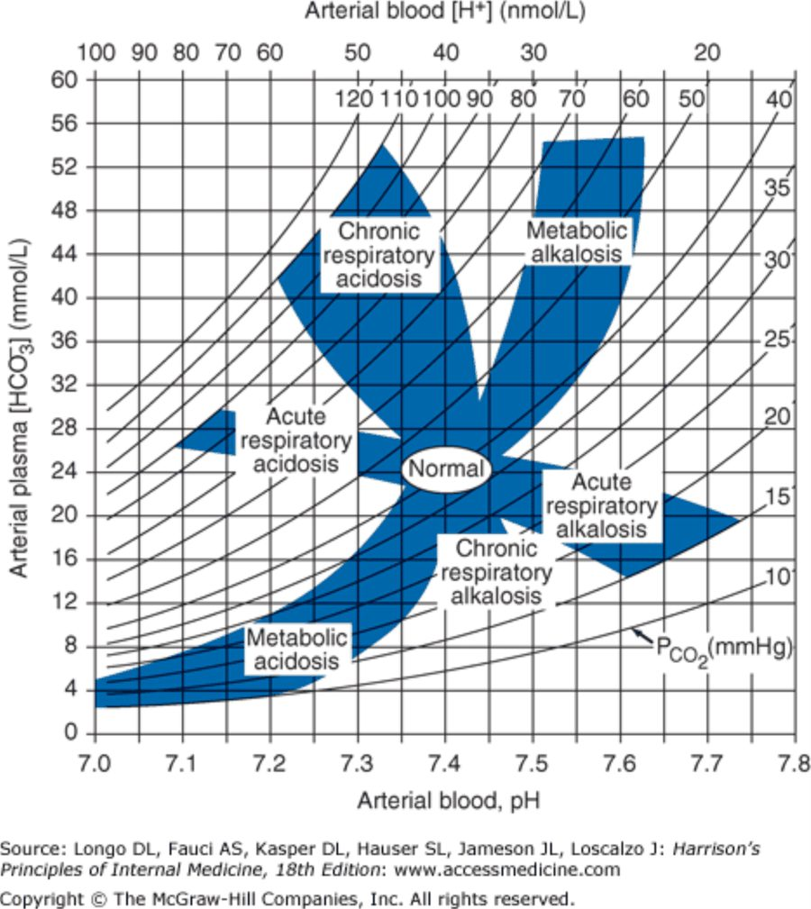
The acid-base nomogram: plot the bicarbonate against the pH and see which shaded band the point falls in (the curved lines are carbon dioxide in mm Hg). A tool for clinical rotations, not the exam: “academic ways I’m going to expect you to calculate it.” Slide 25

7.7 · Approach to the patient and mixed disorders (objectives d, e, f)

Approach to the patient Slide 26
- Identify the primary disorder: order an arterial blood gas and electrolytes. Acidosis or alkalosis? Metabolic or respiratory?
- Calculate the anion gap: sodium − (bicarbonate + chloride). It can be abnormal even when sodium, chloride and bicarbonate are within normal range. An anion gap over 20 mEq/L suggests a primary metabolic disorder. A large anion gap is never associated with compensation for a respiratory disorder alone!
- Evaluate compensation and identify any mixed disorder: calculate the expected compensation (slide 24 table); excess or inadequate compensation → a mixed disorder is present.
★ PROFESSOR EMPHASIS
★ Said three times (slides 4, 23, 26, 30)
- “We can only have one respiratory problem at a time, but we can have multiple metabolic problems at a time” (slide 23: cannot have more than one primary respiratory disorder). You cannot breathe too fast and too slow at once.
- “If we have a big anion gap that’s always going to be a metabolic problem. Respiratory disorders are not gonna cause large anion gaps like that” (slide 26).

One step further: the change in anion gap against the change in bicarbonate Slides 27, 50
- Change in anion gap = calculated anion gap − normal anion gap (10 is an accepted value).
- Change in bicarbonate = lab result for bicarbonate − normal bicarbonate (25 is an accepted value); use the size of the fall from 25.
- The change in anion gap should equal the change in bicarbonate; differences indicate mixed disorders are present (slide 27).
- Examine the patient again: do the clinical findings support the acid-base analysis? (slide 27, in red).
★ PROFESSOR EMPHASIS
★ “This is where it gets new” (slides 27, 50)
Comparison (slide 50) | Reading
Change in anion gap = change in bicarbonate | Metabolic acidosis only
Change in anion gap > change in bicarbonate | Concurrent metabolic alkalosis — only detectable if the anion gap is high
Change in anion gap < change in bicarbonate | Check the change in chloride!
Change in bicarbonate = change in anion gap + change in chloride | Concurrent increased anion gap metabolic acidosis AND normal anion gap metabolic acidosis

“We can really only detect that [the metabolic alkalosis] when we have an elevated anion gap metabolic acidosis.” With the bicarbonate change larger, she said, you pull differentials from both lists (MUDPILES and USEDCAR, 7.10).

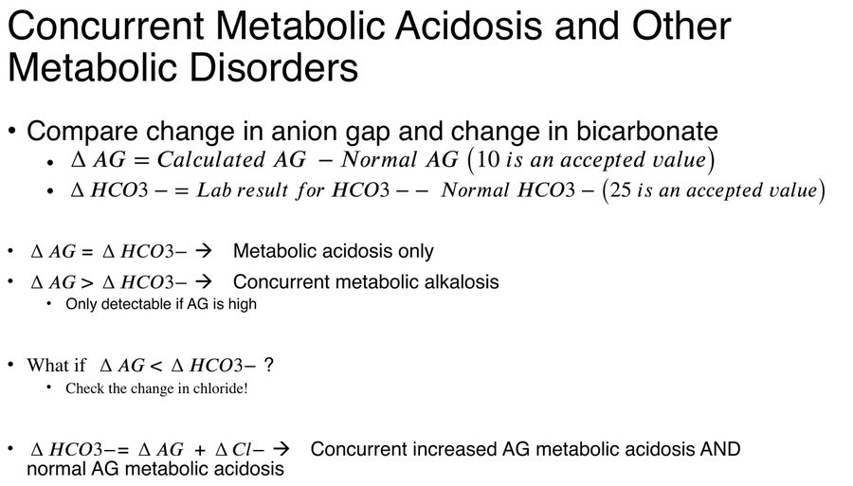
The rules as the slide prints them (typeset as equations, so they appear here as a picture beside the table above). Slide 27 opens with the same two formulas and adds “Do the clinical findings support the acid-base analysis?” Slide 50

Identifying mixed disorders: metabolic and respiratory Slides 28–29
Mixed disorder | Key (slide) | Example (slide) | Working it with the slide rules
Metabolic acidosis — respiratory alkalosis | High or normal anion gap metabolic acidosis; prevailing PaCO2 (arterial carbon dioxide) below predicted value | Sodium 140; potassium 4.0; chloride 106; bicarbonate 14; anion gap 20; PaCO2 24; pH 7.39 (lactic acidosis, sepsis in the intensive care unit) | Winter: 1.5 × 14 + 8 = 29, so 27–31 expected; 24 is below → concurrent respiratory alkalosis. Normal pH, yet two disorders
Metabolic acidosis — respiratory acidosis | High or normal anion gap metabolic acidosis; prevailing PaCO2 above predicted value | Sodium 140; potassium 4.0; chloride 102; bicarbonate 18; anion gap 20; PaCO2 38; pH 7.30 (severe pneumonia, pulmonary edema) | Winter: 1.5 × 18 + 8 = 35, so 33–37 expected; 38 is above → concurrent respiratory acidosis, though 38 is inside the normal range
Metabolic alkalosis — respiratory alkalosis | PaCO2 does not increase as predicted; pH higher than expected | Sodium 140; potassium 4.0; chloride 91; bicarbonate 33; anion gap 16; PaCO2 38; pH 7.55 (liver disease and diuretics) | Bicarbonate 8 above 25; carbon dioxide should rise about 0.75 × 8 = 6, to about 46; it is 38 → concurrent respiratory alkalosis
Metabolic alkalosis — respiratory acidosis | PaCO2 higher than predicted; pH normal | Sodium 140; potassium 3.5; chloride 88; bicarbonate 42; anion gap 10; PaCO2 67; pH 7.42 (chronic obstructive pulmonary disease on diuretics) | Bicarbonate 17 above 25; carbon dioxide should be about 40 + 13 = 53; it is 67 → concurrent respiratory acidosis. Normal pH, yet two disorders

Sepsis: metabolic acidosis plus respiratory alkalosis. Lactic acidosis from sepsis is a raised-gap metabolic acidosis, and the prevailing carbon dioxide sits below the predicted value (expected carbon dioxide = 1.5 x bicarbonate + 8): a concurrent respiratory alkalosis, which can bring the pH back to normal.
Diarrhea with a respiratory depressant. A gap of 139 - (115 + 14) = 10 is normal, with a high chloride: the normal-gap acidosis of diarrhea. Expected carbon dioxide = 1.5 x 14 + 8 = 29, range 27 to 31; a carbon dioxide of 36 is above it, a concurrent respiratory acidosis from the respiratory depressant.
Chronic respiratory acidosis with a concurrent metabolic alkalosis. In chronic respiratory acidosis bicarbonate rises 3.5 mEq/L per 10 mm Hg rise in carbon dioxide from a baseline of 40 mm Hg and 25 mEq/L, so a carbon dioxide of 60 predicts 25 + 3.5 x (60 - 40) / 10 = 32. A bicarbonate above the prediction, such as 37, means something beyond the kidneys is adding bicarbonate (loss of gastric acid by suction, or a diuretic): a concurrent metabolic alkalosis. Discontinuing contributors such as diuretics and treating potassium deficits are the listed steps for metabolic alkalosis.
Chronic obstructive pulmonary disease treated with diuretics. The classic metabolic alkalosis plus respiratory acidosis: chronic obstructive pulmonary disease is a listed cause of respiratory acidosis, and diuretics cause a saline-responsive metabolic alkalosis. The carbon dioxide is higher than predicted and the pH can be normal.

Identifying mixed disorders: two metabolic disorders Slide 30
Mixed disorder | Key (slide) | Example (slide) | Working it with the slide rules
Metabolic acidosis — metabolic alkalosis | Only detectable with high anion gap acidosis; change in anion gap much greater than change in bicarbonate | Sodium 140; potassium 3.0; chloride 95; bicarbonate 25; anion gap 20; PaCO2 40; pH 7.42 (uremia with vomiting) | Change in anion gap 20 − 10 = 10; change in bicarbonate 25 − 25 = 0 → concurrent metabolic alkalosis. pH, carbon dioxide and bicarbonate all normal; only the gap gives it away
Metabolic acidosis — metabolic acidosis | Mixed high anion gap — normal anion gap acidoses; change in bicarbonate accounted for by the combined change in anion gap and change in chloride | Sodium 135; potassium 3.0; chloride 110; bicarbonate 10; anion gap 15; PaCO2 25; pH 7.20 (diarrhea and lactic acidosis, toluene toxicity, treatment of diabetic ketoacidosis) | Change in anion gap 15 − 10 = 5; change in bicarbonate 25 − 10 = 15; the bicarbonate change is larger → check the chloride (raised at 110). Winter: 1.5 × 10 + 8 = 23, so 21–25; 25 is appropriate respiratory compensation

Change in anion gap against change in bicarbonate. Change in anion gap = calculated anion gap minus a normal gap, with 10 the accepted value (using the gap corrected for albumin when albumin is low). It is compared with the change in bicarbonate, measured from an accepted normal of 25; the two should be equal in a simple metabolic acidosis. A gap change larger than the bicarbonate change points to a concurrent metabolic alkalosis, such as from vomiting, holding bicarbonate up.
Uremic acidosis with vomiting: treat both causes. A gap of 143 - (97 + 25) = 21, a change in gap of 11, with no change in bicarbonate is a uremic acidosis with a metabolic alkalosis from vomiting. Both causes need treatment: replace the fluid deficit for the vomiting and treat the uremia (the kidney failure).
Acute respiratory acidosis with a concurrent metabolic acidosis. Acute compensation predicts bicarbonate = 25 + 1 x (70 - 40) / 10 = 28 for a carbon dioxide of 70. A bicarbonate far below it (19) with a raised gap of 22 means a lactic acidosis from blood loss has joined the respiratory acidosis, driving the pH to 7.06.
Raised-gap plus normal-gap metabolic acidosis. When the bicarbonate fell more than the gap rose, and the change in bicarbonate is accounted for by the change in gap and a rise in chloride together, a raised-gap and a normal-gap metabolic acidosis are present at once, as in diarrhea with lactic acidosis, or a clearing diabetic ketoacidosis treated with saline.
★ She worked all six slide examples as cases. Her method each time: pH, then carbon dioxide and bicarbonate against the pH, then the anion gap, then the expected compensation, then the change in anion gap, then “circle back to the patient.” Which disorder came first “doesn’t really much matter because you have to find and fix both.”

7.8 · Respiratory acidosis (objective d.a)
- Increased pCO2 due to decreased alveolar ventilation — NEVER increased carbon dioxide production. The body attempts to increase bicarbonate by cell buffering and increased acid secretion; the two mechanisms occur over different time periods. May be acute or chronic (slide 31).
- Acute: increased carbon dioxide → increased plasma carbonic acid; plasma bicarbonate increases 1 mEq/L for every 10 mm Hg increase in pCO2 (slide 33).
- Chronic: after 24–48 hours of sustained increased pCO2, plasma bicarbonate increases 3.5 mEq/L for every 10 mm Hg; urinary excretion of titratable acid and ammonium → increased plasma bicarbonate (slide 34).
Some causes of respiratory acidosis (slide 32)
Central nervous system depression | Sedatives, central nervous system event
Neuromuscular disorders | Myopathies, neuropathies
“Musculoskeletal disorders” | Kyphoscoliosis, Guillain-Barré syndrome, myasthenia gravis, botulism, polymyositis
Impaired lung motion | Hemothorax, pneumothorax
Thoracic cage injury | Flail chest
Acute airway obstruction | Upper airway, laryngospasm, bronchospasm
Also | Severe pneumonia or pulmonary edema; ventilator dysfunction; obesity-hypoventilation syndrome; pleural effusion
Lung disease | Chronic obstructive pulmonary disease, acute respiratory distress syndrome, pulmonary embolism

★ PROFESSOR EMPHASIS
★ Acute or chronic: read the bicarbonate (slides 33–35)
Slide 35: if the pCO2 is 80 mm Hg, how can we tell whether it is acute or chronic? Look at the bicarbonate on the arterial blood gas and compare it with the calculated expected bicarbonate.
pCO2 80 mm Hg (a rise of 40 from 40) | Expected bicarbonate rise | Expected bicarbonate (from 25)
Acute: 1 mEq/L per 10 mm Hg | about 4 | about 29
Chronic: 3.5 mEq/L per 10 mm Hg | about 14 | about 39

“Is it closer to the 29, or is it closer to 39?” Closer to 29 is acute; closer to 39 is chronic. The kidneys have “kicked in” in the chronic case, which is why the bicarbonate rise is larger.

Treatment Slides 36–37
- Treat the underlying condition. Look at medications: stop respiratory depressants — narcotics, benzodiazepines.
- Medicine review in respiratory acidosis. Treatment starts with the cause and a medicine review: stop respiratory depressants, narcotics and benzodiazepines, which reduce ventilation.
- Acute or severe impairment of carbon dioxide excretion: PaCO2 above 80 mm Hg and life-threatening hypoxia (PaO2, arterial oxygen, below 40 mm Hg): adequate ventilation (may involve emergency airways, a mechanical ventilator); clear secretions, assure airway patency; administer oxygen.
- Severe respiratory acidosis: secure ventilation. A carbon dioxide above 80 mm Hg with life-threatening hypoxia (partial pressure of oxygen below 40) is an acute, severe failure of carbon dioxide excretion. It needs adequate ventilation, which may mean an emergency airway and a mechanical ventilator, plus oxygen.
- Chronic: treatment similar to acute but with careful oxygen administration. A rapidly falling PaCO2 in chronic respiratory acidosis may trigger complications associated with alkalosis: cardiac arrhythmias, reduced cerebral perfusion, seizures.
- Chronic respiratory acidosis: avoid a rapid fall in carbon dioxide. Treatment is similar to acute disease but with careful oxygen, because a rapidly falling carbon dioxide in chronic respiratory acidosis may trigger the complications of alkalosis: cardiac arrhythmias, reduced cerebral perfusion and seizures.
★ She singled out narcotics as respiratory depressants (slides 32, 36), and slow, careful oxygen in the chronic retainer, because the compensating bicarbonate takes days to come back down (slide 37).

Respiratory acidosis
Defining feature: low pH with a high carbon dioxide from decreased alveolar ventilation (never increased production); the bicarbonate rise says acute (1 per 10) or chronic (3.5 per 10)
DefinitionIncreased pCO2 due to decreased alveolar ventilation, with a decreased pH; acute or chronic.Who gets itPatients with central nervous system depression, neuromuscular or chest wall disease, airway obstruction, lung disease or ventilator problems (slide 32).Risk factors / causesSedatives and other respiratory depressants (narcotics, benzodiazepines); myopathies, neuropathies; kyphoscoliosis, Guillain-Barré syndrome, myasthenia gravis, botulism, polymyositis; hemothorax, pneumothorax, flail chest; laryngospasm, bronchospasm; severe pneumonia or pulmonary edema; obesity-hypoventilation syndrome; pleural effusion; chronic obstructive pulmonary disease, acute respiratory distress syndrome.Classic signs & symptomsNot covered in the lecture.Physical exam findingsNot covered in the lecture.Diagnostics / testsArterial blood gas: pH below 7.35 with pCO2 above 45. Expected bicarbonate rise 1 mEq/L per 10 mm Hg (acute) or 3.5 (chronic, after 24–48 hours); compare the measured bicarbonate with the expected.First-line treatmentTreat the underlying condition; stop respiratory depressants. Severe (PaCO2 above 80 with PaO2 below 40): adequate ventilation (emergency airway, mechanical ventilator), clear secretions, airway patency, oxygen. Chronic: careful oxygen.ComplicationsIn chronic disease, a rapidly falling PaCO2 may trigger alkalosis complications: cardiac arrhythmias, reduced cerebral perfusion, seizures. Hyperkalemia from the acidosis shift (slide 5).
Acute bicarbonate rise. In acute respiratory acidosis bicarbonate climbs 1 mEq/L for each 10 mm Hg rise in carbon dioxide (3.5 mEq/L when chronic). A rise from 40 to 70 mm Hg is three steps of 10, so a baseline bicarbonate of 24 rises by 3 to 27 mEq/L.
Slides 5, 24, 31–37

7.9 · Respiratory alkalosis (objective d.b)
- pH above 7.45, decreased pCO2 (slide 38). Compensation: bicarbonate falls 2 mEq/L per 10 mm Hg fall (acute) or 5 (chronic) (slide 24).
- Some causes (slide 39): anxiety; hypoxia (high altitude → physiologic respiratory alkalosis); lung disease with or without hypoxia (decreased lung compliance — interstitial fibrosis); central nervous system disease (catastrophic central nervous system event — intracerebral hemorrhage).
Treatment (slide 40) | What the slide says
Mild pH alteration (pH below 7.50) | Treatment usually not required. Treat pain, anxiety, fever, infection or salicylate overdose. Mindful breathing to help control hyperventilation.
Mechanical ventilation | Decrease minute volume: decrease the number of breaths per minute or decrease tidal volume.

Mild respiratory alkalosis: treat the driver. A mild pH alteration, a pH below 7.50, usually does not require treatment. Management targets the driver, such as pain, anxiety, fever, infection or salicylate overdose, with mindful breathing to help control hyperventilation.

Respiratory alkalosis
Defining feature: high pH with a low carbon dioxide from hyperventilation: anxiety, hypoxia or altitude, lung or central nervous system disease, a ventilator set too high
DefinitionpH above 7.45 with a decreased pCO2.Who gets itAnxious or hypoxic patients, people at high altitude (physiologic), patients with lung or central nervous system disease, ventilated patients.Risk factors / causesAnxiety; hypoxia; high altitude; lung disease with or without hypoxia (interstitial fibrosis); intracerebral hemorrhage; also pain, fever, infection, salicylate overdose (slide 40).Classic signs & symptomsNot covered in the lecture.Physical exam findingsNot covered in the lecture.Diagnostics / testsArterial blood gas: pH above 7.45, pCO2 below 35; bicarbonate falls 2 mEq/L per 10 mm Hg (acute) or 5 (chronic).First-line treatmentMild (pH below 7.50): usually none; treat the pain, anxiety, fever, infection or salicylate overdose; mindful breathing. On a ventilator: decrease minute volume (fewer breaths or lower tidal volume).ComplicationsNot covered in the lecture beyond hypokalemia and decreased oxygen delivery from alkalosis (slide 5) and the unsustainable pH above 7.6 (slide 12).
Slides 5, 12, 24, 38–40

7.10 · Metabolic acidosis (objectives d.c, e)
- Excess of acid to buffer, or net loss of bicarbonate ions from extracellular fluid. Compensation → decrease pCO2 by increasing respiration (slide 41).
- Symptoms (slide 42): primarily associated with the underlying disorder; compensatory hyperventilation may be present; ★ Kussmaul breathing can be seen with severe acidosis: deep, regular, sighing breaths.
★ PROFESSOR EMPHASIS
★ Her mnemonics again (slide 43): MUDPILES and USEDCAR
Increased anion gap → MUDPILES. Normal anion gap → USEDCAR. “Are we dealing with our MUDPILES or are we dealing with our USEDCAR? And this gives us our differential list that we need to work from.”

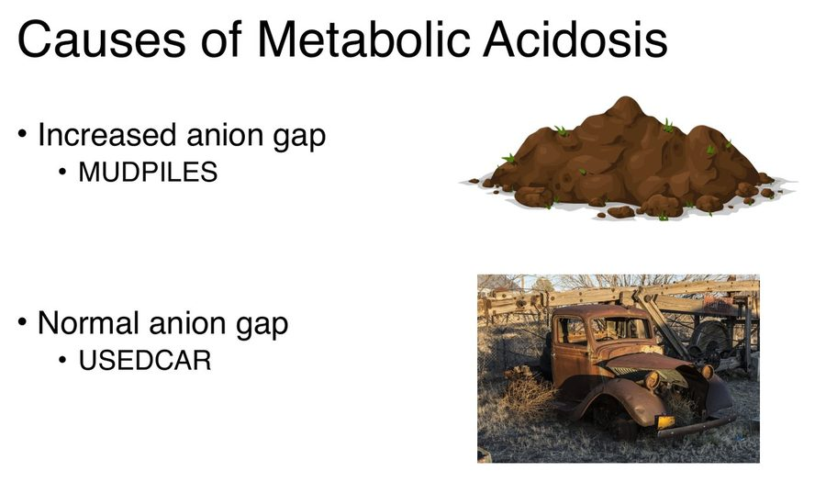
The same pictures as Lecture 34: a pile of mud for MUDPILES (increased anion gap) and a rusted old truck for USEDCAR (normal anion gap). Slide 44 puts the mud pile beside a pair of pliers and bolds the R of its added causes. Slide 43

Causes of increased anion gap metabolic acidosis Slide 44
Letter | Cause
M | Methanol, Metformin
U | Uremia
D | Diabetic / Alcoholic / Starvation ketoacidosis
P | Paraldehyde, propylene glycol
I | Isoniazid, Iron
L | Lactic acidosis
E | Ethylene glycol
S | Salicylates, Starvation
Also: R | Renal failure, Rhabdomyolysis
Think: anion gap > 12. Think: metabolic anions, renal failure, toxins.

The Big 4 causes of increased anion gap metabolic acidosis, “The Usual Suspects” Slide 45
Ketoacidosis | Lactic acidosis | Renal failure | Toxins
Diabetic  Alcoholic  Starvation | Poor tissue perfusion  Tissue necrosis  Severe anemia  Trauma | Chronic  Acute | Salicylates  Alcohols: methanol, ethylene glycol  5-oxoproline acidosis from acetaminophen toxicity

Causes of normal anion gap metabolic acidosis Slide 46
Letter | Cause
U | Ureteral diversion
S | Saline infusion
E | Exogenous acid
D | Diarrhea
C | Carbonic anhydrase inhibitors
A | Adrenal insufficiency
R | Renal tubular acidosis
Also | Chlorine gas exposure, Hyperalimentation (total parenteral nutrition)
Think: gastrointestinal bicarbonate loss, renal tubular acidosis.

★ Of the normal-gap causes, diarrhea (gastrointestinal loss of bicarbonate) and renal tubular acidosis are the common ones; the others are “a little bit less common.”
Anion gap in metabolic acidosis (slides 47–48)
Normal (6–12 mEq) | Loss of bicarbonate: diarrhea; recovery from diabetic ketoacidosis; pancreatic fluid loss, ileostomy (unadapted); carbonic anhydrase inhibitors.  Chloride retention: renal tubular acidosis; ileal loop bladder.  Administration of hydrochloric acid equivalent or NH4Cl (ammonium chloride): arginine and lysine in parenteral nutrition.
Decreased (below 6 mEq) | Hypoalbuminemia: decreased unmeasured anion; the anion gap must be corrected.  Plasma cell dyscrasias: monoclonal protein (cationic paraprotein accompanied by chloride and bicarbonate).  Bromide intoxication.

★ A low anion gap is “nine times out of ten” a low albumin: correct it (7.2) and it usually lands in the normal or raised range. Plasma cell dyscrasias and bromide are “pretty much zebra conditions.”
★ PROFESSOR EMPHASIS
★ “1.5 times our bicarb plus eight plus or minus two” (slide 49)
Compensation for metabolic acidosis, increased-gap and normal-gap alike: determine whether there is adequate respiratory compensation or a concurrent respiratory disorder.
Winter formula: expected pCO2 = 1.5 × (HCO3−) + 8, plus or minus 2 — expected carbon dioxide = 1.5 times the measured bicarbonate, plus 8, plus or minus 2.
Measured pCO2 (slide 49) | Reading
= expected (inside the plus-or-minus 2 range) | Metabolic acidosis only
> expected | Concurrent respiratory acidosis
< expected | Concurrent respiratory alkalosis

Example from slide 28: bicarbonate 14 → 1.5 × 14 + 8 = 29, range 27–31. A measured 24 is below the range: a concurrent respiratory alkalosis.

Carbon dioxide above the Winter range: a concurrent respiratory acidosis. Winter formula: expected carbon dioxide = 1.5 x bicarbonate + 8; with a bicarbonate of 12, 1.5 x 12 + 8 = 26, range 24 to 28. A measured carbon dioxide above that range, even a value below normal such as 34 or 36, is higher than compensation requires: a concurrent respiratory acidosis. Respiratory depressants such as narcotics (an opioid) and benzodiazepines cause decreased ventilation: stop them and treat the cause, such as the infection.
Then compare the change in anion gap with the change in bicarbonate for a second metabolic disorder (7.7, slide 50).

Metabolic acidosis
Defining feature: low pH with a low bicarbonate; calculate (and albumin-correct) the anion gap, then check the carbon dioxide with the Winter formula
DefinitionAn excess of acid to buffer or a net loss of bicarbonate from extracellular fluid, with a decreased pH and bicarbonate; increased, normal or decreased anion gap.Who gets it“The usual suspects”: ketoacidosis (diabetic, alcoholic, starvation), lactic acidosis, renal failure, toxins; for a normal gap, gastrointestinal bicarbonate loss and renal tubular acidosis.Risk factors / causesIncreased gap: MUDPILES (methanol, metformin, uremia, ketoacidoses, paraldehyde, propylene glycol, isoniazid, iron, lactic acidosis, ethylene glycol, salicylates, starvation; also renal failure, rhabdomyolysis). Normal gap: USEDCAR (ureteral diversion, saline infusion, exogenous acid, diarrhea, carbonic anhydrase inhibitors, adrenal insufficiency, renal tubular acidosis; also chlorine gas, hyperalimentation).Classic signs & symptomsPrimarily those of the underlying disorder; compensatory hyperventilation may be present.Physical exam findingsKussmaul breathing (deep, regular, sighing breaths) with severe acidosis.Diagnostics / testsArterial blood gas and electrolytes; anion gap = sodium − (bicarbonate + chloride), corrected for albumin; Winter formula for the expected carbon dioxide; change in anion gap against change in bicarbonate (and chloride).First-line treatmentNo treatment slide for this disorder; slide 12: treat the underlying cause, and an unsustainable pH (below 6.7) may warrant therapy to normalize the serum pH along with it.ComplicationsHyperkalemia from the hydrogen-potassium shift (slide 5); at pH below 6.7, cardiac hypocontractility or irritability, seizures, cerebral edema (slide 12).
Saline is a normal-gap cause. A metabolic acidosis with a normal gap, such as 140 - (15 + 115) = 10, and a high chloride fits saline infusion, a normal-gap cause, so further large-volume normal saline feeding the acidosis is the part to limit.
Raised-gap causes: renal failure, lactic acidosis, metformin. Renal failure, acute or chronic, and lactic acidosis from poor tissue perfusion are among the big four raised-gap causes. Metformin is also on the raised-gap list, and stopping possible contributors is part of treating the underlying cause.
Slides 5, 7–8, 12, 41–50

7.11 · Metabolic alkalosis (objective d.d)
- pH above 7.45; hydrogen ion decreased; bicarbonate increased. Not as common as metabolic acidosis (slide 51).
- Symptoms (slide 52): primarily associated with the underlying disorder; hypokalemia may cause weakness, hyporeflexia; rarely tetany and neuromuscular irritability.
Urine chloride (slide 51) | Type
Lower: below 25 mEq/L | Saline responsive
Higher: above 40 mEq/L | Saline unresponsive

Saline-responsive (slide 53) | Saline-unresponsive, normotensive | Saline-unresponsive, hypertensive
Volume contraction  Diuretics (sodium reabsorption, hydrogen ion secretion)  Vomiting or gastric suction (loss of gastric hydrochloric acid)  Ingestion of alkaline drugs (NaHCO3, sodium bicarbonate)  Post-hypercapnia | Severe potassium depletion  Hypoparathyroidism and hypercalcemia | Primary aldosteronism  Exogenous alkali  Mineralocorticoids  Licorice

★ Two subtypes, split by the urine chloride; then for the saline-unresponsive ones, “consider their blood pressure. Is it normal or is it elevated?” Most saline-responsive cases come with some degree of dehydration.

Treatment Slides 54–55
- Treat the underlying condition. Cause unclear: measure urinary chloride to narrow the differential to saline responsive or unresponsive.
- Discontinue possible contributors: diuretics, nasogastric suction, corticosteroids.
- Treat fluid deficits and potassium deficits if needed — don’t overcorrect!
- If the patient requires corticosteroid treatment: decrease the dose or change to one with less mineralocorticoid activity if possible — consider prednisone or methylprednisolone versus cortisone or hydrocortisone.
- Consider whether these are present: excess alkali intake; glucose ingestion after a period of starvation; high-dose penicillin treatment; profound potassium depletion; endogenous mineralocorticoid excess.
★ PROFESSOR EMPHASIS
★ “Careful not to overcorrect” (slides 5, 54)
The hypokalemia of alkalosis is potassium shifting into cells (slide 5), not a loss of total body potassium; once balance is restored, the potassium moves back out. Replace potassium only if needed, and don’t overcorrect (slide 54), or the potassium ends up too high.

Potassium in metabolic alkalosis: do not overcorrect. Much of the low potassium in alkalosis is a shift into cells. Potassium deficits are treated if needed, but overcorrection is to be avoided, because as the alkalosis corrects potassium shifts back out of the cells.

Metabolic alkalosis
Defining feature: high pH with a high bicarbonate; urine chloride below 25 (saline responsive: vomiting, diuretics, volume contraction) or above 40 (saline unresponsive, then sort by blood pressure)
DefinitionpH above 7.45 with decreased hydrogen ion and increased bicarbonate; saline-responsive and saline-unresponsive types.Who gets itLess common than metabolic acidosis; patients with volume contraction, diuretics, vomiting or gastric suction, steroid or mineralocorticoid excess.Risk factors / causesResponsive: volume contraction, diuretics, vomiting or gastric suction, alkaline drugs, post-hypercapnia. Unresponsive normotensive: severe potassium depletion, hypoparathyroidism and hypercalcemia. Unresponsive hypertensive: primary aldosteronism, exogenous alkali, mineralocorticoids, licorice.Classic signs & symptomsPrimarily those of the underlying disorder; weakness from hypokalemia; rarely tetany and neuromuscular irritability.Physical exam findingsHyporeflexia (from hypokalemia); blood pressure normal or raised in the saline-unresponsive types.Diagnostics / testsArterial blood gas: pH above 7.45, bicarbonate above 26; carbon dioxide rises 0.75 mm Hg per 1 mEq/L bicarbonate rise; urine chloride below 25 (responsive) or above 40 mEq/L (unresponsive).First-line treatmentTreat the underlying condition; stop diuretics, nasogastric suction, corticosteroids (or switch to less mineralocorticoid activity); treat fluid and potassium deficits if needed without overcorrecting.ComplicationsHypokalemia (a shift into cells) and decreased oxygen delivery to tissues (slide 5); potassium overcorrection.
Diuretic-induced metabolic alkalosis. A metabolic alkalosis with a low urine chloride is saline-responsive, and diuretics are a cause. Treatment stops the contributor (the thiazide) and treats the fluid and potassium deficits, without overcorrecting.
Slides 5, 24, 51–55

7.12 · Step-by-step acid-base diagnosis (objective f)
- Obtain an arterial blood gas and electrolytes simultaneously; compare the bicarbonate on the blood gas and on the electrolytes to verify accuracy (slide 56).
- Acidosis or alkalosis? Look at the pH (slide 56).
- Respiratory or metabolic? Look at the PCO2 and bicarbonate (slide 56).
- Calculate the anion gap and correct for hypoalbuminemia if needed (slide 57).
- Estimate the compensatory response: is compensation appropriate? (slide 57)
- Determine what mixed disorders may be present: consider pH, carbon dioxide, bicarbonate; the change in anion gap, bicarbonate and chloride (slide 57).
- Does your assessment of the acid-base disorder match the clinical picture? (slides 56–57, in red).
First step: gas and electrolytes drawn together. Obtain an arterial blood gas and electrolytes simultaneously, so the bicarbonate on each can be compared to verify accuracy and the anion gap can be calculated. A difference of 10 mEq/L between samples drawn together means one result is unreliable: recheck both before any further step.
★ PROFESSOR EMPHASIS
★ “Always, always, always circle back to our patient” (slides 27, 56–57)
Even when the pH is normal, still look at the bicarbonate and the carbon dioxide; then ask whether the physical exam and the clinical picture match the numbers. Conclusion (slide 63): use a step-wise method; identify the primary disorder; calculate the anion gap; assess compensatory mechanisms; is there a second disorder? If so, identify the underlying causes and treat both diagnoses!

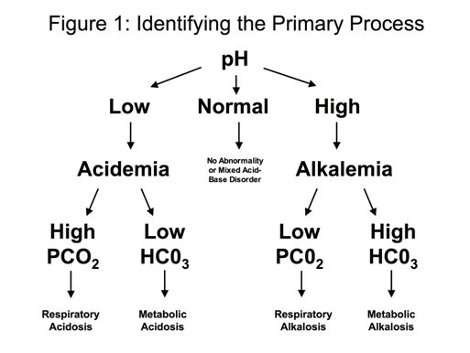  Identifying the primary process  Normal pH = no abnormality or a mixed disorder  Slide 58 | 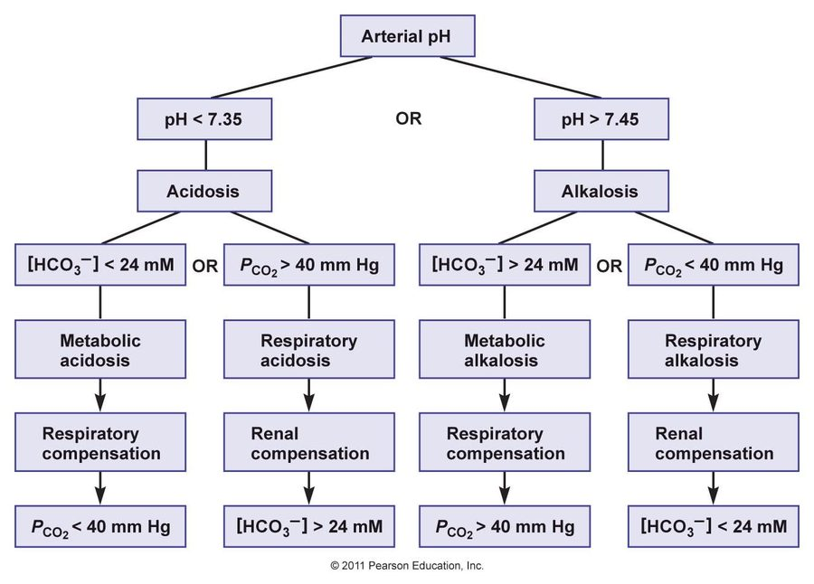  Evaluation of acid-base disturbances  pH, then bicarbonate against 24 or carbon dioxide against 40, then the expected compensation  Slide 59

Slide 59 flowchart | Value that explains the pH | Disorder | Compensation
Acidosis (pH below 7.35) | Bicarbonate below 24 mM | Metabolic acidosis | Respiratory: carbon dioxide below 40 mm Hg
Carbon dioxide above 40 mm Hg | Respiratory acidosis | Renal: bicarbonate above 24 mM
Alkalosis (pH above 7.45) | Bicarbonate above 24 mM | Metabolic alkalosis | Respiratory: carbon dioxide above 40 mm Hg
Carbon dioxide below 40 mm Hg | Respiratory alkalosis | Renal: bicarbonate below 24 mM

